Vale of Glamorgan Council
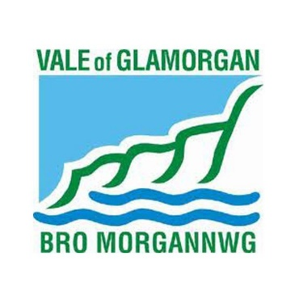
Housing Support Grant Delivery Plan

April 2022- March 2025

Housing Support Grant (HSG) Delivery Plan
2022-2023
Contents

1.Introduction | Page 1
2.Needs Assessment | Page 4
3.Delivery Priorities | Page 6
4.Stakeholder Engagement | Page 12

Annexes
Annex A: Equalities Impact Assessments

Annex B: Spend Plan

Annex C: Commissioning Plan

Annex D: Homelessness Statutory duties

- Introduction

The Vale of Glamorgan Housing Support Grant Delivery Plan outlines the need for housing related support funded by the Housing Support Grant (HSG) in the Vale of Glamorgan from 2022-2025
The HSG is an amalgamation of three existing grants; the Supporting People Programme Grant, the Homelessness Prevention Grant and Rent Smart Wales Enforcement Grant.
Welsh Government has notified the Vale of Glamorgan Council of an indicative HSG budget of £4,718,683.58 for the financial years 2022-23, 2023-24 and 2024-25. In nominal terms this means the budget will remain flat over the 3 year period.

The HSG is an early intervention grant programme to support activity, which prevents people from becoming homeless, stabilises their housing situation, or helps potentially homeless people to find and keep accommodation. The HSG does not fund the statutory duty on local authorities to prevent homelessness, instead HSG funded services augment, complement and support the statutory service to ensure that the overall offer authorities provide helps people into the right homes with the right support to succeed. It supports vulnerable people to address the, sometimes multiple, problems they face, such as debt, employment, tenancy management, substance misuse, violence against women, domestic abuse and sexual violence, and mental health issues. Support is person centred, aimed at supporting people to secure and maintain sustainable housing by addressing their needs and working with them to develop the skills needed to maintain a tenancy.

At the core of the HSG is the prevention of homelessness, as such the HSG Delivery Plan will work to meet the strategic priorities set out in the Housing Support Programme Strategy. This will be achieved by:

- Expanding the capacity of existing floating support, supported accommodation and drop-in support services to meet increased need.
- Reconfiguring existing services to work in new ways to help deliver new strategic priorities.
- Commissioning new projects including a Complex Needs Hostel, 24hr Supported Accommodation for people experiencing mental health issues, Supported Accommodation for people with Learning difficulties and new floating support services for people with housing related support needs.

The Vale of Glamorgan HSG Delivery Plan is based upon a comprehensive needs mapping process which involves collecting data from the Housing Solutions Team, Support Providers, and a range of stakeholders.

…………………………………………………………………………………………………

- Needs assessment
Local authorities are required to undertake a comprehensive needs assessment every four years, with a light touch review every two years to inform development of their HSP Strategy as set out in the HSG Guidance issued by Welsh Government.
This needs assessment also informs the three-year HSG Delivery Plan and the needs identified in this assessment sets the response outlined in the Commissioning Plan (section 5).
2a Needs assessment process
In 2018 a referral form named the Housing Related Support (HRS) Form was introduced. This is now used by all agencies referring into the scheme including Housing Associations, Voluntary Sector Groups, the Local Health Board, Probation and internal services. A single assessment form was also introduced at this point in order that needs can be more easily identified and duplication is reduced for both the client and the services that provide support.
The needs assessment information can be broken down into area specific support needs so that if new funding should become available, services can be developed in the areas showing most need. In addition, providers have been approached to suggest ideas for “off the shelf” project proposals as required by the new guidance. These are projects that can be commissioned at short notice if funding becomes available. However, they will need to be strategically relevant and will be subject to approval via the traditional planning processes.
This year it has been important to interpret the traditional Supporting People data in conjunction with data from the pandemic, as well as attempting to assess the likely ongoing impacts of the pandemic on homelessness, unemployment and the resulting support needs of our citizens. We are seeing an increase in demand on homelessness and support services, and this is likely to continue as more people face financial hardship particularly with current high levels of energy costs and other inflationary pressures.
Identifying Gaps in Services
By combining the data collected over the last year and the additional information provided by the Housing Solutions statistics with the existing supply of services, a picture of the gaps in services emerge. These findings are presented to the core members of the Local Planning Group in the Vale of Glamorgan who determine the future local service priorities for development.

2b Key findings
There has been a significant increase in demand for support between 2020 and 2021 as the chart below illustrates:

The total numbers of referrals made to the Supporting People in 2021 increased by 16% over the previous year. This reflects the experiences of frontline support staff at the Drop-in service where demand for support was higher than originally anticipated. Consequently, this has generated more referrals to the Supporting People Team than in previous years.
The needs mapping process broken down into client groups indicated the current unmet need based on comparing demand with the number of units is displayed in the chart below:

The three highest areas of unmet identified in the are:
- Homeless or Potentially Homeless
- Mental Health
- Domestic Abuse
(see annex B for more needs data)
The high demand for support from people who are homeless or at risk of homelessness reflects the significant increase in the numbers who presented to the Vale of Glamorgan Housing Solutions Team.
For example, in the Vale of Glamorgan 459 households were accepted as homeless under Section 73 in 2020-21 which compares to 342 households accepted as homeless under Section 73 of the Act in 2019-2020. In 2020-21 138 households were accepted as homeless and in priority need under Section 75 which compares to 90 households in 2019-20.
The increased demand from people presenting with Mental Health reflects a trend observed since the outset of the Covid-19 pandemic where increased numbers of people have reported experiencing mental health issues during their needs assessments. This corresponds with research by Mind Cymru published in 2021 which indicates that the number of people experiencing mental health issues in Wales has risen and the numbers reporting increased anxiety have both increased since the beginning of the Covid-19 pandemic.
The needs data indicates that the numbers presenting with Domestic Abuse issues have increased since the Covid-19 pandemic which corresponds with the increased number of people presenting to Domestic abuse drop-in service in the Vale. This reflects a national trend across the UK where an increase in victims reporting domestic abuse in 2021 was recorded by Refuge UK.

- Delivery priorities
The Supporting People Team has the following HSG priorities for the duration of this award period:

HSG Priority One: Increase access to floating support services
We all achieve this by expanding existing floating support services so that a greater number of service users can receive support.
HSG Priority Two: Increase access to Drop-in support services
We all achieve this by expanding existing Drop-in services so that a greater number of service users can receive support.
HSG priority Three: Increase access to temporary supported accommodation
We will achieve this by commission new temporary supported accommodation projects so that a greater number of service users can receive support.
HSG Priority Four: To maintain access to alarm services which helps enable vulnerable people to live independently in their own homes
We will continue to fund a subsidy for vulnerable older people’s emergency alarm services.
HSG Priority Five: To ensure the Supporting People Gateway is efficient, effective, and accessible to all.
We will introduce a new software system to enable a more efficient and effective Gateway system that service users find easier to access. This is a part of the Vale of Glamorgan’s digital strategy.

Spend Plan 2022-2023
Project Type | Number of Units | Spend against Project Type
Private Rented Sector  Access Schemes | 267 | £113,025.00
Emergency Accommodation Provision | 16 | £5000.00
Mediation Service | 85 | £9000.00
Daytime Drop-in Service | 330 | £385,000.00
Enforcement, investigation or compliance with housing legislation | - | £6,000.00
Activities designed to promote and publicise compliance with housing legislation | - | £3,523.00
Floating Support – VAWDASV | 33 | £170,458.00
Floating Support – Learning Disability | 20 | £89,771.00
Floating Support – Mental Health | 105 | £380,272.00
Floating Support – Substance Misuse and/or Alcohol Issues | 37 | £149,140.00
Floating Support – Ex-offenders | 7 | £28,823.00
Floating Support – Young People | 32 | £135,316.00
Floating Support – Older People | 60 | £123,823.00
Floating Support - Generic | 235 | £814,134.06
Floating Support - Other | 40 | £111,897.00
Temp Supported Accommodation – Learning Disability | 34 | £300,262.00
Temp Supported Accommodation – Mental Health | 28 | £406,843.00
Temp Supported Accommodation – Substance Misuse and/or Alcohol Issues (dry accommodation) | 9 | £64,320.00
Temp Supported Accommodation – Ex-offenders | 18 | £75,474.00
Temp Supported Accommodation – Young People | 42 | £464,098.00
Temp Supported Accommodation - Other | 18 | £419,311.00
Alarm Services | 2,402 | £130,113.52
Refuges - Female | 10 | £154,834.00
Refuges - Other | 6 | £35,000.00
Target Hardening Equipment | 770 | £30,000.00
Non-statutory HSG funded posts | 2 | £80,000.00
Other - General | 1 | £33,246.00
Total | 4607 | £4,718,683.58

- Private Rented Sector (PRS) Access Scheme
- HSP Priority 4: Increase Access to the Private Rented Sector
- HSG Priority 1: Increase Access to Floating Support Services
- This funding will continue with the PRS service to help people on the Vale Assisted Tenancy Scheme (VATS) maintain their tenancies.

- Emergency Accommodation Provision
- HSP Priority 6: Increase the supply of permanent and temporary accommodation
- This funding will continue for Emergency accommodation in Penarth.

- Mediation Services
- HSP Priority 1: Provide a robust, targeted prevention service to prevent homelessness and tackle the main causes of homelessness.
- This funding will continue to the fund mediation service to help enable families to stay together and prevent homelessness. It is also being expanded to tenant and landlord mediation. For the first time in 2022 the HPG funded Family mediation service is being transferred across to the HSG with its funding ring fenced for two years. The Vale of Glamorgan is fully committed to continue with this Mediation Service.
- Day-time Drop-in Service
- HSP Priority 5: Support the most vulnerable to sustain their tenancy and integrate into the community
- HSG Priority 2: increase access to Drop-in Support Services
- This funding will continue to fund the Vale One Stop Shop Drop-in Service to help people maintain their tenancies

- Enforcement, investigation or compliance with housing legislation
- HSP Priority 1: Provide a robust, targeted prevention service to prevent homelessness and tackle the main causes of homelessness
- This funding for Rent Smart Wales will ensure landlords comply with housing legislation.

- Activities designed to promote and publicise compliance with housing legislation
- HSP Priority 1: Provide a robust, targeted prevention service to prevent homelessness and tackle the main causes of homelessness
- This funding will continue to promote and publicise compliance with housing legislation.

- Floating Support – VAWDASV
- HSP Priority 1: Provide a robust, targeted prevention service to prevent homelessness and tackle the main causes of homelessness
- HSG Priority 1: Increase Access to Floating Support Services
- This funding will continue to fund housing support for victims for domestic abuse and sexual violence. We are continuing to work with CCG reps to explore support for children.

- Floating Support – Learning disability
- HSP Priority 1: Provide a robust, targeted prevention service to prevent homelessness and tackle the main causes of homelessness
- HSG Priority 1: Increase Access to Floating Support Services
- This funding is for the Esgyn service which provides support for people with Learning disabilities.

- Floating Support – Mental Health
- HSP Priority 3: Strengthen and expand access to mental health support services
- HSG Priority 1: Increase Access to Floating Support Services
- This funding is for several mental health floating support services.

- Floating Support – Substance Misuse and/or Alcohol Issues
- HSP Priority 1: Provide a robust, targeted prevention service to prevent homelessness and tackle the main causes of homelessness
- HSG Priority 1: Increase Access to Floating Support Services
- This funding is for floating support for the Ffynnon project for people with substance misuse and alcohol issues.

- Floating Support – Ex-offenders
- HSP Priority 1: Provide a robust, targeted prevention service to prevent homelessness and tackle the main causes of homelessness
- HSG Priority 1: Increase Access to Floating Support Services
- This funding is for the Holton Road criminal justice floating support service.

- Floating Support – Young People
- HSP Priority 1: Provide a robust, targeted prevention service to prevent homelessness and tackle the main causes of homelessness
- HSG Priority 1: Increase Access to Floating Support Services
- This funding is for the TESS 7 and Tom Holmes Young People’s floating support services.

- Floating Support – Older People
- HSP Priority 1: Provide a robust, targeted prevention service to prevent homelessness and tackle the main causes of homelessness
- HSG Priority 1: Increase Access to Floating Support Services
- This funding is for the Golau Caredig floating support service and Croeso Pawb drop in service.

- Floating Support – Generic
- HSP Priority 1: Provide a robust, targeted prevention service to prevent homelessness and tackle the main causes of homelessness
- HSG Priority 1: Increase Access to Floating Support Services
- This fund is for several generic floating support contracts.

- Floating Support – Other
- HSP Priority 1: Provide a robust, targeted prevention service to prevent homelessness and tackle the main causes of homelessness
- HSG Priority 1: Increase Access to Floating Support Services
- This fund for the Teulu project which provides support to families with support needs.

- Temp Supported Accommodation – Learning Disability
- HSP Priority 1: Provide a robust, targeted prevention service to prevent homelessness and tackle the main causes of homelessness
- HSG Priority 3: Increase access to Temporary Supported Accommodation
- This funding is for the new Learning Disability supported accommodation.

- Temp Supported Accommodation – Mental Health
- HSP Priority 3: Strengthen and expand access to mental health support services
- HSG Priority 3: Increase access to Temporary Supported Accommodation
- This funding is for the new 24hour Mental Health Supported Accommodation

- Temp Supported Accommodation – Substance Misuse and/or Alcohol Issues (dry accommodation)
- HSP Priority 1: Provide a robust, targeted prevention service to prevent homelessness and tackle the main causes of homelessness
- HSG Priority 3: Increase access to Temporary Supported Accommodation
- This funding is for the Croes Ffin substance misuse supported accommodation project.

- Temp Supported Accommodation – Ex-offenders
- HSP Priority 1: Provide a robust, targeted prevention service to prevent homelessness and tackle the main causes of homelessness
- HSG Priority 3: Increase access to Temporary Supported Accommodation
- This funding is for the Holton Road criminal justice supported accommodation

- Temp Supported Accommodation – Young People
- HSP Priority 1: Provide a robust, targeted prevention service to prevent homelessness and tackle the main causes of homelessness
- HSG Priority 3: Increase access to Temporary Supported Accommodation
- This funding for our Ty John Rowley, Ty’r Fro & Ty Newydd young people’s supported accommodation projects.

- Temp Supported Accommodation – Other
- HSP Priority 5: Support the most vulnerable to sustain their tenancy and integrate into the community
- HSG Priority 3: Increase access to Temporary Supported Accommodation
- This funding is for the new complex needs hostel supported accommodation project.

- Alarm Services
- HSP Priority 5: Support the most vulnerable to sustain their tenancy and integrate into the community
- HSG Priority 4: To maintain access to alarm services which supports vulnerable people to live independently in their own homes
- This funding is for a range emergency alarm services for vulnerable older people at risk of slips, trips or falls across all tenures.

- Refuges – Female
- HSP Priority 5: Support the most vulnerable to sustain their tenancy and integrate into the community
- HSG Priority 3: Increase access to Temporary Supported Accommodation
- This funding is for the refuge which provides temporary supported accommodation for victims of domestic abuse.

- Refuges – Other
- HSP Priority 5: Support the most vulnerable to sustain their tenancy and integrate into the community
- HSG Priority 3: Increase access to Temporary Supported Accommodation
- This funding is for the gender neutral dispersed supported accommodation.

- Target Hardening Equipment
- HSP Priority 5: Support the most vulnerable to sustain their tenancy and integrate into the community
- HSG Priority 4: To fund alarm services which supports vulnerable people to live independently in their own homes
- This funding is for target hardening of the houses of domestic abuse victims in the Vale which is done in partnership with the Community Safety Team.

- Non-statutory HSG funded posts
- HSP Priority 5: Support the most vulnerable to sustain their tenancy and integrate into the community
- HSG Priority 1: Increase Access to Floating Support Services
- This funding is for a support role to work with housing solutions clients, to support them through the application process, assess their support needs. Plus, funding for a Mental Health link worker to identify housing solutions clients with MH needs, advise colleagues on how this will impact their housing situation and signpost clients to relevant agencies.

- Other – General
- HSP Priority 5: Support the most vulnerable to sustain their tenancy and integrate into the community
- HSG Priority 5: To ensure the Supporting People Gateway is efficient, effective, and accessible to all.
- This funding is for the Supporting People Gateway officer and the daily running of the Gateway Service.

- Stakeholder engagement
- The Supporting People Local Planning Group
The core members continue to meet to examine the needs data once it is collated.
The core members of the Supporting Planning Group are:
• Operational Manager Public Sector Housing (Chair)
• Operational Manager, Mental Health Services
• Operational Manager Public Health Wales
• Operational Manager Social Services
• Vale Manager, South Wales Area National Probation Service
• Vale Locality Lead Nurse, Cardiff and Vale University Health Board
• Voluntary Sector Representative

- Consultation
As a Local Authority we recognise that to ensure any services being developed are fit for purpose a coproduction approach is essential. We therefore carry out consultation on a regular basis and through a variety of formats to capture as much information from our clients and stakeholders as possible.

- The Supporting People Liaison Group
This is a forum for all Supporting People stakeholders and allows for the exchange of information and for all stakeholders to participate in the planning process. Meetings take place quarterly. This is an inclusive forum, to which service users are also invited.

- Service User Consultation
In 2010 the Council commissioned external Consultants to work with service users to put together a Service User Participation Framework to set out how they wanted to engage with the Council, both on service improvement and new developments.
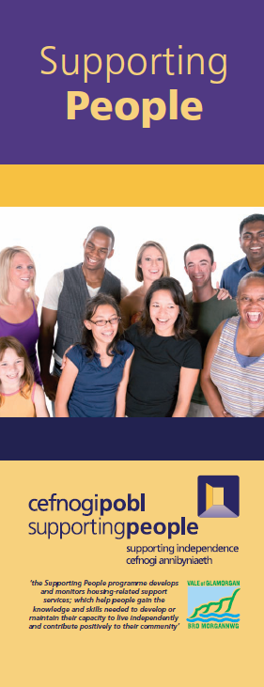
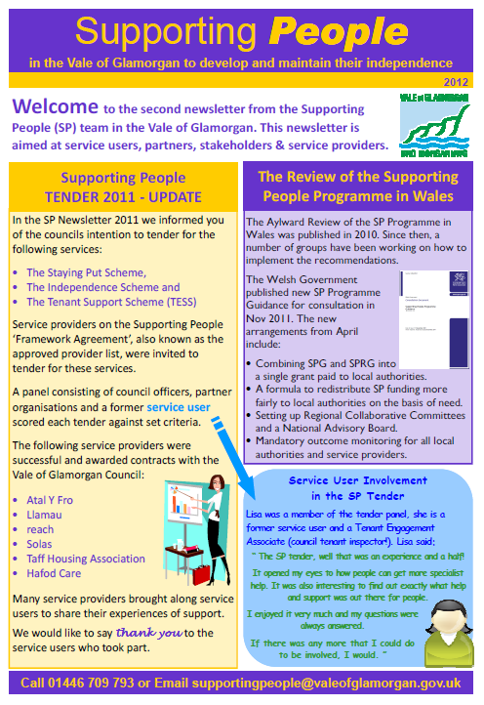
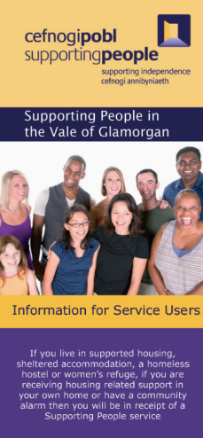
In response to this consultation, the Service User Consultation Framework was developed and the following procedures were introduced by the Council’s Supporting People Team:
Supporting People Leaflet, Newsletter and Pop-Up Banner
- At least 20% of both existing and former service users are interviewed as part of each service review (10% in alarm services).
- Posters and leaflets are available and circulated to service users to advise them how to contact and provide feedback to the Supporting People Team, if they wish.
- The Supporting People Team attends all support provider participation events, with a stall. A questionnaire is used to gather service user feedback.
- An annual Supporting People Newsletter is circulated to all service users.
- A web-based service user questionnaire is available on the Vale of Glamorgan Council’s website for completion.
- All support providers must provide an annual Service User Participation report detailing how service user views are gathered, the impact on the service, and how feedback is provided to the service users.
- Housing Solutions client satisfaction survey is completed to ensure the customer remains at the centre of the service and their care remains excellent.

The Regional Collaborative Committee also developed a Regional Service User Participation Framework in early 2015, which has been implemented by the Supporting People Team. The findings continued to reflect the position outlined above.
However due to the increased focus on service user involvement with the HSG Programme and developments in technology a new Service User Engagement Strategy Task and Finish Group was formed in 2018 by the RCC, consisting of the Supporting People Leads, the Regional Development Coordinator, provider and landlord representatives. This group held a consultation event with service users hosted by Cymorth Cymru in late 2018 which informed the direction of travel for the group. The group has developed a strategy to engage with service users in a variety of ways based on the information they learned from this event, including through the use of social media, online surveys and traditional face to face settings. A survey has been developed that is now being used on the website in order to give service users another means to tell us what they want from support.
During 2019 we held two consultation events. One was aimed at managers of Supporting People funded services and other stakeholders. The other event was aimed at front line staff and service users. Both events were well attended and gave us lots of information to use in future service development. The overwhelming message from the events was that more “drop in” support services were needed so that service users can get support at the point they need it. We also asked how people would like this type of service provided and what they think would improve our current drop-in services. This information helped to inform the service specification for the One Stop Shop as well as helping us establish the priorities for future commissioning.
2021 Stakeholder Survey
In the wake of the Covid-19 pandemic and the significant changes it has brought to society and the environment of support it was decided that an online stakeholder survey should be carried out with stakeholders and service users to gather their views on the shape of the future of housing related support services in the Vale of Glamorgan
In 2021 the survey was launched, and all stakeholders and service users were invited to take part. Due to potential barriers linked with digital participation support providers across the Vale were asked to support service users to take part in the consultation process where support was required.
As part of the consultation Participants were asked a range of questions about housing related support services including the following:
- what they felt about the existing provision of support services
- whether existing services needed expanding or improving
- whether they felt there were any gaps in existing services
- if responders had any ideas or suggestions for new services
- if responders had any ideas ways to improve existing services.
Summary of feedback:
- 37.5% of responders felt that floating support services needed to be expanded.
Comments included:
“There is a long waiting list for support”
“More capacity is needed”
“More MH [mental health] services are needed”
- 75% of responders felt that current provision of Supported Accommodation needed to be expanded.
Comments included:
“More mental health provision and complex needs required”
“There needs to be further supported accommodation for people with complex needs requiring higher levels of support.”
“More supported accommodation provision for individuals and families experiencing any form of Domestic Violence”
- 19% of responders felt the Drop-services needed expanding
Comments included:
“The one Stop Shop appears to be oversubscribed”
“More capacity is needed”

When asked about gaps in services and for ideas to improve services the dominant themes from participants were:
- Greater provision for temporary supported accommodation is needed in the Vale
- There is a need for a 24-hour Mental Health supported accommodation is needed
- There is a need for a Complex Needs supported accommodation
- There is a need for a Learning Disabilities Supported Accommodation
- There is a need to expand Domestic Abuse refuge space
- Current floating support services need increased capacity – particularly for mental health.
- Current drop-in services need increased capacity – particularly the One Stop Shop.

Links with the Children and Communities Grant (CCG)
Excellent links already exist between the strategic and operational staff across both Grants.
The locally developed Poverty Alignment Group (PAG) was established in 2014 and had developed good links between many of the relevant partners involved in both the CCG Grant and HSG. More recently, in preparation for flexible funding, an overarching Flexible Funding board has been developed to ensure strategic oversight across both grants and further strengthen the links between the two new project groups.

Annex A: Equalities impact Assessments

As part of the HSG Delivery Plan a standard Vale of Glamorgan Council Equalities Impact Assessment was carried out and determined that the impact of this delivery plan would be positive for all nine protected characteristics within the Equality Act 2010

A Welsh Language Impact Assessment was carried out which determined that this delivery plan would have a positive impact with regards to the Welsh language.

In addition, a Children’s Rights Impact Assessment was carried out and determined that this delivery plan would not impact Children’s rights.

The Equalities Impact Assessments are available upon request.

Annex B: HSG Spend Plan (full document available separately)
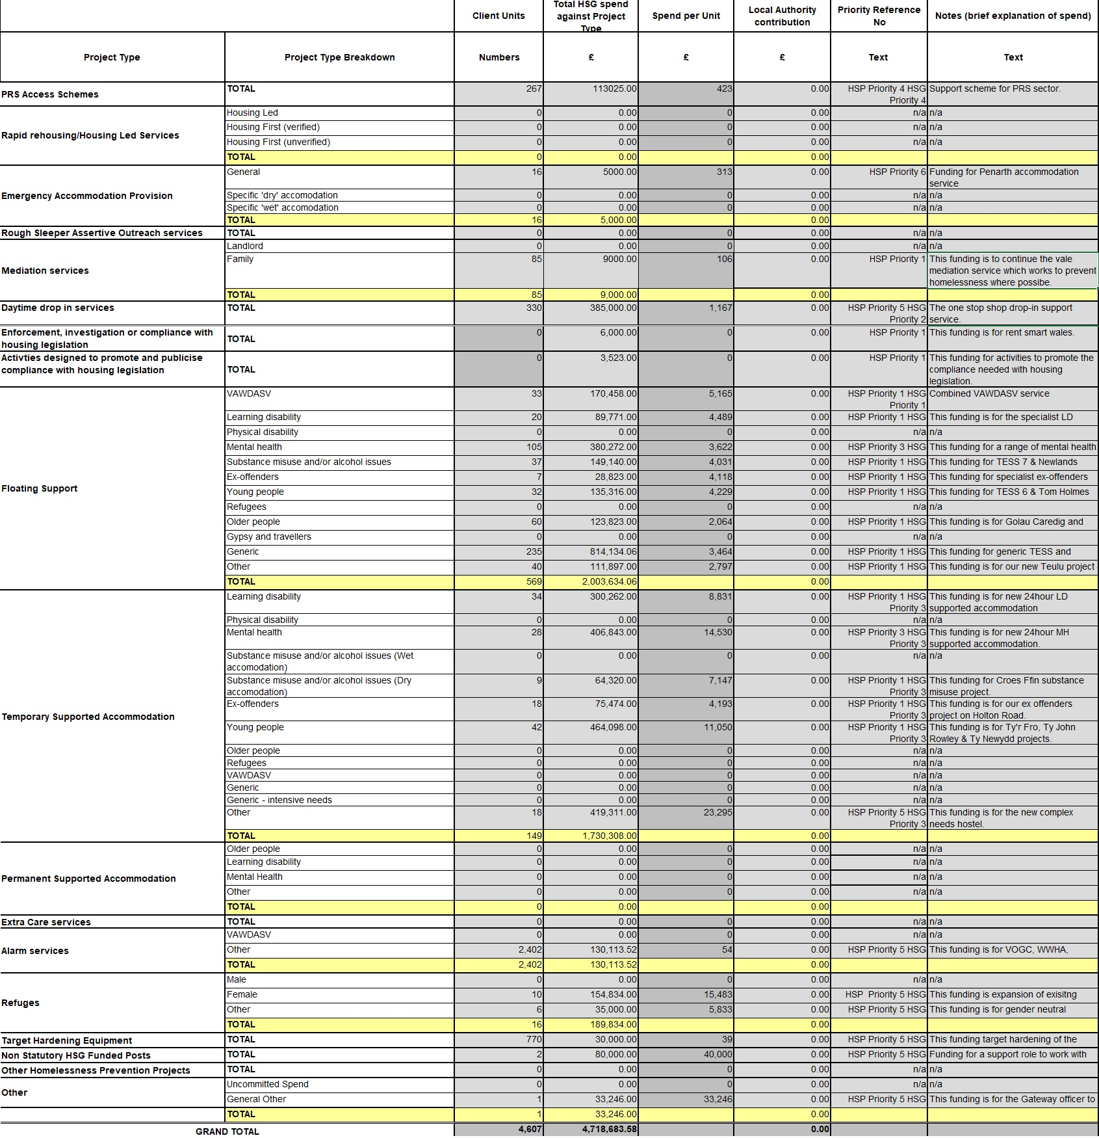

Annex C: Commissioning Plan

Tendering Services:
The Supporting People Team has four housing related support contracts which are due to expire soon and four new services which it plans to commission.
In order to comply with relevant legislation and the Council's Contract Procedure Rules and Financial Procedure Rules, a procurement exercise is required to be undertaken for the contracts due to expire and for commissioning new services. In addition to this, contracts will need to be put in place for any new or re-configured housing related support services to ensure that the Council is meeting its duties under the Housing (Wales) Act 2015 and meeting the needs of the community.
In all these cases each new contract will be advertised on the sell2wales website for a minimum of 30 days and a fair and robust tendering process will take pace overseen by the Supporting People Coordinator. In all cases and open tendering process will be used which will require all providers to pass the standard Vale of Glamorgan council pre-qualification questionnaire (PQQ), provide a written submission with answers to questions set by the Supporting People Commissioning Panel and also attend an interview process with the Supporting People Commissioning Panel.
The total value of the contracts within scope of this exercise is approximately £5 million (over 5 years) with final costings to be decided at tender stage. The current contracts range from £34,000 to £122,000 per year and include services for a several client groups including, people experiencing domestic abuse, homelessness, mental health issues, learning difficulties and vulnerable older people
The contracts due to be retendered:

The Community Mental Health Floating Support scheme
This service is a floating support service delivering flexible housing related support to people suffering with Mental Health Issues in the Vale with the aim of preventing homelessness. This service includes Crisis support for individuals who are at urgent risk of homelessness.
The aim of this project is to provide housing support to improve outcomes for people at risk of homelessness to access information, advice, support and resources to enable them to make informed choices. The service working with individual service users involves a tailored support plan that best meets their needs. The plan focuses on both practical and emotional issues, in order that each person has the best opportunity of living independently as a responsible member of their community.
Contract expiration date: 9th July 2022

The Older Persons Service
Golau Caredig Floating Support
This service is a 60 low level unit floating service delivering flexible housing related support to vulnerable older people (age 55+) living in the Vale of Glamorgan with the aim of preventing homelessness and help to maintain independence.
The aim of this project is to provide housing support to improve outcomes for vulnerable older people to access information, advice, support and resources to enable them to make informed choices. The service working with individual service users involves a tailored support plan that best meets their needs. The plan focuses on both practical and emotional issues, in order that each person has the best opportunity of living independently as a responsible member of their community.
Croeso Pawb drop-in Service
This service delivers regular drop-in sessions providing housing advice & support sessions sheltered/extra care accommodation across the Vale for vulnerable older people. The aim of this pilot is to provide regular drop-in sessions across the Vale which provides advice and support around finances, benefits, suitable accommodation, other housing related issues and sign posting to other agencies (where appropriate). The service is aimed at supporting vulnerable older people and people with low-level dementia and is open to both residents living in sheltered accommodation and elsewhere in the community. The service objective is to help maximise the independence of service users through holding regular drop-in sessions at sheltered accommodation across the Vale.

Contract expiration date: 31st March 2023

Dispersed Refuge Service
This service specification applies to a 6-unit dispersed accommodation scheme for people who need a safe place to live in and require housing related support because of having experienced domestic abuse and/or sexual violence.
The aim of this service is to provide safe, secure, temporary accommodation in a variety of confidential locations in the Vale of Glamorgan for victims of domestic abuses and/or sexual violence who are unable to live in a traditional refuge setting for a variety of reasons. The service will offer support and information to people, to enable them to gain or maintain the skills and confidence they need to be able to live independently. The service will provide flexible housing related support to a maximum of 6 individuals in a temporary accommodation project.
Contract expiration date: 31st March 2023

Poverty Action Group (PAG) Service
This service is a floating support service to work alongside the Poverty Action teams of Families First, Flying Start and Communities First to provide housing related support to their clients living in the Vale of Glamorgan.
The aim of this service is to provide housing related support to people being supported by the Poverty Action Group teams within the Vale of Glamorgan. The service will offer support and information to people, to enable them to gain or maintain the skills and confidence they need to be able to live independently within a home. The service will provide flexible housing related support to individuals in their own accommodation. The support will be delivered through the Team Around the Family model and will be a flexible model of support which is tailored to meet individual needs.
Contract expiration date: 31st March 2023

Commissioning Priorities: New Services 2022-23
Complex Needs Hostel
This service will provide 24 hour supported accommodation for up to 13 individuals with complex needs.
The aim of this service is to provide flexible housing related support to vulnerable people with complex needs in a temporary supported accommodation setting. The service will offer support and information to people, to enable them to gain or maintain the skills and confidence they need to be able to move-on successfully. Referrals will be made via the Supporting People Gateway.
24 Hour Mental Health Supported Accommodation
This service will provide 24 hour supported accommodation for up to 7 individuals experiencing mental health issues.
The aim of this service is to provide flexible housing related support to vulnerable people experiencing mental health issues in a temporary supported accommodation setting. The service will offer support and information to people, to enable them to gain or maintain the skills and confidence they need to be able to move-on successfully. Referrals will be made via the Supporting People Gateway.

Learning Disabilities Supported Accommodation
This service will provide supported accommodation for 4 to 6 individuals with low level learning difficulties. The aim of this service is to provide flexible housing related support to vulnerable people experiencing mental health issues in a temporary supported accommodation setting. The service will offer support and information to people, to enable them to gain or maintain the skills and confidence they need to be able to move-on successfully. Referrals will be made via the Supporting People Gateway.

Second stage Refuge service
This service will provide supported refuge accommodation for 5 women who are victims of domestic abuse and/or sexual violence in a secure and undisclosed location in the Vale of Glamorgan. The aim of this service is to provide safe, secure, temporary accommodation in a confidential location. The service will offer support and information to people, to enable them to gain or maintain the skills and confidence they need to be able to live independently. This service is aimed at victims that require a reduced level of support and are closer to move-on when compared to service users accessing the standard Refuge service.

Annex D: Homelessness Statutory Duties

The Housing Wales Act 2014 is the main legislation covering Homelessness in Wales. The main aim of the Act is to ensure homeless people and those threatened with homelessness, receive help at an early stage. The Act was also designed to ensure that everyone receives help, not just people within the priority need groups. Other notable parts of the Act include a strengthening of the prevention duties on Local Authorities and the ability for Councils to use suitable accommodation in the private rented sector.
Other relevant legislation includes the Children Act 1989, the Children Leaving Care Act 2000, the Immigration and Asylum Act 1999, the Nationality, Immigration and Asylum Act 2002 and the Data Protection Act 1998, the Social Services and Wellbeing (Wales) Act 2014 and the Renting Homes (Wales) Act 2016.

The Housing Solutions Team have identified several key issues:

There is an imbalance between single person accommodation and the numbers of single people presenting as homeless and staying in temporary accommodation for significant periods of time. To address the issue the Council has begun working to the Rapid Rehousing Model which will offer varied support levels to ensure households presenting get the correct support when it is needed. Single homeless people under 35, people with mental health support needs and people with criminal offending issues represent a high proportion of presentations to the homelessness team. Support needs are more complex with mental health, criminal offending and domestic abuse increasing. Homelessness is not just about housing and many of the people who experience housing issues and homelessness often have complex support needs. Improve pathways for support and ensure there is a multi-agency working approach to dealing with complex needs. This will also ensure people can access all services in a timely manner.

Access to Private rented Sector (PRS). Limited social housing, increasing demand, and lengthier waiting times, mean that supporting people to access the private rental sector is more important than ever. Having dedicated officers working with landlords, letting agencies and prospective private renters to remove barriers to securing a privately rented home in the Vale.

Recruitment issues due to short term contracts, pay scales. Staff wellbeing and to be able to retain staff with good terms and conditions across all commissioned projects. To ensure training in all areas is provided and staff are supporting individuals using a Trauma informed/multi agency approach. Re-commissioning of all Housing Support Grant projects to ensure they meet the needs of the people accessing the services.

Single homeless people under 35 living in Barry. Post covid, there has been an alarming increase in the number of younger single people accommodated in temporary bed and breakfast provision.
Mental Health and support needs are increasing, anxiety and depression is increasingly a concern, specifically amongst clients presenting as homeless. To address this the Council have created specialist mental health links worker roles who operate within the Housing Solutions team to provide front line advice and assistance to clients, however on-going service reviewing is provision is required to fulfil the needs of increasing mental physical and health, complex needs, decreasing access to services, and the potential shifts in demographics.
Young homeless people aged 16/17 yrs old and care experienced children with complex needs. The demand for support from Children’s Services is high with a small group of complex young people who do not manage to sustain temporary accommodation or supported housing. These young people presenting as homeless or with support needs have been found to have numerous complexities and this is currently an unmet need for a small group of the most complex young people with a duty to be accommodated and supported.
High risk offenders and repeat offenders. There is a gap for repeat offenders who need ongoing support and high-risk cases where accommodation is incredibly challenging to source.
Women fleeing domestic abuse Support needs are reported to be more complex, often with multiple support needs like mental health and addictions as well as domestic abuse. Older people (over55) with support needs There is an emerging theme of over 55s presenting to as homeless with support needs relating to their tenancies.
To meet these statutory duties and prevent homelessness the Vale of Glamorgan Council will:

- Provide a robust, targeted prevention service to prevent homelessness and tackle the main causes of homelessness.
- Raise awareness of the Housing Solutions service and ensure it is accessible to people who are homeless or threatened with homelessness.
- Provide high quality advice and assistance so service users feel supported and empowered to take steps to resolve their homelessness.
- Facilitate a rapid rehousing approach to ensure that homelessness is brief, and households move onto more permanent accommodation as quickly as possible.
- Strengthen and expand access to mental health support services.
- Maximise access to homes in the private rented sector.
- Support the most vulnerable to sustain their tenancy and integrate into the community. Increase the supply of permanent and temporary accommodation.

Housing Solutions Team structure:

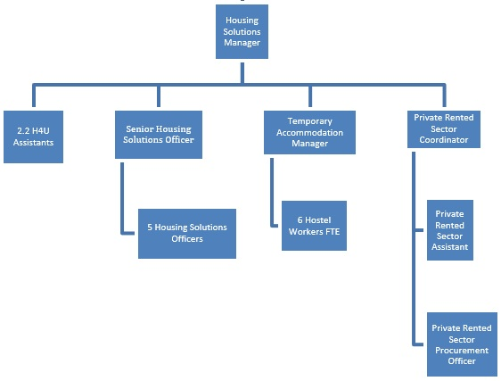

The housing solutions team is managed by the Housing Solutions Manager.
The social housing allocations system known as homes4u is administered by the Homes4u Assistants.
The team of housing solutions officers assess all homelessness applications to ensure they meet the Council’s statutory duty under housing legislation, the senior officer supervises each caseworker.
The Temporary Accommodation Manager runs the family hostel and nearby temporary accommodation properties, and line manages the hostel staff.
To facilitate using the private rented sector to discharge duty the Private Rented Sector coordinator liaises with private landlords and works with the Private Rented Sector assistant to liaise customers and work with landlords. The Private Rented Sector Procurement officer’s main role is to find and secure suitable private properties and landlords for the Vale Assisted Tenancy Scheme (VATS).

