Vale of Glamorgan Council – Team Planning 2016/17
Guidance for Team Managers

Background

Our Team Plans are key documents which show how individual teams contribute to the Council’s overall priorities and how by working together we can deliver our vision of Strong Communities with a Bright Future. | 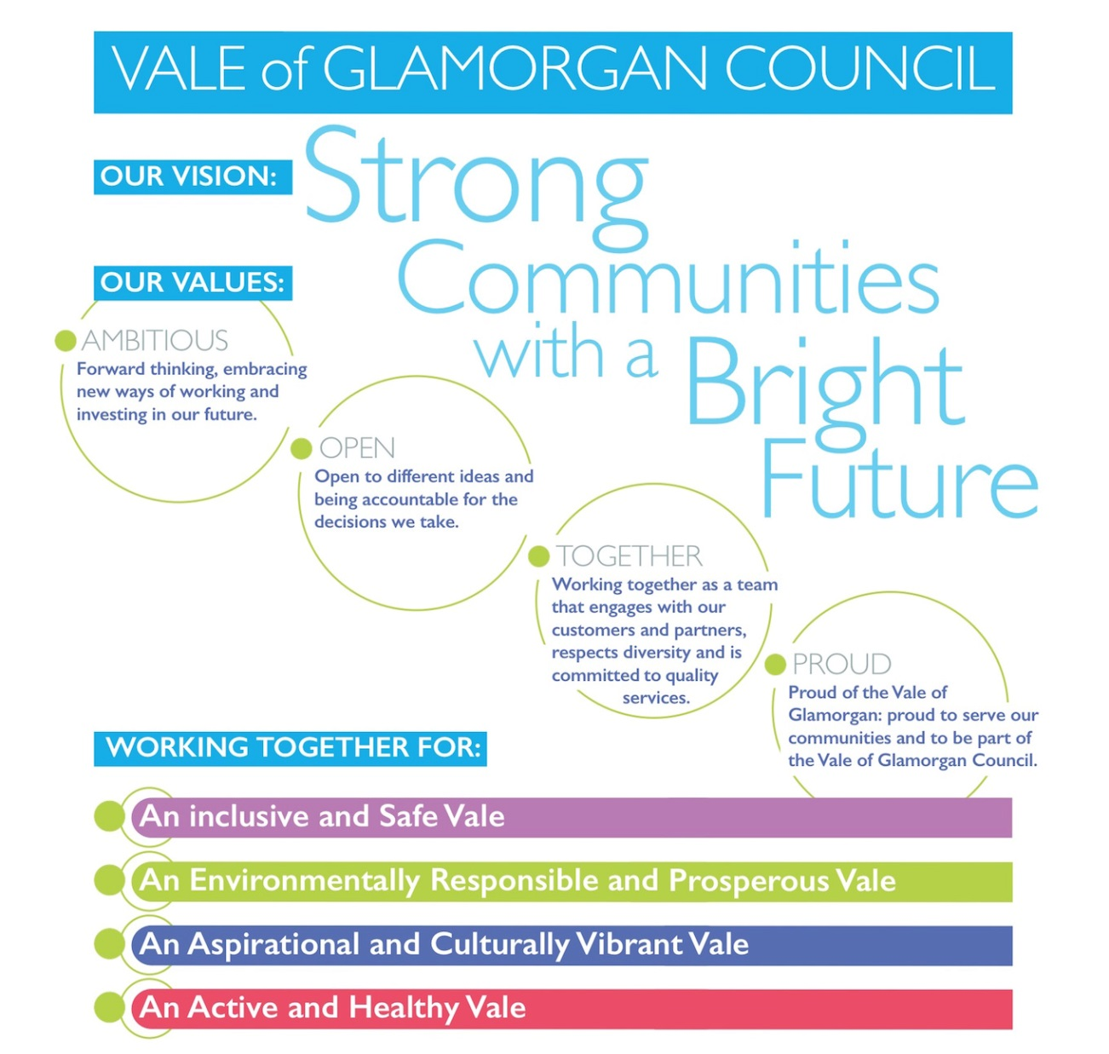
The Team Plans are the third level of the ‘Golden Thread’ which consists of the Corporate Plan, Service Plans, Team Plans and PDRS/TDRS. The Team Plans are the way in which we disseminate the information contained in a Service Plan to individual teams. This helps to ensure that team’s priorities are focused on the Council’s priorities and that all services work together to achieve continuous improvement. The information contained in the Team Plans is then used to inform the PDRS/TDRS process and will help identify actions and objectives for individual members of staff.

As you will be aware, the recently developed Corporate Plan (2016-20) has taken into account the requirements of the Well-being of Future Generations (Wales) Act 2015. The Corporate Plan identifies four Well-being Outcomes and eight Well-being Objectives which are unique to the Vale of Glamorgan and that all departments work towards together. These outcomes and objectives are set out at page 4 of your Team Plan template within ‘Our Team Plan Summary’ alongside the Council’s vision, values, integrated planning actions and ways that we work.

As a Team Leader/Manager you play a key role in ensuring that your teams understand how you will contribute to the Council’s overall priorities. By facilitating this part of the performance management process your input and oversight will be particularly valuable in ensuring that your Team Plan is closely aligned to your Service Plan and Corporate Plan.

How to complete your Team Plan

The Team Plan template has been designed to make it as easy as possible to complete and highlight the way in which actions link back to Service Plans. Team planning is also an opportunity to discuss the process with individual team members and how we all work together to achieve the Council’s vision. For this reason we’d encourage you to involve your team in the development process as they will be the ones carrying out the actions identified.

The following highlights the main steps involved in team planning with some guidance notes:

- 1. Introduction: Refer to the “Introduction” of your Service Plan at section 1 and complete this section of your Team Plan with a brief overview of the more specific work your Team undertakes.

- 1.1 Who we are: Complete with a brief overview of your Team’s structure and who works with you.

- 1.2 What we do: Refer to “About our Service” in your Service Plan at section 1.1 and complete with a brief overview of your Team’s broad functions.

- 2. Our Priorities for 2016-20: This is a standard section which provides information for you to communicate with your colleagues and explains how your Team will contribute towards achieving the Council’s vision, values, Well-being Outcomes, Well-being Objectives, Integrated Planning Actions and Ways that we Work. You do not need to change or update this section of the Team Plan.

- 3. Our Team Plan Summary: This should set out how your Team contributes to the Council’s vision, values, Well-being Outcomes, Well-being Objectives, Integrated Planning Actions and Ways that we Work in one quick reference table.

This part of the Team Plan has been designed to help you identify and easily explain the clear links from your Service Plan to your Team Plan. To do so, you will need to review both Appendix A and Appendix B of your Service Plan and identify which Well-being Outcomes, Well-being Objectives and Integrated Planning Actions your Service is contributing to and subsequently which of these your Team is contributing to. There should be no need for you to add any additional Well-being Outcomes, Well-being Objectives or Integrated Planning Actions here which have not already been identified in your Service Plan.

The content of the table itself must not be changed but you will need to highlight the sections your Team contributes to, specifically the:

- Well-being Outcomes
- Well-being Objectives
- Integrated Planning Actions.

For example, if Appendix A of your Service Plan contains actions that contribute to Well-being Outcome 1, 2 and 4
and if your Team also contributes to these Outcomes, highlight them in blue and bold the text as shown.

However, if your Team only contributes to one of the
three Outcomes mentioned in your Service
Plan, just highlight/bold the relevant one.

If Appendix A of your Service Plan contains
Actions that contribute to Well-being
Objectives 1, 4 and 7 and your Team also
contributes
to these Objectives,
highlight/bold them as shown.

Appendix B of your Service Plan contains
actions that relate to the Integrated Planning
Actions listed here. By using the ‘Reference
Key’ on the final page of this guidance, identify
which Integrated Planning Actions your
Service contributes to; then identify those
actions that directly link to your Team
and highlight/bold them as shown.

The five ‘Ways That we Work’ are applicable
to all Teams as they form an integral part
of the Well-being of Future Generations
(Wales) Act and demonstrate how we challenge
ourselves to deliver sustainable development.
There is no need to highlight/bold these.

- Appendix A - Team Action Plan 2016/17: To be completed, in detail, with your planned Team related actions for 2016/17. From Appendix A of your Service Plan you should identify the specific action and corresponding reference number that your Team will directly contribute to during 2016/17. Duplicate the relevant reference into the ‘Ref’ column of the Team Plan Action Plan 2016/17 and complete the remaining columns ‘Action, Outcome and Key Milestones (2016/17) and Officer Responsible’ in line with the prompts provided ‘in red’ within the Team Plan template.

- Appendix B – Integrated Planning: To be completed, in detail, with your planned Team related actions for 2016/17. Again you will need to review Appendix B of your Service Plan and identify the reference number and specific action that your Team will directly contribute to during 2016/17. Duplicate the ‘Ref’ into the first column of your Integrated Planning Action Table at Appendix B of your Team Plan and complete the remaining sections ‘Action, Outcome and Key Milestones (2016/17) and Officer Responsible’ in line with the prompts provided ‘in red’ within the Team Plan template.
Reference Key
CP1 - Reshaping Services
W - Workforce Planning & PDRS
F - Financial Planning
WA - Well-being Assessment with Partners
E - Consultation & Engagement
C - Collaboration & Partnerships
PM - Performance Management
IT - ICT & Information Management
SC -Scrutiny & Challenge
R - Risk Management
P - Procurement
A - Asset Management

Please note that for Appendix A and Appendix B, you are only copying the ‘Ref’ from the Service Plan to the Team Plan. You do not need to copy the Service Plan Action because this will be too high level for your Team Plan.

What to do once you have completed your Team Plan
Once you have completed your Team Plan, please ensure it is signed off by your Head of Service/ Director and published on your StaffNet homepage. All Team Plans need to be completed and returned to Sian Clemett-Davies/Julia Archampong by 30TH June 2016. We will be quality checking a sample of Team Plans in xxx and will feedback to relevant Heads of Service.

What to do if you need support or have any questions about your Team Plan
If you have any queries in relation to the planning process, please contact a member of the Improvement and Development Team who will be happy to help (Sian Clemett-Davies ext. 883287 or Julia Archampong ext. 883318).

Useful links: (to be completed)
Corporate Plan 2016-20
Performance Management Framework
Service Plans

