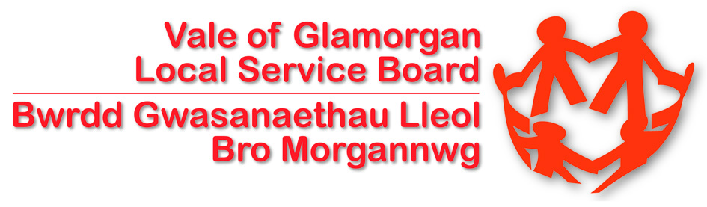

Vale of Glamorgan Local Service Board

Local Service Forum

5th October 2012

Planning and Working Together

TABLE OF CONTENTS

Aims of the Conference 3

Conference Attendance and Format 3

Presentations 4

Presentation One: The Work of the Vale Local Service Board 4
Presentation Two: Overview of Development and Regeneration in the Vale 5
Presentation Three: Families First FACT Service 6
Presentation Four: University Hospital Llandough 6
Presentation Four: University Hospital Llandough 7

Discussion – Improving Community Engagement 8

Workshops 9

Forthcoming Review of Regeneration Policy in Wales 9

Communities First Barry Cluster Delivery Plan 10

Accessible Homes Register; Making better use of our existing housing 11

Creating the Virtual Team Around Wyn 12

Implementing the Alcohol Strategy 13

Early Years and Childcare – Who Cares? 14

Welfare Reform Act 15

Making Every Contact Count - Promoting Health Improvement 16

Valuing Our Environment 17

Addressing the NEETS Issue Post 18 18

Conclusion 19

Next Steps 19

Appendix 1 19

Appendix 2 21

Aims of the Conference

The purpose of the conference was to bring together representatives from a wide range of organisations who provide services in the Vale. The conference enabled stakeholders to hear about some of the projects being undertaken in partnership in the Vale and to participate in workshops on some of the challenges. The Local Service Board were keen to provide an opportunity for discussion about how to progress some of the partnership projects and obtain views on what needs to be done

The presentations and workshops covered a wide range of topics highlighting the diversity of work undertaken in partnership in the Vale and covering all ages.

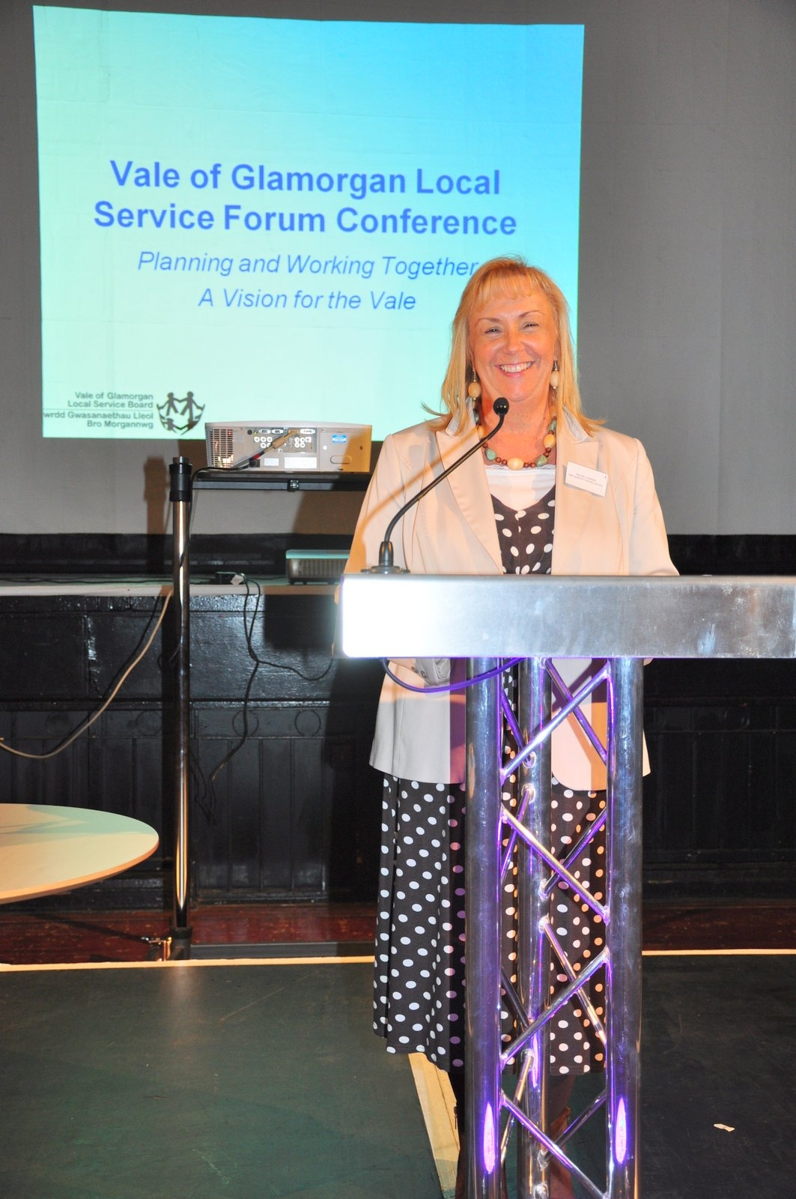
Rachel Connor, Executive Director of Vale Centre for Voluntary Services was the host for the day on behalf of the Local Service Board and Councillor Stuart Egan, Deputy Leader and Cabinet Member for Adult Social Care and Health, Lifelong Learning and Libraries welcomed everyone to the conference. Councillor Egan emphasised that the day was about recognising the importance of working in partnership and focusing on some of the most important and challenging areas and discussing how we can work together to make things better.

Councillor Egan highlighted that there is an excellent track record of partnership working in the Vale and the need to keep building on this to ensure partners are delivering the best for local people. He also emphasised that the LSB has a leadership role to ensure that difficult issues are managed and addressed and not avoided or ignored, their role is to improve the way that public bodies and communities work together but that this can only be achieved through engagement with residents and a range of organisations.

Councillor Egan concluded by reminding everyone that the purpose of the day was to discuss improving services and improving life in the Vale.

Conference Attendance and Format

More than ninety representatives from the public, private, voluntary and community sector in the Vale as well as Town and Community Councils attended the conference. The day was structured around a number of presentations which highlighted some of the key developments in the Vale and the importance of working in partnership. There was also a facilitated discussion on improving engagement which all delegates had the opportunity to participate in as well as 11 workshops which provided the opportunity for more focused discussion on a wide range of topics.

Presentations

Presentation One: The Work of the Vale Local Service Board - Huw Isaac, Head of Performance and Development, Vale of Glamorgan Council

An overview of what has been achieved in the first year of the Community Strategy was given. An Annual Report has been produced and the agenda for the forum focused on some of the areas where performance needs to improve and on some of the projects being taken forward over the next twelve months.

Areas of particular interest that were highlighted were that;

- 97% of respondents in the Council’s Public Opinion Survey either agreed or strongly agreed with the statement ‘I am proud to live in the Vale of Glamorgan’ which is an incredibly high figure.
- The monetary value of volunteering activity in the Vale was a remarkable £29, 487, 731 in the Vale in 2011/12.
- The percentage of young people aged 16-18 who are NEET had reduced although there are concerns that this can not be maintained in the current economic climate and with changes in funding.
- The reduction in crime by 9.1% was also highlighted as was the development of the Community Resource Centre at Cadoxton House.

The need for improving the coordination of engagement activities across partner organisations was emphasised as well as ensuring robust performance management arrangements and using a strong evidence base to underpin and inform activities.

More information about the Vale Local Service Board and the Community Strategy 2011-21 is available at http://www.valeofglamorgan.gov.uk/our_council/local_service_board.aspx

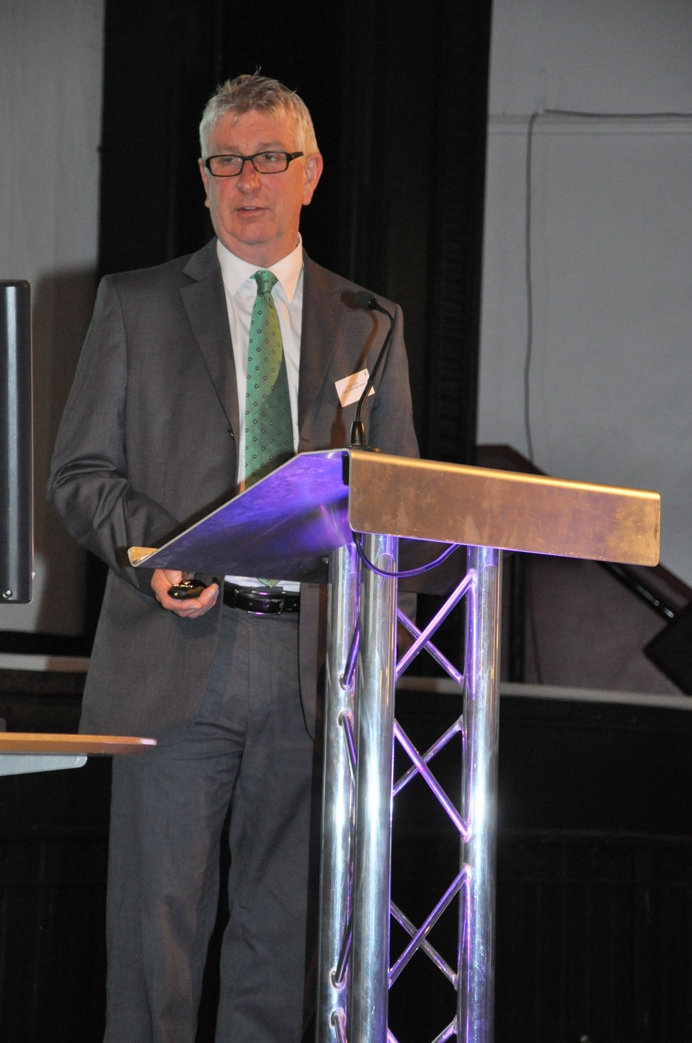

Presentation Two: Overview of Development and Regeneration in the Vale – Rob Thomas, Director of Development Services, Vale of Glamorgan Council

Rob Thomas gave a colourful presentation and emphasised the range of investment and exciting new developments across the Vale. Rob provided the context for regeneration and development in the Vale, an overview of current activity and emerging issues and influencing factors. He concluded with the challenges and opportunities for the future.

Current regeneration activity includes, rural regeneration through the Creative Rural Communities which is overseen by a Rural Partnership, the Barry Regeneration Area which was established by Welsh Government in 2010, St Athan and the Enterprise Zone which was designated in April 2012 and for which an interim board has been established. Other regeneration activities include, Communities First, Housing Renewal Schemes, and major Council schemes like Penarth Heights, investment in the Innovation Quarter, Cowbridge School and Penarth Learning Community, Penarth Pier Pavilion and a range of transport infrastructure schemes.

Rob also referred to the planned Welsh Government review of regeneration policy and indications are that there will be a focus on town centres and coastal towns so it is important that the Vale fully engages with the review.

Other aspects which Rob highlighted in his presentation were the Community Infrastructure Levy which will be used for strategic infrastructure requirements, a framework for the Town Centres in the Vale which has been commissioned by the Council and the importance of tourism and events for the local economy.

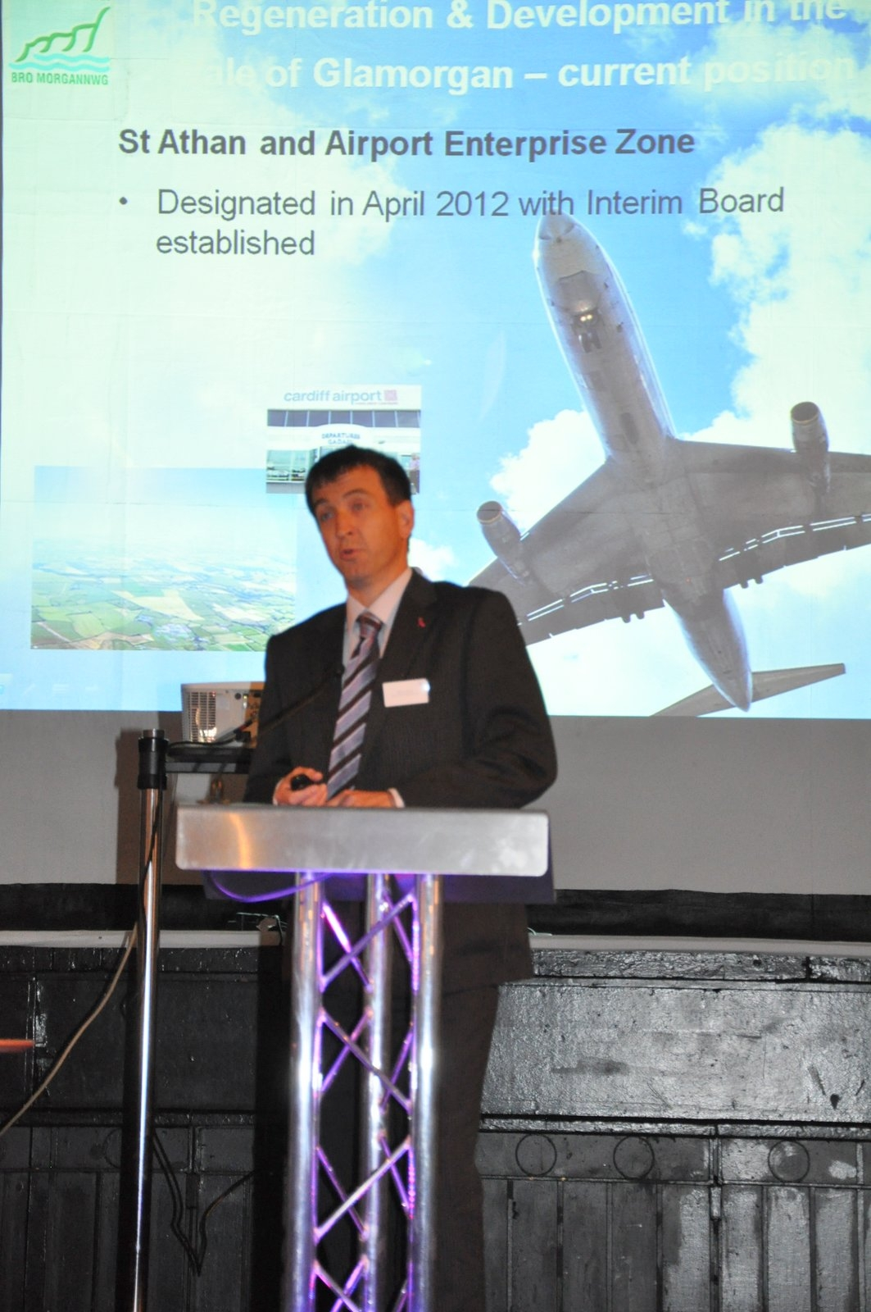
In terms of challenges and opportunities Rob emphasised that despite the economic downturn the Vale has a good track record and there are signs of increased activity. It is critical that we make money go further and ensure the viability of new developments. There is also a need to make synergies and avoid silo working, linking investment to employment and opportunities for local people. If regeneration opportunities are to be maximised then our thinking needs to be joined up. There is also a need to focus on collaboration and working in partnership at a regional as well as a local level.

Rob concluded by advising delegates that local organisations need to work together to ensure that the Vale is in the best possible position to influence Welsh Government policy direction.

For information on regeneration activity in the Vale http://www.valeofglamorgan.gov.uk/working/regeneration.aspx

Presentation Three: Families First FACT Service - Families Achieving Change Together – Gareth Powell, Practitioner Manager and Rob Couchman, Project Worker, Children and Young People Services, Vale of Glamorgan Council

Gareth and Rob gave an interesting presentation on the Families Achieving Change Together (FACT) project which is funded through Families First. Families First is a new Welsh Government funded initiative established to target early intervention and prevention services to children, young people and families. This minimises the need for higher level support and intervention from statutory services.

The FACT team has been developed in line with the ‘Team Around the Family’ (TAF) model and will be supported by a raft of programmes. The team will manage referrals and provide a team of support workers who will complete a Joint Assessment Family Framework to ensure that they deliver family support through holistic multi-agency service tailored to the identified needs of individuals and the family as a whole.

Gareth provided an update on how the development of the team is progressing including the employment of key staff, drafting of systems and processes and piloting referrals. The team have been live since the beginning of September and the aim of the service is to identify and coordinate support enabling families to make positive changes, reducing the numbers of families developing more complex and challenging needs.

Gareth and Rob explained the criteria for accessing the service and how consent is required from the family. He then explained the process of a referral and how the team will work. Gareth and Rob emphasised that the key focus is early intervention and prevention and that it is a whole family approach delivered through multi agency working.

More information about FACT is available http://www.valeofglamorgan.gov.uk/our_council/achieving_our_vision/partnerships,_policies,_plans/cypp_team/families_first.aspx

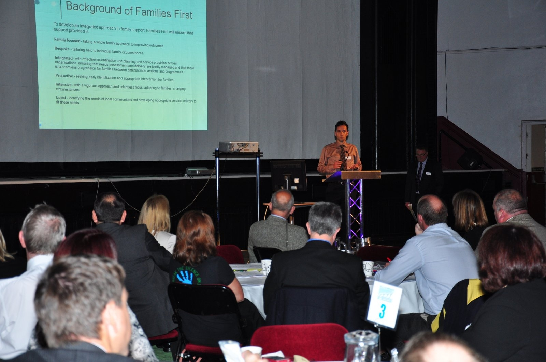

Presentation Four: University Hospital Llandough ; Development and Community Partnership Working - Peter Welsh, Hospital General Manager, Cardiff and Vale University Health Board

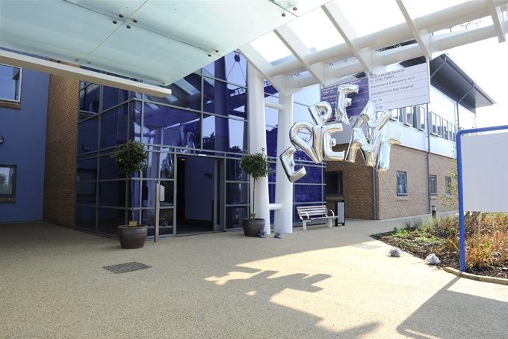
Peter gave a very informative presentation on developments at University Hospital Llandough (UHL) both in terms of current and future plans for the site and its role in overall provision for Cardiff and Vale residents by the University Health Board. To provide some context for work at the hospital Peter explained that in 2011/12 there were 200,460 outpatients/day cases/diagnostics, there were 37,500 inpatients plus over 20,000 emergencies and all these services were delivered by approximately 2,500 staff.

Service developments at UHL include;

- Mental Health Assessment Unit for Older People
- Stroke Rehabilitation Centre
- The Development of Specialist Neuro and Spinal Rehabilitation Services
- Adult Mental Health Inpatient Unit
- Other general improvements for patients, staff and the local community

Peter showed a series of photos illustrating the impressive, ew facilities at the site.

Work was completed for the Mental Health Services for Older Persons in August and inpatient service transfers from Whitchurch, Barry and St Davids Hospitals were to be completed by the end of October. The Stroke Rehabilitation Centre will be a result of integrating the existing Vale Stroke Rehabilitation ward at UHL and the transfer of the Cardiff Stroke Unit and associated staff from CRI West Wing. Specialist Neuro and Rehabilitation Services will replace those provided at Rookwood Hospital and services should be transferred by 2014. The Adult Acute Mental Health Unit will have 135 beds with a total investment of £100 million and it is anticipated that works will be complete in Spring 2013.

Peter emphasised the importance of links to the local community and also partnership working. The hospital is part of the local community and it is crucial that the community are kept informed and that the UHB listens to the local community. In 2013 there will be celebrations for the 80th anniversary of the hospital and the community will be part of the celebrations.

Peter concluded with how the UHL will look in 3-5 years time. Over £200 million will have been spent, there will be an increase in beds, improved community links, the UHL will continue to be a major employer in the area and there will be new facilities for staff, patients and the community.

Discussion – Improving Community Engagement

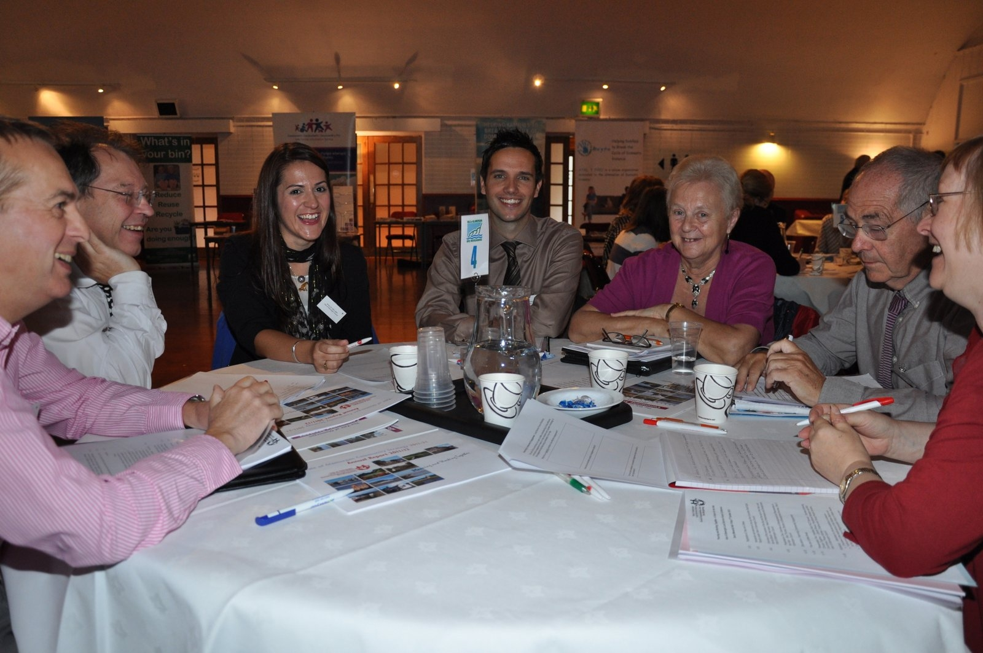
The aim of the session was to gain a better understanding of what effective community engagement means to the residents of the Vale of Glamorgan and to gain a greater knowledge of engagement activities already being undertaken in the Vale. The exercise highlighted a number of issues that will be taken into account in the development of the Vale of Glamorgan LSB Information and Engagement Strategy.

- Effective pathways of communication must be established and maintained throughout the engagement process. This will keep residents fully informed of the aims, events and outcomes of an engagement project, as well as providing the residents with valuable feedback.

- The use of social media and online resources should be increased, to both promote events and communicate with residents. At the same time, it is important to ensure that more traditional methods of communication, such as newsletters, leaflets and newspapers, are not neglected so as not to alienate the 25% of Vale residents who do not have internet access.

- Through communicating with residents, their role in promoting change for the better must be emphasised. If possible, the ability to demonstrate tangible changes can be used as a powerful tool. Informing residents of their valuable contribution will empower them and encourage them to further engage with Vale projects.

- The needs of the target audience must be considered and responded to when planning an engagement project. In appealing to the lifestyles, mentalities and sympathies of the target audience the likelihood of successful engagement will increase.

- To facilitate the measurement of success, baseline measures must first be taken and then the goals of the engagement project must be outlined before its introduction. Success will then be more easily gauged.

- A code of best practice should be disseminated to all LSB members to ensure that all engagement projects are being conducted in the best manner possible.

- In order to improve working partnerships within the LSB, a data sharing scheme should be introduced. This will allow LSB members to use other organisations’ information to improve their engagement process and perhaps create an increased scope for collaborative working.

For more information about the development of the Engagement Strategy contact Helen Moses, Strategy and Sustainability Manager hmoses@valeofglamorgan.gov.uk

Workshops

Forthcoming Review of Regeneration Policy in Wales- Issues for the Vale of Glamorgan

The workshop conducted a ‘lucky dip approach’ where all participants were asked to think of a key issue in terms of regeneration activity and where efforts need to be focused. Participants were asked to write down their issue on a piece of paper and put it into a box. Issues were then selected at random and the person who had written down the issue was asked to expand on it briefly and then it was opened up for discussion. Six issues were discussed during the workshop but all have been recorded for future consideration.

Issues discussed on the day included:

- Maximise value of the environment to citizens of the Vale of Glamorgan
- Quality and growth of private rented accommodation
- Benefits of regeneration for all communities and people
- Does the Vale of Glamorgan need to develop a brand?
- Broadband coverage

The issues raised will assist in formulating the response to the Welsh Government Policy Review of regeneration and also provide an opportunity to try and make links between the different programmes currently in place.

A more detailed report of the issues raised at the workshop will form a report for discussion at a future meeting of the Regeneration Partnership.

If you have any queries regarding the work of the Regeneration Partnership please contact Dave Williams, Principal Regeneration Officer DCWilliams@valeofglamorgan.gov.uk

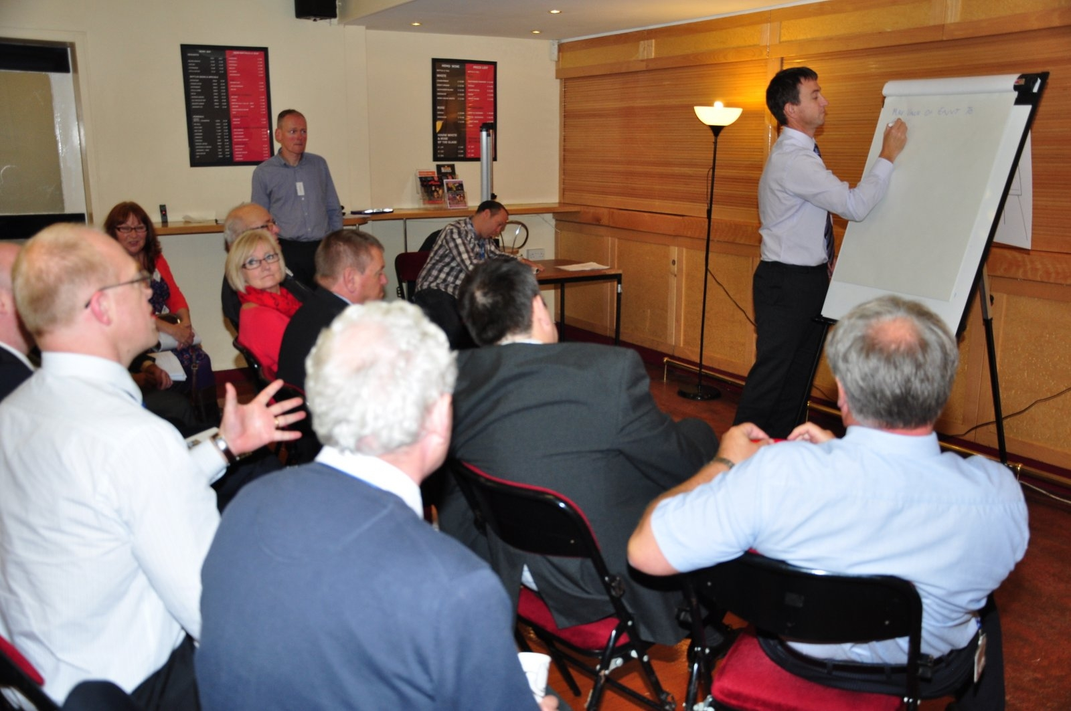

Communities First Barry Cluster Delivery Plan

The first aim of the workshop was to raise awareness of the new Cluster Programme and provide partners with information on how the cluster areas and projects had been decided and would then be delivered. Projects in the Cluster programme are;

- Learning - The Learning for Life project will support and extend the Putting Families First programme which currently runs in schools across the Vale. The programme works from within the school engaging vulnerable families through regular weekly activities which coordinate a range of local services through engagement with key partners.
- NEETs - The Jobs Growth Wales Programme Mentoring project is designed to provide additional support to young unemployed people who may face additional barriers to employment by the introduction of Youth Employment Mentors in Communities First Clusters.
- Prosperity - The Growing skills and creating wider employment routes for local people project aims to maximise the benefits of regeneration, development and investment for the benefit of all residents, particularly those who live within the Cluster area.
- Health - The 5 A day (Healthy eating) project aims to reduce health inequities through targeted healthy eating advice, support, mentoring and activities thereby supporting participants from the Cluster to lead healthier lives.

The second aim of the workshop was to see what the partners could offer the Cluster Programme in terms of direct partnership working, resource sharing etc. The group reviewed the prosperity projects with partners. Feedback on the proposals was encouraging as Service Managers saw that Communities First would be filling a gap in provision by for instance selling regeneration opportunities (especially potential jobs) to local cluster residents. The main difficulty recognised would be engagement from employers, and it was felt that the Communities First Officer leading on this project would have to make it easier for employers to employ local people by developing the skills of their potential workforce beforehand.

There was also a useful discussion about the potential opportunity to develop social clauses within the Health and Social care sector to enable more people from the Cluster to access jobs within this field as there is scope for good workforce development within this sector. Volunteering was also discussed as another positive route, so developing strong links with organisations such as the Vale Volunteer Bureau was viewed as essential.

If you have any queries regarding Communities First please contact Michelle MESullivan@valeofglamorgan.gov. or Colin codavies@valeofglamorgan.gov.uk

http://castlelandcommunitiesfirst.co.uk/
http://gibbonsdownandcourt.org/

Accessible Homes Register; Making better use of our existing housing

The purpose of the workshop was to discuss the social housing Accessible Home Register (AHR), council housing adaptations, the Vale Incentive to Move scheme and how these services can be taken forward.

These service improvements have made much better use of housing stock with the use of new social housing for complex cases saving circa £1m from the adaptations budget. These moves have enabled tenants with a disability to move to housing which is far more appropriate to meet their needs. The council housing adaptations service have speeded up the time taken to deliver adaptations using call off contracts, new training for housing staff and better quality standards which along with the £2m investment over the last
three years has made a significant impact on the lives of tenants.

There was an extremely lively discussion at the workshop ranging from;

- Welfare reform changes
- Support in place when moving tenants
- More effective management of hospital discharges
- Telecare
- Extra care housing is not available in the Vale which increases the demand for adaptations
- Community Infrasture levy - potential funding for adaptations/ AHR
- Location of housing and local inaccessible environment is a big issue
- Empty home issues
- Crime prevention action where heavily adapted/ visible stock
- Implementing AHR for private sector housing

The three main areas proposed for taking forward in next year’s action plan were:-

- Investigate the setting up an Accessible Home Register for private sector housing as the social housing sector has achieved significant saving on council housing adaptations budget etc
- Develop a closer working relationship between Public Sector Housing and Cardiff & Vale UHB to address delayed transfer of care issues and make better use of funding
- Investigate sourcing adaptation funding from the new Community Infrastructure levy

If you have any queries about the issues discussed in this workshop please contact Rob Lucas, Asset and Improvement Manager RLucas@valeofglamorgan.gov.uk

Creating the Virtual Team Around Wyn - Supporting Older People to ‘retain and regain independence’

The Wyn Campaign is a workstream of the Integrated Health and Social Care Programme and involves partners working together to improve the experience of frail and older people. Wyn is a familiar Welsh name that can be attributed to a man or a woman and having a name in the title is a constant reminder that this is about designing services around people. The test throughout the new model is ‘what would Wyn want?’

The aims of the session were to raise awareness about the campaign and share the developing care pathway for Wyn, identify where other organisations link with the pathway and finally to identify the facilitators and barriers to moving forward.

In order to achieve the session’s aims and increase stakeholders’ knowledge of this multiagency work, the facilitators shared the model “Team Around Wyn”, the campaign’s principles and explained the scope of the work given the number of different teams (Health, Social Care and Third Sector) that have been identified as providing care to Wyn. The group also heard how Wyn’s care, under the model, can be classified as receiving “Universal Services”, “Targeted Interventions” or “Longer-term care” and through discussion of the care pathway the group started to understand what support and care would be available to Wyn depending upon his/her needs.

The group were very interested and engaged in this work and made a number of very helpful observations and contributions about the campaign and how it would work in practice. Through the enthusiastic discussion a number of key points emerged, which are that:

- This work is ambitious and important
- The Campaign must keep Wyn’s needs at the forefront of any developments
- Wyn wants to remain independent
- Wyn wants easy access to accurate, up-to-date information in a variety of ways
- Wyn wants us to close loops and does not want to suffer because of interagency “squabbles”.

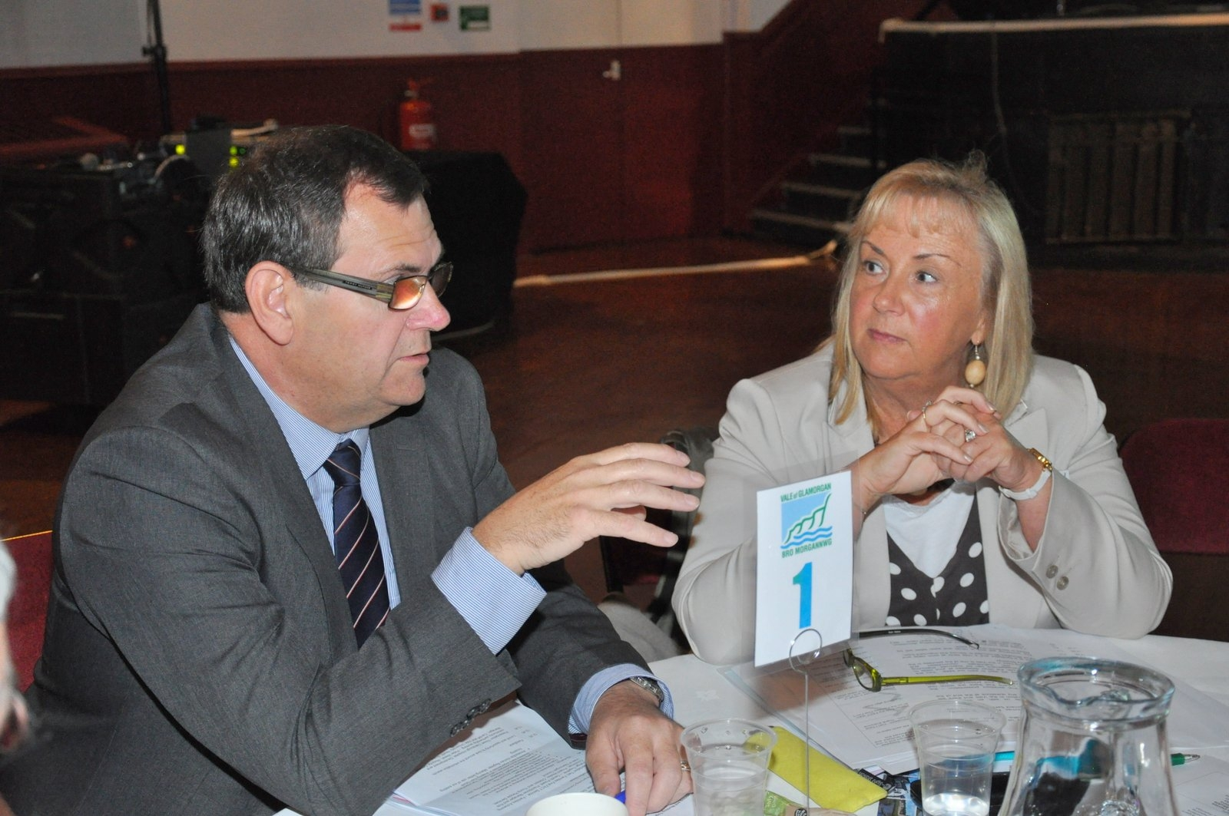
Attending this Conference was part of the Wyn Campaign Engagement Strategy to understand the views of key stakeholders as the model of care is developed and delivered. The discussion was helpful to inform the principles and to inform the development of the wider/virtual team around Wyn.

If you have any queries about the Wyn campaign please contact Lynda Chandler, Programme Manager Lynda.chandler@wales.nhs.uk

Implementing the Alcohol Strategy

The purpose of the workshop was to widen understanding about the strategic plan to address the issues of alcohol and misuse and to understand the mechanisms and structures for delivery. The group were given a brief introduction to the strategy before moving onto an open discussion where the following issues were raised.

Improving information sharing locally was raised e.g. data from A&E in relation to alcohol related violence, this non personalised data is useful in building a wider picture of issues in relation to the night time economy and alcohol fuelled violence. The police have also experienced issues in relation to onward referral. Specific examples of this revolved around dual diagnosis and individuals being turned away from mental health services as a substance user. These boundaries need to be addressed as issues persist with individuals unable to access the right support at the right time.

There was a discussion around having information available to the local authority about referral pathways for families and individuals affected by alcohol – this is currently in place but perhaps needs to be better advertised and more available.

The Vale as a whole, has a fairly low level of alcohol related crime linked to licensed premises. It was felt that this needed to be acknowledged, along with the good work of licensing and trading standards teams, including proactive work with licensees across the area. Overall it was felt that what was being done well needed to be pushed more as the good news stories sometimes get forgotten.

A newly configured substance misuse service system should help with issues around housing with aftercare provision due to be increased. It was suggested that social services’ ‘short term family placement scheme’ for individuals who may have completed residential treatment could be used. Agencies could utilise voluntary placements to ensure that those at risk of relapse or slipping into hazardous drinking habits have diversionary activities to occupy their time. It was advised that this is currently in place via a European Social Funded programme, Peer Mentoring, as well as other local voluntary sector organisations.

There was a discussion around the cultural issues in relation to binge drinking, and how this can be tackled. There are ongoing projects in relation to Young People both in and out of education in relation to attitudinal change.

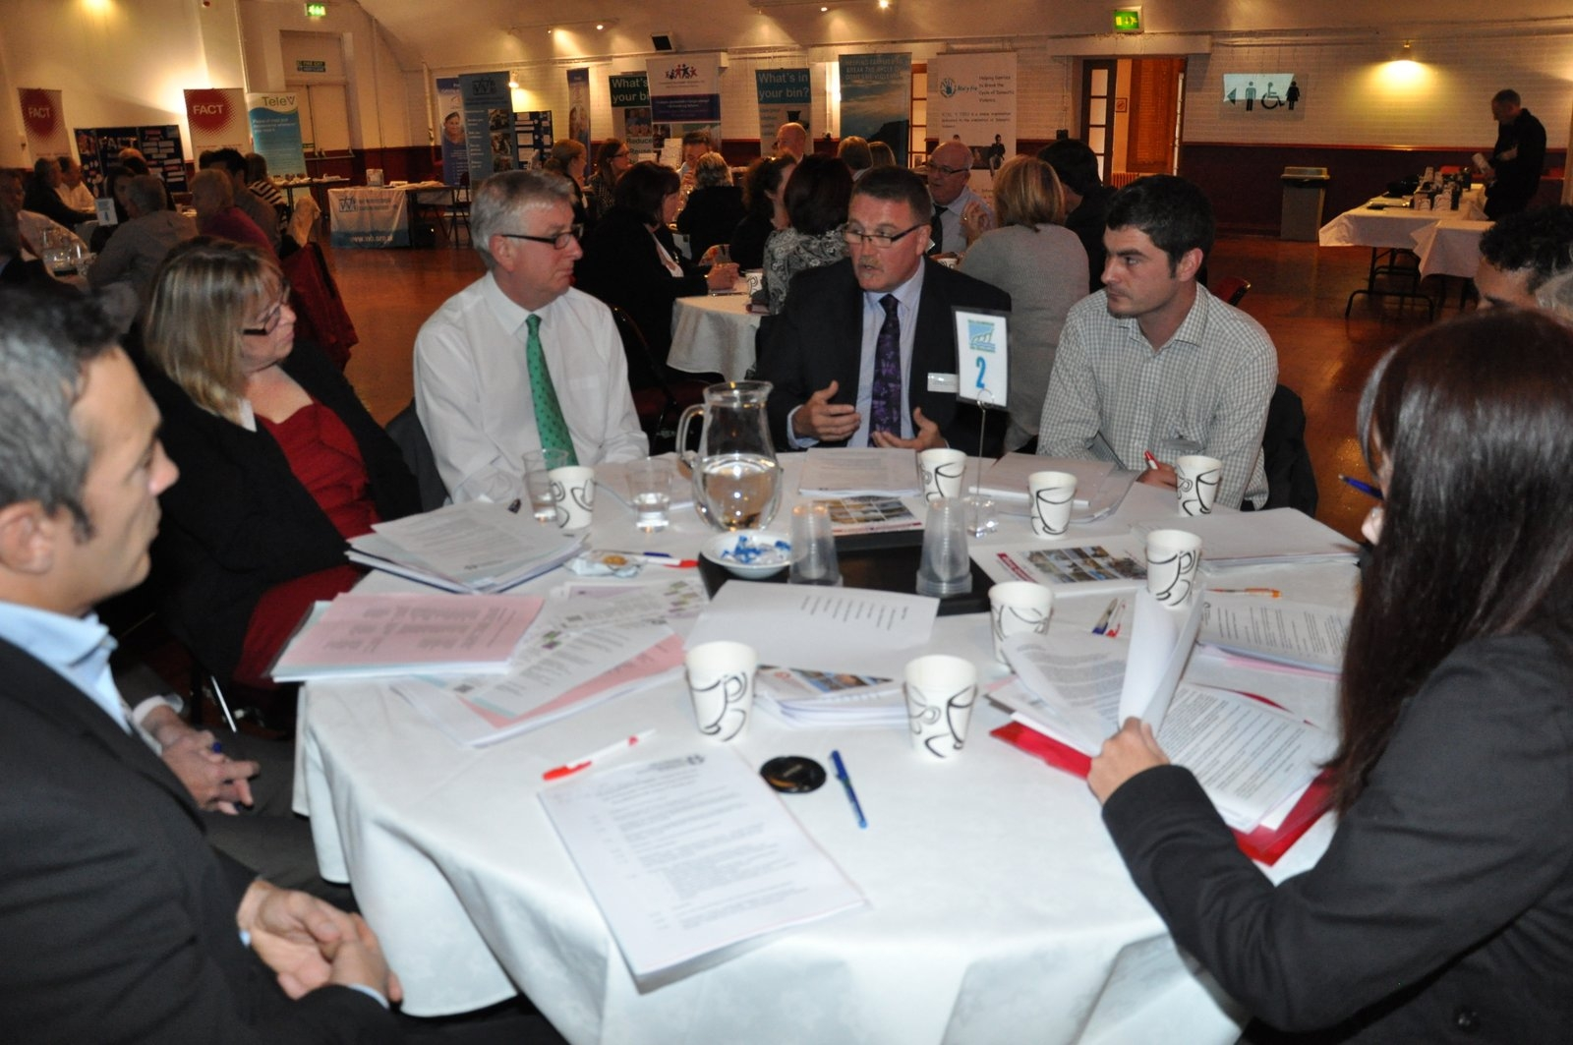
There was a discussion around using other areas/countries as examples of good practice, and a question raised around whether there are any areas that have managed to eliminate issues. Unfortunately examples such as this are rare and often very culturally defined.

If you have any queries regarding the Alcohol Strategy please contact Sean Maidment, Substance Misuse Coordinator smaidment@valeofglamorgan.gov.uk

Early Years and Childcare – Who Cares? The Importance of Childrens Early Experiences in Shaping Their Future

The purpose of the workshop was to focus around the important issues of the benefits of providing the right services and support at an early age.

A number of issues were raised during the workshop including the importance of interaction with the child and homework clubs in particular were highlighted as a critical interaction for some children. It was also recognised that childcare maybe be the only form of interaction for some children.

With regards to the quality of childcare issues raised included;

- Parents don’t always understand what qualifications and procedures should be in place at their child’s childcare setting.
- Funding for childcare does not support parents going back to work.
- Different agencies/ childcare settings need to talk to each other to ensure transition is smooth.
- Parents can often be unsure of what a ‘quality childcare’ setting is and what, ‘registered childcare’ means.
- There are different types of deprivation in different areas but there is a postcode lottery as to eligibility for childcare funded places.

Other points raised related to play provision which has suffered significantly due to the change in Welsh Government funding criteria – closing of Cymorth funding for the introduction of Families First (April 2012). On a positive note the provision of day camps at leisure centres for school holidays was identified as a successful scheme.

Actions that arose from the workshop included;

- Adding Families First to the mail list for the Family Information Service
- Consideration by the Early Years Development and Childcare Partnership (EYDCP) of how to improve promotion of Childcare Vouchers as many parents are still not aware of the scheme
- EYDCP to consider how resources can be better aligned and report to the Children and Young Peoples Partnership.

If you would like more information on Childcare and the work of the EYDCP please contact Debbie Maule, Children’s Partnership Coordinator DMaule@valeofglamorgan.gov.uk. Further information is also available on the Family Information Service website http://www.valeofglamorgan.gov.uk/living/social_care/children__young_people/childcare__-_fis.aspx

Welfare Reform Act; An Overview of the Implications and How we can work together to prepare for the changes

Two workshops were run on the subject of the Welfare Reform Act. The morning workshop focused on the implications of the changes and the afternoon workshop provided an opportunity for discussion about how partners could work together.

The group were advised that the changes arising from the Welfare Reform Act include the introduction of Universal Credit, the abolition of many existing benefits and a modified pension credit. Disability Living Allowance will be replaced and there will be changes to the Social Fund. The changes to Housing Benefit rules and the implications were discussed and examples were given of how this might impact on individuals of different ages and on families.

Partners discussed the far ranging implications of the changes including difficulties of people having to apply on line for Universal Credit, monthly payments in arrears and direct payment to the claimant into one bank account.

Maureen Neave and Clive Teague explained about some of the work being undertaken by the Council through an officer working group and a Scrutiny Task and Finish Group.

There was support from attendees at both sessions for the establishment of an external stakeholder group which will now be established.

If you have any queries about this workshop or the external stakeholder group please contact Clive Teague CHTeague@valeofglamorgan.gov.uk

More information about Universal Credit is available on the Department of Work and Pensions website http://www.dwp.gov.uk/policy/welfare-reform/universal-credit/

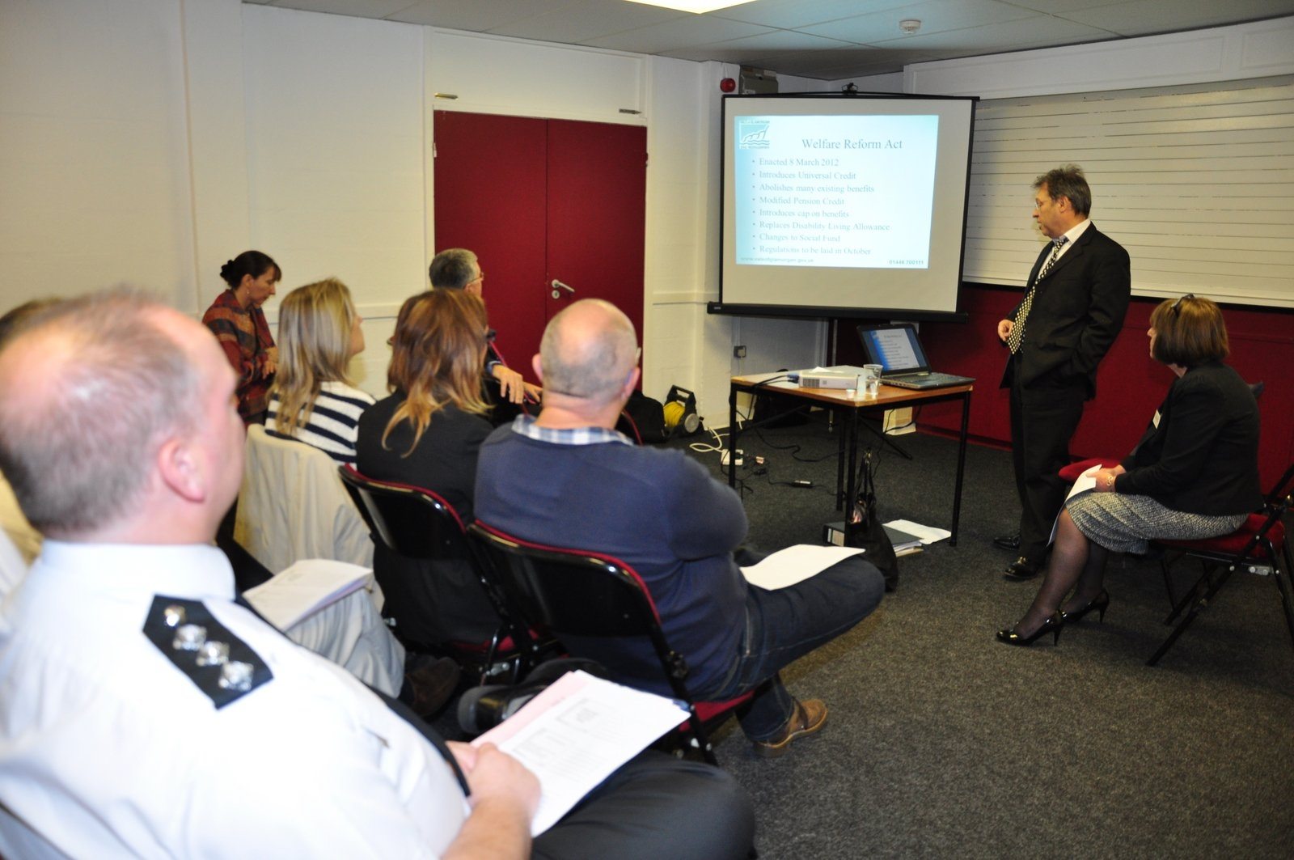

Making Every Contact Count - Promoting Health Improvement

Making Every Contact Count (MECC) aims to equip staff with the knowledge and skills to opportunistically discuss key public health topics and signpost people who wish to access further support. The overall objectives are to:

- develop a training programme, appropriate information and signposting resources;
- promote the approach through all levels of partner organisations;
- deliver and embed the programme.

It was proposed to the group that the initial pilot should focus upon highlighting priority health promotion areas of tobacco, alcohol, food, physical activity and immunisation using three staff groups, one each from the UHB, Local Authority and third sector.

MECC was seen to be a simple idea with huge potential for ways to use it across the Vale of Glamorgan. It might help to build bridges between different services (leisure centres, etc), workstreams and communities, and would also help to give confidence to raise ‘uncomfortable’ topics. It was noted that this would build on some of the work already being undertaken.

The ‘train the trainer’ approach was considered to be the most cost effective way of sharing the messages. Whilst the link to encouraging increasing use of leisure centres was identified, the group also raised perceived access barriers for certain groups in the community. There is also a need to ensure that MECC is linked to the Health Challenge Vale work so that people have an up-to-date repository of information that they can access easily.

Tobacco appeared to be a relatively ‘easy’ subject to raise with people. The group considered that the topic of greatest difficulty to highlight would be food. There would be a need to provide some very factual information as part of the training process to help back up arguments for behaviour change. The group considered that one likely response from clients would be ‘It’s too late for me to stop …’ and responses to such a comment should again be included in the training. Future messages might include Falls Prevention and Mental Health First Aid.

The private sector need to be involved, particularly those providing care home provision. It would be particularly helpful in this context if there was a certificate of recognition as part of the training process. Flying Start was also recognised as a useful group – having 10,000 contacts a year. Linking in with the Community Wellbeing Coaches was also suggested as they would be doing one-to-one work as part of the Communities First Programme.

The next step is to work up the implementation plan to be launched formally over the next few months and this work will be led by the Health and Wellbeing Partnership.
If you would like more information about the Making Every Contact Counts initiative please contact Meredith Gardiner meredith.gardiner2@wales.nhs.uk

Valuing Our Environment

The workshop was in three parts, firstly the group looked at a range of statements about wellbeing and the group discussed the positive and negative effects of the environment on wellbeing. This highlighted the close links between how people feel and the state of the environment.

The group then identified and discussed positive and negative statements about the environment and considered whether the Community Strategy recognised these issues in terms of developing and protecting the positive and addressing the negative. Positive issues raised included green open spaces and beaches, coastal paths and parks e.g. Cosmeston and good access and ambitious plans for the Vale. Some of the negative issues raised included pollution from industry, poor transport in some areas and continuous roadworks and litter. Issues raised that the group were undecided about included, the Severn Barrage, infrastructure improvements and whether the size of the Vale restricts its impact.

The final task was to consider the ten priority outcomes in the Community Strategy and the environmental aspects of each one and nearly all of the outcomes had some link to the environment.

Future action will be to consider how through the Community Strategy and the work of the key partnerships we can ensure we are valuing the environment and taking account of the issues that matter most to local people. The importance of sustainable businesses was also seen as a significant issue for the LSB.

If you require any further information about the work of the Environment Agency please contact John Harrison at john.harrison@environment-agency.wales.gov.uk

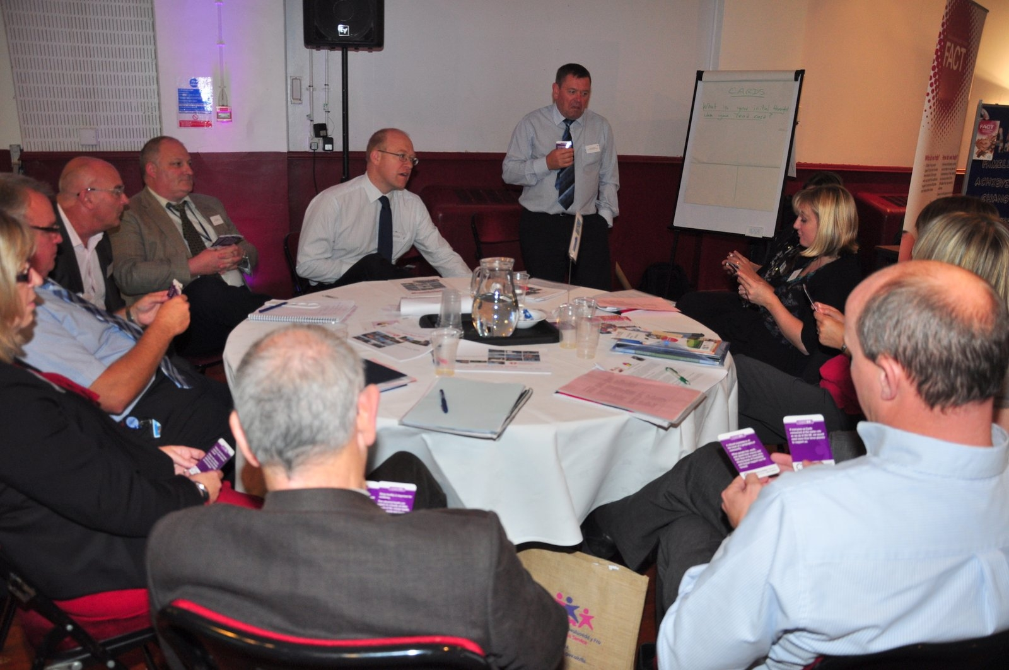

Addressing the NEETS Issue Post 18

The purpose of workshop was to address gaps in provision and current issues in engaging 18 plus NEETs in the Vale and also difficulties in engaging with services in the Vale. In the past the primary focus has been to engage pre16 and 16-18 categories. Job centre Plus (JCP) has recorded 2,807 claimants in the Vale of which 925 are aged18-24 this is 33% of all claimants.

Careers Wales demonstrated their website which is where young people need to apply for apprenticeships and Jobs Growth Wales opportunities, particularly for post 18, and this demonstration will hopefully raise awareness across agencies so that they can direct young people towards this service and also towards Careers Wales to help them access opportunities and prevent young people becoming NEET.

Some of the key issues which arose at the workshop and which the Learning and Skills Partnership will take forward include:-

- Work experience - Although the Vale of Glamorgan Council take referrals for work experience, JCP pointed out that the Local Authority is not ‘signed’ up to an agreement to offer work experience; the Local Authority can advertise such opportunities with the JCP. In response to this connections between colleagues have now been made to sign an agreement and move forward.

- Social Responsibility - Employers often see 18-24 NEETs as a risk to employ. The aim will therefore be to target employers who are willing to adopt social clauses in contracts as a duty to the community in helping to reduce the number of NEETs in the Vale. Young adult NEETs find it hard to sustain employment and as a result of deep entrenched issues job set skills are not acquired. Work will be undertaken with schools and training providers to address basic skills problems and to embed the values of employers in the training and support provided to NEETs. Work will also be undertaken with young people who are ‘work ready’ to enable them to become familiar with these values through a support programme involving the voluntary sector.

- Attitudes of young people – The challenging behaviour of some NEETs include social issues, lack of confidence and self esteem; we need to look at individual needs and tailor services for small numbers, and ensure there are clear pathway/ progression route that are visible for the young adult.

If you would like more information about the work of the Learning and Skills Partnership please contact Nisha Shukla, Learning and Skills Partnership Officer nshukla@valeofglamorgan.gov.uk

Conclusion

Rachel Connor thanked everyone for attending and for their contributions to the day and highlighted a number of key points which had arisen during the day.

One of the key themes from the day was that more can be achieved by working together and that the right people need to be involved. The morning discussion on engagement had highlighted that this is a vital area where partners need to work together to make the necessary improvements. Issues that arose during the discussion on engagement were around transparency, making it attractive and meaningful and being honest. The need to empower and make sure everyone is aware of their responsibilities was also a significant issue. Rachel emphasised that these are all aspects of partnership working and we need to get them right.

Referring back to the presentations through the day Rachel reminded everyone of the exciting developments in the Vale from the various regeneration projects that Rob had described to the new facilities at Llandough Hospital and the new ways of working that the FACT team are taking forward.

Rachel concluded that despite the challenging times ahead there is a great deal to be positive about and again thanked everyone for their participation in making the event a success.

Next Steps

The issues raised during the day will be considered by the relevant partnerships and assist them in taking forward their priorities. All of the workshops focused on areas of work within the Community Strategy that can make a difference to the social, economic and environmental wellbeing of the Vale and improve the quality of life for local residents. The Local Service Board will continue to monitor progress across all of these projects and ensure that the views expressed at the Forum are taken into account in the planning of new services and service improvements.
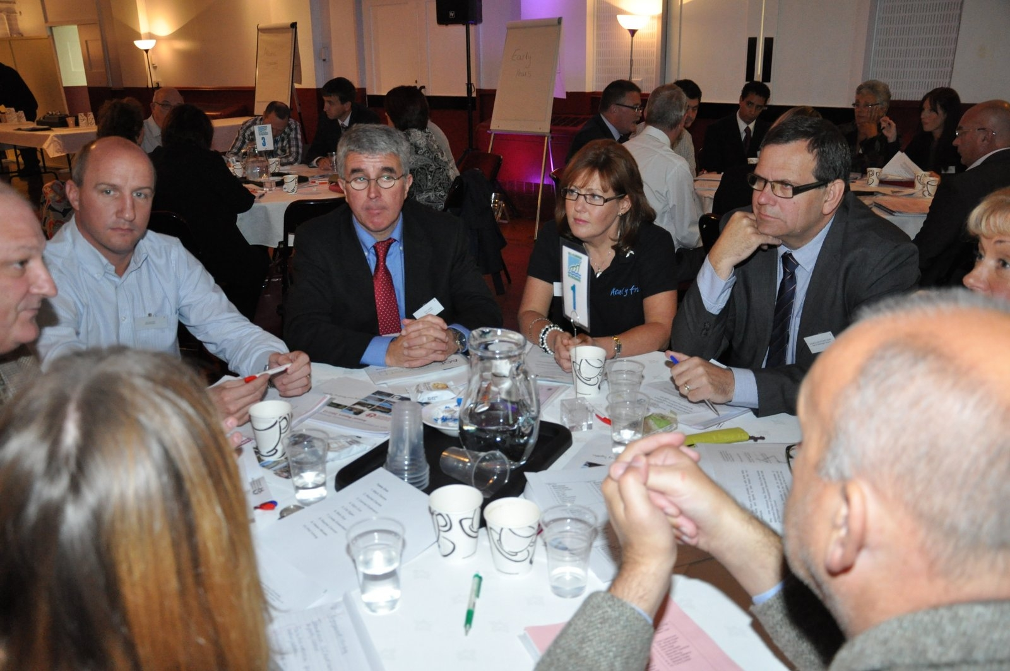

Appendix 1

Conference Feedback

Delegates were asked to complete evaluation forms and overall the responses were very favourable.

The most popular presentation was the ‘Overview of Development and Regeneration in the Vale’, delivered by Rob Thomas, the Director of Development Services in the Vale of Glamorgan Council. 76% of respondents rated this presentation as very good, while the remaining 25% rated it as good. 100% of respondents rated the presentation given by Peter Welsh, Hospital General Manager at the Cardiff and Vale University Health Board, as either very good or good. 98% of respondents rated the presentation given by Gareth Powell and Rob Couchman, Families Achieving Change Together, as either very good or good. The remaining 2% did not give this presentation a rating.

The feedback also indicated that a designated time for questions would have been appreciated for all presentations.

There was positive feedback for all the morning workshops with 100% of all those who completed the feedback forms rating them as either very useful or useful. The ‘Forthcoming Review of Regeneration Policy in Wales – Issues for the Vale of Glamorgan’ was the most popular morning workshop, with 36% of respondents attending. Of these 36%, 77% and 23% rated this workshop as very useful and useful respectively. Attendance at the other morning workshops ranged from 21% to 11%. ‘Creating the Virtual Team Around Wyn’ was the highest rated workshop and 80% of attendants rated it as very useful, while 20% rated it as useful.

Attendance at the afternoon workshops was more evenly distributed. ‘Making Every Contact Count – promoting health improvement’ had the highest turnout, with 25% of respondents attending. ‘Valuing Our Environment’ had the lowest attendance, with 15% of respondents attending. Only one respondent gave a negative review of the afternoon workshops, rating ‘Valuing Our Environment’ as not useful.

The Local Service Forum was seen as successful and worthwhile by the majority of those who provided feedback. The further comments section highlighted recurring themes with a strong current of opinion that the Local Service Forum should be an annual event. The organisations in attendance highlighted the opportunity to network and build new contacts as one of the greatest benefits of the day.

Appendix 2

List of Attendees

DELEGATE NAME | ORGANISATION
Chris Ashman | Wales Council for Voluntary Action
Jason Baker | Barnardos
Maria Battle | Cardiff and Vale UHB
Shelley Bellamy | Vale of Glamorgan Council
Mike Bendall | Vibe
Alun Billinghurst | Vale of Glamorgan Council
Antonia Bridges | Vale of Glamorgan Council
Laura Bryon | Vale of Glamorgan Council
Chris Cashmore | Cardiff and Vale UHB
Lynda Chandler | Cardiff and Vale UHB
Caroline Chapman | Mind in the Vale of Glamorgan
Phil Chappell | Vale of Glamorgan Council
Jane Clay | Citizens Advice Bureau
Helen Cocks | Communities First
Rachel Connor | Vale Centre for Voluntary Services
Robert Couchman | Vale of Glamorgan Council
Glyn Cox | RWE npower
Tony Curliss | Vale of Glamorgan Council
Amy Davidson | Job Centre Plus
Mark Davies | Vale of Glamorgan Council
Colin Davies | Vale of Glamorgan Council
Rachel Davies | Vale of Glamorgan Council
Mikki Down | Careers Wales
Dave Edwards | Vale Centre for Voluntary Services
Mike Edwards | Vale Older Peoples Strategy Forum
Councillor Stuart Egan | Vale of Glamorgan Council
Mark Ellis | Vale of Glamorgan Council
Phil Evans | Vale of Glamorgan Council
Conrad Eydmann | Cardiff and Vale UHB
Councillor Chris Franks | Vale of Glamorgan Council
Meredith Gardiner | Cardiff and Vale UHB
Deborah Gibbs | Vale of Glamorgan Council
Marcus Goldsworthy | Vale of Glamorgan Council
Linda Greenfield | Atal Y Fro
Dr. Sian Griffiths | Public Health Wales
Bob Guy | Vale of Glamorgan Council
John Harrison | Environment Agency
Will Hills | The People Business-Wales Ltd
Steve Hodgetts | Cardiff Airport
Elaine Hopf | Careers Wales
Huw Isaac | Vale of Glamorgan Council
Mike James | Cardiff and Vale College
Rob Jones | Vale of Glamorgan Council

DELEGATE NAME | ORGANISATION
Mike Jones | Vale of Glamorgan Council
Stewart Kelly | Hafod Care Association
Eric Kitchen | Cardiff and Vale UHB
Dave Knevett | Vale of Glamorgan Council
Kerri Llewellyn | Carers Forum
Rob Lucas | Vale of Glamorgan Council
Sean Maidment | Vale of Glamorgan Council
Paul Marks | Vale of Glamorgan Council
Kay Martin | Cardiff and Vale College
Deborah Maule | Vale of Glamorgan Council
Kieran Montague | Newydd Housing Association
Alexis Morley | Vale of Glamorgan Council
Helen Moses | Vale of Glamorgan Council
Gill Munro | Gibbonsdown Childrens Centre
Maureen Neave | Vale of Glamorgan Council
Gary Osborne | South Wales Police
Phil Pinches | South WalesFire and Rescue Service
John Porter | Vale of Glamorgan Council
Gareth Powell | Vale of Glamorgan Council
Amy Powell | Vale of Glamorgan Council
Linda Pritchard | Vale Centre for Voluntary Services
Kay Quinn | Atal Y Fro
Tara Reddy | Vale of Glamorgan Council
Emma Reed | Vale of Glamorgan Council
Sue Roberts | Communities First
Paul Roberts | Newydd Housing Association
Andy Robinson | Environment Agency
Natalie Sargent | Vale Volunteer Bureau
Nisha Shukla | Vale of Glamorgan Council
Steve Slocombe | Welsh Government
Michelle Sullivan | Vale of Glamorgan Council
Clive Teague | Vale of Glamorgan Council
Rob Thomas | Vale of Glamorgan Council
Rob Thompson | Vale of Glamorgan Council
Kim Vidal | Workers Educational Association
Phil Vining | Age Concern
Dave Vining | Vale of Glamorgan Council
Lynda Wallis | Vale Older Peoples Strategy Forum
Helen Watkins | Cardiff and Vale UHB
Anne Wei | Cardiff and Vale UHB
Peter Welsh | Cardiff and Vale UHB
Brian West | Vale of Glamorgan Care Homes Association
Becky Wickett | Vale of Glamorgan Council
Dave Williams | Vale of Glamorgan Council
Councillor Mark Wilson | Vale of Glamorgan Council
Jay Winslade-Gregory | South Wales Police

