

**Our Vale - Our Future is the Vale of Glamorgan Public Services Board’s plan to make life better for everyone in the Vale – today and for future generations. We have set out a long term vision for 2050 which has been informed by our well-being assessment which we published in 2017.**

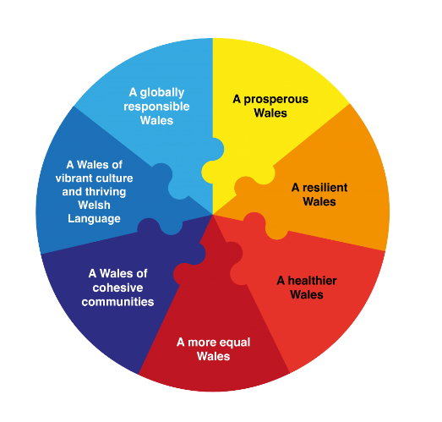

**We have spoken to a range of people and organisations who live or work in the Vale of Glamorgan and agreed four well-being objectives. We think these objectives reflect what we can do together over the next five years to make life in the Vale better and are the first steps towards achieving our long term vision.**

**We also think these things show how we can maximise our contribution towards the national well-being goals for Wales.**

|  |  |
| --- | --- |
| **Enable people to get involved, participate in their local communities and shape local services** | **Reduce poverty and tackle inequalities linked to deprivation** |
| * Adopt the national principles for public engagement in Wales * Research best practice to develop new approaches * Support and promote volunteering opportunities * Produce an engagement toolkit * Work with the community to identify and deliver a project together as a model for future work * Develop more knowledge about our local communities * Work with frontline staff and volunteers to empower them to signpost to services and information * Explore the potential of a Vale Timebanking scheme | * Undertake further work to better understand the issues facing our most deprived communities * Work in partnership with projects and agencies already supporting those in poverty * Promote healthy behaviour messages * Work with the community to develop and deliver an environmental project in one of our more deprived areas * Develop a more strategic and aligned approach across programmes designed to tackle poverty and support vulnerable people * Develop and promote job opportunities * Tackle fuel poverty * Improve the environment to encourage outdoor play within our more deprived communities * Work with the Food Vale partnership to address issues relating to access and affordability of food |
| **Give children the best start in life** | **Protect, enhance and value our environment** |
| * Use research and best practice to inform early years provision * Develop parenting skills through play activities linked to the natural environment * Develop a better understanding of adverse childhood experiences and develop new approaches to protect, support and prevent * Review how we work together to provide services for children and young people * Improve how we work together to support people and prevent domestic abuse, anti social behaviour and other related issues recognising the needs of adults and children | * Understand and reduce any negative impact that our organisations may have on the environment e.g. around air pollution, energy use and flood risk * Promote both active and sustainable travel choices, encouraging people to walk or cycle and working with the Capital City Region to improve public transport * Review our land assets and how they can be used to benefit the community and the environment * Work with local business and industry to maximise the economic benefits of our environment whilst minimising negative impacts * Work together to explore how our own procurement policies and practices can benefit the environment and the local economy * Work with the Food Vale partnership to gain Sustainable Food Cities status |



**We want to keep talking to you about what you think is important and about what we need to do, We also want to talk to you about what you can do to help meet our objectives and make the Vale a better place for everyone. Every year we will tell you how we think we have done and ask you what you think of our achievements. For more information about the PSB and to read our Well-being Plan please go to ….**

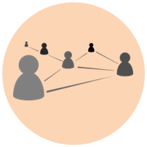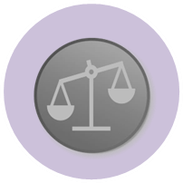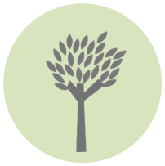

**Detailed below are our four well-being objectives and the steps we will take over the next five years to achieve them.**