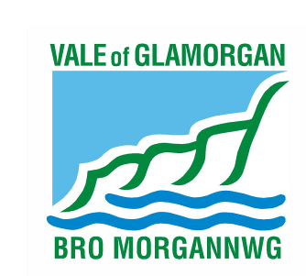
To: Electoral Registration
Vale of Glamorgan Council
Civic Offices
Holton Road
Barry
CF63 4RU

I (print full name)…………………………………………………………………………………….

of (print full address including postcode)

…………………………………………………………………………………………………………

…………………………………………………………………………………………………………

…………………………………………………………………………………………………………

Require you to cease or not begin processing the personal information relating to me from the
Electoral Register for the purposes of direct marketing as soon as possible, by not including my
details on the next and future versions of the Open Register until further notice.

Signed: ……………………………………………………………

Date: ………………………………………………………………

Please provide your contact details in case of any query with this form

Telephone number: ……………………………………………..

E-mail address: ………………………………………………….

Please return this form to:

Electoral Registration, Vale of Glamorgan Council, Civic Offices, Holton Road, Barry CF63 4RU

Or e-mail: electoralregistration@valeofglamorgan.gov.uk

Correspondence is welcomed in Welsh or English/Croesawir Gohebiaeth yn y Gymraeg neu yn Saesneg

At sylw: Cofrestru Etholiadol
Cyngor Bro Morgannwg
Swyddfeydd Dinesig
Heol Holton
Y Barri
CF63 4RU

Yr wyf i (nodwch eich enw mewn priflythrennau)……………………………………………………….

o (nodwch eich cyfeiriad a’ch côd post mewn priflythrennau)

…………………………………………………………………………………………………………

…………………………………………………………………………………………………………

…………………………………………………………………………………………………………

am i chi ymatal rhag prosesu / roi’r gorau i brosesu fy ngwybodaeth bersonol o Gofrestr yr Etholwyr i ddibenion marchnata uniongyrchol cyn gynted ag sy’n bosibl, drwy beidio â chynnwys fy manylion yn y fersiwn nesaf o’r gofrestr a phob fersiwn ar ôl hynny, nes i mi eich hysbysu’n wahanol.

Llofnod: ……………………………………………………………

Dyddiad: ………………………………………………………………

Rhowch eich manylion cyswllt rhag ofn y bydd holi ynglŷn â’r ffurflen hon

Rhif ffôn: ……………………………………………..

Cyfeiriad e-bost: ………………………………………………….

Anfonwch y ffurflen hon yn ôl i’r cyfeiriad hwn:

Cofrestru Etholiadol, Cyngor Bro Morgannwg, Swyddfeydd Dinesig, Heol Holton, Y Barri CF63 4RU

neu anfonwch neges i: electoralregistration@valeofglamorgan.gov.uk

Correspondence is welcomed in Welsh or English/Croesawir Gohebiaeth yn y Gymraeg neu yn Saesneg

