Count Information

Venue - Barry Leisure Centre (Legacy Leisure), Greenwood Street, Barry, CF63 4RU

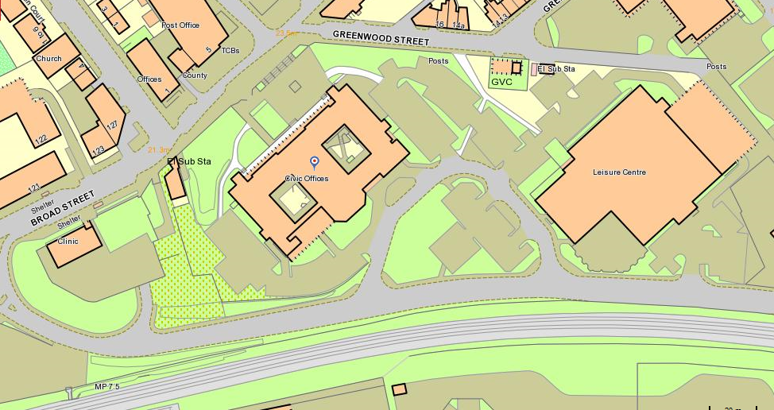
Count Venue
Dock View Road
Civic Car Park

Verification of the count to commence at 10pm, candidates welcome from 9:15 pm Refreshments may be purchased from the café which is situated at the entrance to Leisure Centre. If you are travelling by car please park in the Civic Offices car park and not the Leisure Centre car park.

Order of Count

Verification of County Council Election and Town / Community Councillor Elections

Count for County Councillors

Declaration

Count for Town & Community Councillor

Declaration

