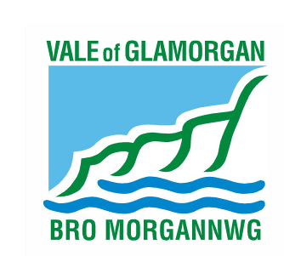

Vale of Glamorgan Council
County Councillor

Thursday 4th May 2017

Candidate Contact Information

Please ensure completion and return with your nomination as the Local Government Data Unit Wales (LGDUW) will be undertaking a survey on behalf of the Welsh Government during and after the election and this information will be required to release to the LGDUW. This information will also help the electoral registration team to contact you should there be a need

Candidate / Party

Name:_________________________________________________

Telephone

work:_________________________________________

home:_________________________________________

Mob:________________________________________

e-mail:

work:_________________________________________

home:_________________________________________

I the undersigned give authority for the above information to be provided to the Local Government Data Unit Wales

Signed: ___________________________________ Date: ________________

