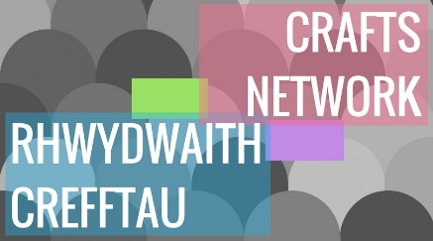
Crafts Network – An Overview and Observations from Cowbridge Old Hall, Tuesday 11th September 2018
Contents
Overview 1
1. Rural Vale Crafts Festival 1
1.1 Draft Plan 1
1.2 Event map – concept idea 3
1.3 Overall management – Proposed Concept 3
1.4 Event Schedule – Proposed Concept 3
1.5 Activity summary by place – Concept ideas 4
1.6 Festival Title – Concept ideas 5
2 Other offers and opportunities mentioned at the meeting 5
2.1 Vale Courses 5
2.2 Gwion ap Rhisiart – Agora 5
2.3 Tracey Harding – Arts development Officer, Vale of Glamorgan Council 5
3 Contact Us 6

Overview
The Vale Crafts Network has been invited by the LAG to propose a pilot project. The aim of the pilot is to bring together the various members to work on a shared project, giving the group focus and a tangible outcome (which if successful could be repeated without the LAGs support).
A number of ideas were proposed at the network meeting in June 2018, including an Open Studio Trail, discussions also included ideas around using pop up shops as pop up studios for people who do not have studios that would be suitable for visitors.
A further discussion took place with Sally Perini from Vale Courses about using the pop up shop and Cowbridge College as a venue, and ideas around an extended market and studio event ensued. A subsequent research visit to the Swansea Festival of Stitch, (in which a number of the network members were exhibiting) resulted in an enthusiastic discussion at the Crafts Network meeting on Tuesday 11th September 2018, whith the focus on reolicating the model in the Vale.

1. Rural Vale Crafts Festival

1.1 Draft Plan
A draft plan for a new crafts based festival in the rural Vale of Glamorgan was conceived at the meeting, which includes, but is not exclusive to, an Open Studio Trail. It was proposed that the event/festival would take place over a two week period, with a key weekend in the middle which centred around Cowbridge Old Hall.
The key activities would include:
- Artisan & Traders Market (could include crafts, and supplies such as fabrics)
- Master Clsses
- Taster Sessions and demonstrations
- Social taster session (kint and natter, coffee morning, wine and skills)
- Exhibitions
- Open Studios/Pop Up Studios (People can share spaces as well for time saving, confidence, increased appeal, reduce costs if applicable)
- Other, (Talks etc)
Core support elements would include:
- Logo and branding
- Website
- Marketing Plan (Online and ard copy marketing, social media, flyers, posters, signs for windows, A frames for streets)
- Central Co-oridnator
- Volunteer Co-ordinators/Advisors
- Research Visits (To open studios and similar events elsewhere) and Mentors
- Guidance notes on best practice (for example: Hosting an Open Studio in Your Home/Insurance/Risk Assessments)
- Guidance notes on marketing (so that individuals can take responsibility to compliment the central marketing plan.)
- Memoradum of understanding between event organisers, venuws and artisans
- Infrastructure, tools, facilities
- Temporary road signage
For those who feel they are being asked to ‘run before they can walk’ we hope that the festival will offer a range of opportunities so that everyone can do as little as they like, perhaps just have a table at the market for one day for example, or as much as they like, such as open their studio, run master classes and co-ordinate an exhibition

1.2 Event map – concept idea
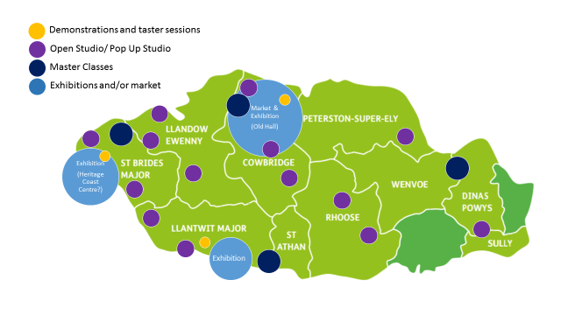

1.3 Overall management – Proposed Concept
Sally Perini has offered to take the lead on applying for funds from Creatove Rural Communities, the overall marketing of programme of events, and set up a booking system for taster and master classes, as well as oversee the general management of the activites at Old Hall, Cowbridge. The organisation and management of the events taking place across the rural Vale aside from the Old Hall would be the responsibility of individuals or small groups of artsians.

1.4 Event Schedule – Proposed Concept
Activity/ Location | Weekend One | Week One | Weekend Two | Week Two
Market Old Hall
Exhibition Old Hall
Demos & Tasters – Old Hall
Master Classes Old Hall
Pop Up Studios – Old Hall
Open Studios/ Pop Up Studios - Other
Exhibition Heritage Coast
Demos & Tasters – Heritage Coast
Master Classes - Heritage Coast
Exhibition – St Donats Arts Centre
Demos & Tasters – St Donats Arts Centre |  | (One evening?)
Master Classes - St Donats Arts Centre
Misc (Exhibitions in cafes, talks etc)
The current date proposed for the event would be the weekend of 21st September 2019, with activity taking place in the weeks either side. There will be some cross over with the Cowbridge Music Festoval dates but generally this was considered a good thing, increasing footfall and opportunities for collaboration.

1.5 Activity summary by place – Concept ideas
This is just an illustration of how the festival could look, more venues and activity are likely to emerge as the planning progresses. Other places noted so far include Coed Hills, Cowbridge Wool Barn, Ogmore Crafts Centre, The Barn at West Farm, Southerndown Church, Llantwit library, a barn at Merthr Mawr (out of area – more details on this to follow).
Old Hall
The market could be held throughout the Old Hall over a weekend, offering artisans the opportunity to hire a table to sell their work. An exhibition of work could also be displayed throughout the Old Hall gallery on show during the market weekend and throughout the fortnight. Artisans would be encouraged to offer either demonstrations at their trade table, or taster activities either at their table, or at short scehduled sessions throughout the weekend in one hour slots. (Small fees charged?) Following the market weekend, a series of one day master calsses could follow, or promotion of the summer school programme featuring crafts tutors. (Organisers: Vale Courses, who would also be responsible for the overall marketing and booking for the whole programme across the rural Vale.)
Heritage Coast
An exhibition of work could be displayed in the Heriage Coast centre, or other location, with the options for sales, demos and tasters, either ad hoc (depending on the attending invidulator) or scheduled one hour sessions and/or one day master classes to be pre-booked. (Organisers: Coastal Community Arts?)
Llantwit Venue and/or St Donats Arts Centre
An exhibition of work could be displayed at the gallery, with the options for sales, demos and tasters, either ad hoc (depending on the attending invidulator) or scheduled one hour sessions and/or one day master classes to be pre-booked. (Organisers: St Donats Arts Centre, or group of artisans.)
Open/Pop Up Studios
Private or Pop Up studios could be open throughout the fornight, welcoming visitors to view work, see demonstrations and partcipate in small scale taster sessions. (Organisers – Individuals)

1.6 Festival Title – Concept ideas
‘Discover Vale Artisans’ - Working title to fit in with Visit Wales ‘Year of Discovery’ 2019, up for discussion! Could ‘Discover the Vale’ be a theme for the event? This would fit neatly with Visit Wales’ plan to focus on discovering culture in the Autumn of 2019.
Also suggested; ‘Made in the Vale’, ‘Vale Makers’.

2 Other offers and opportunities mentioned at the meeting

2.1 Vale Courses
Special thanks to Sally Perini from Vale Courses for the free use of the venue for the meeting. Here’s a quick reminder of what Vale Courses can do to support crafts:
- Run a variety of courses but always on the lookout for new courses and tutors.
- There is a Pop-Up-Shop at the Old Hall with an entrance on Cowbridge High Street, this can be hired at £13 per day.
- The Old Hall affords a light and spacious gallery area in the foyer and ground floor communal spaces, this includes wall space and a number of glass display cabinets, and new exhibition proposals are always welcome.
- Vale Courses offers a number of short and one day courses aimed at small businesses, such as Excel, Social Media, Photography & Photoshop to name a few.

2.2 Gwion ap Rhisiart – Agora
Gwion gave a brief update about Agora which is a collaborative project supporting growers and makers across the Vale of Glamorgan and a number of counties in South Wales. Agora can support those using land based products in their crafts such as wool, wood and willow. The type of support includes:
- Knowledge Transfer
- Mentors
- Facilitators
- Workshops
- Study Tours
- Business Development Officer time
- Meet the Buyer events
- Developing your supply chain

For more information or to arrange a 121 session, please contact Gwion or see the Agora website.
gwion.ap.rhisiart@menterabusnes.co.uk
agora@menterabusnes.co.uk
02920 467 408 / 07961205302

2.3 Tracey Harding – Arts development Officer, Vale of Glamorgan Council
Tracey reminded us of the Artist Exchange which is part of Arts Connect, an Art Development partnership between the Vale of Glamorgan, Rhondda Cynon Taf, Merthyr Tydfil and Bridgend local authority areas. It provides the opportunity to connect, promote, share and celebrate your art practices both locally and regionally and further afield. The Artists Exchange provides an online listing for artists and crafts practitioners, application forms can be found on the webpage.

3 Contact Us
Creative Rural Communities, Old Hall, High Street, Cowbridge, CF71 7AH
www.creativeruralcommunities.co.uk
01446 704707
@ruralvale
f/CreativeRuralCommunities

