Parent and Child Activities Together
  - OVERVIEW
Children’s activity providers needed!
Creative Rural Communities (CRC), the Vale of Glamorgan Council’s Rural Regeneration Team want to work with activity providers to extend their existing offer to provide activities with parents and school aged children together or side by side.
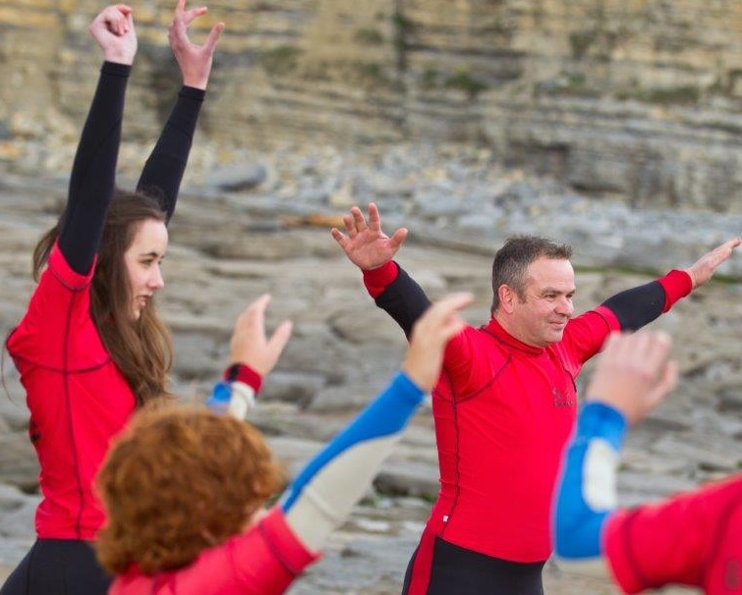
Contact:
Creative Rural Communities
Tel: 01446 704 226
Email: create@valeofglamorgan.gov.uk
Parents feedback have fed back to CRC that there were limited activities for school aged children in parts of the rural Vale and where there were activities parents were at a loss of what to do in that hour during their children’s activity. Parents said that they did not have time to do any activities themselves as they were either rushing around with the kids or had childcare issues. Many realized they spent less quality time with their children once they were at school and have limited ‘me’ time..
“Call out to activity providers – we need your help!”

We want to address this by piloting:

Parent and child activities together
Providing opportunities for parents / grandparents / guardians to take part in leisure / fitness activities with their children together. This will help strengthen family bonds and encourage both generations to take up new activities.

Parent and child activities side by side
Offering opportunities for children and parent / guardians to participate in activities separately but at the same time in the same location. Parent’s ‘dead time’ can be used and childcare barriers are removed.

target communities
There are 4 pilot communities where the activities can piloted:
- St Athan
- Rhoose
- Wenvoe
- Ystradowen
These communities were part of the community mapping pilot project let by CRC and residents highlighted the need for more activities for school age children and families.

what type of activities can be supported?
Any range of activities may be suppored as long as they are activities with parents and children together or alongside each other and within the target communities. They may include crafts, food, fitness / sport, music or performing arts.

The activities must be a new model for the activity provider (ie. Not activities that currently operate on a parent and child basis).

The proposed activitities should target school aged children (aged 4 to 18 years) with their parents / grandparents / careers. Particular activities may target a more specific age group if appropriate (eg. Key Stage 2 children). All proposed activities should be for group classes. Activities for one parent and one child would not be supported.

All activities need to be linked and booked as a package for parent and child at the same time. Children can not be booked on an activity without a parent.

‘Get in touch with your ideas for new parent and child activities together.’

HOW LONG IS THE PILOT PROJECT?
An initial expression of interest from activity providers needs to be submitted to Creative Rural Communities by Friday 26th January 2018. Ideas will be asssessed to ensure they meet the eligibilty criteria.

Approriate training / networking opportunities will be provided to activity providers during February / March 2018.

From April to October 2018 activities will be run in groups of 6 weeks. These activities can be weekly 1 or 2 hours sessions or a series of full day activities during the school holidays / weekends.

what funding is available?
Funding will be available to cover the full cost of the activity for the first group of activities (approximately 6 weeks), so there is no risk to the activity provider if the activity does not have a successful take up.

If the activity provider wishes to continue the activity after the initial pilot, there will be potential support under a joint activity marketing programme.

What do activities providers get?
- Opportunity to test a new way of delivering a service at no risk to yourself.
- Joint marketing of parent and child activities together.
- Training support – let us know what you need help with.
- Networking opportunities to learn from other activity providers and the local community.
what we need from you?
- Buy in to the co-operative ethos of the project and networking opportunities
- Organise and run activities for parents and children.
- Attendance at a half day training session.
- Assistance with the evaluation.

