**A close up of a logo

Description generated with high confidence**

**186 Railway Road, Rhoose, CF62 3FG** *Low Cost Home Ownership*

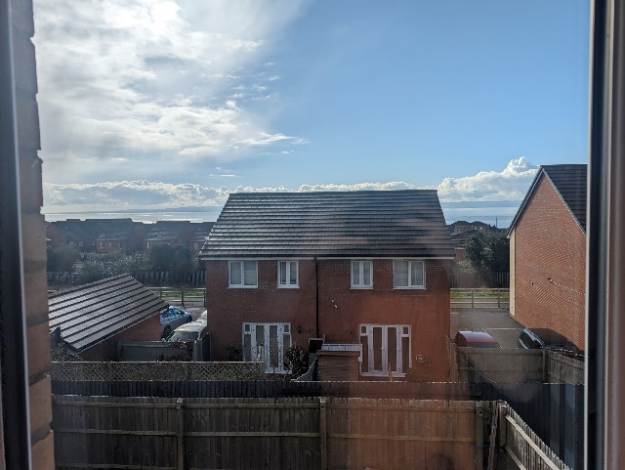 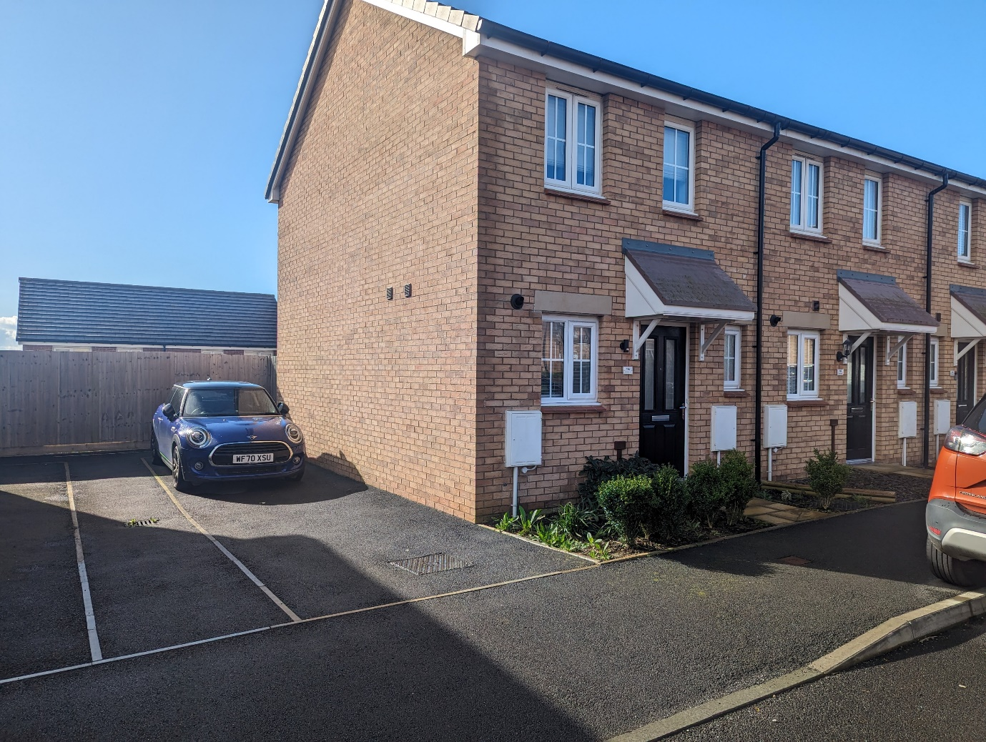

* EPC Rating B
* Shared Equity Purchase
* Generous Garden
* Off Road Parking
* Views over Estuary





1

2

1





A close up of a sign

Description generated with high confidence

Applicants interested in purchasing this superb home will need to register their interest through Aspire 2 Own.

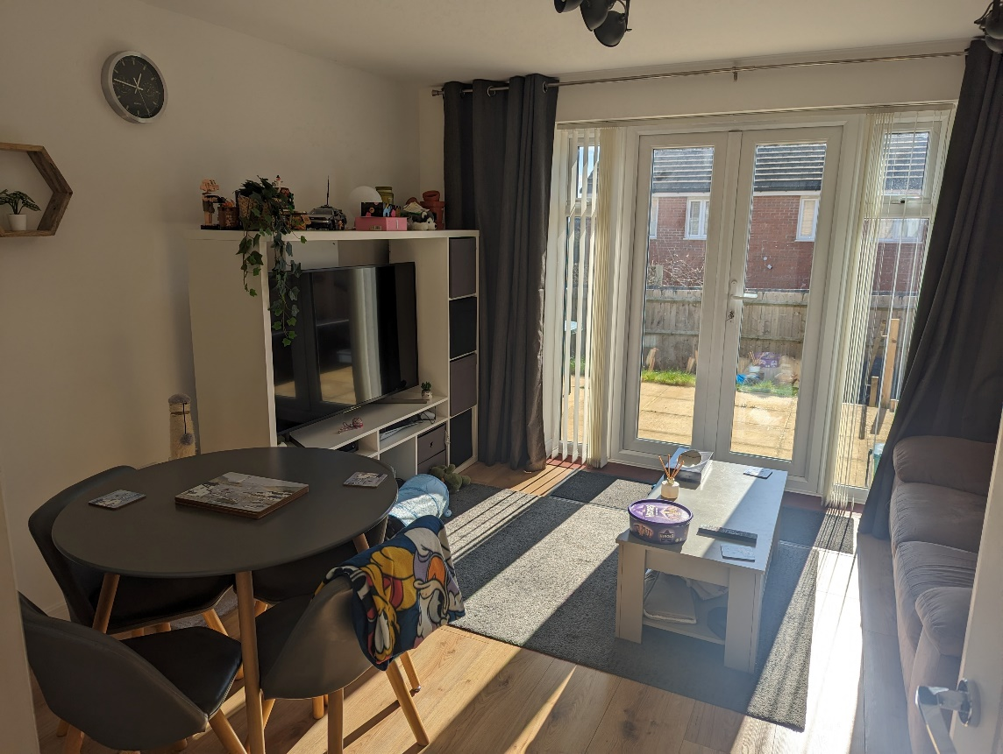

About the property

Two-bedroom end terrace new build property with wonderful sea views, large south facing garden and off-street two car driveway located on highly desirable estate in the centre of Rhoose.

 Tiled hallway leading to fitted kitchen with Electrolux 4 burner hob and oven with a downstairs cloakroom opposite. The large bright living/dining room features laminate flooring and french doors with side windows leading to the rear garden. There is a generous under stairs cupboard and cosy nook perfect for a sofa.

Upstairs offers a central landing to the bedrooms and family bathroom. Bedroom One has two windows and a large integrated double wardrobe as well as a cupboard located over the stairs providing plenty of storage space.

Bedroom Two spans across the rear side of the property with one large central window offering stunning views over the garden out to the sea. The family bathroom features a tiled shower over full length bath and has a tiled floor.

The two-car off street driveway runs alongside the house where there is direct access to the rear garden via gate.

The large south facing garden with extended patio area provides generous sea views and all day sunshine with a lower chipped area accessed by chipped steps.

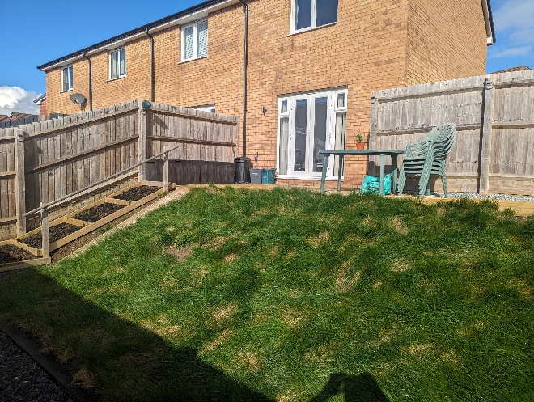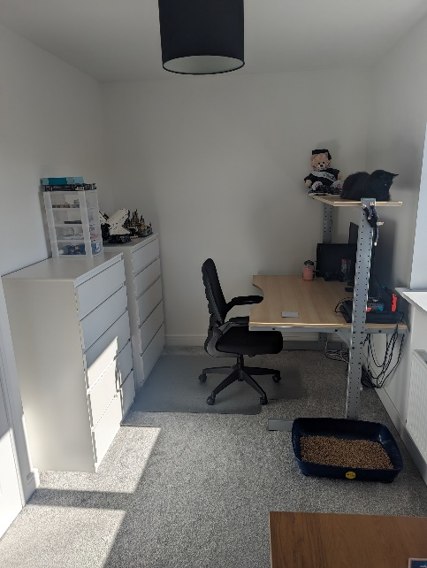

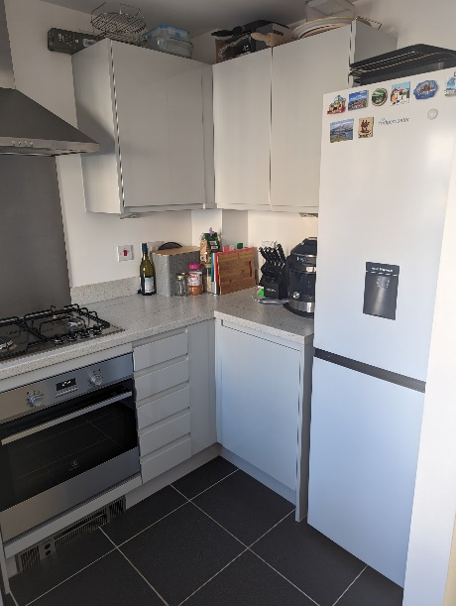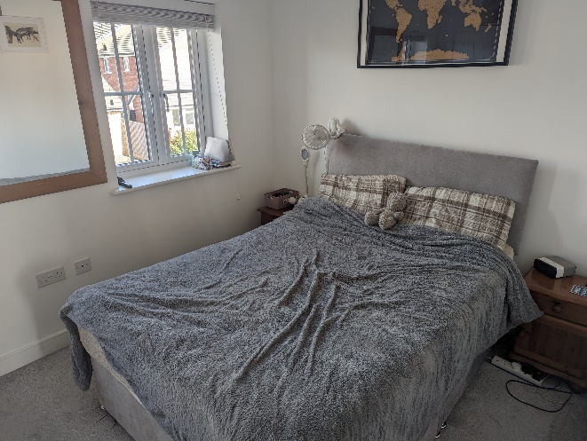  
**Criteria**

Eligible applicants will:

* Have a local connection
* Be a first time buyer
* Be able to raise a mortgage for the value of the property
* Have access to a deposit
* The property is offered at 70% of the open market value (subject to certain criteria). Please note the advertised price is the 70% share value. You would own 100% of the property and a legal charge would be held on 30% with no rent or interest payable on the equity share. (100% value £210,000).

All interested parties will need to complete an application form through the Aspire 2 Own website.

<https://www.valeofglamorgan.gov.uk/en/living/Housing/Affordable-Housing/Aspire-to-Own.aspx>

A close up of a logo

Description generated with high confidence

Contact the Aspire 2 Own team to arrange a viewing/ complete an application form.

You will find more information on Low Cost Home Ownership on our website <https://www.wwha.co.uk/en/find-a-home/>