**A close up of a logo

Description generated with high confidence**

**Gwel Yr Ynys, Sully** *Low Cost Home Ownership*

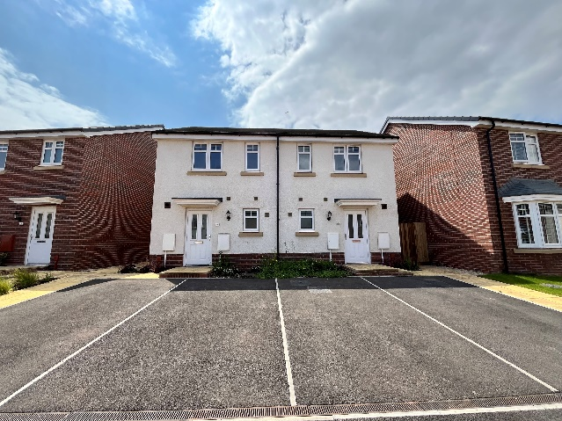 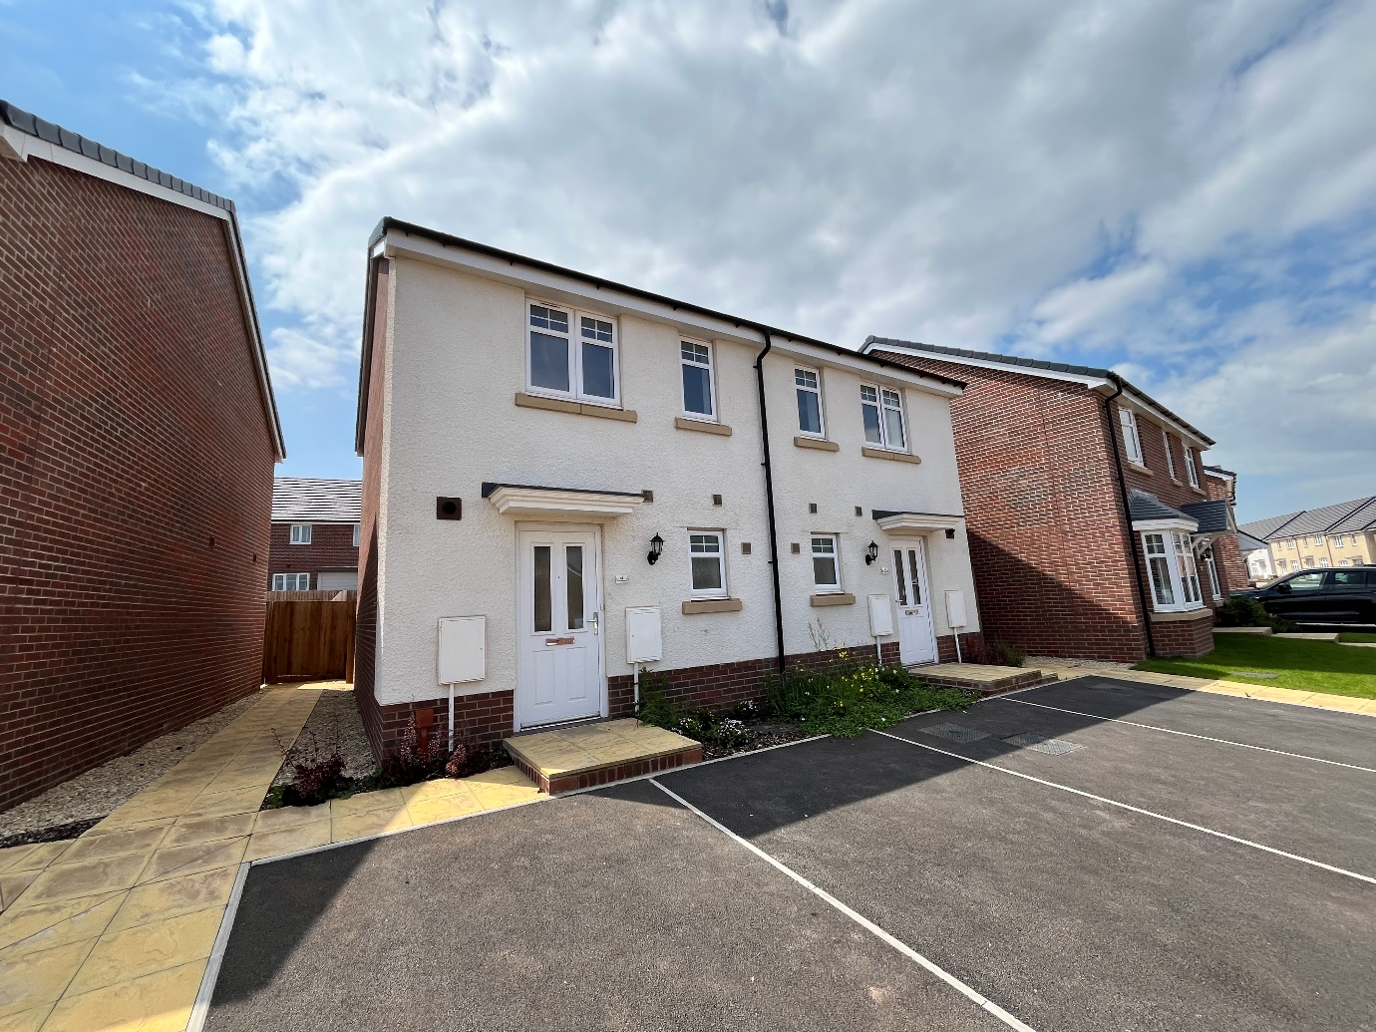

* EPC Rating B
* Shared Equity Purchase
* Two Bedrooms
* Open Plan Living
* Popular Location

From £175,000 (70%)



1

2

1





A close up of a sign

Description generated with high confidence

Applicants interested in purchasing this superb home will need to register their interest through Aspire 2 Own.

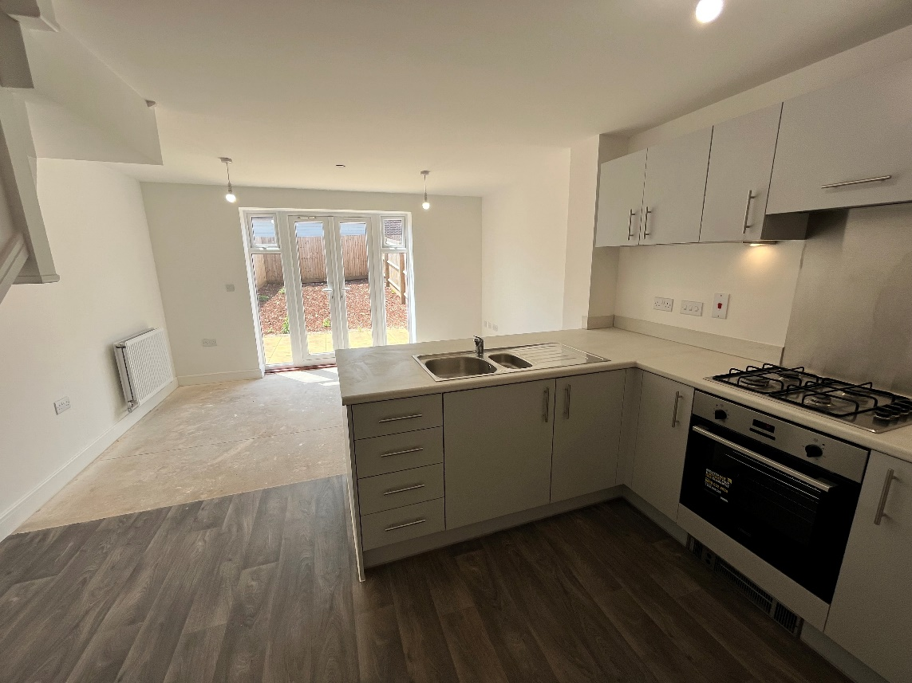

About the property

Wales & West Homes are delighted to offer 2 bedroom homes on the popular Gwel Yr Ynys development.

These homes are available under the Shared Equity scheme where you will purchase 100% of the property at 70% of the current market value (subject to qualifying criteria), with no rent or interest charged on the equity share.

To be eligible for the scheme, applicants must:

* Be over the age of 18
* Be a UK or EU/EEA passport Holder or have Indefinite Leave to Remain in the UK
* Be able to raise a mortgage and be able to afford the financial costs of purchasing a property, including the deposit required by the lender
* Use the property as their main residence
* Either be living or working in the Vale of Glamorgan or for those leaving the Armed Forces to have lived in the Vale of Glamorgan for 6 months prior to joining.

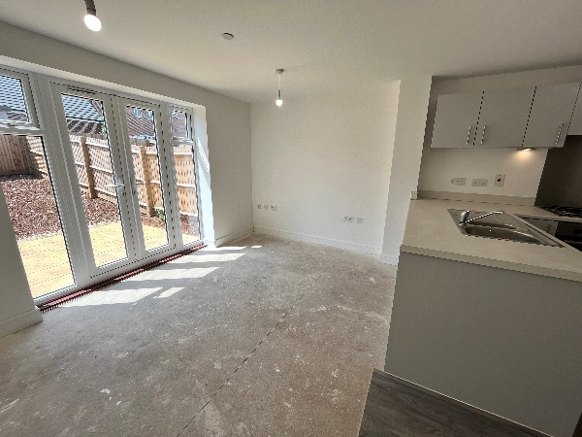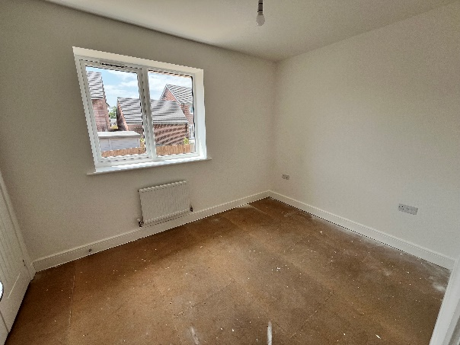

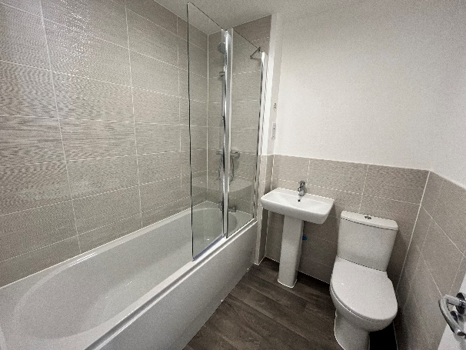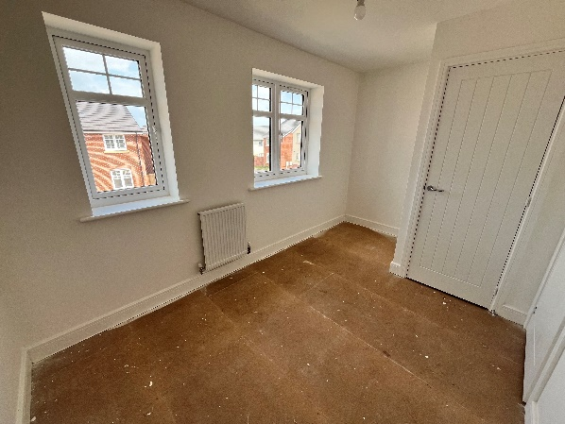

**Available Plots;**

**Plot 275 – 72 Castle Wood Road – 2 bed semi-detached - £178,500 (70%)**

**Plot 279 – 68 Castle Wood Road – 2 bed semi-detached - £178,500 (70%)**

**Plot 178 – 21 Beechwood Road – 2 bed end of terrace - £178,500 (70%)**

**Plot 179 – 22 Beechwood Road – 2 bed mid-terrace - £175,000 (70%)**

**Plot 180 – 23 Beechwood Road – 2 bed end of terrace - £178,500 (70%)**

**Plot 181 – 24 Beechwood Road – 2 bed semi-detached - £178,500 (70%)**

**Plot 182 – 25 Beechwood Road – 2 bed semi-detached - £178,500 (70%)**

**Plot 209 – 37 Beechwood Road – 2 bed end of terrace - £178,500 (70%)**

**Plot 210 – 36 Beechwood Road - 2 bed mid-terrace - £175,000 (70%)**

**Plot 211 – 35 Beechwood Road - 2 bed end of terrace - £178,500 (70%)**

**Plot 214 – 43 Beechwood Road – 2 bed end of terrace - £178,500 (70%)**

**Plot 215 – 42 Beechwood Road – 2 bed mid-terrace - £175,000 (70%)**

**Plot 216 – 41 Beechwood Road – 2 bed end of terrace – £178,500 (70%)**

**Interested?**

To register your interest, or for further information on the scheme, either contact;

Aspire 2 Own (Vale of Glamorgan’s affordable housing)

Telephone: 01446 700111 Email: housingstrategy@valeofglamorgan.gov.uk

Or

Bethan Christofides

Residential Sales Officer at Wales & West Housing

Telephone: 07790396683 Email: [beth.christofides@wwha.co.uk](mailto:beth.christofides@wwha.co.uk)

A close up of a logo

Description generated with high confidence

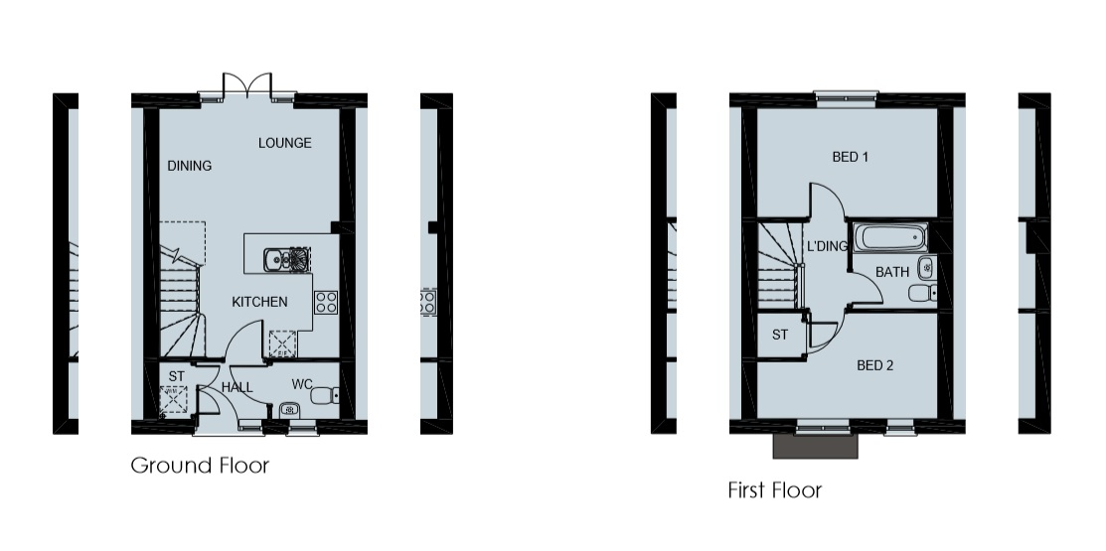

Contact the Aspire 2 Own team to arrange a viewing/ complete an application form.

You will find more information on Low Cost Home Ownership on our website <https://www.wwha.co.uk/en/find-a-home/>