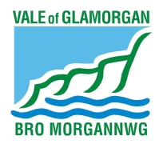
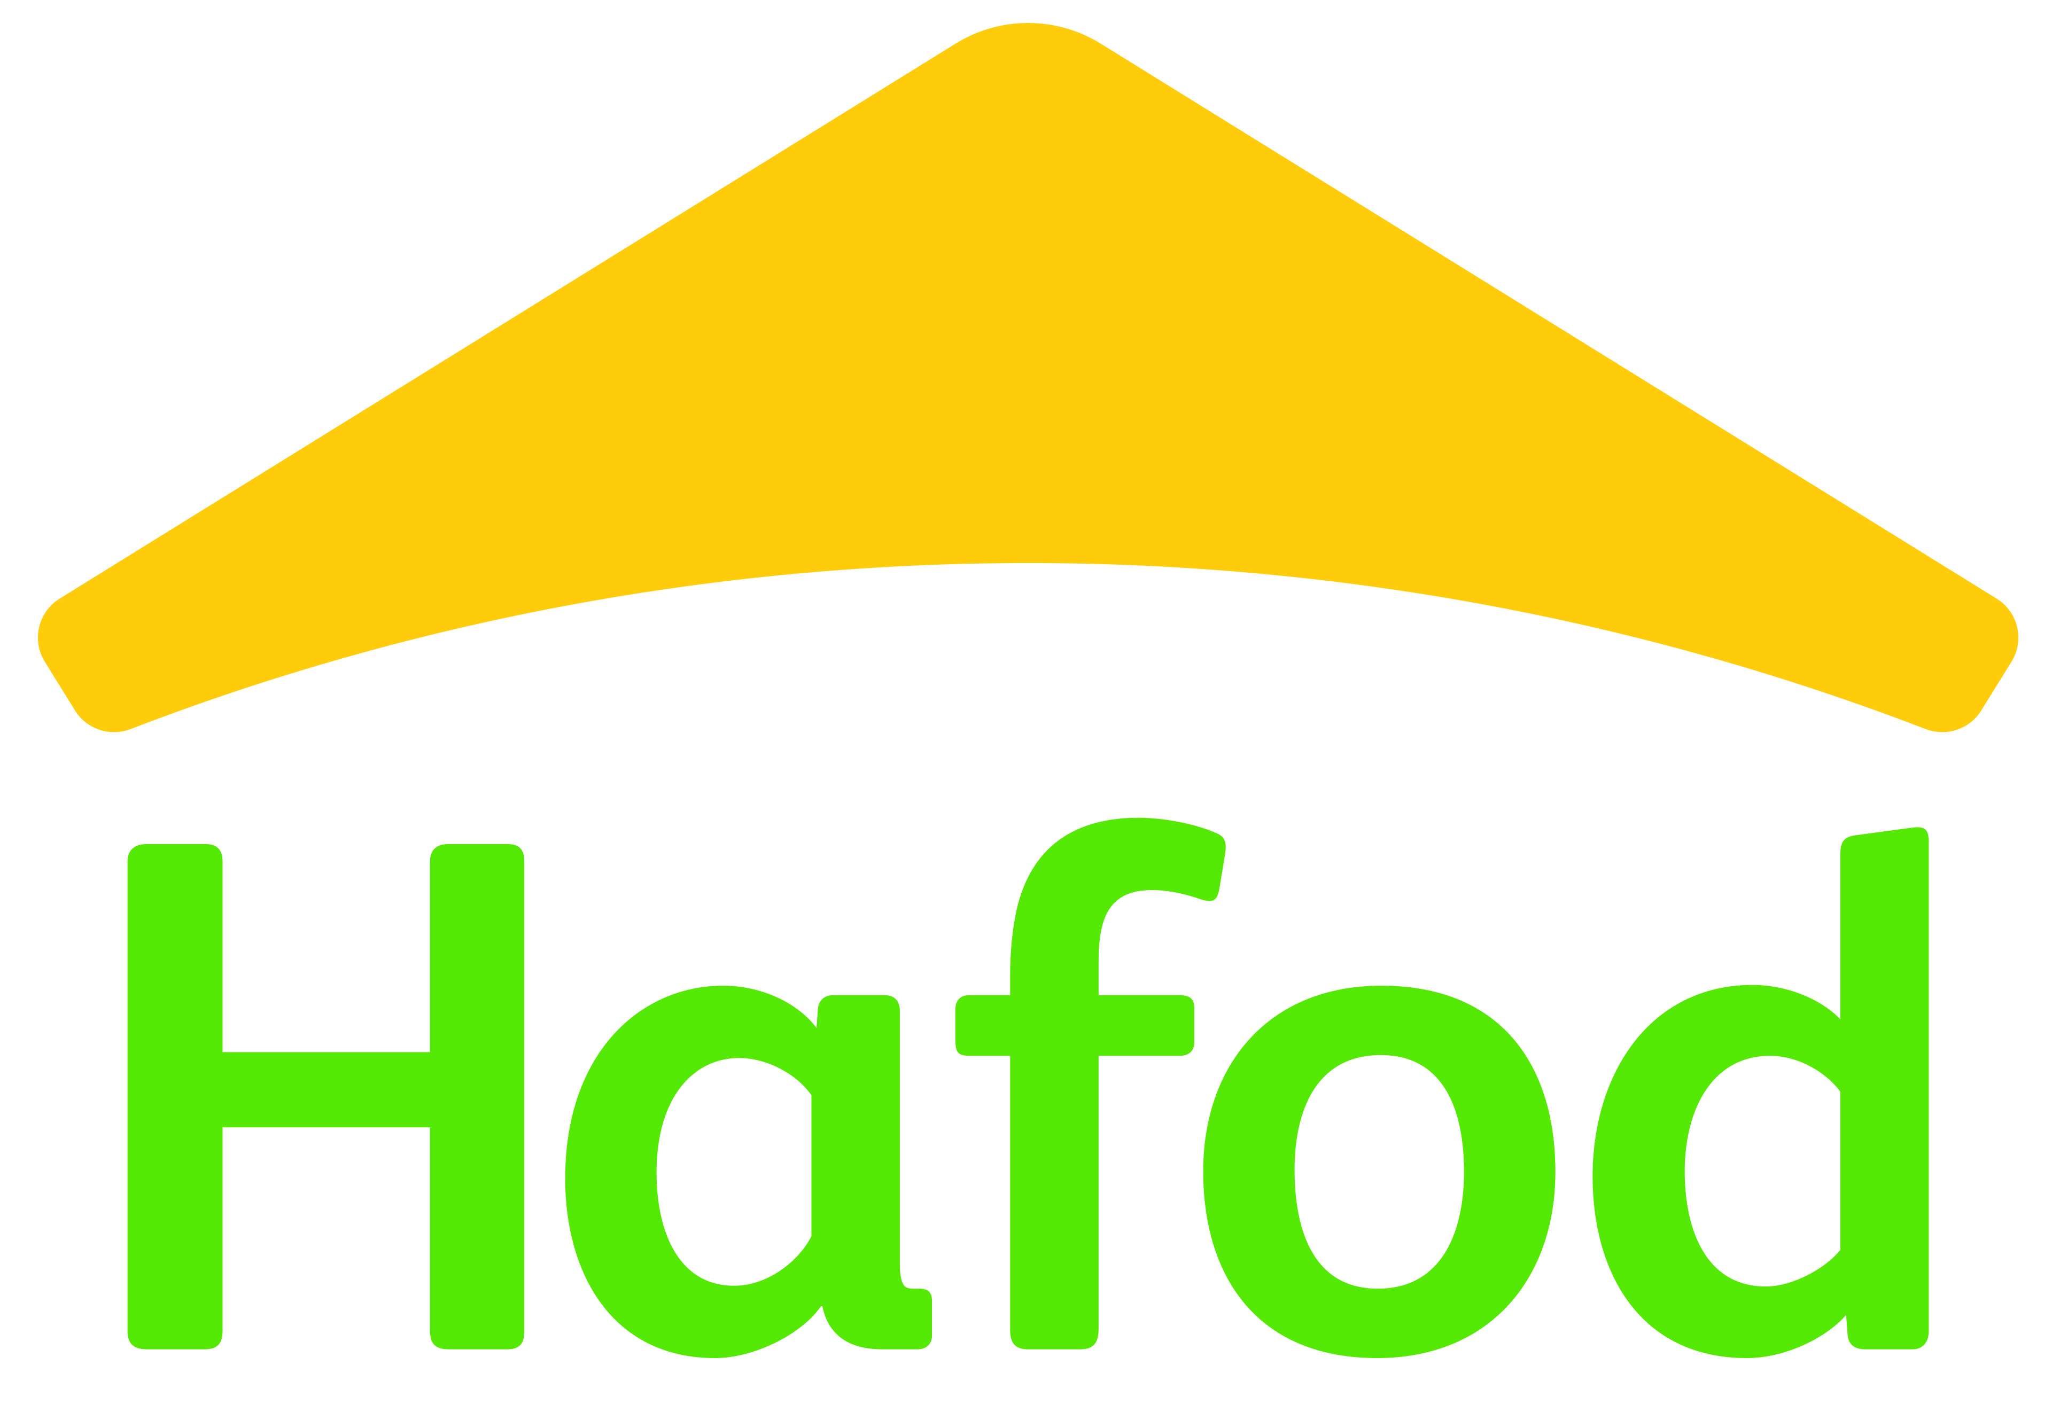

Cwrt Dochdwy, Llandough
Local Lettings & Sales Policy

The aim of the Llandough Local Lettings and Sales policy is to ensure that the new Hafod development at Cwrt Dochdwy, Llandough, is sustainable and will become part of the local community which residents wish to remain in and will show a commitment to the locality in which they will become residents. To achieve this aim, a lettings policy for the scheme has been agreed in partnership with the Llandough Community Council, Hafod Housing Association and the Vale of Glamorgan Council.

The social housing element within the development consists of the following:

Rented:
6 x 1 bedroom flats
12 x 2 bedroom flats

All lettings should satisfy the main principles of the lettings policy for Llandough, which are as follows:

Priority will be given to applicants as follows:

1) Currently living in the Llandough Community Council area and having lived in the Llandough Community Council area for 5 years or more OR having a close family member currently living in the Llandough Community Council area, including and limited to husband/ wife, children, grandchildren, brothers and sisters.

2) Currently living in the Llandough Community Council area and having lived in the Llandough Community Council area for 3 - 5 years.

3) Currently living in the Llandough Community Council area and having lived in the Llandough Community Council area for 12 months – 3 years.

After taking into account the above priorities, properties will then be allocated in line with current HOMES4U policy - by band priority and by the length of time registered with HOMES4U.

4) In the event that not enough applicants matching Priorities 1 to 3 apply then priority will next be given to applicants who have a currently live in the Penarth Town Council area, Dinas Powys Community Council area or Michaelston Community Council area (in no particular order).
Further priority will be given to applicants who satisfy Priority (4) and also have a local connection to the Llandough Community Council area – i.e., wider family connections, community connections etc.

5) If required, lettings can then be finally extended to those applicants residing elsewhere in the Vale of Glamorgan.

When letting properties at Cwrt Dochdwy, Hafod Housing and Homes4U will match the size of the accommodation with the household’s needs, in line with current allocation policies.

Nothing in this policy precludes new membership of Homes4U and Aspire2Own.

To help ensure a sustainable community, Hafod Housing will complete a pre tenancy questionnaire and tenancy check with all prospective tenants, to ensure the suitability of the property and to offer advice and assistance on affordability.

