

VALE HOMES

“Improving the Tenants Voice” - Our Tenant Engagement Strategy

1.0 Introduction

This Strategy sets out our approach to giving tenants a greater say in the services delivered by the Council. This document develops the themes identified in the previous strategy (2012-15) and is designed to promote higher levels of engagement, involving tenants from different demographic groups who may not have taken part previously.

Our vision is to:

“Improve the tenants’ voice by increasing the range of tenant engagement and involving a broad range of tenants from different backgrounds”

It is also vital that tenant engagement leads to changes which improve the quality of the housing and building services provided by the Council, therefore there is also a need to make tenant engagement an integral part of our business, influencing how services are provided, how decisions are made and how money is spent. This document applies to general needs and sheltered housing tenants.

2.0 The strategic context

Back in 2007, the Welsh Government published its first National Tenant Participation Strategy (NTPS). This required all social landlords in Wales to develop their own Local Tenant Participation Strategy in order to maximise tenants’ right to participate and to promote excellence in tenant participation.

The first Vale of Glamorgan Strategy was published in 2008 and was focussed on getting the basics right. Previously, there had been low levels of engagements and few opportunities for residents to get involved and influence the services they received. The next document was completed in 2010 and was a more aspirational document intended to make significant improvements in tenant engagement. It was informed by a comprehensive consultation with tenants and staff and a review of best practise available from other landlords

The current strategy is designed to build on the good work completed to date and expand and develop levels of tenant engagement, enabling more people from a variety of backgrounds to get involved. There is also a need to ensure that the tenants voice is heard and plays an important part in the key decision making process.

3.0 Links with other Strategies- Corporate Plan

The following graphic highlights the links between the key aims in this Strategy and the key objectives in the new Corporate Plan 2016-20. The eight circles depict the objectives in the Corporate Plan and those with the darker shading are the ones which are most closely aligned. It is not to say the Strategy does not link with those lighter shaded objectives.

The biggest contribution is around homes and communities as well as protecting the environment; however the impact in terms of regeneration and alleviating the impacts of poverty cannot be underestimated.
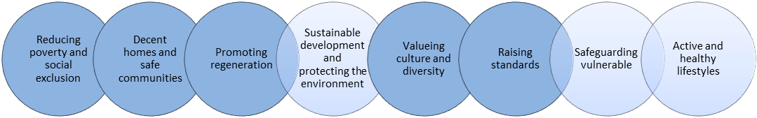
Other strategies and initiatives supporting the Tenant Engagement Strategy are; the Community Investment Strategy, Environment & Neighbourhood Strategy (Housing) the Housing Revenue Account Business Plan and the Departmental Service Plan. Together, these documents will ensure tenant engagement is a cross cutting theme and the best interests of Council tenants are at the heart of what we do.

4.0 Financial support

The Housing Business Plan sets out the Council’s significant commitment to funding tenant engagement.

- Over £36,000 is provided to formalised tenants groups each year in order to support their activities and running costs;

- Revenue commitments have been made to fund two Community Investment and Involvement Officers;

- Participatory budgets of £10,000 per annum for smaller, resident led schemes in each of the 4 neighbourhood management areas (total of £40,000) plus an additional £20,000 allocated to the 2 Senior Neighbourhood Managers to fund additional improvement projects.
It is the intention to continue with this funding for a number of years in order to build the capacity of local communities and increase empowerment to take the lead in their own areas.

5.0 Existing framework for Tenants Engagement

Over the last few years, considerable work has been done to improve the level of influence tenants have over the housing service and the landlord function. The following charts sets out the range of mechanisms currently in place for tenants to engage both formally and informally:

Formal engagement

Group | No of tenants | Purpose
Homes and Safe Communities Scrutiny Committee | X4 tenant representatives | Review performance  Consider new proposals/ ideas
Quality Design Forum | 6 tenants | Oversee WHQS programme
Tenant Working Group | In region of 15 tenants | Umbrella group of tenants from different resident boards who meet and consider strategic issues affecting the housing service e.g. new policies, performance, new services etc.
Sheltered Housing Group | In region of 20 tenants | Umbrella group representing tenants at all five sheltered housing complexes.
Local Residents Boards (x9) | Attendance at groups varies, typically between 8 and 25 tenants go to each meeting | Discuss local issues on estates including estate conditions, anti-social behaviour, facilities, parking, traffic etc.

Informal engagement

Representative on Newsletter Advisory Panel | The Panel agrees content for the bi annual tenant newsletter, including the range of articles, design
Estate Walkabouts | Estate walkabouts give an opportunity for tenants to work with their Neighbourhood Manager and partners from other agencies in order to make estates better places to live
Survey/ Focus Groups | Groups are convened for specific purposes including coordination of the large scale tenants survey, the management of the Community Garden at Treharne etc.
Training opportunities | A wide range of training sessions are offered to tenants to help them improve their knowledge and skills. Examples of sessions include: health and safety for construction sites, digital inclusion, cooking on a budget etc.
Community Events/ Activities | Held regularly and provide information about the housing service promoting tenant involvement and increasing social interaction. Examples include the annual Festivale event attended by over 500 tenants, the Community Helping Hand roadshows which have been run on a number of estates across the Vale, ’Kicks’ the initiative to get young people playing football
Individual consultation | Individuals provide valuable feedback by filling in satisfaction surveys, participating in telephone surveys, providing comments/ complaints etc.

 | 

6.0 Resident views and priorities

A number of consultations have been carried out with tenants and have provided valuable insight on what is important to them. These include, feedback from meetings with various Residents Boards, discussions with the Tenants Working Group, consultations at popular events, including Festivale and various estate roadshows. In addition, the large scale tenants’ survey, (also referred to as the STAR survey) provided views from over 1,300 tenants.

The following graphs and charts provide a summary of the key feedback received. Firstly, the STAR results:

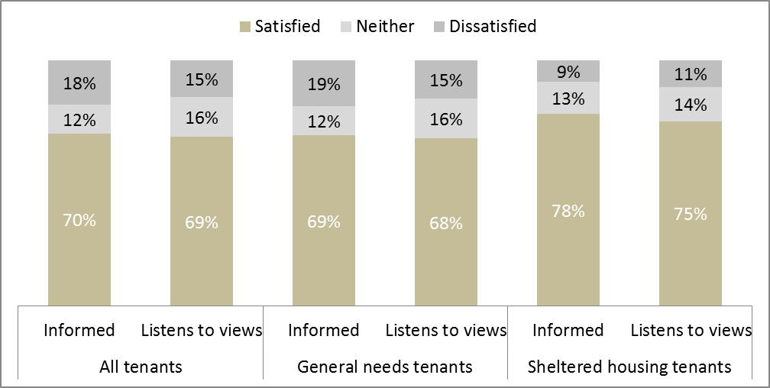

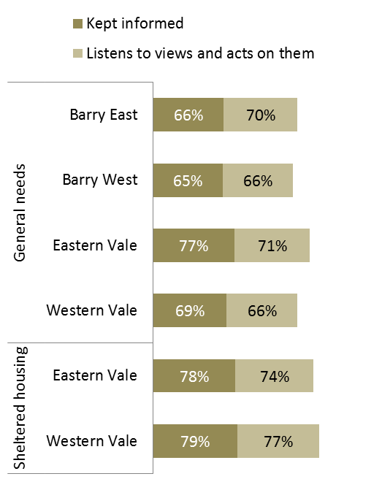
Forty eight survey forms were completed by tenants, at the 2017 Festivale event, specifically about tenant engagement and the results are shown below:

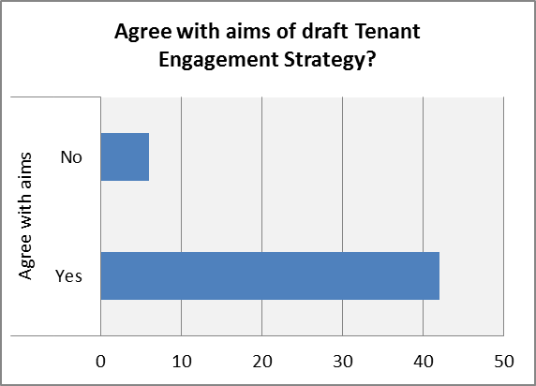 | 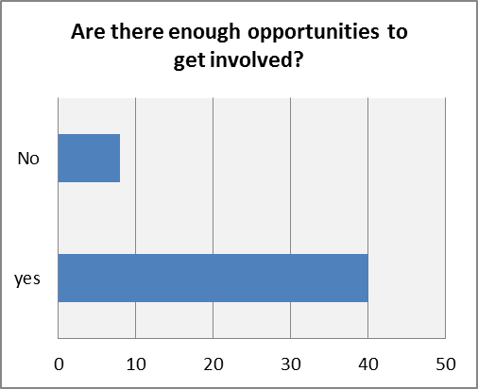

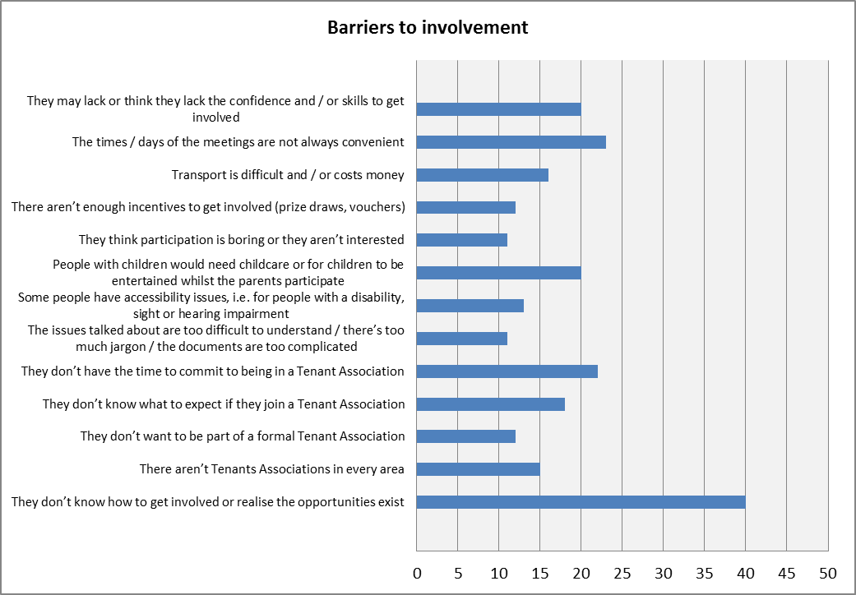
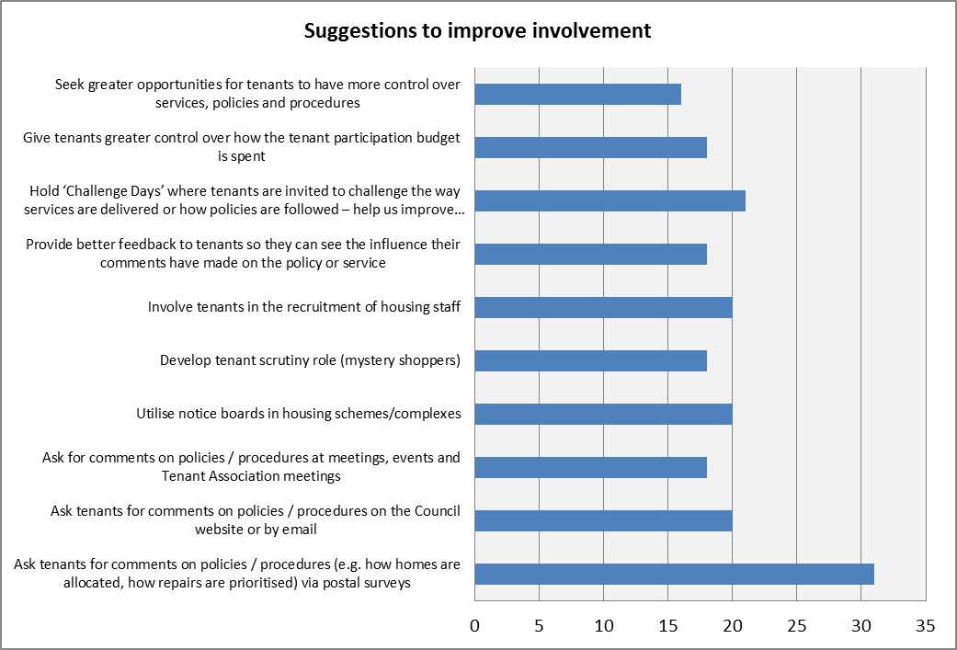

Some recurring themes stand out and include:

- Communication/Keeping People informed: the results from the STAR survey showed that only 70% of tenants felt the Council is good at keeping them informed. General needs tenants were less impressed (69%) compared to tenants in sheltered accommodation (78%);

- Listening to views and acting on them: 69% of tenants agreed that the Council took views of tenants on board and acts on them, this is just below the median point for social landlords (70%) and gives scope for improvement. A significant number of tenants were indifferent to this question (16%);

- Creating opportunities for more tenants to get involved: membership of the existing tenants groups can include a significant proportion of older people; in addition, the groups tend to be established groups located on some of the larger estates. This highlights the potential for involving tenants from different demographic groups and for new groups in areas where there may currently be less representation;

- There is interest from tenants to contribute in a number of ways, including reviewing policies and procedures, mystery shopping, sounding boards/ consultation panels, decisions about budgets etc.

- Tenants being unaware of opportunities for them to participate with suggestions including expanding use of social media and community notice boards being seen as positive ways to share information;

- Some tenants may lack the confidence or perceive they have lack of skills to take part.

6.0 SWOT analysis

A SWOT analysis has been carried out on the current arrangements for tenant engagement as a means for identifying future priorities:

Strengths | Weaknesses
High number of existing Residents Boards covering different areas across the Vale  Reliable pool of active tenants  Tenants take active role in Homes and Safe Communities Scrutiny Committee | Active tenants not representative of broader tenant population (tend to be older tenants living in sheltered accommodation)  Tenants do not take an active role in reviewing performance or testing services  Opportunities for tenants to get involved are fairly limited and tend to be formal (rather than informal)
Opportunities | Threats
Scope for tenants to have a larger influence on the decision making process (governance structure)  Empower local groups to become more active in their communities  Attract new tenants to take part in creative ways  More flexible menu of tenant involvement  Promote tenant engagement and opportunities for tenants to take part | Apathy- tenants have busy lives and taking part in broader community projects may not be a priority for some  Current tenant involvement methods used are ineffective at attracting ‘active’ tenants  Tenant voice is not heard i.e. does not feed into Council’s decision making process (or is not given appropriate weight

7.0 What are the objectives?
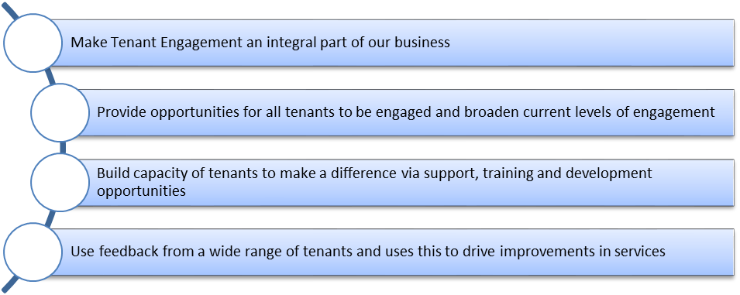

8.0 Tenant Engagement Objectives and Outcomes

Objective 1: INTEGRATE- make tenant engagement an integral part of our business, influencing how services are provided, how decisions are made and how money is spent.

Outcomes
1.1 Tenants and tenants groups take a meaningful part in the Department’s decision making process
1.2 Front line staff are bought into the principles of Tenant Engagement

What we will target |  | Case study
Chief Officer (Head of Service) to act as a champion for tenant engagement and take overall responsibility for implementation of the Strategy |  | There are four places reserved for tenants on the Homes and Safe Communities Scrutiny Committee. This means that tenants are at the centre of all key discussions and strategic decision making regarding the service as well as approving the budget process.  Two tenant groups form an important part of the governance structure, namely the tenant working group and the quality design forum. Both groups meet regularly and review strategic decisions, approve policies, review performance and satisfaction levels, often acting as the sounding board prior to reports being submitted to Cabinet or Scrutiny. This ensures that all areas of work are considered from a tenants perspective.
Work closely with the tenant working group and the Quality Design Forum to increase membership and develop capacity. Also, ensure both groups are routinely consulted on services and have meaningful input to key strategies and policies which effect tenants
Housing staff are bought in to the principles of tenant engagement and are able to demonstrate a positive contribution through their own work
Establish tenant scrutiny team and provide training to enable them to carry out quality checks and service reviews

Objective 2: INCLUSIVE- ensure that opportunities are provided for all tenants to get involved and broaden the current levels of engagement

Outcomes
2.1 Tenants feel empowered
2.2 Tenant engagement is representative of the broader tenant population

What we will target |  | Case study
Developing a flexible menu of tenant involvement which enables a broader cross section of tenants to take part |  | There are a broad range of Residents Boards operating across the Vale; many of these are long established groups who meet regularly to discuss issues relevant in their areas. As well as the formal groups, many informal opportunities to take part exist, including taking part in estate walkabouts, filling in surveys or attending community roadshows and fun days.
Promotion of tenant involvement opportunities to engage more tenants in creative ways
Target groups who are currently under represented e.g. young people, single mums, BME etc. and put in place different means of getting them involved
Support existing tenants groups to have a meaningful impact
Engage local people in development of local actions e.g. local action plans, estate walkabouts, spending estate budgets

Objective 3: BUILD CAPACITY- provide support, training and development opportunities to enable tenants to make a difference

Outcomes
3.1 Tenants possess the skills and confidence to take part
3.2 Tenants and Tenant groups have access to practical support and advice they need

What we will target |  | Case study
Undertake skills/ knowledge audits of existing tenants groups to identify gaps and opportunities for further training |  | The Community Investment and Involvement team have set up a range of ‘employability initiatives’ designed to help tenants pack in to work. Training sessions run have included health and safety, driving theory test and site construction and safety (which enable card holders to get employment on building sites. The sessions have been well attended and a number of individuals who have previously been out of work for some time to get jobs with local contractors.  Another example has been the establishment of a group to run the Community Garden at Treharne. The Council recently took over the responsibility for the management of the garden and worked with a new group of volunteers. The group were supported by Council staff and training arranged with the GVS, the Vale Volunteer Bureau in order to get the group formally constituted and taken over all aspects of day to day management of the community garden.
Develop bespoke Training/ development plans for different tenant groups
Promote training opportunities for tenants to improve quality of life i.e. employability, healthy lifestyles, financial inclusion etc.
Develop the range employability initiatives
Produce information toolkit for new groups to start up
Work with TPAS to provide training or provide guidance

Objective 4: LISTENS AND LEARNS- feedback is sought from a wide range of tenants and this drives improvements in the services provided

Outcomes
4.1 A comprehensive range of feedback is received from tenants
4.2 Feedback from tenants is used to inform service delivery

What we will target |  | Case study
Run large scale tenant satisfaction survey biannually in order to provide feedback on services |  | A large scale tenants’ survey was completed last summer which gave all council tenants the opportunity to provide feedback on the full range of services provided by the Housing and Building Services Team. There was a great response and over 25% of tenants filled in and returned the questionnaire. This enabled us to compare how we are doing against a range of other social landlords and identify areas for improvement.  A working group was established to analyse the results in detail and put together an action plan to target the main concerns. This group includes staff from different teams and meets regularly to monitor progress and ensure the tenant feedback leads to improved services.
Monthly surveys on specific issues e.g. Anti-Social Behaviour (ASB), new lettings
Establish tenants consultation panel to provide feedback on chosen issues
Put in place action plan to address issues identified in tenants survey
Publish results of tenants survey in newsletter

Operational Delivery Plan

Objective 1: INTEGRATE- make tenant engagement an integral part of our business, influencing how services are provided, how decisions are made and how money is spent.

Intended outcome | Success criteria (Measure) | Action | Start date | Finish date
1.1 Tenants and tenants groups take a meaningful part in the Department’s decision making process | Number of tenants groups  Number of active tenants | Chief Officer (Head of Service) appointed to act as a champion for tenant engagement and take overall responsibility for implementation of the Tenant Engagement Strategy | March 18 | On-going
 | Number of tenants groups  Number of active tenants | Work closely with the tenant working group and the Quality Design Forum (QDF) to increase membership and develop capacity | March 18 | June 18
 |  | Tenant Working Group to be routinely consulted on services and have meaningful input to key strategies and policies which effect tenants. Evidence of tenant consultation to form part of reports to Scrutiny Committee | March 18 | On-going
 |  | Establish tenant scrutiny team who are able to undertake quality checking and service reviews | June 18 | June 19
1.2 Front line staff are bought into the principles of Tenant Engagement |  | Tenant Engagement to become a fixed agenda item at team meetings and for monthly staff 1-1 sessions | March 18 | On-going

Objective 2: INCLUSIVE- ensure that opportunities are provided for all tenants to get involved and broaden the current levels of engagement

Intended outcome | Success criteria (Measure) | Action | Start date | Finish date
2.1 Tenants feel empowered and are satisfied with opportunities to get involved | % tenants satisfied with opportunities to get involved | Develop a flexible menu of tenant involvement which enables a broader cross section of tenants to take part | April 18 | Dec 18
 | % tenants satisfied with opportunities to get involved | Promotion of tenant involvement opportunities via tenant newsletter, web site, social media, leaflets etc. | Jan 18 | On-going
 | % tenants satisfied with opportunities to get involved | Target groups who are currently under represented e.g. young people, single mums, BME backgrounds etc. and put in place different means of getting them involved | April 18 | Dec 18
 | % tenants satisfied with opportunities to get involved | Meet with existing Tenants and Residents Associations and explore opportunities for further involvement, additional projects etc. | June 18 | Dec 18
 | % tenants satisfied with opportunities to get involved | Engage local people in development of local actions e.g. local action plans, estate walkabouts, spending estate budgets | March 18 | March 19
2.2 Tenant engagement is representative of the broader tenant population |  | Establish tenant consultation panel/ sounding board which can be used to provide feedback on specific themes | Dec 18 | April 19
 |  | Review current membership of Working Group and Quality Design Forum and undertake a campaign to recruit more members | June 18 | Sept 18

Objective 3: BUILD CAPACITY- provide support, training and development opportunities to enable tenants to make a difference

Intended outcome | Success criteria (Measure) | Action | Start date | Finish date
3.1 Tenants possess the skills and confidence to take part | Number of active tenants | Carry out skills audits of existing tenants groups to identify gaps and opportunities for further development | June 18 | Oct 18
3.1 Tenants possess the skills and confidence to take part | Number of active tenants | Develop training/ development plans for existing tenants groups | June 18 | Nov 18
3.1 Tenants possess the skills and confidence to take part | Number of active tenants | Promote training opportunities for individual tenants to improve employability | March 18 | On-going
3.1 Tenants possess the skills and confidence to take part | Number of active tenants | Identify tenants who are interested in joining a scrutiny group and provide training and support | June 18 | June 19
3.2 Tenants and Tenant groups have access to practical support and advice they need |  | Produce toolkit for new tenants groups to start up | April 18 | Sept 18
 |  | Work with Tenant Participation Advisory Service (TPAS) and/or Welsh Tenants Federation (WTF) to provide training and/or support to existing tenants groups | Sept 18 | March 19

Objective 4: LISTENS AND LEARNS- feedback is sought from a wide range of tenants and this drives improvements in the services provided

Intended outcome | Success criteria (Measure) | Action | Start date | Finish date
4.1 A comprehensive range of feedback is received from tenants | % satisfaction that views are taken into account and acted on  Number of service changes arising from tenant input | Run large scale tenant satisfaction survey every two years in order to drive improvements in standards | Sept 18 | Jan 19
 |  | Undertake monthly tenant surveys on specific issues e.g. ASB, new lettings etc. | March 18 | On-going
 |  | Establish tenants consultation panel to provide feedback on chosen issues | Dec 18 | April 19
4.2 Feedback from tenants is used to inform service delivery |  | Put in place action plan to address issues identified in tenants survey | March 18 | June 18
4.2 Feedback from tenants is used to inform service delivery |  | Performance information to be made available to tenants via the tenants newsletter, including comparative information showing how the Vale performs relative to other social landlords | May 18 | Oct 18
4.2 Feedback from tenants is used to inform service delivery |  | Publish a ‘you said, we did’ section within the tenants newsletter, highlighting examples of how tenant feedback has led to positive change | May 18 | Oct 18

