

Genesis 2
Cymru  Wales
Referral Form
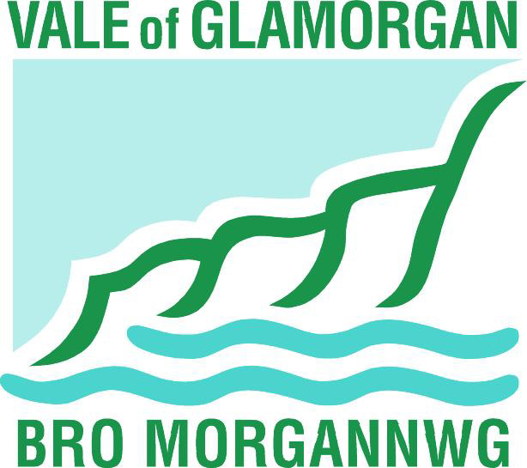

The project aims to support individuals in our communities who are furthest away from the labour market and provides support in order for them to take the first steps towards training and ultimately employment.

In order to be eligible to become a Genesis 2 Cymru Wales participant, an individual must, either be Economically Inactive or Unemployed and priority will be given to individuals who fall into at least one of the categories below:

- Lone parents
- NEETs
- Individuals with work limiting health condition or disability
- BME
- Older participants

Participant Information:

Title | Surname | First name(s)
Mr,Mrs,Miss,Ms,Dr

Address 1
Address 2
Address 3
Local Authority
Postcode
Contact no (incl area code) |  |  |  | h | o | m | e |  | n | u | m | b | e | r
Alt. contact no (eg mobile) |  |  |  | e | m | e | r | g | e | n | c | y
National Insurance No
Date of Birth: |  |  |  | d | d | m | m | y | y | y | y

Family Circumstances: No and age of children
Children’s Name(s) | Date of Birth | Age

Referring Agency Information
Name of Referrer
Referral Agency
Address
Telephone Number
Signature (referrer)
Date
Reason for referral and support required:

Risk Assessment:
Please advise if there are any known risks to a Genesis Advisor if a home visit was to be carried out.

Other agencies involved: | Contact Name: | Tel no:

Eligibility Criteria

Category | Definition | Please tick
Economically Inactive | Not in education, training or employment and not actively seeking employment AND not in receipt of Job Seekers Allowance
Unemployed | Actively seeking employment and in receipt of Job Seekers Allowance
Lone Parent | Sole caring responsibility for a child or children
Work limiting health condition or disability | Any health condition which has an impact on an individual’s ability to work or remain in work
Older participant | Over 50 years old
BME
NEET | Aged 16 – 18, Not in Education, Employment or Training

For completion by Genesis 2 Cymru Wales staff

Eligible for support: | Yes / No
Staff signature
Date

 | Day | Month | Year | Soft Outcomes | Action Plan
Date 1st visit
Date 3 month review
Date 6 month review

Please Return forms to:

Genesis 2
Vale of Glamorgan Council
Town Hall
Kings Square
Holton Road
Barry
CF63 4RW

