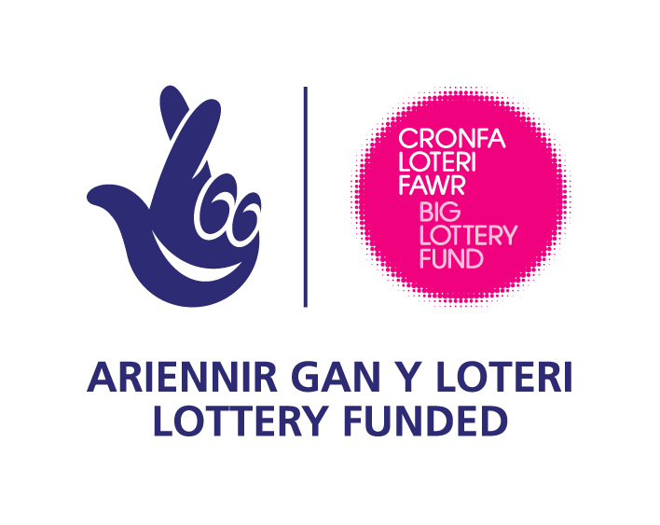
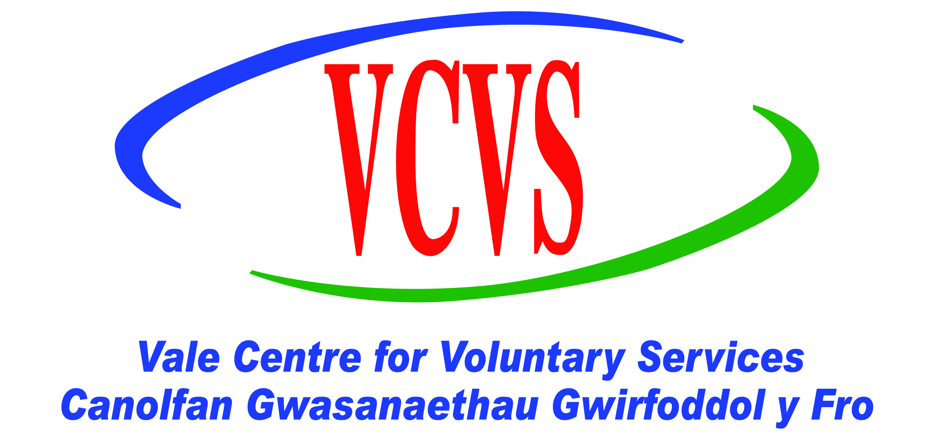

Hi

I’m Sandra Roberts Project Manager for the “Friendly AdvantAGE” Project. This exciting new project, will offer a range of befriending services to reduce loneliness and isolation and improve the wellbeing of people aged 50+ in Cardiff and the Vale of Glamorgan. The project funded by the Big Lottery aiming to reach 900 beneficiaries will be delivered over a four year period through a consortium of service providers experienced in supporting older people.
The project aims to address gaps in current service delivery via five models of befriending for specific target groups as follows:

- ‘Let’s Get Out’ will work with people aged 50+ including those who are carers/ex carers who would benefit from short term support to develop their confidence to increase their social networks and their participation in activities. Age Concern Cardiff & the Vale of Glamorgan are managing this model in Cardiff and the Vale of Glamorgan.

- ‘Rural Connections’ will work with individuals and communities to identify ways of overcoming rural isolation and connecting individuals and groups together. Age Concern Cardiff & the Vale of Glamorgan will manage this model in the Rural Vale.

- The Getting on with IT Model will work with residents in care homes to help them gain computer skills, build confidence levels, increase social interaction and reduce loneliness. VCVS will manage this model in Cardiff & the Vale of Glamorgan

- The Long Term Befriending Model will work with people aged 50+ who are housebound and males aged 50 + who have recently been bereaved living in the Dinas Powys area. Dinas Powys Voluntary Concern will manage this model in Dinas Powys in the Vale of Glamorgan.

- The Disability Inclusion Model will enable people of all ages to be recruited, trained and supported to become volunteer befrienders for older disabled people (aged 50+) who live in Cardiff and the Vale of Glamorgan. Scope Cymru will manage this model in Cardiff and the Vale of Glamorgan.

VCVS is the lead partner and provides the base for the Project Manager and Project Assistant. Project Co-ordinators have been employed for each befriending model and they will be jointly managed by the named lead in each project delivery partner and the Project Manager.

“Friendly AdvantAGE” will use volunteers extensively, especially in its aim to become self-sustainable. Each befriending model will recruit volunteers to work on the implementation of the model. We aim for 50% of our volunteers to be aged fifty plus. Volunteers will be managed by the Project Co-ordinators.

To make a referral, enquire about volunteering or if you’d like further information about our project please contact Sandra Roberts Friendly AdvantAGE Project Manager or Cath Haines Project Assistant at Vale Centre for Voluntary Services on 01446 741706 or email Sandra@valecvs.org.uk or cath@valecvs.org.uk.

