**The Vale of Glamorgan**

**Local Housing**

**Market Assessment 2021**

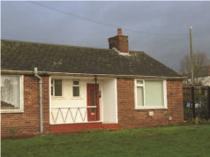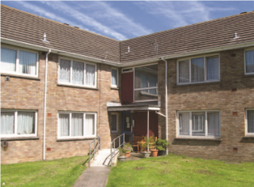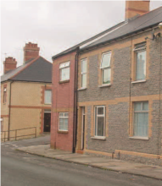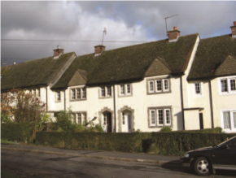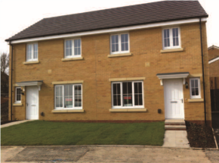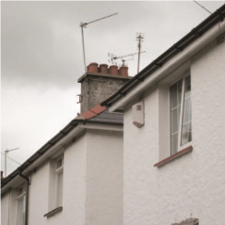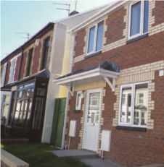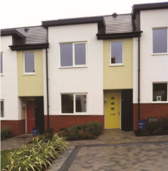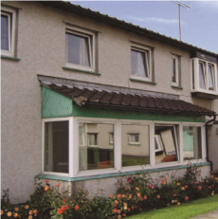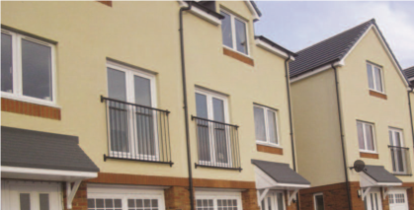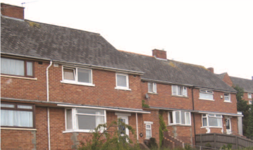

# Executive Summary

This Local Housing Market Assessment (LHMA) uses the Welsh Government’s approved methodology to conduct a periodic review and assessment of the housing market within the Vale of Glamorgan, fulfilling the Council’s statutory duties, as set out under Section 8 of the Housing Act 1985.

This LHMA assesses the housing market in the Vale of Glamorgan, considering all geographical areas, at ward level and/or by major settlements. A range of information sources are used to feed into the assessment, including household projections, homelessness data, house prices, rental prices, household incomes, the Homes4U social housing register, Aspire2Own low cost home ownership database, social housing stock turnover and projected housing supply data.

In assessing the housing market, the LHMA calculates the net need for affordable housing, including social rented housing, intermediate rented housing and low-cost home ownership housing products, over the coming five years.

The headline annual need for affordable housing in the Vale of Glamorgan from 2021 to 2026 is: **1205 units per annum,** comprising:

* 915 units of social rented accommodation
* 211 units of intermediate rented housing
* 79 units of low-cost home ownership

It should be noted at this point that an LHMA does not provide a definitive target figure for affordable housing. The assessment should be considered an art and not a science, as the data is only correct at the time the calculation is conducted and should only be used as a periodic review of the housing market.

In addition, whilst it is necessary to provide a net affordable housing figure across all property types, affordable tenures and areas, this figure in itself is highly misleading as it distorts differences in submarket areas, tenures and property types required. In particular, the need for social rented accommodation is masked by accommodation which is either considered to be surplus or has a relatively high turnover rate, due to the nature of the LHMA calculation. Consequently, even if the headline gross social housing need of 1205 was delivered every year in the Vale of Glamorgan, this would by no means meet the actual need present in many of the housing market areas. Hence, more consideration should be given to the specific need identified by property type and size within each housing market area as summarised within the assessment.

The LHMA informs the Local Development Plan and provides evidence for the need for affordable housing in the Vale of Glamorgan. Operationally, it also provides a tool to negotiate affordable housing provision on planning applications, allocate Social Housing Grant and inform strategic housing priorities at the local level.

TABLE OF CONTENTS

Contents

Executive Summary 1

FIGURES 5

1 Introduction 7

1.1 LHMA 2015 - 2019 7

Previous Local Housing Market Assessment 7

1.2 Assessment and Methodology 8

Overview of Assessment and Methodology 8

2 Household Projections and changes from 2017 11

2.1 Projected growth at ward level 11

New households 11

2.2 Newly Arising Need from New households 15

Newly forming households in need of Social Rented Housing 15

Newly forming households in need of Low-Cost Home Ownership 17

Newly forming households in need of Intermediate Rent 18

Total Annual Newly Arising Need by Tenure 19

2.3 Newly Arising Need from Existing Households 20

Homelessness presentations 20

2.4 Backlog of need for affordable Housing 23

3.3.1 Backlog of need for Social Rented Housing 23

3.3.3 Backlog of need for Intermediate Rent 33

3 Affordable Housing Supply 36

3.1 Projected Social Rented Lets 36

3.2 Committed supply of New Affordable Housing 37

3.3 total units of affordable housing for social rent 38

3.4 units of affordable housing for low cost homeownership 39

3.5 total units of affordable housing for intermediate rent 40

4 Net Need for Affordable Housing 41

4.1 Bath Tub analogy 43

5 Conclusion 46

5.1 headline housing need 46

5.2 general needs social rent 46

5.3 intermediate rent and low cost home ownership 47

5.4 purpose built adapted social rent 47

5.5 key policy consideration and areas for development 48

5.5.1 Affordable Housing Products 48

5.5.2 Need for Smaller Units 48

5.5.3 Older Persons Accommodation 49

5.5.4 Private Rented Sector 50

5.5.5 Help to Buy Wales 51

# FIGURES

|  |  |  |
| --- | --- | --- |
| NUMBER |  | PAGE |
| 1 | Map of Vale | 7 |
| 2 | Bathtub | 9 |
| 3 | Market Areas by Ward | 10 |
| 4 | Welsh Government Population Projection Figures | 11 |
| 5 | Annual Growth by Census Proportions | 12 |
| 6 | Affordable Housing Defined | 13 |
| 7 | Homes4U Allocations Policy | 16 |
| 8 | Entry Level House Prices by Ward245 | 17 |
| 9 | Annual Arising Need by Tenure | 19 |
| 10 | Repossession Caseload Data for Vale of Glamorgan | 21 |
| 11 | Homelessness Presentations | 22 |
| 12 | Homelessness Applications Accepted as Unintentional | 23 |
| 13 | Accepted Homelessness Cases by Ward and Household Type | 24 |
| 14 | Allocation Banding Priorities | 28 |
| 15 | Backlog of Need for Social Rent from Homes4U Waiting List | 29 |
| 16 | Applicants by Household Type based on annual number | 29 |
| 17 | Figure 17 Applicants on Homes4U and Housing Benefit | 31 |
| 18 | Applicants in each band | 31 |
| 19 | Applicants by Bedroom Size and Type of Housing | 33 |
| 20 | Income needed to enter housing market by Ward | 34 |
| 21 | LCHO Areas of Choice | 35 |
| 22 | Entry level Intermediate Rent by Ward | 36 |
| 23 | Areas of Choice Intermediate Rent | 36 |
| 24 | Bath Plug | 38 |
| 25 | Annual Re-lets of Social Rented Properties by size, type and ward | 39 |
| 26 | Annual Committed Supply of New Build properties for Social Rent | 40 |
| 27 | Combined New Build and Re-lets for Social Rented Properties | 41 |
| 28 | Committed Supply of Low-Cost Home Ownership New Build Properties | 41 |
| 29 | Average Annual Turnover of Social Rented Properties by Number  of Bedrooms and Property Type | 43 |
| 30 | Average Annual Turnover of General Needs Rented Properties by Area | 43 |
| 31 | Headline Need for Affordable Housing | 44 |
| 32 | Headline annual need for affordable housing by tenure | 44 |
| 33 | Previous Annual Need for Affordable Housing | 45 |
| 34 | Summary of Need | 45 |

# Introduction

## LHMA 2015 - 2019

### Previous Local Housing Market Assessment

The Local Housing Market Assessment (LHMA) 2019 provided an up to date picture of the housing market information in the Vale of Glamorgan, this has now been reviewed to give an updated view as of 2021. The methodology for the LHMA is discussed in the next section, but it should be noted at this point that an LHMA does not provide a definitive target figure for affordable housing. The assessment should be considered an art and not a science, as the data is only correct at the time the calculation is conducted and should only be used as a periodic review of the housing market.

Figure 1 Map of Vale

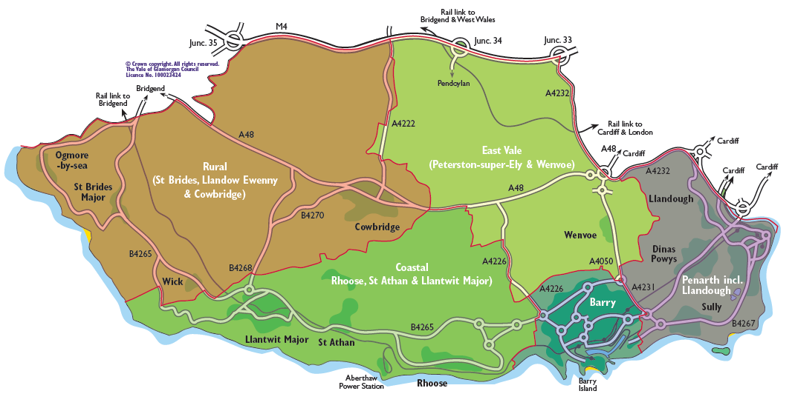

## Assessment and Methodology

### Overview of Assessment and Methodology

The updated LHMA 2021 in common with previous LHMAs assesses the housing market in the Vale of Glamorgan, considering all geographical areas, at ward level, an overview of population statistics, and a quantitative assessment of housing need.

The housing market includes a range of tenures which vary in cost, both between the tenure types and from area to area. The tenures range from home ownership, private rented and intermediate housing to social rented accommodation.

Historically, only households in need of social rented accommodation have been considered to be in housing need. However, the on-going economic climate with increasing housing costs putting pressure on household incomes has resulted in many households being unable to afford their housing and living costs, leading to households being squeezed out of the home ownership and private rented sectors and being left in need of alternative forms of affordable housing. These alternative forms of affordable accommodation include properties available for intermediate rent and low-cost home ownership.

For the purposes of the LHMA, affordable housing is defined as: ‘housing provided to those whose needs are not being met by the market’ and should: -

* Meet the needs of eligible households, including availability at a low enough cost for them to afford, determined regarding local incomes and local house prices.
* Include provision for the home to remain affordable for future eligible households (affordable in perpetuity), or if a home ceases to be affordable or stair-casing to full ownership takes place, any subsidy should generally be recycled to provide replacement affordable housing.
* Include social rented housing, intermediate rented housing and low-cost home ownership opportunities.

Social rented housing is that provided by local authorities and registered social landlords. Intermediate housing is that where prices or rents are above those of social rent but below market housing prices or rents. Affordable housing differs to market housing, which is classed as private housing for sale or rent where the price is set in the open market and their occupation is not subject to control by the Local Planning Authority.

In assessing the housing market, the LHMA specifically estimates the need for affordable housing, including social rented housing, intermediate rented housing and low-cost home ownership products, over the coming years. This process can be explained using the bathtub analogy, which was originally conceptualised by Bramley et al as illustrated in figure 2.

**Figure 2 Bathtub**

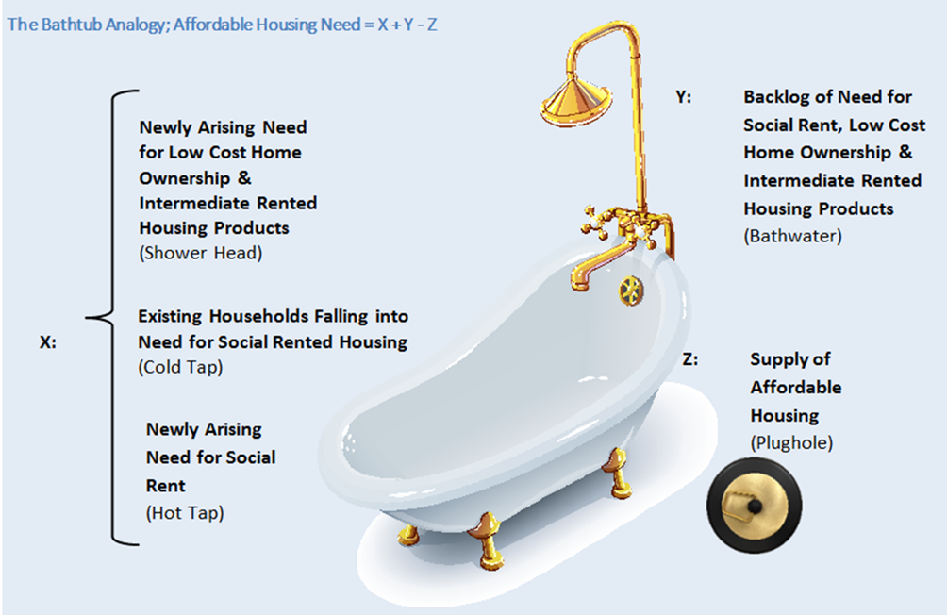

In common with the previous LHMA, this update considers housing data and need across 12 housing market areas in the Vale of Glamorgan; outside of Barry and Penarth and Llandough these areas are coterminous with the ward boundaries. Primarily Barry, and Penarth and Llandough combined are considered standalone areas which are made up of eight and five separate wards respectively as in figure 3.

Figure 3 Market Areas by Ward

|  |  |  |
| --- | --- | --- |
| **LHMA Housing Market Areas** | | |
| Barry | Llantwit Major | St Athan |
| Cowbridge | Penarth and Llandough | St Brides Major |
| Dinas Powys | Peterston-Super-Ely | Sully |
| Llandow/Ewenny | Rhoose | Wenvoe |

# Household Projections and changes from 2019

## Projected growth at ward level

### New households

The LHMA in 2019 used the 2011 Census data and the local authority household projections as published by Welsh Government (WG) in 2016 which related to the 2014-based projections. Whilst a new Census has since taken place in 2021, the outcome remains unknown. WG issued an update to their projections in 2020 which were for the 2018-based projections. Based on these it is estimated that the number of households in the Vale of Glamorgan will increase to 61,316 by 2026, see figure 4.

Figure 4 Welsh Government Household Projection Figures

|  |  |  |  |  |  |  |  |  |  |
| --- | --- | --- | --- | --- | --- | --- | --- | --- | --- |
|  | **2018** | **2019** | **2020** | **2021** | **2022** | **2023** | **2024** | **2025** | **2026** |
| **2018-based** | 57,230 | 57,762 | 58,297 | 58,816 | 59,358 | 59,885 | 60,383 | 60,863 | 61,316 |
|  |  |  |  |  |  |  |  |  |  |
| **2014-based** | 55,722 | 55,989 | 56,251 | 56,494 | 56,757 | 57,009 | 57,240 | 57,455 | 57,649 |
|  |  |  |  |  |  |  |  |  |  |
| **Difference** | 1,508 | 1,773 | 2,046 | 2,322 | 2,601 | 2,876 | 3,143 | 3,408 | 3,667 |

Translated into households by type gives rise to the detail below

|  |  |  |  |  |  |  |  |
| --- | --- | --- | --- | --- | --- | --- | --- |
| **Overall Change** | **2021** | **2022** | **2023** | **2024** | **2025** | **2026** | **Change** |
| 1 person | 18,977 | 19,318 | 19,655 | 19,967 | 20,256 | 20,533 | **1,555** |
| 2 person (no children) | 18,290 | 18,390 | 18,483 | 18,580 | 18,683 | 18,779 | **489** |
| 2 person (1 adult, 1 child) | 2,202 | 2,234 | 2,268 | 2,299 | 2,329 | 2,355 | **153** |
| 3 person (no children) | 3,707 | 3,707 | 3,708 | 3,708 | 3,708 | 3,718 | **11** |
| 3 person (2 adults, 1 child) | 4,179 | 4,204 | 4,233 | 4,263 | 4,289 | 4,307 | **128** |
| 3 person (1 adult, 2 children) | 1,141 | 1,147 | 1,149 | 1,148 | 1,149 | 1,146 | **5** |
| 4 person (no children) | 1,334 | 1,342 | 1,352 | 1,364 | 1,378 | 1,397 | **64** |
| 4 person (2+ adults, 1+ children) | 5,572 | 5,602 | 5,628 | 5,651 | 5,672 | 5,687 | **115** |
| 4 person (1 adult, 3 children) | 410 | 416 | 420 | 423 | 426 | 428 | **18** |
| 5 + person (no children) | 274 | 278 | 282 | 287 | 293 | 299 | **25** |
| 5 + person (2+ adults, 1+ children) | 2,596 | 2,586 | 2,573 | 2,559 | 2,546 | 2,532 | **-64** |
| 5 + person (1 adult, 4 + children) | 133 | 134 | 135 | 135 | 135 | 134 | **1** |
| **Total** | 58,816 | 59,358 | 59,885 | 60,383 | 60,863 | 61,316 | **2,500** |

One limitation with the WG household projections is that they are only available at local authority level. It is thus necessary to estimate how this growth will be accommodated across the Vale of Glamorgan.

The projected increase in households has been disaggregated to sub local authority level using the household data % from the Census 2011 to proportion the overall population increase by ward as shown in figure 5.

Figure 5 Annual Growth by Census Proportions

|  |  |  |  |  |
| --- | --- | --- | --- | --- |
|  | **Census - All Households** | **Census Household Area Proportions** | **Total Growth** | **Annual Growth** |
| Barry | 22,167 | 41% | 1036 | 207 |
| Cowbridge | 2715 | 5% | 126.84 | 25 |
| Dinas Powys | 3333 | 6% | 155.71 | 31 |
| Llandow/Ewenny | 1024 | 2% | 47.84 | 10 |
| Llantwit Major | 4365 | 8% | 203.93 | 41 |
| Penarth& Llandough | 10475 | 20% | 489.38 | 98 |
| Peterston | 913 | 2% | 42.65 | 9 |
| Rhoose | 2811 | 5% | 131.33 | 26 |
| St Athan | 1446 | 3% | 67.55 | 14 |
| St Bride's Major | 1134 | 2% | 52.98 | 11 |
| Sully | 2025 | 4% | 94.60 | 19 |
| Wenvoe | 1097 | 2% | 51.25 | 10 |
| Total | 53,505 | 100% | 2500 | 500 |

Clearly there remain two main areas of household growth, Barry which is seeing the largest increase, followed by Penarth and Llandough. This is unsurprising as these are the two largest settlements in the Vale; both are located within commuting distance of Cardiff and accessible on main public transport routes. Outside of these settlements, Llantwit Major, Dinas Powys, Rhoose and Cowbridge are also key areas of household growth.

**Housing Need Calculation**

Prior to 2015 the previous Housing Needs Assessments analysed the housing market of the Vale of Glamorgan as a whole. However, a fundamental aspect of the bi-annual LHMAs completed since 2015 is to calculate the net housing need for ‘affordable housing’ across different housing market areas within the county.

Housing need generally refers to households lacking their own housing or living in housing, which is inadequate or unsuitable, who are unlikely to be able to meet their needs in the local housing market because they have insufficient income to satisfy their needs by accessing suitable market housing without assistance.

Local authorities have a statutory obligation to ‘secure accommodation for eligible, unintentionally homeless households in priority need’, although non-priority households who are homeless or reside in unsuitable housing are also entitled to apply for affordable housing. As explained at the start of this assessment, this does not only include households in need of social housing, but also the growing number in need of intermediate rented housing or low-cost home ownership. Since the start of the Covid 19 Pandemic, and from March 2020 to the time of writing, the criteria has once again changed and all those presenting as homeless now should be given accommodation regardless of whether they would be classed as “vulnerable” under the Housing (Wales) Act 2014. Welsh Government has made a commitment that the “vulnerability test” should not be used going forward and anyone in housing need should be offered accommodation which will continue to place unprecedented pressure on the sector.

For clarity, the definitions of affordable, social and intermediate housing are provided in figure 6 below:

Figure 6 Affordable Housing Defined

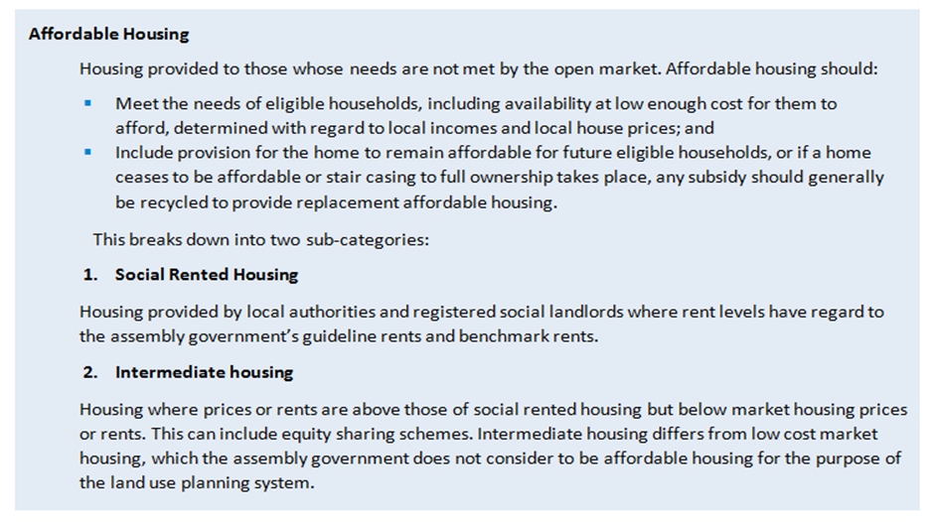

To estimate the levels of housing need, various elements and components relating to household circumstances, market conditions and housing supply have been analysed. This data has helped to provide an insight into way the local housing market is working, based on the current knowledge and understanding.

It is important to emphasise that even the most robust data cannot provide the ‘answer’ alone and that it must be subject to necessary interpretation and comprehension. Indeed, it is fundamental to consider all the evidence, make clear any assumptions where applicable, and allow for alternate scenarios.

The process helps to give a view on the extent to which the housing market is failing to meet the needs of a percentage of local households and the scale of intervention required (i.e., the type and size of affordable housing needed in different areas).

Further clarity of methodology is provided at each stage of the housing need calculation for transparency, although as previously mentioned, the process can be explained by utilising an updated version of the bathtub analogy as in figure 2.

## Newly Arising Need from New households

### Newly forming households in need of Social Rented Housing



As explained in section 2.1 the latest Welsh Government household projections show that **2500** additional households will form in the Vale of Glamorgan over the next five years, an average of **500 per year**. These household projections are used for the purposes of the LHMA to be consistent with the projections used in the Local Development Plan.

The annual number of households deemed to be in need of social housing are subject to stringent allocation criteria. Therefore, although the Welsh Government output already provides projected household compositions, a more thorough assessment was required to convert these household types into property types. The existing Homes4U (common housing waiting list) Allocation Policy, as in figure 7 was utilised to determine the number of bedrooms suitable for each household category.

**Figure 7 Homes4U Allocations Policy**

|  |  |  |
| --- | --- | --- |
| **Accommodation Size** | **Applicants** | **Household Projections Applied** |
| One Bedroom | * Couple * Single person | * 1 person * 2 persons   (no children) |
| Two Bedroom | * Co-tenant * Single parent or couple with 1 child * Single parent or couple with 2 children of the same sex both aged under 16 * Single parent or couple with 2 children of the opposite sex both aged under 10 | * 2 persons   (1 adult, 1 child)   * 3 persons   (no children)   * 3 persons   (2 adults 1 child) |
| Three Bedroom | * Single parent or couple with 2 children of the same sex where one is, or both are aged 16 or over Single parent or couple with two children of the opposite sex * Single parent or couple with 2 children where one is, or both are aged 10 or over * Single parent or couple with three children (if two can share a room being under 16 and the same sex or under 10 and the opposite sex) * Single parent or couple with four children   (if all children can share rooms) | * 3 persons   (1 adult, 2 children)   * 4 persons   (no children)   * 4 persons   (2+ adults, 1+ children) |
| Four Bedroom | * Single parent or couple with three children (if none can share a room) * Single parent or couple with four children (all other) | * 4 persons   (1 adult, 3 children)   * 5 + person   (no children) |
| Five Bedroom and Larger | As above, then one additional bedroom for each:   * Person or couple living as part of the household * Two children under 16 of same gender * Two children under 10 regardless of gender | * 5+ person   (2+ adults, 1+ children)   * 5+ person   (1 adult, 4+ children) |

### Newly forming households in need of Low-Cost Home Ownership

The first consideration was the amount that first time buyers would need to borrow to purchase a home on the open market income.

Entry level house prices in each area were obtained from Hometrack and are shown in figure 8.

Figure 8 Entry Level House Prices by Ward



The ratio of 3.5 times income was considered as a good benchmark in the past, is a simplification of the sophisticated assessments which lenders conduct on potential borrowers. These days it is more common for lenders to assess a wide range of factors such as income, expenditure, family makeup, lifestyle and job security to allow them to make an informed decision as to a borrower’s likelihood of being able to meet the mortgage repayments. These complex assessments cannot be replicated in a study of this type so despite its limitations, the 3.5 times multiplier remains a pragmatic means of estimating market affordability and has been used in this assessment. This is coupled with the assumption that each newly forming household will have a deposit when required.

CACI Paycheck data was used to estimate the potential income differentials amongst the newly arising households within each ward by analysing the span of income across each area in the Vale of Glamorgan (i.e., the percentage of those earning within different £5,000 income bands). The 3.5 times multiplier was then applied to calculate the proportion able to afford a mortgage for an entry level (two bedroom) property within each area.

This exercise revealed that out of the **500** households due to form each year from 2021-2026, **172** households are likely to be able to obtain a mortgage or meet their needs in the private market depending on availability of deposit and mortgage criteria. The remainder are unlikely to be able to meet their needs in the market and thus will need an alternative form of affordable housing

Using the same exercise as above on a 30% discounted entry level (two bedroom) house price in each area, it is estimated that **87** of the remaining **328** newly forming households per annum could potentially meet their housing needs through Low Cost Home Ownership (LCHO).

Property types for low cost home ownership housing are not governed by size criteria allocations and are instead based on affordability of the sale price.

### Newly forming households in need of Intermediate Rent

Conventionally the remaining **241** households would have been judged to need social rented accommodation. However, there are still a proportion of newly forming households estimated as having moderate incomes that are just priced out of the LCHO market. The scope for an intermediate rental product was therefore firstly considered. WG guidance suggests that such housing rental costs ‘should equate to no more than approximately 30% of gross income’ inclusive of any service charges. Furthermore, 80% of mean market rent is generally considered to be the basis for setting an intermediate rental value. Households were thus assessed using these criteria in each area and a total of **98**households per annum were deemed to need this product, leaving **143** per year in need of social rented housing

This analysis is based purely on the potential rent that each household can afford rather than availability in the private rental market. It is important to consider whether there is scope within the housing market for an intermediate rental product, the target should be approximately 80% of mean market rents, whilst being at or below Local Housing Allowance rates and above benchmark rents.

Local Housing Allowance Rates are low across the Vale of Glamorgan, even when considered in the areas with the lowest rental values, so the introduction of an intermediate product priced at 80% of market rent would in most areas exceed LHA. Conversely, in one area of the Vale 80% of market rent is lower than the average benchmark social rent and so again would not be possible. This combination of factors presents little scope in the housing market for delivery of a standard intermediate rental product. However, the need for intermediate rent (irrespective of market conditions) is presented separately in case alternative models arise in the market throughout the LHMA period.

Property types for intermediate and low-cost homeownership housing are not governed by size criteria allocations used for social rented and are instead based on sale or rental price affordability

### Total Annual Newly Arising Need by Tenure

Successively the total estimated newly arising need for all tenures of affordable housing is shown in figure 9 below; disaggregated by property size and housing market area. This represents the newly arising **annual need** to be addressed over the assessment period, rounded off.

Figure 9 Annual Arising Need by Tenure



## Newly Arising Need from Existing Households

Another element of newly arising need stems from existing households ‘falling’ into this category each year. This essentially includes those households that were previously housed satisfactorily but encountered some form of difficulty or hardship (financial or personal).

The WG suggests that recent trends are most useful to estimate the number of affected households that will come forward each year of the LHMA period. In terms of estimating existing households falling into need the number of households presenting as homeless have been analysed to determine trends and project the number likely to fall into need over the period of the LHMA.

### Homelessness presentations

The chart in figure 10 shows the annual number of homeless presentations in the Vale of Glamorgan~~.~~ The number of presentations reflects the economic climate and the number of households who find themselves facing homelessness due to financial difficulties.

Figure 10 Homelessness Presentations

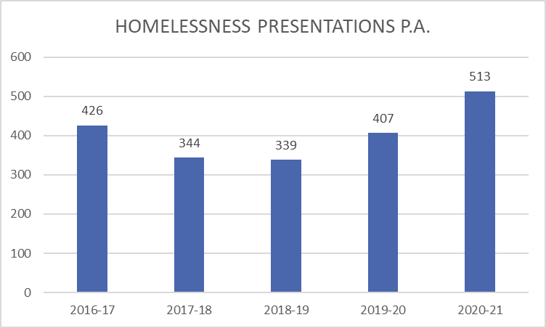

To provide an estimate of the level of presentations that will be made to the local authority each year of the LHMA period an average has been taken of the presentations over the five-year period considered above. As such, it is expected that there will be an annual average of **312** household presentations made each year to the local authority. It should be noted that following implementation of the Housing [Wales] Act 2014 there has been an increase in the numbers presenting. For clarification, this figure includes all households presenting to the Council as homeless or potentially homeless, both priority and non-priority homelessness cases, as the latter are still in need of suitable affordable housing and are included in the Homes4U data.

The number of cases accepted as unintentionally homeless however is much lower and is shown in figure 11. The average number of accepted cases for the last 5 years of **117.60** has been used in the calculations.

Figure 11 Homelessness Applications Accepted (as Unintentional pre March 2020 only)



It is also fundamental to consider the type of households that are likely to fall into housing need over the LHMA period. Analysis of the figures show that most housing applicants considered to be homeless or potentially homeless have needed one-bedroom properties (55%), with a smaller proportion needing two bedroom (32%), three bedroom (10%) and four bedroom properties (4%). Interestingly the % needing 4 bedroom properties has doubled from 2% in 2019. The demand for small properties is perhaps no surprise with the projected number of single persons, couples with no children and single parents growing, and the option available prior to the removal of the Spare Room Subsidy for households to be allocated a property larger than they required if there was a surplus of larger housing stock available.

The annual need for each property size, arising from people who are accepted as homeless and to whom the council has a duty, is translated to ward level using homeless application trends.

The percentage of each property size required is disaggregated to ward level, using the proportion of households residing in each ward as in figure 12.

Figure 12 Accepted Homelessness Cases by Ward and Household Type



The legislative changes introduced from April 2015 changed the way the local authorities are required to treat people who present as homeless, with a greater emphasis on preventing homelessness and relieving it in the cases where it cannot be prevented. Additional changes took place in March 2020 with the onset of the Covid 19 Pandemic, when all those presenting as homeless were required to be accommodated. In the main the type of household affected by the changes brought in by Public Health Wales (PHW) at the start of the pandemic were households with a one bedroom need, placing further demand on this type of property.

## Backlog of need for affordable Housing

The backlog of need for affordable housing can be generically defined as, ‘the current number of households who are in housing need and unable to meet their needs in the market’. Traditionally, these only included households waiting for social rented accommodation, captured by analysing households registered with Homes4U (the common housing waiting list).

Whilst this source is still useful, it is no longer the only data source that forms the backlog of housing need. As previously explained, an increasing proportion of households are ‘squeezed’ out of the current housing market and are left in need of an alternative form of affordable accommodation, such as intermediate rented or low-cost home ownership. The Council operates Aspire2Own, a register for those first-time buyers in a financially stable position, yet still unable to purchase a home outright without assistance. This source of data is used with Homes4U to assess the total backlog of housing need in the Vale of Glamorgan.

### 3.3.1 Backlog of need for Social Rented Housing

Homes4U was established in the Vale of Glamorgan in 2003, so has been in operation for 19

years. The principal aim of Homes4U is to offer service users a single point of contact for applying for social housing within the Vale of Glamorgan. The Council operate the common housing waiting list on behalf of the Council’s landlord service and the four housing associations with stock in the area:

* Hafod Housing Association
* Newydd Housing Association
* United Welsh Housing Association
* Wales and West Housing Association

All households and individuals in need of social housing in the Vale of Glamorgan are registered with Homes4U and no separate registers are held by the individual social landlords. Re-registration of applicants is conducted on a rolling basis, on average every 18 months, and a complete re-registration of applicants was last carried out in 21st January 2020. This provides a single principal source of data to measure the backlog of housing need for social rented properties in the Vale of Glamorgan. Homes4U provides useful information on household characteristics, sizes, property types required and first choice areas. Applicants can choose the properties they wish to be considered for by ‘bidding’ on them when they are advertised. This means that applicants can choose any areas they would consider moving to. However, on the Homes4U application form they are asked to select their first choice area purely for statistical purposes. This selection is not related to the housing application in any other way and therefore ensures that it is not fettered by availability of accommodation.

Before proceeding with the analysis, it is imperative to outline three caveats that are integral to understanding the social housing backlog. Firstly, to enable an analysis of Homes4U, a snapshot of households waiting on the Register was taken on 30th September 2021 (a total of 6938 households were registered at this time); disaggregated by the first-choice area, property size (number of bedrooms) and property type (general needs, adapted or sheltered housing) selected by each applicant. Homes4U data also captured all those homeless households deemed to be in priority need and to whom the local authority has a statutory duty to assist, together with non-priority homelessness cases in housing need. The data is only correct on the day of the snapshot; there are new registrations every week and the number of households registered continues to increase until a re-registration process takes place. The backlog of social housing used in the LHMA is likely to be an underestimation as people register daily so information on the need for social housing should always be supplemented by ‘live’ waiting list data.

Secondly, although housing registers provide a good estimation of existing households in need, they can also include a proportion of households who are not in need. Prior to being accepted onto the register applications are assessed according to the Homes4U Policy and then banded according to their level of housing need as in figure 13. However, there are few restrictions in terms of income or affordability, as it is recognised that in the Vale of Glamorgan house prices and rental levels can differ significantly and so setting a maximum income level would exclude people in more expensive areas. For example, a household with connections to the rural Vale (i.e., family support, employment, children in local schools) may be not be able to afford to rent privately or buy a home there, whereas they would be able to in a cheaper or more urban location. Whilst the household may consider moving areas to be able to afford to buy/rent, it is also recognised that there are benefits to households being able to remain in the communities they grew up in, work in and have connections to, so to ensure that the social housing backlog is an accurate a snapshot as possible, each household’s income was subject to a secondary analysis compared to house prices and market rents*.*

*Thirdly,* applicants waiting for adapted or accessible accommodation were scrutinised in accordance with national guidance to separate applicants in need of minor adaptations from those in need of significant adaptations and purpose-built properties. Applicants in need of significant adaptations and purpose-built properties were identified by their ‘Accessible Home’ banding which is based on a medical and / or occupational therapy assessment.

**Figure 13 Allocation Banding Priorities**

|  |  |
| --- | --- |
| **BAND / PRIORITY LEVEL** |  |
| **Gold**  **Priority Band 1**  **Priority Group** | The applicant/s   * has/have been accepted as statutorily homeless by the Council and issued a Priority Card. * live in private rented accommodation that is subject to a Prohibition Order, and recovery of the premises is required to comply with the Order as defined by Section 33 Housing Act 2004. * Has/have been assessed by the HOMES4U Lettings Panel and awarded a medical priority for rehousing. * is/are the tenant/s of a participating landlord and under-occupying their current accommodation (in line with the Homes4U Matrix) * is/are the tenant/s of a participating landlord and must transfer under an approved re-designation or regeneration programme. * current accommodation is overcrowded as defined by the Housing Act 1985 and where a Category 1 hazard has been identified under the provisions of the Housing Act 2004. * Is/are a licensee of a Supported Housing Project and require move on accommodation |
| **Silver**  **Property Band 2**  **Urgent Group** | The applicant/s   * is/are lodging with friends and family and sharing facilities in your current home. * do not live with their family (spouse/partner and children) and want to live with them. * is/are a Key Worker/s who has/have been offered a full-time job in the Vale of Glamorgan and need accommodation under a recognised key worker scheme. * is/are un-intentionally homeless but have been determined as not in ‘priority need’. * is/are un-intentionally homeless and not owed a duty by the Local Authority. * has/have a child under 10 and live in a flat above ground floor level (without a lift). * need to move closer to receive essential support/care services or to assist their family with day-to-day living. * relationship with their spouse/partner has broken down and they want to live separately. * is/are overcrowded by at least one bedroom in their current accommodation. * is/are threatened with homelessness. * is/ are roofless. |
| **Bronze**  **Priority Band 3** | * All other Applicants that are tenants of the Council or Registered Social Landlord and live in accommodation that is sufficient for their needs. * All other applicants with no apparent housing need or not covered by any other category as outlined above. |

Figure 14 shows the **gross** backlog of need taken from the Home4U waiting list for social rented housing to be addressed **each year** of the LHMA period. (6938 divided by 5 = 1388) As is evident, most households on the Homes4U require general needs accommodation with either one or two bedrooms

Figure 14 Backlog of Need for Social Rent from Homes4U Waiting List



It is possible to provide some further context to the nature of the 1388 applicants registered with Homes4U in terms of the household composition, income and level of housing need. However, it is not possible to provide this analysis for those on the Aspire2Own register deemed unable to afford either LCHO or IR as we do not collect this information at present.

The chart in figure 15 shows most of the 1388 households registered with Homes4U are now single people (38%), with families with children being the second highest (37%), this is a reversal of the 2019 data when 37% were families with children and 36% were single people. The minority of applicants are single older people (11%), couples without children (9%) and older couples (5%). The combined total for single people awaiting accommodation is therefore 49%, almost half of the entire waiting list.

Figure 15 Applicants by Household Type based on annual number

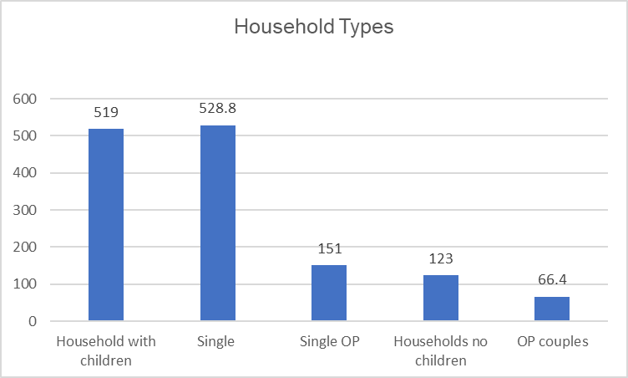

The household income of the 6938 Homes4U applicants has also been analysed and income levels and sources varies significantly.

There are 2502 people on the waiting list with no earned income, the majority being single people of all ages, with or without children. Of the 58% of Homes4U applicants who have an earned income from employment; most of these households (36%) earn between £100 and £199 per week, followed by 21% of households earning £200 – £299 per week. A minority of households earn £400 - £499 per week (8%) and £500+ per week (6.5%). It should be recognised that households on what may appear to be a ‘good’ household income may still not be able to afford to rent privately in their local area, for example households in the most expensive rural communities, or they may not be able to afford or access a home suitable for their needs, for example an adapted or accessible home.

Further to the information relating to income. The information in figure 16 provides information about households in receipt of Housing Benefit in 2021. The number of applicants on the Homes4U list in receipt of housing benefit remains at 40% (43% in 2017 and 65.5% in 2015). The low number is most likely due to the applicants having no home of their own on which to claim housing benefit. Of those claiming housing benefit over half are receiving full housing benefit, an increase and reflects the growing needs of both the unemployed and those in employment and on low income who are receiving help with their rent.

Figure 16 Applicants on Homes4U and Housing Benefit

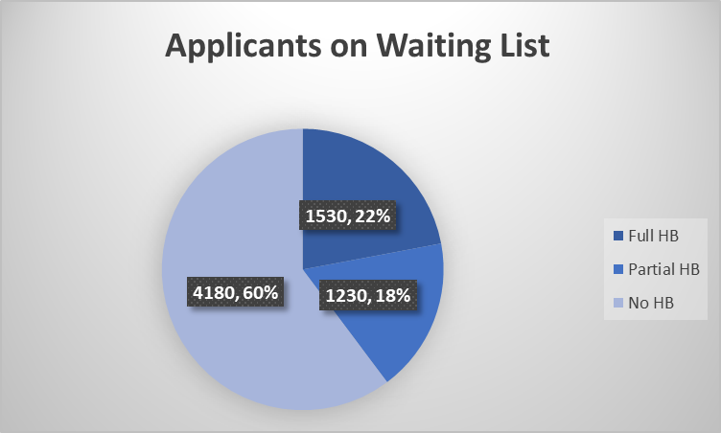

Each Homes4U Applicant is given a banding based on their housing circumstances and level of housing need. An illustration of applicants’ bandings at the time of the snapshot taken for the purposes of the LHMA in September 2021 and broken down on an annual basis is shown in figure 17: -

Figure 17 Applicants in each band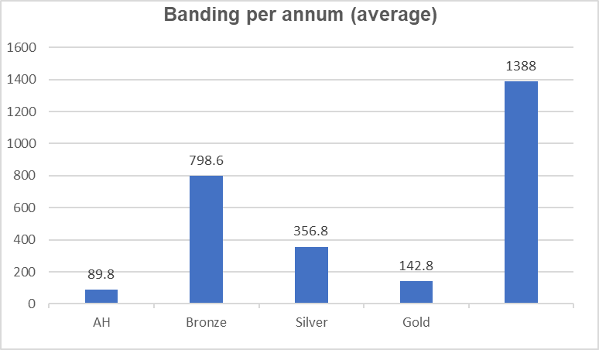

An explanation of the banding system can be found in figure 13. Broadly speaking, most applicants are in the lowest level of housing need, with the number of applicants then reducing as the severity of housing need increases.

**6%** of applicants have an Accessible Homes banding; this banding is for households where a member is disabled, has mobility issues or a chronic illness and may need a property which is accessible or adapted to meet their needs. This includes a small number of people with a very high priority as they are awaiting release from hospital to a suitable home.

**10%** of households have a Gold banding; this is the highest priority banding and for households with the highest level of housing need. Within this banding there are separate categories defined by the type of housing need, including those who are statutory homeless or adversely affected by the bedroom tax and under-occupying their home so needing to down-size to avoid rent arrears.

**26%** of households have a Silver banding; this banding is for households in an urgent housing need. Within this banding the three categories with the highest number of applicants are those who: are sharing facilities, non-statutory homeless and over-occupying; lacking at least one bedroom.

**58%** of households have a Bronze banding; this banding is for households who are currently living in accommodation suitable for their needs or in no apparent housing need. Within this banding the three categories with the highest number of applicants are those who are in low housing need and those registered because they will at some point need to move on from supported accommodation, but who are not currently ready to live independently.

More than half of the total number of applicants on the waiting list of 6938 in need of social rented housing, require one-bedroom accommodation; this is closely followed by those in need of two bedroom properties, although there is also a significant need for larger general needs accommodation, see figure 18.

There is also a significant need for older person’s accommodation, most of which is for one-bedroom properties. As older people are currently exempt from the housing benefit restrictions on spare rooms, they will be eligible for 2-bedroom accommodation which is generally the preferred option. Accommodation for older people has changed over recent years and traditional types of accommodation such as bedsits are now unpopular.

Figure 18 Applicants by Bedroom Size and Type of Housing

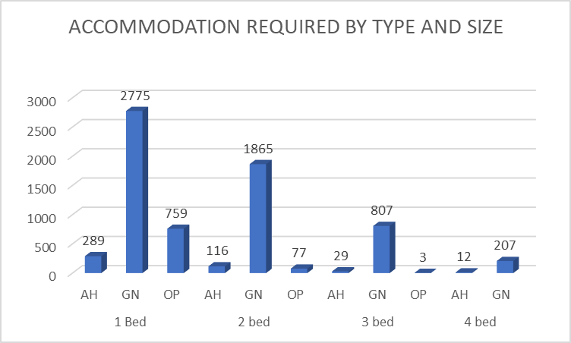

Key

AH – Accessible Housing

GN – General Needs Housing

OP – Older Persons Housing

**3.3.2 Backlog of need for Low Cost Home Ownership**

The Aspire2Own register has been operating in the Vale of Glamorgan for over nine years. Registered households are simply expressing an interest in low cost home ownership and wish to be kept informed of housing opportunities when they are available. There is no restriction on the households who can register and often people will register for the future while they save for a deposit. Applicants are not subject to the same allocation criteria for different property sizes as that used for social rented. Basic information is held on each applicant including area preferences, income, employment details and current living arrangements.

A snapshot of the Aspire2Own register was taken on 30th September 2021, to enable an analysis of householder preferences and affordability at that point in time, there were 1225 applicants on the register. This is a significant increase on the number registered two years ago. The register tends to be supply led and more households register when there is a lot of activity on the development front. Since the last LHMA in 2019 there have been several new developments completed in the Vale with many properties for sale, hence demand has increased. Properties offered for sale via the Aspire2Own scheme have proved to be in high demand and the enquiries far outweigh the homes available to buy.

An initial analysis of the 1225 applicants registered with Aspire2Own looked at whether each registered household would be able to afford LCHO or would be better suited to intermediate rent.

The 3.5 times income multiplier was used to assess each household’s capacity to borrow based on their current income levels. This was compared to the income needed to afford a 30% discounted entry level (two bedroom) average house price as per the table in figure 19.

Figure 19 Income needed to enter housing market by Ward



This exercise revealed that **158** households (**32** per year) needed and could afford an LCHO product based on their current circumstances. This was further analysed into the wards of first choice as in figure 20.

Figure 20 LCHO Areas of Choice



### 

### 3.3.3 Backlog of need for Intermediate Rent

There are several households in the remaining **1193** on the Aspire2Own register who are estimated as having moderate incomes and are just priced out of the LCHO market.

The scope for an intermediate rental product has been considered, using guidance issued by WG, and a total of 692 households were deemed to need this product, 138 per year. This figure includes people who are unable to afford to buy now, but who aspire to home ownership and are saving for a deposit. The Welsh Government has developed a new Rent First model of low cost home ownership, which will help people caught in the situation of paying high private rents and struggling to have any surplus income to save for a deposit This was introduced from April 2019 along with a new low cost home ownership product, we have yet to see properties under these two schemes developed in the Vale, in any significant numbers.

Weekly rent levels for both entry level and intermediate rent are shown in figure 21, alongside the income needed to be able to afford intermediate rent, based on the guidelines that no more than 30% of a household’s income should be spent on rent or mortgage outgoings.

Figure 21 Entry level Intermediate Rent by Ward



Using the above guidelines **692** (**138** per year) households were identified as being able to afford intermediate rent, shown below by ward in figure 22:-

Figure 22 Areas of Choice Intermediate Rent



The remaining households whilst being registered with Aspire2Own and thus aspiring to home ownership are unable to afford a low-cost home ownership or intermediate rented product. Therefore, these households are considered to need social rented housing at least in the short term. There are 375 on the Aspire2Own register (75 per year.) who are in this category, we have not included them with the general waiting list figures, as we believe they are already on the Homes4U waiting list and to include them would be double counting.

# Affordable Housing Supply

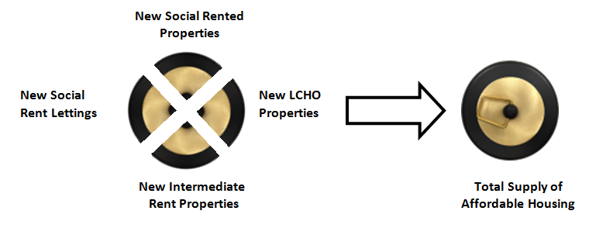Figure 23 Bath Plug

To counterbalance the gross housing need already outlined, the supply of affordable units expected to come forward over the next five years also must be considered. This is possible by conducting a trend-based analysis of annual lettings within the existing social housing stock and forecasting the quantity of new affordable housing planned to be built and/or acquired over the LHMA period (including LCHO and intermediate rental properties as well as social rented units). This combined supply of affordable housing units from the three tenures effectively forms the plughole from the bath analogy as shown in figure 23.

## Projected Social Rented Lets

The first consideration is therefore the anticipated number of social lets from existing properties that will come forward each year of the LHMA period, ‘this can be calculated based on past trends’ and ‘generally the average number of re-lets over the last three years should be taken as the predicted annual level’. Consequently, the total number of social lets over this period were obtained for Council owned social housing and the four local housing association. Information was collected on the type of property, size and location. These trends were converted into an annual average to provide an anticipated level of lettings per annum over the next five years.

In the three years 2018-19, 2019-2020 and 2020-21 the average number of relets is 532, disaggregated to ward and property type/size as in figure 24

Figure 24 Annual Re-lets of Social Rented Properties by size, type and ward



## 

## Committed supply of New Affordable Housing

The anticipated quantity of affordable housing (for social rent, intermediate rent and LCHO) ‘already planned to be built (and/or acquired) over the period of the Assessment’ is an important consideration to offset gross housing need.

In 2019 it was estimated that 134 units of affordable housing would be completed each year over a 5-year period. However, in 2018-19 286 units were developed, in 2019-20 180 units were developed and 176 units have been developed in 2020-21 period, the Vale of Glamorgan has therefore delivered beyond the 134 units per annum predicted under the previous LHMA by 59.7% based upon the last 3 annual completion periods.

A variety of potential sources have been analysed to identify the existing committed supply of affordable housing as of December 2021. These include:

* Sites granted planning permission subject to s106 for affordable housing that had already started on site and/or were due to be completed over the LHMA period.
* Sites that were allocated Social Housing Grant [SHG] or Recycled Capital Grant and were scheduled for completion in the next five years as identified in the Programme Delivery Plan.
* Sites that were being developed by housing associations using other courses of public subsidy (e.g., the Welsh Government’s Housing Finance Grant) or via private finance.
* Existing private market units that were due to be acquired through the Welsh Housing Partnership and re-utilised as intermediate rental properties.

Only schemes that are highly likely to be delivered over the five years of the assessment were included. In updating the committed supply, we have accounted for two factors: first the delivery of private sector allocated sites in the Local Development Plan and secondly, new SHG schemes planned for the end of the period having netted off abortive SHG schemes. It is predicted that 201 affordable units will be delivered each year over the next 5 years based upon committed supply. The breakdown of committed supply of new affordable homes for social rent is shown in figure 25 below:

Figure 25 Annual Committed Supply of New Build properties for Social Rent



## total units of affordable housing for social rent

To reach a figure for the number of units of affordable housing expected to be delivered for social rent, the committed supply of social rented housing going forward has been added to the average re-lets to give the estimated number of affordable homes for rent that will be provided. The total is shown in figure 26.

Figure 26 Combined New Build and Re-lets for Social Rented Properties



## units of affordable housing for low cost homeownership

The committed supply for low cost home ownership by ward is shown in figure 27 and is purely the number of new builds expected; turnover has not been factored into as this type of housing, as Low-Cost Home Ownership (LCHO) is relatively new and has not become available for re sale very often. Going forward a review of the Aspire2Own scheme may identify different needs of homeowners in relation to the size of their home and if turnover increases in future years this would have to be taken account of.

Figure 27 Committed Supply of Low-Cost Home Ownership New Build Properties

|  |  |  |
| --- | --- | --- |
| **Wards** | LCHO 2 Bed | LCHO 3 Bed |
| Barry | 4 | 1 |
| Cowbridge | 8 | 2 |
| Dinas Powys | 0 | 0 |
| Llandow/Ewenny | 0 | 0 |
| Llantwit Major | 5 | 1 |
| Penarth & Llandough | 5 | 1 |
| Peterston | 0 | 0 |
| Rhoose | 0 | 0 |
| St Athan | 3 | 1 |
| St Bride's Major | 0 | 0 |
| Sully | 6 | 1 |
| Wenvoe | 1 | 0 |
| **TOTAL** | **32** | **8** |

## total units of affordable housing for intermediate rent

Due to the need identified, work will be done with planning colleagues to determine if the Supplementary Planning Guidance (SPG) for affordable housing requires review and if an intermediate rental product is required in addition to the Rent to Own product being introduced by Welsh Government.

|  |  |  |
| --- | --- | --- |
| **Wards** | 2 bed | 3 bed |
| Barry | 1 | 0 |
| Cowbridge | 4 | 1 |
| Dinas Powys | 0 | 0 |
| Llandow/Ewenny | 0 | 0 |
| Llantwit Major | 3 | 1 |
| Penarth & Llandough | 5 | 1 |
| Peterston | 0 | 0 |
| Rhoose | 0 | 0 |
| St Athan | 3 | 1 |
| St Bride's Major | 0 | 0 |
| Sully | 4 | 1 |
| Wenvoe | 0 | 0 |
| **TOTAL** | **20** | **5** |

# Net Need for Affordable Housing

To calculate the net need for affordable housing per annum, the total backlog (water within the bath) must be added to the annual newly arising need (coming through the shower head for intermediate products and taps for social rented products). The anticipated annual supply (emptying through the plug hole) must then be subtracted from this figure to estimate the annual supply of affordable housing.

However, one further issue relates to turnover. Essentially, social rented units differ to intermediate rent and low-cost home ownership products, as they re-let relatively frequently, and it would be inaccurate to assume that they will only be occupied once over the LHMA period. It is thus necessary to consider the rate at which properties re-emerge as re-lets, and this effects areas where there is an overall deficit and surplus of social housing (hence headline housing need can decrease or increase following a turnover assessment). Current levels of turnover were therefore calculated and factored into the calculations.

Average turnover is integrally related to property size (number of bedrooms) and area. As an average across the Vale of Glamorgan, smaller properties become re-available at a higher rate than larger homes, figure 28. In terms of area, those areas with higher rates of turnover tend to be those with higher levels of social housing stock. A few of the very high turnover rates (e.g., four-bedroom properties in Peterson-Super-Ely) are due to very low stock levels and an equally small number of re-lets, rather than genuine levels of high turnover.

Figure 28 Average Annual Turnover of Social Rented Properties by Number of Bedrooms and Property Type

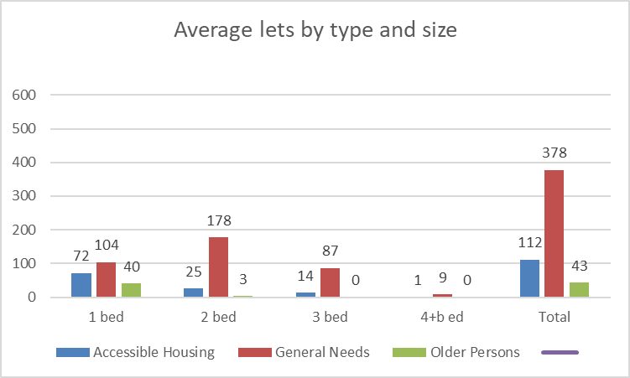

Turnover by areas can be seen in Figure 29, and this shows the highest turnover is in the wards of Barry, Dinas Powys and Penarth & Llandough.

Figure 29 Average Annual Turnover of General Needs Rented Properties by Area

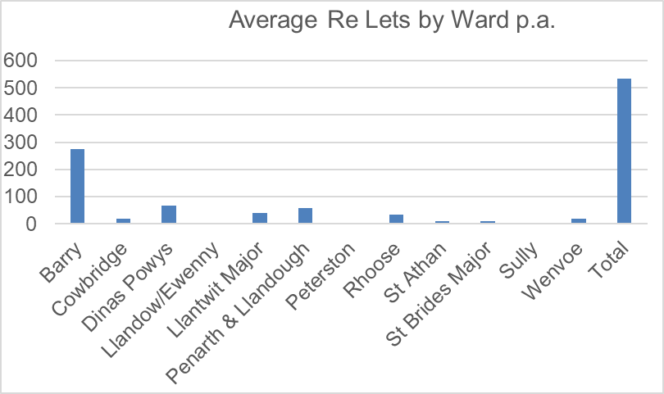

## Bath Tub analogy

With the calculation for turnover factored in, the headline need for affordable housing calculation is shown below in figure 30 utilising the bathtub analogy.

Figure 30 Headline Need for Affordable Housing

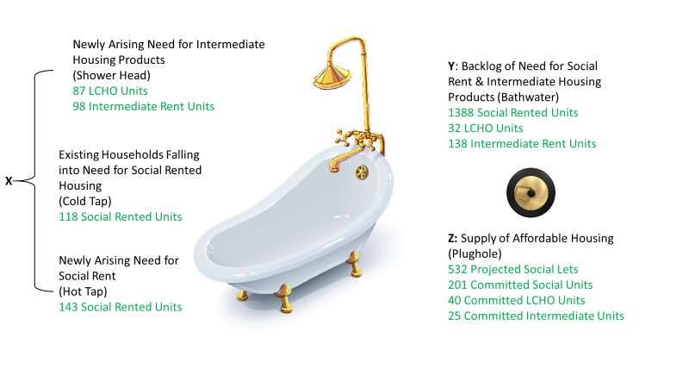

**TOTAL NEED FOR AFFORDABLE HOUSING 2021-2026**

The headline annual net need for affordable housing in the Vale of Glamorgan is **1205 units per annum** for the period of the Local Housing Market Assessment, from 2021-26.

Figure 31 Headline annual need for affordable housing by tenure

|  |  |  |  |  |
| --- | --- | --- | --- | --- |
|  | **Social Rent** | **Low Cost Home Ownership** | **Intermediate Rent** | **Total** |
| Newly arising need | 143 | 87 | 98 | 328 |
| existing falling into need | 118 | 0 | 0 | 118 |
| Backlog | 1387 | 32 | 138 | 1557 |
| **Sub Total** | **1648** | **119** | **236** | **2003** |
| Supply | 733 | 40 | 25 | 798 |
| **Net Annual Need** | **915** | **79** | **211** | **1205** |

It should be reiterated at this point that this is not a definitive target figure for affordable housing; it is an indication of need. It should also be noted that again the assessment should be considered an art and not a science, as the data is only correct at the time the calculation is conducted.

In comparison the previous affordable housing need was: -

Figure 32 Previous Annual Need for Affordable Housing

|  |  |  |  |  |
| --- | --- | --- | --- | --- |
| **Year** | **Social Rent** | **Low Cost Home Ownership** | **Intermediate Rent** | **Total** |
| **2019** | 799 | 21 | 70 | 890 |
| **2021** | 915 | 79 | 211 | 1205 |

The charts in figures 32 and 33 show that when comparing the data for there has been a large increase in the annual need for affordable housing in 2021. In 2019 there were 5986 on the Homes4U list by 2021 this had increased to 6938. The Aspire2Own register also saw a large increase from 560 in 2019 following a review, to the current number 1126.

Figure 33 is a summary chart showing different needs between 2015 and 2019, it can be noted that newly arising need fell in 2017, this was due to the changed household projections by Welsh Government. The number of households falling into need also dropped following the emphasis now placed on homelessness prevention.

Figure 33 Summary of Need

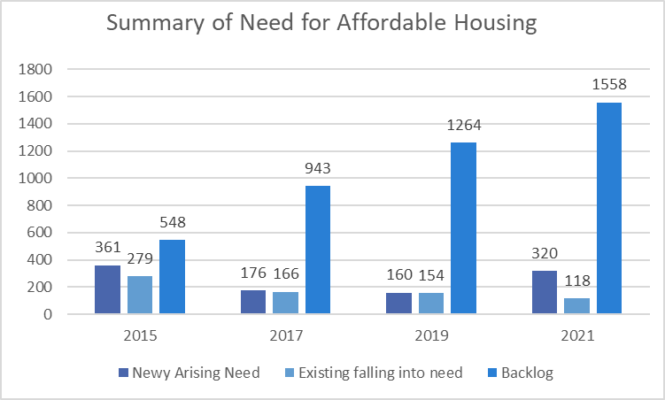

# Conclusion

The Local Housing Market Assessment has utilised the Welsh Government’s approved methodology to assess the housing market within the Vale of Glamorgan from 2021-2026 to determine the need for Affordable Housing. It replaces the 2019 Assessment with a refreshed analysis of numerous data sources.

## headline housing need

Whilst this Assessment analysed the housing market of the Vale of Glamorgan as a whole, a fundamental aspect of any LHMA is to calculate the net housing need across the administrative area. Estimates of shortfalls or surpluses of affordable housing in different areas are crucial inputs into the local housing and planning framework.

This Assessment identified an annual need for **1205 Affordable Housing Units**, comprising 915 social rented units, 79 units of low-cost home ownership and 211 units of intermediate housing.

Whilst it is necessary to provide a net affordable housing figure across all property types, affordable tenures and areas, this figure is highly misleading as it distorts local differences. For example, housing which is surplus or has a relatively high turnover rate masks the gross need for affordable housing in the Vale. Consequently, even if the headline net social housing need was delivered every year in the Vale of Glamorgan, this would by no means meet the actual need present in many of the housing market areas. Hence, more attention should be paid to the type of housing needed and characteristics identified within each localised market area to enable effective strategic planning.

## general needs social rent

The need for general needs social rented accommodation remains at its highest in the Barry and Penarth and Llandough housing market areas, followed by the urban settlements along the south of the county boundary. There are also pockets of moderate need in the rural north, especially around principal settlements. What is most notable is that all areas demonstrate a deficit of general needs social housing of some level.

In terms of the properties needed, the trend continues to be for smaller units, one- and two-bedroom properties, across all areas of the Vale of Glamorgan.

This demand should also be balanced with larger properties as there remains a gross need for three- and four-bedroom properties. A mix of properties also ensures the development of mixed, balanced communities and good community cohesion.

## intermediate rent and low cost home ownership

There is a need for intermediate rented housing of **211** units per year in the Vale of Glamorgan. The need for low cost home ownership is currently **79** per annum.

Implementation of an intermediate rent model has historically been hampered by the significant gap between Local Housing Allowance and low market rent levels in most areas. However, consideration will be given once again as to how a model of intermediate rent can be developed in the Vale of Glamorgan to meet the identified need.

The ‘Rent to Own’ scheme may assist with meeting the demand for intermediate rented products and low cost home ownership, helping those who are currently struggling to save for a deposit due to the high level of rents in the private sector. A viability study will be undertaken into providing Rent to Own Housing.

## purpose built adapted social rent

To determine the net need for adapted and accessible social rented accommodation, applicants waiting for adapted accommodation are identified by the Homes4U bandings: AH1, AH2 and AH3.

Most of the purpose built adapted accommodation will be built by social landlords and not by market developers. This is due to the space requirements needed for these properties and the relatively high cost of developing such accommodation.

Securing new accessible and adapted social rented accommodation is likely to be through the development of suitably adapted ground floor accommodation. In addition, on affordable housing developments led by social landlords, efforts are made to include a minimum of two accessible homes to meet the needs of a household with higher needs

## key policy consideration and areas for development

### Affordable Housing Products

Low Cost Home Ownership (LCHO)

The Aspire2Own scheme in the Vale of Glamorgan is a partnership with Registered Social Landlords, operating in the county, to offer first time buyers the opportunity to purchase properties at 70% of the open market value.

This LHMA has analysed house prices and household income levels to assess the demand for a low cost home ownership product based on the 70/30% equity share model and it is evident that there is considerable demand for the product, however it is very often hidden, and the need is only identified when developments receive planning permission. More work therefore needs to take place in rural communities to raise the profile of the LCHO product and to encourage first time buyers with a connection to the area to register.

### 5.5.2 Need for Smaller Units

Much of the need for affordable housing consists of smaller one- and two-bedroom units for social rent across many parts the Vale of Glamorgan. There has been a historical misconception that this need was created by the removal of the Spare Room Subsidy and that need, and delivery of such units would have been short term, a reactive response to this policy change. However, this need reflects societal trends in household composition and the high prevalence of single person households and households comprising of couples with no children.

In some areas developments of just one and two bedroom properties should be considered or clusters of smaller units among market housing. When flats are provided to meet the demand, walk up flats are preferable to blocks with communal spaces. Walk up flats are more easily made accessible, and they minimise management issues, whilst maximising tenancy sustainability.

When possible two-bedroom properties should be provided in the form of houses as two-bedroom flats are not suitable to meet the needs of couples with young children and single people and couples without children may be unable to under-occupy such properties without paying a subsidy.

### 5.5.3 Older Persons Accommodation

.

People aged 65 or over currently make up 21% of the total population of the Vale of Glamorgan with the number of people in this age range increasing more quickly than the population as a whole. The predicted increase of people aged 65+ between 2021 and 2031 in the Vale of Glamorgan is 20%. This is a similar picture to Wales as a whole.

It is important to recognise the differences within the older population demographics, and therefore the number of people aged 85 or over has also been considered with the most recent predictions showing a likely increase of 33% in this age group over the next 10 years.

The increases in both age ranges is in the main due to people living longer, although there has also been a small inward migration of people aged 65+ to the Vale.

As people live longer the need for additional care and support increases as a result of more people experiencing difficulties with day to day activities. This impacts the type of care and support needed to support this cohort, and naturally impacts on the type of accommodation required. It is therefore important that the needs of this age range are considered in more detail.

In order to get an understanding of the needs of older people living in the Vale of Glamorgan and Cardiff, The Cardiff and Vale Regional Partnership Board Commissioned Housing LIN to complete an Assessment of Older Person’s Housing and Accommodation including accommodation with Care and Care Ready. The report was published in 2018. The main aim of the assessment was to provide a comprehensive understanding of the nature of current housing and accommodation provision for older people – including both social and private sector housing.

The report can be found here <https://www.cvihsc.co.uk/wp-content/uploads/2018/12/An-Assessment-of-Older-Persons-Housing-and-Accommodation-2018.pdf>

However, it is recognised that there are marked differences between the Vale and Cardiff’s older population and therefore a more detailed assessment of older people living within the Vale of Glamorgan is needed. In addition, it is noted that the pandemic has had an impact on this demographic and therefore the assumptions within the 2018 report are now outdated. In response to this the Vale of Glamorgan Council has commissioned Housing Lin to develop an Older Person’s Strategy for the Vale of Glamorgan , which will be published in summer 2022. This will help to inform the future accommodation needs of older people living within the Vale of Glamorgan more accurately and ensure that future housing provision adequately meets the need of our aging population.

### 5.5.4 Private Rented Sector

Work continues to develop to maximise the housing opportunities in the Private Rented Sector. Support is delivered to both tenants and landlords across the Vale of Glamorgan, which has been acknowledged as best practice in the sector. A very well attended Local Landlord Forum is established, facilitated by the Council’s Housing Solutions Service. There is also a significant focus on the Empty Homes initiatives. A new Empty Homes Strategy has recently been developed and there is excellent ongoing joined up working taking place in the Authority.

However, it should be noted that finding good quality affordable private rented accommodation within the Vale of Glamorgan is becoming increasingly challenging. This is because of several factors outside of the control of the authority, including the rising house prices in the area which are incentivising landlords to sell their properties; the ever increasing gap between Local Housing Allowance (LHA) rates and market rents; changes to taxation on certain types of mortgages and legislative changes including the extended notice period required to be given to private tenants. The picture is similar across Wales as a whole.

The Vale of Glamorgan Housing Solutions Team continues to look at new incentives to encourage private landlords to work with people in need of private rented accommodation, as well as working closely with Welsh Government to consider these issues.

### 5.5.5 Help to Buy Wales

This is a scheme developed and run by Welsh Government, providing a further avenue for first time buyers, with a limited deposit, to buy a new home directly from house builders on new developments. As more new estates have been built in recent years, take up of this product in the Vale of Glamorgan has increased correspondingly. Latest information from Stats Wales shows that up to 23rd January 2020, 921 households had used Welsh Government’s Help to Buy scheme to purchase a home in the Vale of Glamorgan, with most of these purchasers having income levels between £20,001 and £30,000.