ate/Dyddiad | 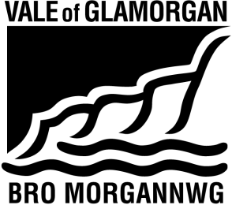  2 April 2025  The Vale of Glamorgan Council  Learning and Skills  Civic Offices, Holton Road, Barry CF63 4RU  Telephone: (01446) 700111 www.valeofglamorgan.gov.uk  Cyngor Bro Morgannwg  Dysgu a Sgiliau  Swyddfeydd Dinesig, Heol Holton, Y Barri CF63 4RU  Rhif ffôn: (01446) 700111 www.bromorgannwg.gov.uk
Ask for/Gofynwch am | S Mawhinney
Telephone/Rhif ffôn | 01446 - 709727
Fax/Ffacs
e-mail/e-bost | Admissions@valeofglamorgan.gov.uk
Your Ref/Eich Cyf
My Ref/Cyf | SM

To: Headteacher and the Governing Body of Community Secondary, Primary, Nursery and Special Schools, Foundation Schools, Church in Wales Aided and Controlled Primary Schools and Catholic Secondary and Primary Schools
Neighbouring Local Authorities
Diocesan Directors of Education
Vale of Glamorgan Admissions Forum

Dear Consultee,

VALE OF GLAMORGAN COUNCIL - SCHOOL ADMISSION ARRANGEMENTS 2027/2028

I refer to my letter of the 6 January 2026 inviting comments on the Councils proposed admissions arrangements for the academic year 2027/2028. Comments on the admission arrangements were invited to be returned by the 17 February 2026.

Further to the consultation undertaken, the Councils Cabinet met on the 26 March 2026 and determined the Councils admission arrangements. The admission arrangements are attached that will become the authority’s admission policy for the year 2027/2028.

Yours sincerely

L Lewis

Lisa Lewis
Operational Manager, Strategy and Resources

