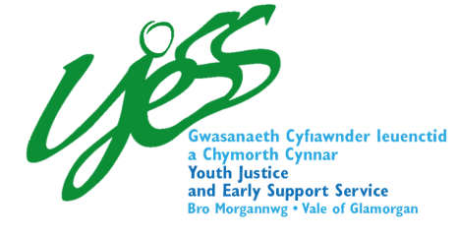
Prevention
Service
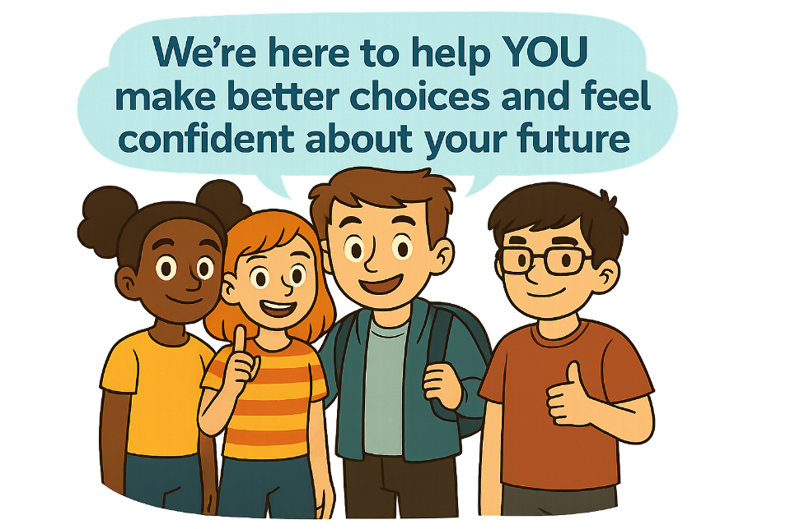

How It Works
You can choose to work with us. It is voluntary and all about YOU.
We meet with you and your family to talk about what is best for you and plan for a better future.

What We Do
Support children and families to:
• Talk about feelings and experiences
• Build skills around making safe and positive choices
• Understand and prevent anti-social behaviour



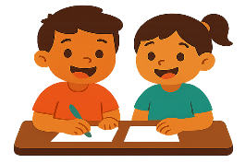
Your Voice Matters
You can share your thoughts by:

• Talking to a person at YJESS
• Writing down your feelings
• Asking a parent or carer to speak on your behalf

Get in Touch
Phone: 01446 745820
Email: YJESS@valeofglamorgan.gov.uk
Visit:

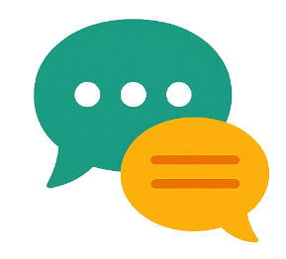


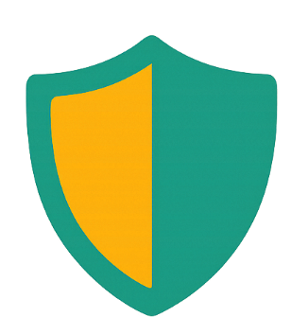
More details

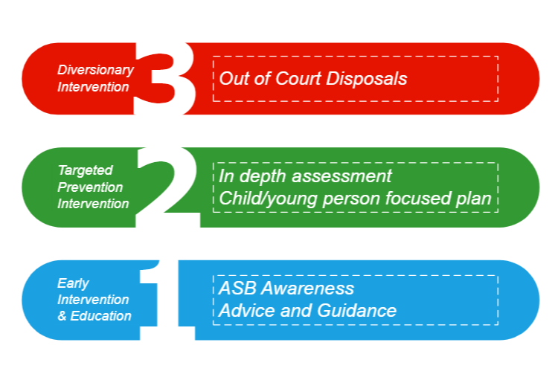
We aim to:
• protect children from factors related to anti-social
behaviour and crime.

• Work with schools and supportive services in the area you live to get access to the right support services at the right time.

Levels of Support


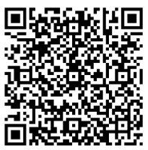
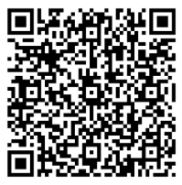
Service Feedback
Want to give feedback about your plan? Whether you’re a parent/carer or a child, please scan one of the QR codes below.

Parent/Carer Child

