Mae'r Cyngor yn ymgynghori ar Lwybr Teithio Llesol arfaethedig yn seiliedig ar y cynllun a ddangosir. Mae rhagor o fanylion am yr ymgynghoriad hwn ar gael yn https://www.valeofglamorgan.gov.uk/cy/living/Transportation/Active-Travel.aspx.

Llwybr Teithio Llesol Ffordd Llanmaes
Llanmaes Road Active Travel Route

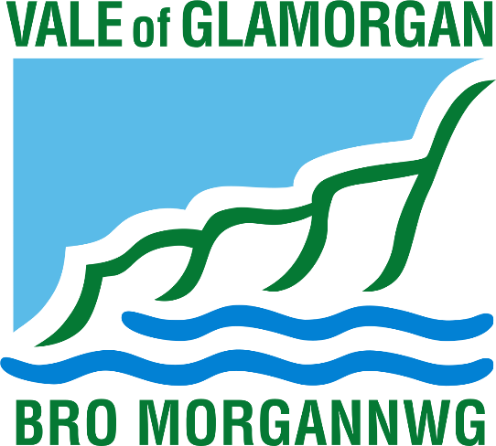

The Council is consulting on a proposed Active Travel Route based on the plan shown. Further details about this consultation are available at https://www.valeofglamorgan.gov.uk/en/living/transportation/Active-Travel.aspx.
Description of Scheme Proposal

The Council is consulting with residents over plans to construct an Active Travel route from Ffordd Bro Tathan to Llantwit Major Interchange. The proposed route is creating a shared use facility for pedestrians and cyclists by increasing the width of the existing pathway.

Project Zero is the Vale of Glamorgan Council’s response to the climate change emergency. Our key target is to reduce the Council’s carbon emissions to net zero by 2030 but we also want to influence and encourage others to reduce their emissions and to be part of Project Zero. Improvements to sustainable travel options and increasing the number of journeys made by active travel (walking and cycling) is a key part of the plan.

Concerns have been raised about the highway environment in this area, specifically for pedestrians, and those school pupils who will be walking, scooting, or cycling to school. In response, officers from the Council have investigated options to make improvements which will create a safer walking, cycling and wheeling environment.

The main road safety issues identified were related to vehicle speeds and the pedestrian facilities. To combat the road safety issues we are proposing the following as part of the active travel improvements:

- 3m wide tarmacadam shared used pathway along the route to improve the current surface which is paved and has a number of trips hazards;
- Carriageway narrowing to a minimum of 6.1m to reduce speed;
- Pedestrian crossing improvements and junction narrowing to provide safer crossing for vulnerable road users;
- Pathways marked as shared use so users understand both pedestrians and bikes are present;
- Additional seating and planting along the route to make it a more pleasant environment.

The measures will deliver a safer pedestrian and cyclist environment, particularly for vulnerable road users and school pupils, and will improve accessibility to schools, the town centre and transport interchange.

This scheme is being funded through the Welsh Government Active Travel grant. Details of current active travel schemes can be found by following this link: https://www.valeofglamorgan.gov.uk/en/living/transportation/Active-Travel-and-Safe-Routes-in-Communities-Projects.aspx

We would appreciate any comments you may have regarding the proposals. We understand you may have suggestions for other improvements to increase safety within this area. Due to funding constraints we may be unable to accommodate any significant changes to these plans at this time, however we will keep a record of any suggestions we receive to incorporate into future schemes.

Disgrifiad o Gynnig y Cynllun

Mae'r Cyngor yn ymgynghori â thrigolion ynghylch cynlluniau i greu llwybr Teithio Llesol o Ffordd Bro Tathan i Gyfnewidfa Llanilltud Fawr. Mae'r llwybr arfaethedig yn creu cyfleuster defnydd a rennir ar gyfer cerddwyr a beicwyr trwy ledu’r llwybr presennol.

Prosiect Sero yw ymateb Cyngor Bro Morgannwg i argyfwng y newid yn yr hinsawdd. Ein prif darged yw lleihau allyriadau carbon y Cyngor i sero net erbyn 2030 ond rydym hefyd am ddylanwadu ar eraill a’u hannog i leihau eu hallyriadau a bod yn rhan o Brosiect Sero. Mae gwella opsiynau teithio cynaliadwy a chynyddu nifer y teithiau a wneir trwy deithio llesol (cerdded a beicio) yn rhan allweddol o’r cynllun hwn.

Mynegwyd pryderon am yr amgylchedd priffyrdd yn yr ardal hon, yn benodol i gerddwyr, a'r disgyblion ysgol hynny a fydd yn cerdded, yn sgwtera neu'n beicio i'r ysgol. Mewn ymateb i hyn, mae swyddogion y Cyngor wedi ymchwilio i ffyrdd o wneud gwelliannau a fydd yn helpu i greu amgylchedd cerdded, beicio ac olwynio diogelach.

Y prif broblemau diogelwch ar y ffordd a nodwyd oedd cyflymder cerbydau a diffyg cyfleusterau i gerddwyr. Er mwyn mynd i'r afael â'r materion diogelwch ar y ffyrdd, rydym yn cynnig y canlynol fel rhan o'r gwelliannau teithio llesol:

- Llwybr tarmac a rennir 3m o led ar hyd y llwybr i wella'r arwyneb presennol sydd wedi'i balmantu ac sydd â nifer o beryglon baglu;
- Culhau’r lôn gerbydau i 6.1m o leiaf er mwyn lleihau cyflymder;
- Gwella croesfannau i gerddwyr a chulhau cyffyrdd i sicrhau croesfannau mwy diogel i ddefnyddwyr ffyrdd sy'n agored i niwed;
- Llwybrau wedi'u marcio fel defnydd a rennir fel bod defnyddwyr yn deall bod cerddwyr a beiciau yn eu defnyddio;
- Seddi a phlannu ychwanegol ar hyd y llwybrau i'w gwneud yn amgylchedd mwy dymunol.

Bydd y mesurau’n creu amgylchedd mwy diogel i gerddwyr a beicwyr, yn benodol i ddefnyddwyr ffyrdd sy’n agored i niwed a disgyblion ysgol, a byddant yn gwella mynediad i ysgolion, canol y dref a’r gyfnewidfa drafnidiaeth.

Grant Teithio Llesol Llywodraeth Cymru sy’n ariannu’r cynllun hwn. Ceir manylion y cynlluniau teithio llesol cyfredol trwy ddilyn y ddolen hon: https://www.valeofglamorgan.gov.uk/cy/living/Transportation/Active-Travel-and-Safe-Routes-in-Communities-Projects.aspx

Byddem yn gwerthfawrogi unrhyw sylwadau sydd gennych ynghylch y cynigion. Rydym yn deall y gallai fod gennych awgrymiadau eraill i wella diogelwch yn yr ardal hon. O ganlyniad i gyfyngiadau ariannol efallai na fydd modd i ni newid y cynlluniau hyn yn sylweddol ar hyn o bryd, ond byddwn yn cadw cofnod o unrhyw awgrymiadau a ddaw i law er mwyn eu cynnwys mewn cynlluniau yn y dyfodol.

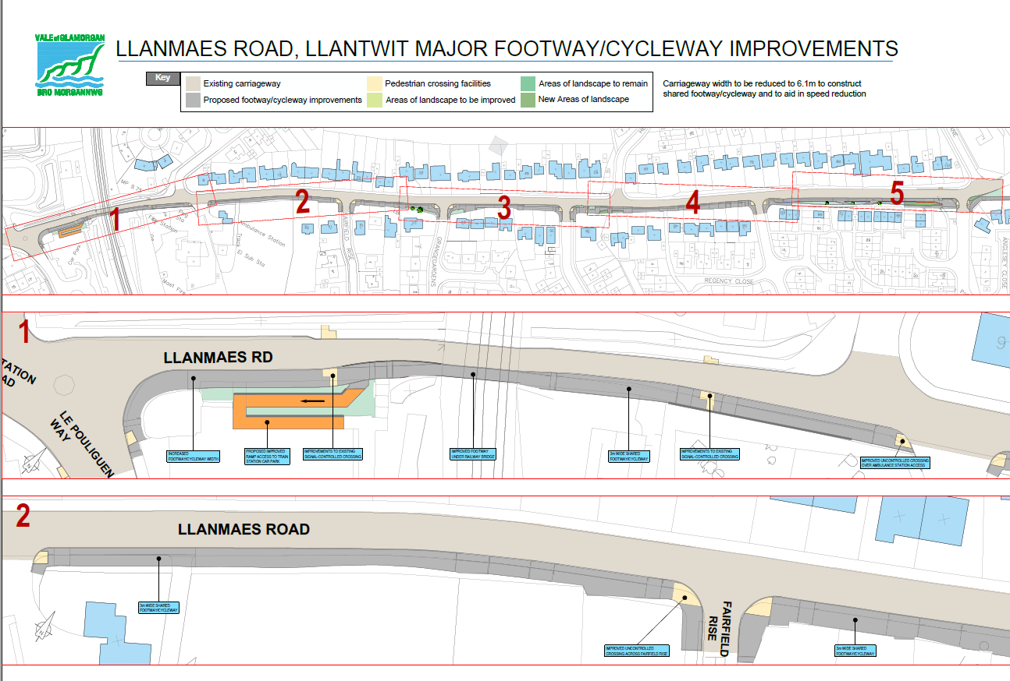
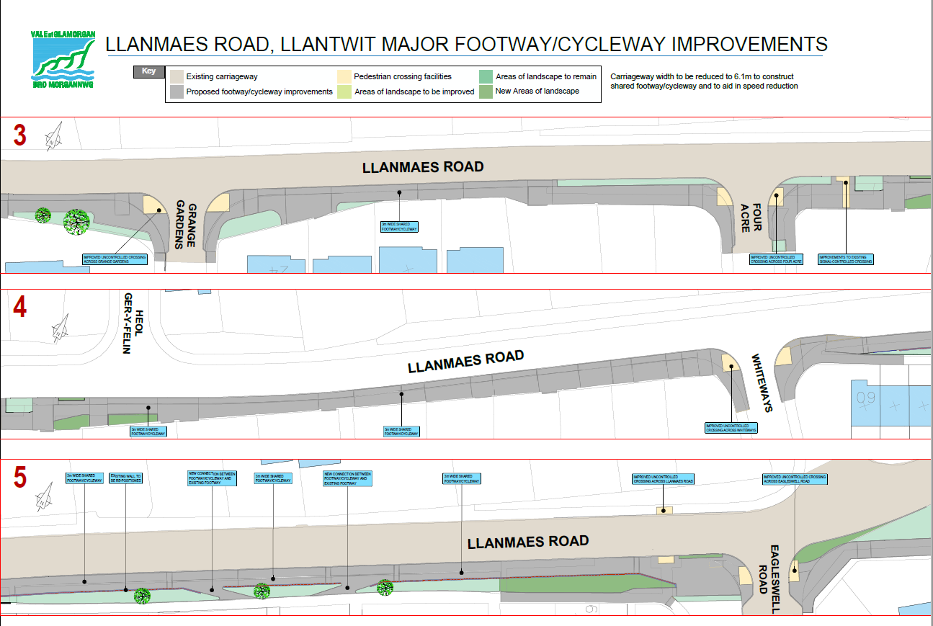

How to respond

An online survey is available here for you to respond to the proposals:
https://www.valeofglamorgan.gov.uk/en/living/transportation/Active-Travel-and-Safe-Routes-in-Communities-Projects.aspx

Responses must be submitted by 22 September 2021.

If you would like to make any comments about this proposal please let us know by 22 September 2021 by email to ActiveTravel@valeofglamorgan.gov.uk or write to Active Travel, Vale of Glamorgan Council, The Alps Depot, Quarry Road, Wenvoe

Sut i ymateb

Mae arolwg ar-lein ar gael yma i chi ymateb i'r cynigion:
https://www.valeofglamorgan.gov.uk/cy/living/Transportation/Active-Travel-and-Safe-Routes-in-Communities-Projects.aspx

Rhaid cyflwyno ymatebion erbyn 22 Medi 2021.

Os hoffech chi wneud unrhyw sylwadau am y cynnig hwn, rhowch wybod i ni erbyn 22 Medi 2021 drwy e-bost i ActiveTravel@valeofglamorgan.gov.uk neu drwy ysgrifennu at Teithio Llesol, Cyngor Bro Morgannwg, Depo'r Alpau, Heol y Chwarel, Gwenfô

