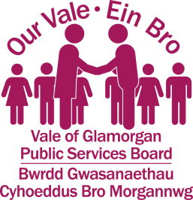

Vale of Glamorgan Public Services Board Meeting
31st January 2017 @ 2pm - 4 pm
Committee Room 1, Civic Offices, Barry.

Agenda

No. | Agenda Item | Lead
1 | Welcome and Introductions | Cllr Neil Moore
2 | Apologies for Absence | Lloyd Fisher – Policy Officer, Vale of Glamorgan Council
3 | Minutes of the Public Services Board 15th December 2016 | Huw Isaac – Head of Performance and Development, Vale of Glamorgan Council
4 | The Challenge of Youth Employment | Reuben Bergman – Head of HR – Vale of Glamorgan Council
5 | Apprenticeship Levy | Emil Evans - Vice Principal – Cardiff and Vale College
6 | Presentation: Cardiff Capital Region City Deal  http://cardiffcapitalregioncitydeal.wales/ | Rob Thomas – Managing Director, Vale of Glamorgan Council
7 | Well-being Assessment Update  (Verbal Update) | Helen Moses – Strategy and Partnership Manager, Vale of Glamorgan Council
8 | Developing our Well-being Objectives and the Well-being Plan | Huw Isaac – Head of Performance and Development, Vale of Glamorgan Council
9 | Forward Work Programme | Cllr Neil Moore
10 | Any Other Business | Cllr Neil Moore
11 | Date of next Public Services Board meeting  9th March 2017

