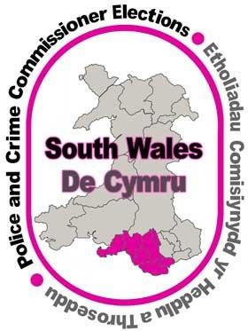

Website links to the 7 Local Authorities in the South Wales Police Area

Gwefan yn cysylltu â'r 7 awdurdod lleol yn ardal Heddlu De Cymru

Bridgend / Pen y Bont
https://www.bridgend.gov.uk/my-council/elections/current-elections/

Cardiff / Caerdydd
https://www.cardiff.gov.uk/ENG/Your-Council/Voting-and-elections/Pages/default.aspx

Merthyr / Merthyr
https://www.merthyr.gov.uk/council/voting-and-elections/police-and-crime-commissioner-election/

Neath Port Talbot / Castell-nedd Port Talbot
https://www.npt.gov.uk/22289

Rhondda Cynon Taf / Rhondda Cynon Taf
https://www.rctcbc.gov.uk/EN/Council/Votingandelections/PoliceandCrimeCommissionerElectionMay2020/PoliceandCrimeCommissionerElectionMay2020.aspx

Swansea / Abertawe
https://www.swansea.gov.uk/PCC2020

Vale of Glamorgan / Bro Morgannwg
https://www.valeofglamorgan.gov.uk/en/our_council/Council-Structure/Police-and-Crime-Commissioner-Elections-2020/South-Wales-Police-and-Crime-Commissioner-Election.aspx

