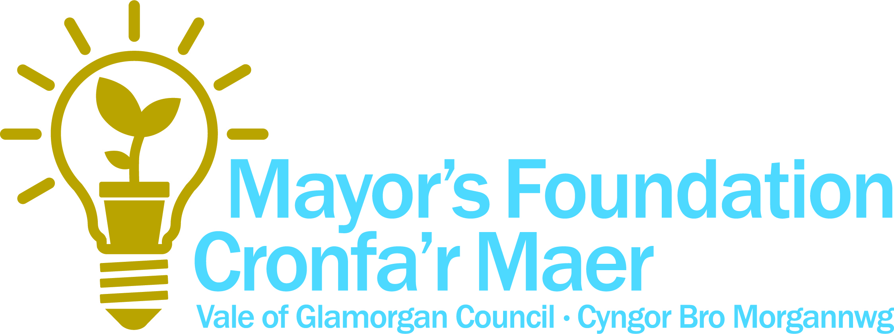

Application Form
Please refer to the Guidance Notes in completing this form and if you are not sure about anything please get in touch with us as we are here to help.

Section 1. Your organisation
Name of group / organisation
Project title
Contact name:
Address for correspondence:
Phone Number:
Mobile Number:
Email:
Legal status of organisation
Briefly tell us what your organisation / group does:

Section 2. Project summary
Please provide details of your project.

Anticipated Project start date:
Anticipated Project completion date:

Section 3: Project costs

Item or activity | Total
 | £
Total Mayor’s Foundation Grant applied for
Total Project Cost
Explain where ALL funding for your project will come from, including any unsecured funds.

Section 4: Project details and strategic fit

All applicants must demonstrate how the project fits with the Council’s vision of supporting “Strong communities with a bright future”
How will your project contribute to the Vale of Glamorgan Council’s Priorities? Projects should be able to demonstrate a link to one or more of the outcomes, please tick which ones apply to you below.

Outcome 1: An inclusive and safe Vale
Reducing poverty and social exclusion. ☐
Providing decent homes and safe communities.☐

Outcome 2: An environmentally responsible and prosperous Vale
Promoting regeneration, economic growth and employment.☐
Promoting sustainable development and protecting our environment.☐

Outcome 3: An aspirational and culturally vibrant Vale
Raising overall standards of achievement.☐
Valuing culture and diversity.☐

Outcome 4: An active and healthy Vale
Encouraging and promoting active and healthy lifestyles.☐
Safeguarding those who are vulnerable and promoting independent living.☐
Well-being of Future Generations (Wales) Act 2015
The Well-being of Future Generations (Wales) Act is about improving the well-being of Wales.
More information on the Future Generations Act can be found here.

Projects should be able to demonstrate a link to one or more of the wellbeing goals and five ways of working, please tick which ones apply to you below.
The Act has 7 well-being goals:
• A globally responsible Wales ☐
• A prosperous Wales ☐
• A resilient Wales ☐
• A healthier Wales ☐
• A more equal Wales ☐
• A Wales of cohesive communities ☐
• A Wales of vibrant culture and thriving Welsh language ☐

The Act has 5 ways of working:

• Integration ☐
• Collaboration ☐
• Prevention ☐
• Long-Term ☐
• Involvement ☐
Explain the need for the project and the extent to which your local stakeholders have been involved in its development. This could be people that would benefit such as local residents or service users.

What do you hope to achieve through your project? Please list any specific outcomes. We have put some suggested outcomes in the step by step guidance. You may choose from these suggested outcomes below or add in some additional ones of your choosing.

Please confirm that all consents and permissions in place to allow the project to proceed? ☐

Section 5: Your signature
I confirm that the answers given on this application form are true and accurate to the best of my knowledge and belief. I understand that the Vale of Glamorgan Council (VOGC) may collect corroborating information at any time during the application process.

I further confirm that this information is made on the basis that I shall agree to the following conditions, should the application be successful:

- To use the grant for the purpose agreed in the Grant Contract
- To prepare any reports as required relating to the work for which funding is received.
- To agree to any additional monitoring as required
- In the event of the organisation terminating before completion of the work for which the grant is received, any part of the grant which is unspent/unused shall be returned to, including the return or transfer to VOGC of any assets purchased with the grant
- In the event that the organisation terminates, the applicant is expected to return or transfer to VOGC any assets purchased with the grant.

Please be aware that images and information on your organisation or group may be used to publicise the scheme in the press, and in marketing materials.

The information that you provide to VOGC will be held for the purpose of monitoring and evaluation. You will also be added to a database of community organisations in order to receive information on other sources of funding and support that me be of benefit to you.

Please sign below to confirm that you consent to all of the above and that the information that you have provided is accurate and true
Signature:
Name in BLOCK CAPITALS:
Date:
Your completed application along with supporting evidence and checklist may be sent electronically to TheMayor@valeofglamorgan.gov.uk or sent in hard copy to The Mayor’s Foundation Fund, Vale of Glamorgan Council, Civic Offices, Holton Road, Barry, CF63 4RT along with supporting evidence and signed checklist. If you have any queries about this application form please contact mpetherick@valeofglamorgan.gov.uk or call 01446 704853.

Application Checklist
 | Yes | No
I have read and understood the guidelines/notes for applicants. (This will help you complete your application correctly and avoid delays in processing).
I have fully completed and signed the application form (if in hard copy).
I have attached quotations for each item in accordance with the tender guidelines. (If only one quotation is provided I have noted this and explained why).

I have attached copies of the organisation ‘s constitution and equal opportunities policy.

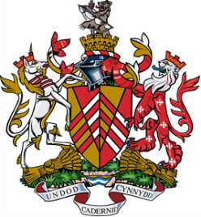

Mayor of the Vale of Glamorgan
Vale of Glamorgan Council
Civic Offices
Holton Road
Barry
CF63 4RU

T: 01446 709853
E: TheMayor@valeofglamorgan.gov.uk

