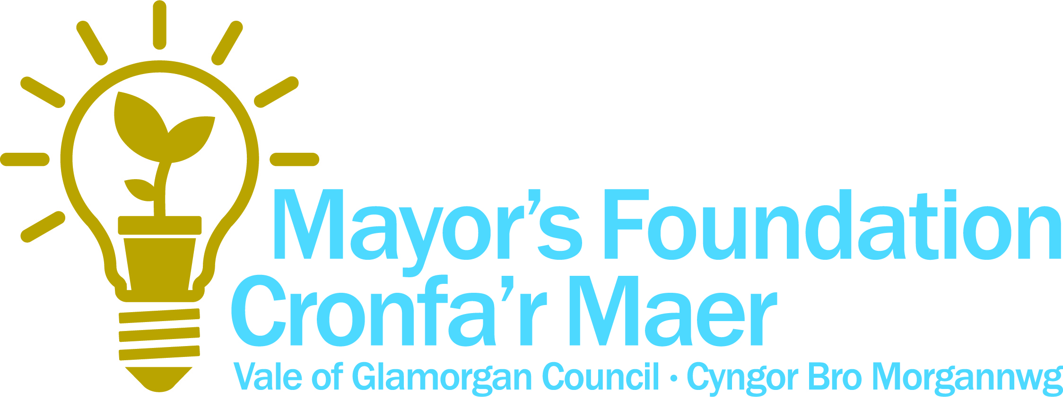
Step-by-step guide to completing the Mayor’s Foundation Grant Application Form

If in doubt – ask. We are here to help you through this process!

Section 1: Your organisation

Name of your group or organisation – if applicable, as it appears on your governing document.

Project title - Give a short, meaningful title for your project.

Contact name - someone in the group/organisation we can contact during office hours and who is familiar with both the application and the project.

Address for correspondence - this is where we will send all paperwork for the project.

Telephone number - please provide a daytime contact number for the contact person.

Mobile number - for the contact person.

Email address – for the contact person.

Legal status of your group or organisation. - I.e. constituted group, village hall committee, charity, community council. Please refer to separate ‘Legal structures summary’ document for guidance.

Your organisation - briefly tell us about the aims and objectives of your organisation and how long it has been established.

Section 2: Project summary

Tell us about your project, as follows:

- Describe what currently exists, what it is that you want to do and what the end product(s) will be.
- Specify the location of your project if it relates to particular property or land.
- Tell us who will manage your project and describe their relevant experience.
- Provide any other information that will help us to fully understand your project and its benefits.
- Provide us with a realistic assumption of when you anticipate starting and completing your project
- Please limit to 250 words

Section 3: Project costs

Project costs - Give an itemised breakdown of how much funding you want from the Mayor’s Foundation Fund for each financial year. Total the amounts at the bottom of the column. Include VAT if applicable. You must only include VAT in the amount you request from us if you cannot claim it back from HM Revenue and Customs. If you later find that you can recover VAT that we have included in our grant, you must repay this amount to us. VAT can add a considerable cost to a project. We recommend that you contact HM Revenue and Customs for advice before you apply.

Match funding - You don’t need to have match funding towards the project but it is great when you can add value using other sources of funding.

Tell us if you have secured funding from other funders for your project, or if you are using your own funds or if you have no match funding. If you have tried to secure match funding but been unsuccessful please provide details. Please provide evidence of the secured match funding i.e. an offer letter of funding or a bank statement with sufficient funds for the amount required. You can use your own funding as match on projects.

Section 4: Project details and strategic fit

The information you provide in this section will be used to assess the merits of your project and it is important that you answer all questions fully.

All applicants for the Mayor’s Foundation Fund Grant are required to demonstrate that there is a proven need for their project. You should describe how you have engaged with their local stakeholders in developing their project and how they have helped to shape the project.

Please confirm that where relevant the relevant consents and permissions are in place to allow your project to proceed e.g. ownership or land agreement, planning consent or other consents and licences.

Section 5: Signature

Please read the terms and conditions of under which you are applying for grant and ensure that these are acceptable to your organisation. Please state your role within the organisation.

Mayor of the Vale of Glamorgan
Vale of Glamorgan Council
Civic Offices
Holton Road
Barry
CF63 4RU

T: 01446 709853
E: TheMayor@valeofglamorgan.gov.uk

