
Annex 5 - Project ideas, educational resources and top tips
This resource is designed to help you with nature area creation and management top tips, project ideas and a list of free educational resources created by environmental organisations such as the Wildlife Trusts, RSPB and Learning Through Landscapes. We have also included advice on creating and managing allotments and orchards.
Top tips for increasing nature
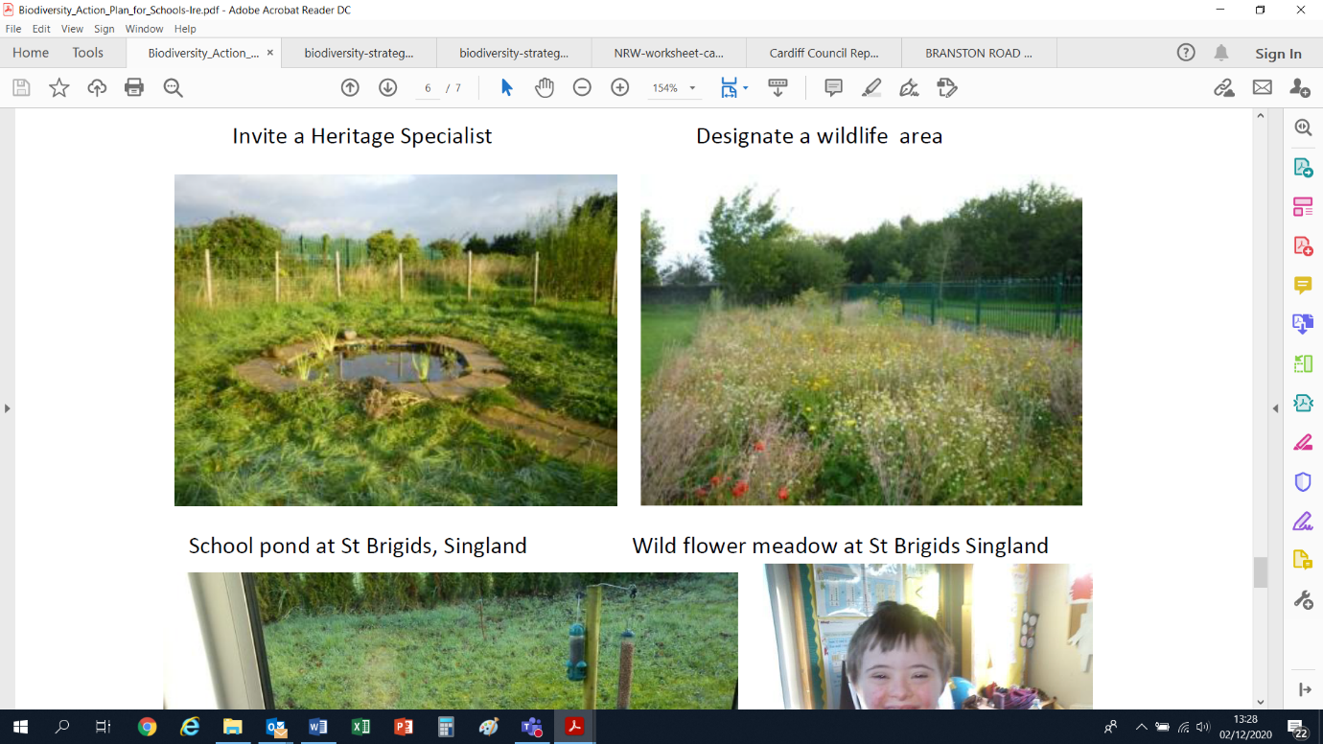
By changing a small area in your school grounds into a wildlife garden you will be providing a valuable habitat for local wildlife. The wildlife garden will also be an outdoor classroom where you can discover the natural world and develop your understanding of environmental issues through first-hand experience.
Simply planting some native plants and providing attractive conditions for wildlife such as insects and garden birds to shelter and feed will increase the wildlife population.
Anything you can do to increase the number of different habitats found (for example longer grass, compost heaps, boggy areas, wetlands) or to improve the different heights or structures of plants (such as mature trees, shrubs, climbers, tall and shorter plants) will help wildlife.
We have included some top tips for helping wildlife below. Please remember to review your grounds before implementing any projects (see annex 4 for advice) as this will help to determine which actions will be most appropriate and beneficial.
1. Hedges, trees, shrubs and wildflowers
Plant trees, shrubs and hedgerows that are native to the area. These will help to attract a wide range of insects, birds and small mammals that feed on them. Trees, shrubs, and hedgerow are particularly important for insect larvae and can provide roosting opportunities for bats. Choose tree species with berries or nectar rich flowers (rowan or guelder rose), and that are usually found in local semi-natural habitats (birch, oak, alder, and willow).
Bare rooted native trees (small whips or saplings) can be bought for winter planting. Suitable smaller native trees include species like hawthorn, rowan, crab apple, and hazel.
Newly planted trees will require regular watering in dry spells for 3 to 5 years to ensure good root growth. Use bark or other mulch to keep the grass down around new saplings. If a guard is used this would need to be removed as soon as they split and before they start to disintegrate (usually after 5-10 years). Check tree ties and stakes to ensure they are secure and ties are not too tight; look for signs of rubbing as this can create a scar, which leaves the tree open to disease.
As your woodland matures, thin out and maintain the wooded areas to allow a semi-natural tree and shrub mix to develop.
For more advice visit:
- Wildlife Trust’s - How to plant a tree
- Wildlife Trust’s - How to create a woodland edge garden
- Woodland Trust’s – Tree planting advice
- Woodland Trust’s – Free trees for schools
- Woodland Trust’s – Twigged! A guide to your trees through the seasons
Plant shrubs closely together in groups or as a hedge to provide living space and food for all sorts of wildlife. Native choices include hawthorn, blackthorn, wild rose, holly, hazel, and elder.
For hedgerows, regularly prune in years 1-3 to create desired structure and density; spring, summer, and autumn/winter cut recommended. Then a single cut every 2-3 years, avoiding the bird nesting season (February-August). Cutting times depend on what you want from the hedge and which of the planted trees are the most successful. Avoid cuts when main flowering species are in flower, e.g. blackthorn (March-April), hawthorn (April-May). Light trimming is best once established, rather than heavy cuts.
For other scrubby areas, aim to rotationally cut to create a diverse habitat structure and carry out management in the autumn/winter, ideally early February, avoiding the bird nesting season (February to August inclusive). Work on fruit-bearing scrub is best delayed until after December, leaving valuable autumn and winter fruits and seeds as food for wildlife. Where scrub is almost entirely composed of bramble, undertake rotational cutting, where 1/5 or 1/6 of the entire scrub patch is cut each year. Over 5-6 years the whole patch will have been cut. This creates a mosaic of bramble at different stages of growth.
For more advice visit:
- Wildlife Trust’s - How to make a hedge for wildlife
Example trees and shrubs
Large (>25m at maturity) | Alder, Beech, Holly*, Hornbeam*, Pedunculate Oak (English Oak), Scots Pine, Sessile Oak
Medium (10-20m at maturity) | Aspen, Bird Cherry, Downy Birch, Hawthorn*, Mountain Ash (Rowen), Silver Birch, Weeping Willow [plant near bird feeders], Whitebeam, Wild cherry, Wild Service Tree, Wych Elm
Small Trees (5-9m at maturity) | Alder Buckthorn*, Blackthorn*, Crab Apple, Elder*, Field Maple, Hazel*, Strawberry tree
Large Shrubs (3-6m at maturity) | Buckthorn, Common wayfaring tree*, Dog Rose, Dogwood*, Guelder-rose, Juniper, Purple Willow, Spindle, Wild privet*
Avoid | Ash (due to Ash dieback), Elm (due to Dutch Elm disease), Eucalyptus, Cypress, Griselinia, Leylandii, Laurel
*can also be clipped and kept as hedging
Plant gardens with local wildflowers. Survey the grounds for good sunny spots for wildflower beds. Plant border gardens around buildings or convert an entire lawn into a meadow. You could purchase native seeds from a local garden centre and consult employees there about how much seed to purchase for each planting area.
Example meadow and bedding plants
Bedding plants | Aubrieta, Bluebells, Field Scabious, Heather, Nasturtium, Pansy, Primrose, Purple Loosestrife, Sweet Pea, Sweet Rocket
Late flowering herbs | Chives, Lavender, Mint, Rosemary, Thyme
Wildflower seed mix | Bird’s Foot Trefoil, Black Meddick, Burdock, Burnet Saxifrage, Cat’s ear, Common Vetch, Corn Marigold, Corn Poppy, Corn Cockle, Corn Flower, Dame’s Violet, Dog Violet, Devil’s Bit Scabious, Field Scabious, Fleabane, Foxglove, Greater trefoil, Hawkbit, Hedge mustard, Kidney Vetch, Lady’s Bedstraw, Lesser Knapweed, Marjoram, Meadow Vetchling, Meadowsweet, Ox-eyed Daisy, Purple Loosestrife, Ragged Robin, Red Campion, Red Clover, Ribwort Plantain, Scented Mayweed, Shepherd’s Purse, Sorrel, St John’s Wort, Teasel, Water Avens, Wild Angelica, Wild Carrot, Wood sage, Yarrow
Till the planting areas, add about 2 inches (5.1 cm) of composted garden soil, and water the soil well. Scatter the seeds, rake them into the soil, then pack the soil with a hand tamper or by stepping over the entire area. Some species require winter frosts to germinate so planting in autumn ready for the following spring is recommended.
A class or after-school club could plant the garden, and year groups could take turns maintaining it. For instance, year 6 might water it one week, and year 5 will water it the next.
Recommend 2-3 mows per year maximum: year 1 mow in March (spring cut), mid-late July (summer cut) and late September to October (autumn cut). Mow the edges of paths more regularly than the rest to help show residents that this is a deliberate activity. Try not to mow all areas at the same time. Leave a few patches of longer vegetation over winter. Don’t use weedkiller as this will kill the flowers you want to encourage.
Where possible, leave the cuttings in place for 1-3 days to give any sheltering wildlife a chance to move away. Don’t leave the cuttings for longer than this time as this can increase soil fertility and reduce the diversity of plants that can grow. Where possible cuttings could be moved elsewhere on site, as they can provide food and shelter for other wildlife. Some plant materials such as hollow plant stems can be used in bug hotels and bee nests.
For more advice visit:
- Grow Wild – How to get wildflower seeds
2. Provide shelter
With bird and bat populations decreasing, making bird and bat boxes is an excellent idea to help our flying friends live and breed. January and February are the ideal times to build the box for use in the spring. Make sure the boxes don’t face the sun and are not exposed to the rain.
If possible, place birdhouses and feeders within 10 feet (3.0 m) of trees and shrubs. Evergreen plants are the best choices. Place a birdhouse's entrance hole away from the prevailing winds. For instance, position the hole toward the south during winter away from freezing northerly winds. Then place it toward the north in the summer to help keep birds cool.
Different birds use different types of nest:
- Standard nest boxes for species such as Blue tits, Great tits, and Starlings.
- Open fronted nest boxes for species such as Robins, Wrens, and Pied wagtails.
- Birds of prey boxes for species such as Tawny owl and Kestrel.
- Swift boxes.
- House martin nests cups.
- Sparrow boxes.
For standard and open fronted nest boxes, consider placing nest boxes at different heights to encourage different species. Nest boxes should be cleaned out annually between 1 September and 31 January, but always check the nest is unoccupied first.
For more advice visit:
- The British Trust for Ornithology – Nestbox guide
- Wildlife Trust’s – How to build a nestbox
Bats are pollinators and can help keep insect populations in check. Provide shelter for them with bat boxes, which are similar to birdhouses. Hang a bat box on a tree or pole at a height of about 15 feet (4.6 m). Find bat boxes online and at home and garden stores or make have students make them in art and DT classes out of untreated plywood or woodcrete. Woodcrete is an insulated material. Unlike plywood, it’ll offer protection during colder months.
A basic bat box is 2 feet (61 cm) tall, 1 foot (30 cm) wide, and 3 inches (7.6 cm) deep with a 1 inch (2.5 cm) slit in the bottom. Set grooves about 1⁄2 inch (1.3 cm) apart on the back inside wall for bats to hang.
When making bat boxes, it is important to remember that bats do not like drafts. Well-sealed joints are important whilst removable lids should be avoided. All timber used should be rough-sawn to allow bats to climb and should be untreated as bats are very sensitive to chemicals. A special licence is required under law to inspect bat boxes and disturbance without this is illegal.
Bat boxes are most likely to be used if located in places where bats are known to feed. Ideally, two or three boxes should be placed facing in different directions to allow a range of roosting temperatures throughout the year. The important thing is to ensure that there is a clear flight-line to any boxes and that a reasonable amount of sun reaches the box.
For more advice visit:
- Wildlife Trust’s - How to build a bat box
Purchase or make and install homes for hedgehogs in carefully selected locations. Ensure there are spaces or holes (13 cm x 13 cm) at the base of fences or walls. To create hedgehog highways, remove a brick from the bottom of the wall, cut a small hole in the fence if there are no gaps or dig a channel underneath the wall, fence or gate.
Monitor condition of houses and highways. Clear out the hedgehog house once a year (late March - early April) to prevent the build-up of pests. Do not clean it out if a hedgehog is in residence. Check hedgehog highways are kept clear of obstructions (e.g. encroaching vegetation).
For more advice visit:
- Wildlife Trust’s - How to build a hedgehog home
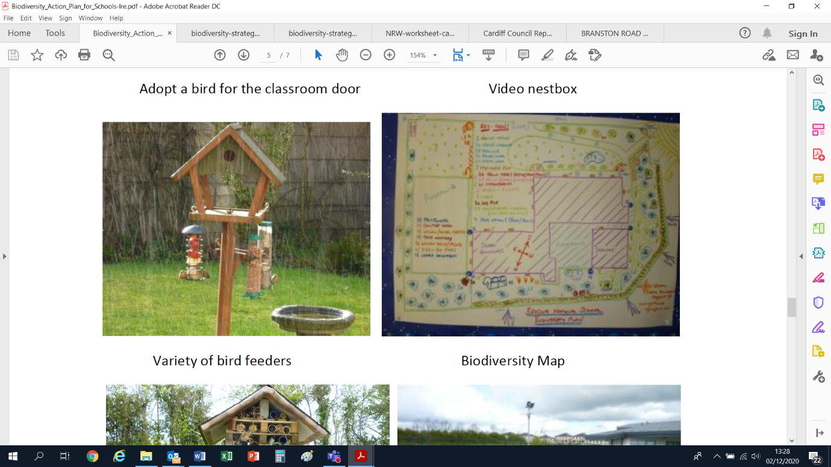
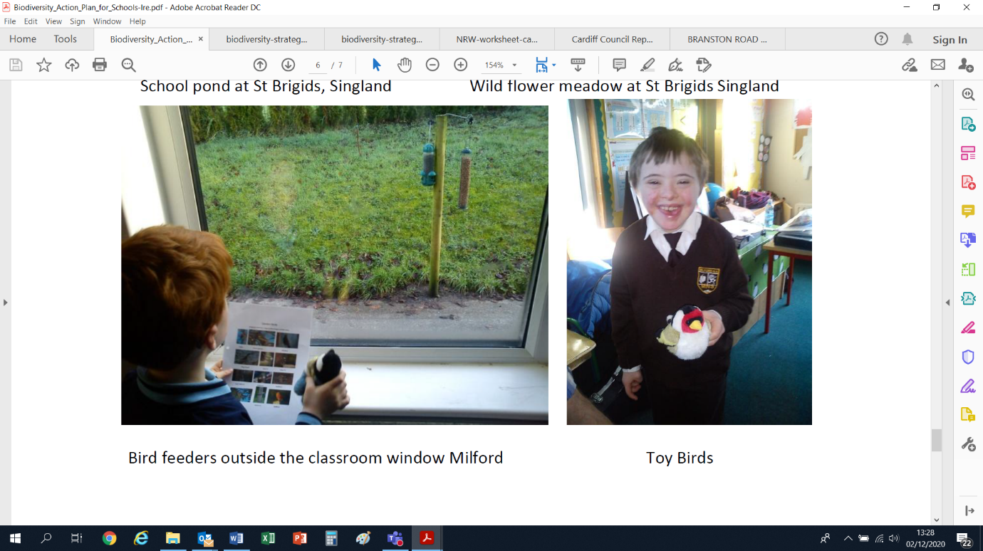
3. Provide food and water
By providing food for birds and other animals, you will help to attract them to your grounds where they can be watched and studied.
Different birds eat different foods in different ways and different places. Provide nuts, seeds, fat and kitchen scraps in feeders, trays and on the ground to allow for the various diets and feeding methods of many species, particularly in winter. Individual classes can add seed to different feeders or take turns maintaining one feeder. You should also grow trees, shrubs and flowers which provide seeds and berries for birds to feed on.
Move feeding places occasionally to guard against predators, disease and unwelcome visitors such as rats. Trees and shrubs provide cover, but keep in mind placing food too close to branches could attract seed-hungry squirrels. If squirrels are a problem, you could also invest in squirrel-proof feeders.
Bird feeders and shelters are particularly helpful during colder months, when food and warmth are scarce. In winter also dig over an area of bare ground to help birds like robins look for insects. Birds certainly need a lot of energy when they are caring for their young. Once you start feeding the birds, don't stop as they will come to depend on you.
Use sunflower seeds to attract the widest variety of birds. Choose black oil sunflower seeds, which are also known as "oilers." These have thin shells and easy for almost all birds to eat. You'll also find bags of striped sunflower seeds. These have harder shells, and smaller birds, such as sparrows, have trouble eating them.
Birds also need water for drinking and bathing, especially in winter if ponds are frozen - something similar to an old bin lid makes an ideal bird bath.
When thinking about providing food for bats, try to include plants from the following:
- Flowers that vary not only in colour and scent but also in shape
- Pale flowers that are more easily seen in poor light and thus attract insects at dusk
- Native wildflowers will attract far more species of insect that exotics
- Flowers that bloom throughout the year
Help insects by providing nectar and pollen rich flowers for as long as possible in the year. This means growing flowers like crocus and aubrieta in early spring right through to plants like sedums flowering in late autumn. Simple, old cottage garden plants which are easy for insects to get into are better sources of nectar then more complex highly bred flowers. Purple and blue flowers are particularly good at attracting bees. Avoid double headed flowers as these are less useful sources of food and it can be difficult for insects to get through the petals to the nectar.
Make a butterfly border of long-flowering, sweet-smelling, sun-loving plants. Plant them in a sheltered sunny spot and arrange to have some plants in flower all year round. Moths are attracted to night-scented stocks such as honeysuckle and evening primrose.
Host Plants for Butterflies
Plant | Butterfly
Meadow Vetchling | Wood White
Bird’s foot trefoil | Wood White, Common Blue, Dingy Skipper
Buckthorn | Brimstone
Cabbage family | Large White, Small White, Green-veined White
Lady’s Smock | Orange Tip
Dock or sorrel | Small Copper
Holly | Holly Blue
Nettle | Small Tortoiseshell, Peacock, Red Admiral
Thistle | Painted Lady
Grasses | Speckled Wood, Meadow Brown, Ringlet
For more advice visit:
- Wild About Gardens – Plant a butterfly border
- Wildlife Trust’s – Grow a bee and butterfly garden
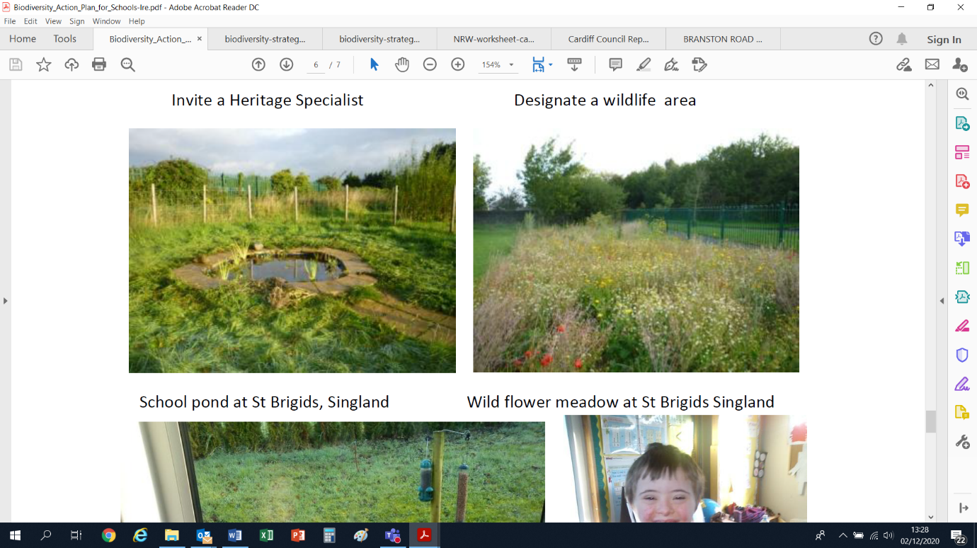
4. Wet areas
Water is vital for all living things, providing a source of water in your school grounds will increase the range of plants and animals that can survive there.
One of the most significant things you can do to encourage wildlife into your grounds (if it is safe to do so) is to build a small pond. Make sure you have a shallow end where amphibians can easily exit and leave an area of long grass. Don't add ornamental fish (or ducks) or they will eat your minibeasts! Piling logs around the edge provides extra hiding places for amphibians and insects.
Water provides a wealth of insects and many bat species feed over water for precisely this reason. Species like Daubenton’s bat and soprano pipistrelles are unlikely to be found when water is not present. Native marginal plants on pond edges and streams will encourage insects. Even a small marshy area will increase the biodiversity.
Most of the plants and animals that use ponds are highly mobile. If a wildlife friendly pond is created, it will soon be colonised by a variety of species.
Example pond plants
Marginal / Marsh plants | Arrowhead, Bogbean, Brooklime, Flag iris, Globeflower, Lesser spearwort, Marsh marigold, Marsh woundwort, Pillwort, Purple loosestrife, Ragged robin / white robin, Water forget-me-not, Water avens, Water mint
Surface plants | Frogbit, Water crowfoot, Waterlilies
Oxygenating plants | Hornwort, Spiked water milfoil, Water soldiers, Water violet
Avoid | Parrot’s feather, Fairy fern, Floating pennywort, New Zealand pygmyweed, Himalayan balsam, Water lettuce
As your pond and the plants establish over time, it will need rotational clearance of a proportion of the vegetation and, as it infills with sediment and dead vegetation, some periodic dredging. For a well vegetated, small sunken container-type pond this may happen quite quickly, but it is an easy enough task to carry out to maintain it with open water. Bare pond edges are particularly susceptible to colonisation by invasive non-native plant species.
It is likely in the first few years of your pond being established that green algae will build up. This may subside over time as the nutrient cycle adjusts but ensuring a large area of the pond surface is covered by native oxygenating plants will help keep algae under control.
For more advice visit:
- Wildlife Trust’s – Make a wildlife pond
- Wildlife Trust’s – How to make a bog garden
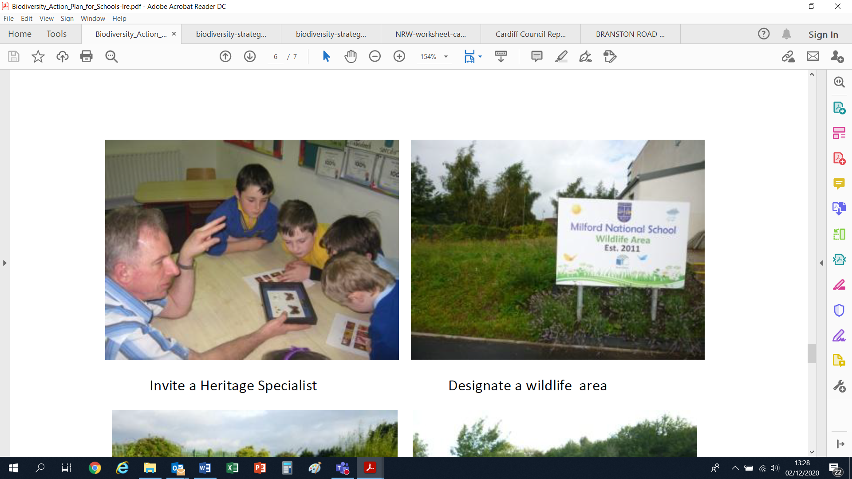
5. Wild areas
Undisturbed ‘wild’ areas where grass and wildflowers grow can provide valuable shelter and food for wildlife, including minibeasts. Create a sign to show the area has been deliberately left for nature to avoid it being disturbed or accused of being just ‘messy’.
You could let the grass grow longer in areas not needed for sports or play. Cutting less frequently will allow more species to thrive and create more diversity of plant heights beneficial for different insects. This would be particularly useful adjacent to mature trees and hedgerow or wet areas as wildlife will be able to travel more safely from one habitat to the next.
For more advice visit:
- Plantlife – No Mow May
- Wildlife Trust’s - How to grow a wild patch
Leave a pile of rotting logs for insects to live on. Damp log piles also create an ideal winter home for hibernating frogs, toads and newts. Put piles of leaves and stones under your hedge and leave an area of grass a little longer. This does not just help insects to live and survive winter but other animals like voles, hedgehogs and amphibians.
Create a ‘bee bank’ for mining bees by leaving a mound of bare soil for them to burrow into. Sandy soil in a warm spot is best and install a small barrier to avoid it being trampled on.
You could also build several ‘bug hotels’. Make sure they are secure and well positioned (for example avoid where they will receive too much direct sunlight), avoid plastic tubing and glues, and give it a good roof to reduce mould build up. To avoid unnaturally high aggregations of nesting bees, it is recommended to use lots of smaller bug hotels spaced around the site. Each bug hotel should focus on different sized entrance holes to provide suitable nesting sites for a wide range of solitary bee and wasp species. It is far better to create multiple small areas than attempt to house unsuitable species together in one giant bug hotel.
Annually inspect bug hotels and remove old debris from previously used and unoccupied structures such as hollow tubes (reeds, bamboo etc). Change the nesting blocks or parts every few years. This will help reduce the build-up of diseases and parasites. Be careful not to disturb any occupied tubes.
You may be thinking about installing a beehive to collect honey. Whilst this can be a great activity to teach pupils about food growing and insects, it is not the best solution for increasing pollinators as honeybees will compete with other species for resources. If you are planning on introducing a hive, ensure there is sufficient access to wildflowers for more than your introduced bees and avoid entirely if your site is adjacent to a protected area (such as an SSSI).
For more advice visit:
- Wildlife Trust’s – How to build a hibernaculum (for amphibians and reptiles)
- Buglife – How to build a bee bank
- Biodiversity in Schools – Build a solitary bee bank
- Wildlife Trust’s - How to make a bee hotel
- Buglife – Honeybee advice
Wider Actions; protecting your local environment
1. Use the classroom to demonstrate good practice for the environment: recycle waste and use water and energy wisely.
Install a water but to collect rainwater and use it to water your new habitat areas. This will decrease your water waste and save money on bills.
Ensure lights and electronic equipment are turned off when not in use. If your sports pitches have lighting, avoid leaving them on overnight, reduce ‘spill’ by directing lights downwards (you could retrofit with a baffle or shield), and ideally an amber hue should be used. This will decrease the negative impacts from light pollution upon bats and other nocturnal wildlife.
Install recycling bins for plastic, glass, paper, and cans. Encourage staff to reuse paper and avoid printing whenever possible. Talk to the administration about purchasing recycled paper for teachers and staff to use. Additionally, swap plastic and Styrofoam cafeteria containers and utensils for reusable or biodegradable options.
For more advice visit:
- RHS – Water: collecting, storing and using
- Recycle now – Set up recycling at your school
- Veolia – Tips for successful recycling in school
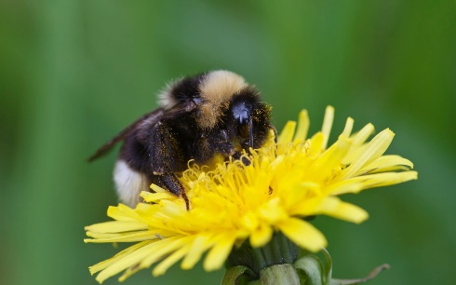
2. Don’t use pesticides or herbicides or compost containing peat.
Chemical pesticides and herbicides can kill beneficial species, such as pollinating insects. Harmful chemicals can also spread throughout the food chain and contaminate the water table.
Promoting native species or manual weeding might help to keep invasive and competitive species in check. Plants which made be viewed as “weeds” could actually be a vital part of the ecosystem; for instance, dandelions are some of the first sources of nectar for bees and nettles are a valuable food source for butterflies. Creating a balance within the ecosystem through companion planting and encouraging birds can help keep pests at bay.
Use chemical agents only as a last resort and in consultation with the local authority. If you have an invasive plant or animal species issue, contact the local authority or Natural Resources Wales.
Commercial peat extraction has damaged fragile, wild habitats and releases large quantities of CO₂ into the atmosphere, so buy peat-free compost or make your own.
For more advice visit:
- Garden Culture Magazine – Leave the weeds
- The Spruce – Companion planting
- RHS – Compost advice for schools
3. Encourage pupils and staff to walk, cycle, or carpool.
Reducing vehicle emissions will benefit wildlife that lives on and around your school grounds. Since driving is often unavoidable, create a carpool sign-up sheet at the beginning of the school year. There are also apps and websites that help organize carpools for schools and businesses. Additionally, you could push for lower-emission vehicles when mini-buses are replaced.
For more advice visit:
- Sustrans – How schools can promote an active school run
4. Join a conservation organisation
Join a conservation organisation like The Wildlife Trust as a school member. Join Eco-Schools or continue to work towards the higher awards.
5. Each term, the school could pledge to ‘Do One Thing’ for nature.
Activities could include seed planting, creating mini-beast habitats, feeding wildlife, creating wildlife homes and water habitats.
For more advice visit:
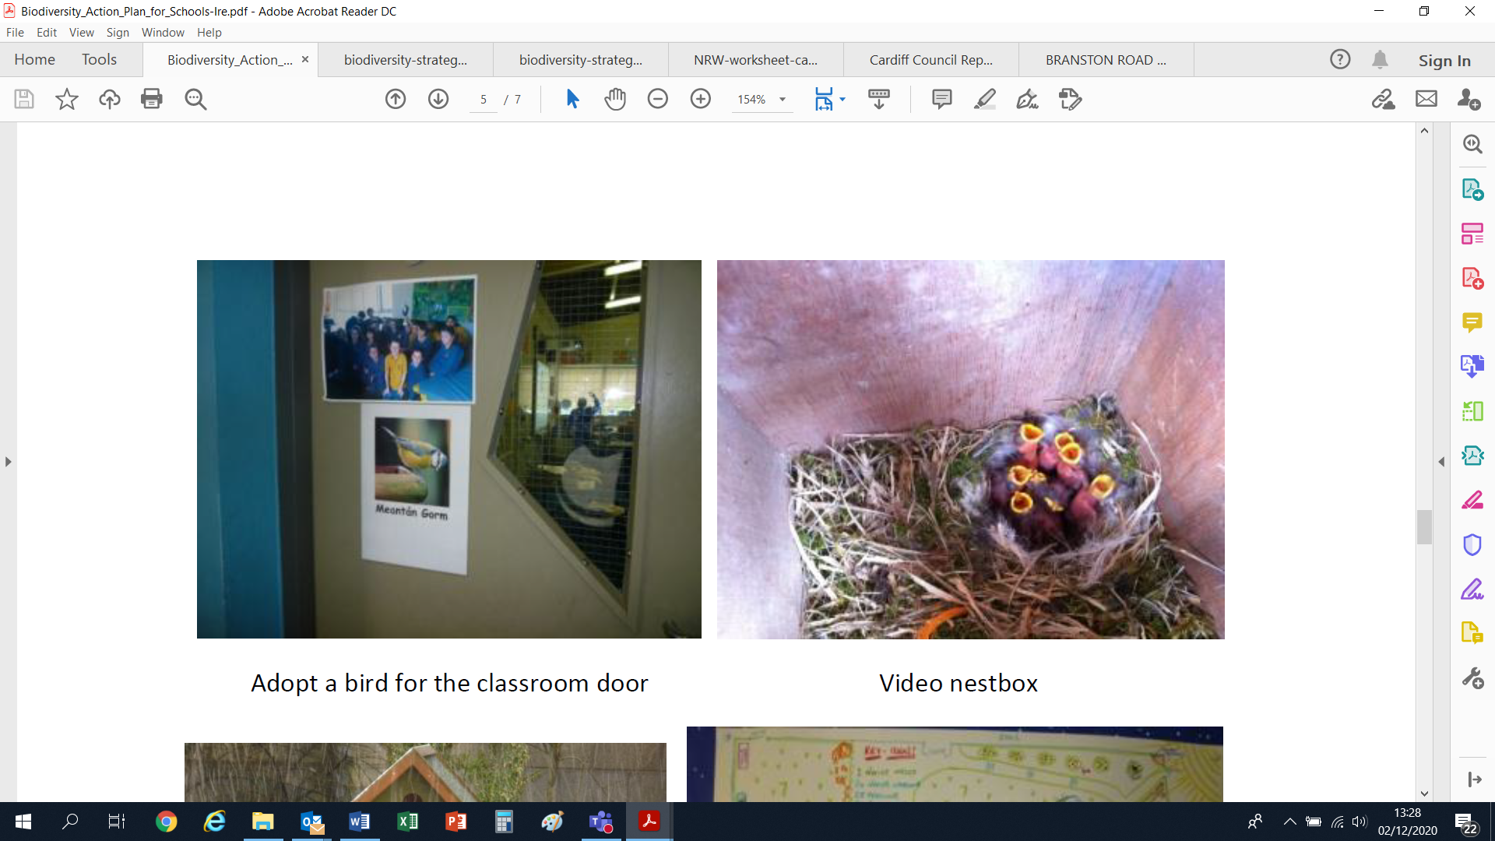
- Wildlife Trusts – 30 Days Wild Schools

Project ideas and educational resources
Organisation | Activity / Resources | Description | Resource Link
Amphibian and Reptile Conservation Trust | Educational resources | Amphibian and reptile learning resources, including ID sheets and activities | https://www.arc-trust.org/education
 | Snakes in the Heather project resources | Smooth snake conservation project resources | https://www.arc-trust.org/snakes-in-the-heather
Bat Conservation Trust | Educational resources | Factsheets about bats | https://www.bats.org.uk/resources/education-outreach-resources/resources-for-teachers-youth-leaders/explore-the-world-of-bat-conservation-through-the-national-curriculum
Bridgend Council | Educational resources | Nature based lesson plans, split into key stages | https://www.bridgend.gov.uk/residents/schools-and-education/outdoor-education/
Buglife | Educational resources | Activities focussing on insects | https://www.buglife.org.uk/get-involved/children-and-schools/activities-for-schools/
 | B-Lines resources | Pollinator facts and activities | https://www.buglife.org.uk/get-involved/children-and-schools/b-lines-school-pack/
Butterfly Conservation | Munching Caterpillar resources | Butterflies and moths learning resources, including ID sheets and activities | https://munchingcaterpillars.org/resources/
Coastal School | Beach Academy Wales resources | Learning resources based on coastal ecosystems | https://www.beachacademywales.com/athome
Eco-schools | Eco-schools resources | Award framework to help schools become more sustainable, range of learning resources based on ten environmental topics | https://www.eco-schools.org.uk/
Forest School | Forest School | Training and support for setting up forest school sessions | https://www.forestschoolassociation.org/what-is-forest-school/
Hwb Cymru | Outdoor learning handbook | Guidance on outdoor learning, including risk management and involving parents/carers | https://hwb.gov.wales/storage/fcb8539c-9be7-4883-8542-35d7b54b56f2/foundation-phase-outdoor-learning-handbook.pdf
Learning Through Landscapes | Educational resources | Outdoor learning resources, sorted by key stage, curricular area and age suitability | https://www.ltl.org.uk/free-resources/
Magnificent Meadows | Magnificent Meadows resources | Plant ID and management advice for meadows | http://www.magnificentmeadows.org.uk/visit-learn/school-activities
Marine Conservation Society | Beach Clean resources | Coastal litter pick resources | https://www.mcsuk.org/media/gbbc-sourcetosea-education-resource.pdf?fbclid=IwAR00CnMdyFLTT3L92GiXJuz6SUulfXaq102rjZQI2wkE2-FgK5PvDwuuxL4
 | Cool Seas resources | Marine and coastal learning resources | https://www.mcsuk.org/coolseas/
 | Ocean literacy resources | Ocean literacy resources | https://www.mcsuk.org/oceanindoors/educate
 | Plastic Free Challenge | Reducing plastic resources | https://www.mcsuk.org/campaigns/plastic-challenge-faq
Monmouthshire County Council | Nature Isn’t Neat resources | Planting for pollinators resources | https://www.monmouthshire.gov.uk/nin/
Natural Resources Wales | Outdoor learning resources | Range of environmental learning resources, linked to subjects | https://naturalresources.wales/guidance-and-advice/business-sectors/education-learning-and-skills/looking-for-learning-resources/learning-resources-search-by-topic/?lang=en
People’s Trust for Endangered Species | Educational resources | Learning resources, mainly mammal focussed | https://ptes.org/get-informed/education-resources/
 | Help Hedgehogs resource | Top tips for creating hedgehog friendly spaces | https://www.hedgehogstreet.org/help-hedgehogs/
 | Log pile for stag beetles resource | Guide on creating a friendly space for stag beetles | https://ptes.org/wp-content/uploads/2019/06/Build-a-log-pile-for-stag-beetles.pdf
RSPB | Educational resources | Environmental learning resources, including ID sheets and activities | https://www.rspb.org.uk/fun-and-learning/for-teachers/lesson-plans-and-supporting-resources/
 | Wild Schools Challenge | Award framework to develop pupil’s outdoor knowledge | https://www.rspb.org.uk/fun-and-learning/for-teachers/schools-wild-challenge/
SEWBReC | Educational resources | Links to range of wildlife based educational resources | http://www.sewbrec.org.uk/sewbrec-surveys/home-based-wildlife-resources-for-children.page
Size of Wales | Educational resources | Environmental learning resources to learn about wider world’s ecosystems, includes classroom activities | https://sizeofwales.org.uk/education/education-resources/
Wales Biodiversity Partnership | Vale Local Nature Partnership | Local support group for nature enhancements | https://www.biodiversitywales.org.uk/Vale-of-Glamorgan
 | Environmental Volunteering Toolkit | Wales wide environmental volunteering opportunities and ideas | https://drive.google.com/file/d/1AX0lWNvFPbotefgiXSARaEaLG9z0AYwZ/view
 | Invest in Nature Resources | Range of environmental resources, including guide of simple actions to help nature | https://www.biodiversitywales.org.uk/Invest-in-Nature---Resources
 | Wales Nature Week | Range of environmental resources celebrating nature in Wales, annual event usually in summer (May / June) | https://www.biodiversitywales.org.uk/Wales-Nature-Week
Wild About Gardens | How to plant a butterfly border resource | Guide to develop an area for butterflies | https://www.wildaboutgardens.org.uk/sites/default/files/2020-02/Grow%20a%20secret%20garden%20for%20butterflies%2C%20Wild%20About%20Gardens%202020.pdf
Wildlife Trusts | 30 Days Wild resources | Challenge to do one 'wild' thing a day every day throughout June, includes activity ideas | https://www.wildlifetrusts.org/30DaysWildStayWild
 | Action for Insects resource | Guidance on creating insect friendly spaces | https://www.wildlifetrusts.org/take-action-insects-your-school
 | Actions for Wildlife resources | Range of environmental resources, including guidance on creating habitat areas | https://www.wildlifetrusts.org/actions
 | Mini pond resource | Guidance on creating a small pond | https://www.wildlifetrusts.org/actions/how-create-mini-pond
Woodland Trust | Nature Detectives resources | Range of environmental resources, including guidance on planting and caring for trees | https://www.woodlandtrust.org.uk/blog/2020/03/nature-detectives/

Creating and maintaining allotments and orchards
- Plan what you want to achieve, choose the location, and design your layout accordingly:
- Size – e.g. for schools with limited space, fruit trees can be trained to grow across walls and fences
- Key elements – e.g. raised beds, gardening tools, greenhouse/poly tunnels
- Types of growing beds, plants, and fruit tree species
- Arrangement of plots – e.g. a sheltered, sunny south or southwest facing area is better for fruit development
- Access, paths, and seating areas
- Clear the plot of unwanted materials and debris. Aim to clear in early spring, in time for early planting and sowing.
- For allotments
- When clear of weeds the soil can be broken up and organic matter added by digging or rotovating, or while building raised beds. Alternatively, you could try a ‘no dig’ system by laying down cardboard and building up layers of organic matter. Outfit the plot with tools, compost bins and other useful items. Vegetation can be buried as green manure after removing the roots of perennial weeds.
- For orchards
- bramble, nettle, thistle, and other weed species can be controlled by regular mowing, hand pulling or digging. Herbicides should not be used.
- Plant out your allotment / orchard plots. It’s a good idea to arrange parent and community volunteers to help staff and pupils with planting. This will save time, effort and create a wider sense of ownership.
- For allotments
- Start to create vegetable plots that have areas of biodiversity interest by planting flowers that attract bees, hoverflies and other beneficial insects for pollination
- Take advantage of companion planting to control pests and get the best yields
- Plant shrubs at the perimeter that produce berries in the autumn and winter (to attract birds)
- Mix up your plots for variety
- For orchards
- Select and plant the trees. Bare rooted trees should be planted from December to March, when they are not in leaf, but not during periods of frost. Trees in containers can be planted at any time.
- Choose a variety of orchard species
- Incorporate wildflowers and other environmental features which attract insects. Attracting insects will help to pollinate your orchard
- Plant shrubs at the perimeters. Shrubs that produce berries in the autumn and winter will attract birds to your orchard
- Maintain your allotment / orchard plots (for more advice see the seasonal checklist below). During the summer holidays keep a task board updated, and those who come to tend the resources during the summer can be rewarded by taking a share of produce home.
- For allotments
- rotate vegetables annually to avoid nutrient deficits in your soil and manage pests, although you may want to leave certain plants in the ground until after flowering in order to collect the seeds and to let insects overwinter in the hollow stems
- For orchards
- Manage your grassland around the fruit trees. For grass at the tree base maintain sward height between 5 and 15cm, to both aid growth of the fruit tree and allow access.
- Rough grass on the edges of the orchard can be left unmown or managed to provide a wildflower area, to attract bumblebees and insects
- (see more advice on maintaining fruit trees in “Hedges, trees, shrubs and wildflowers” section in top tips above)
Allotments and orchards seasonal checklist
Month | Planting advice | Maintenance tasks | Nature to look out for
September | Broad beans and spring cabbage. | Harvest black and red currants, French and runner beans, courgettes and salad. Keep on top of weeding and pest control. | Shrubs forming berries. Summer migrants leaving, like swallows.
October | Plant out cabbages. | Harvest apples, pears, plums and any other remaining fruit. Store excess fruit in a cool place. Lift and dry main crop potatoes. Continue weeding. | Birds and animals like the hedgehog feeding on windfall fruit.
November | Early peas under cloches. Plant fruit bushes such as blackcurrant. | Shred woody and non-thorny prunings and other tough stems and use them as a mulch around shrubs, fruit trees and as cover for paths. | Winter migrants arriving (such as fieldfare, redwings and waxwings).
December | Continue to plant any fruit bushes. | Start feeding birds when their natural food stores, such as shrub berries, run low. | Look out for birds visiting the bird feeding station, such as tits, finches and robins.
January |  | Harvest any parsnips and cabbage family. Dig over beds and add manure and compost (if not done in December). Keep bird feeding station topped up. | Winter visitors, such as the waxwing, feeding on shrub berries.
February | Sow early peas (under cloches). | Prune and/or shape bush and tree fruits in allotments and orchard before their buds start to burst. Continue to dig allotment beds. | Winter visitors, such as the fieldfare, feeding on apples and berries.
March | Start to sow early vegetable crops outside (e.g. beetroot, parsnip, turnips and spinach). | If beds dug over and weed free, mark out read for sowing seeds. Spread further (peat free) compost. | Garden birds feeding and preparing to breed. Look out for frogs and toads returning to the pond to spawn.
April | Complete sowing of vegetables (e.g. onion sets, main crop potatoes, and winter cabbages) and flower seeds (e.g. marigolds, parsley and comfrey). | Leave self-sown annuals (e.g. marigolds and alyssum) to grow and flower among food crops where they will attract beneficial insects). Harvest purple sprouting broccoli. | Tits (blue, great and/or coal) nesting in nest boxes near the orchard and allotments.
May | Sow salad (radishes, lettuce, rocket), courgettes and runner beans | Hoe regularly to kill seedling weeds growing between vegetables. Treat slugs with eco-friendly slug pellets. | Watch nesting tits feeding their young. Look out for bees and hoverflies starting to pollinate.
June | French beans and salad crops. Plant out leeks. | Make as much garden compost as possible from garden waste. Keep fruit bushes well-watered. | Look out for butterflies, bees and an array of insects.
July | Continue with salad crops. | Harvest strawberries and salad crops. Continue active weeding and thin out any vegetables too close together. | Butterflies, dragonflies, swifts and swallows.
August | Sow early winter lettuces and spring cabbages. | Harvest raspberries, salad crops, keep on top of weeding. Water if necessary. | Insects, butterflies, and bees visiting late flowering plants.

