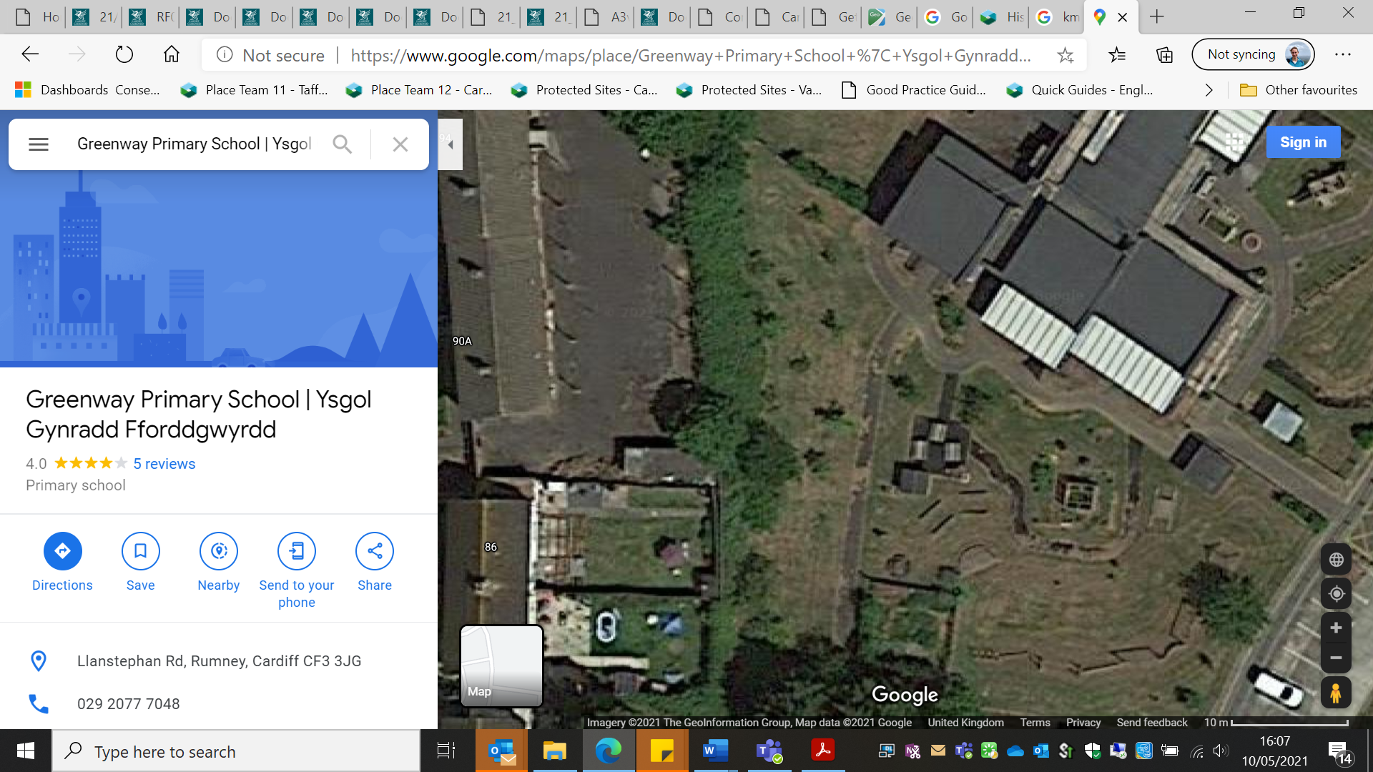

Wildflower strip, approx. 20m

Mown path through the orchard

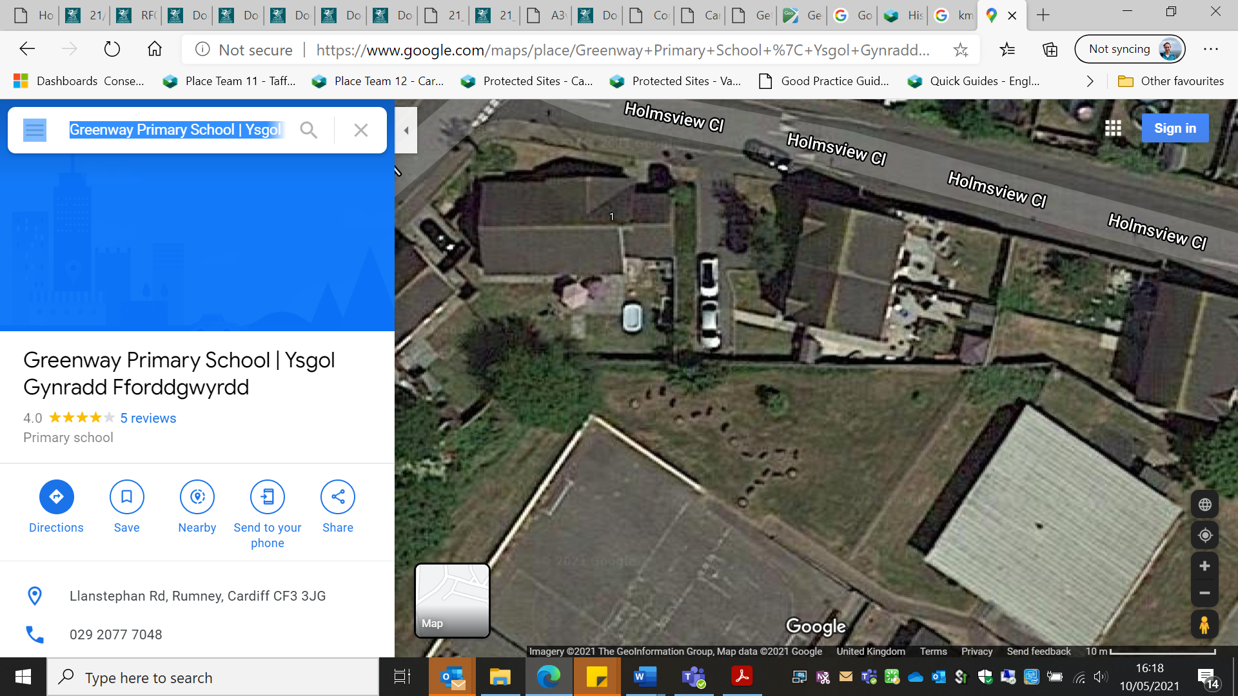

Pond to be created here

Hedging plants to be planted here

