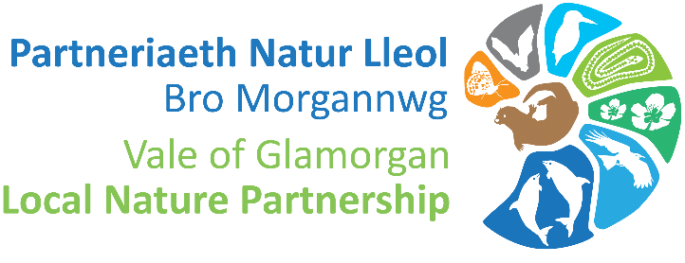

Vale Local Nature Partnership Biodiversity Grant Scheme 2023/24

The Vale of Glamorgan Local Nature Partnership are looking for biodiversity projects from local organisations and groups in the Vale of Glamorgan, which will deliver on our aim to maintain and enhance biodiversity and promote the resilience of ecosystems. Your project must engage and have impact with the local community and benefit biodiversity using the funding provided. The funding of this grant is made possible through the Local Places for Nature Scheme, funded by Welsh Government.
Maintain and enhance biodiversity means looking after those special places for wildlife through management, recording and surveying – there are lots of ways we can improve green spaces for nature.
Ecosystem resilience is the capacity of an ecosystem to deal with pressures, changes and demands, either by resisting, recovering or adapting to them to benefit now and into the future.

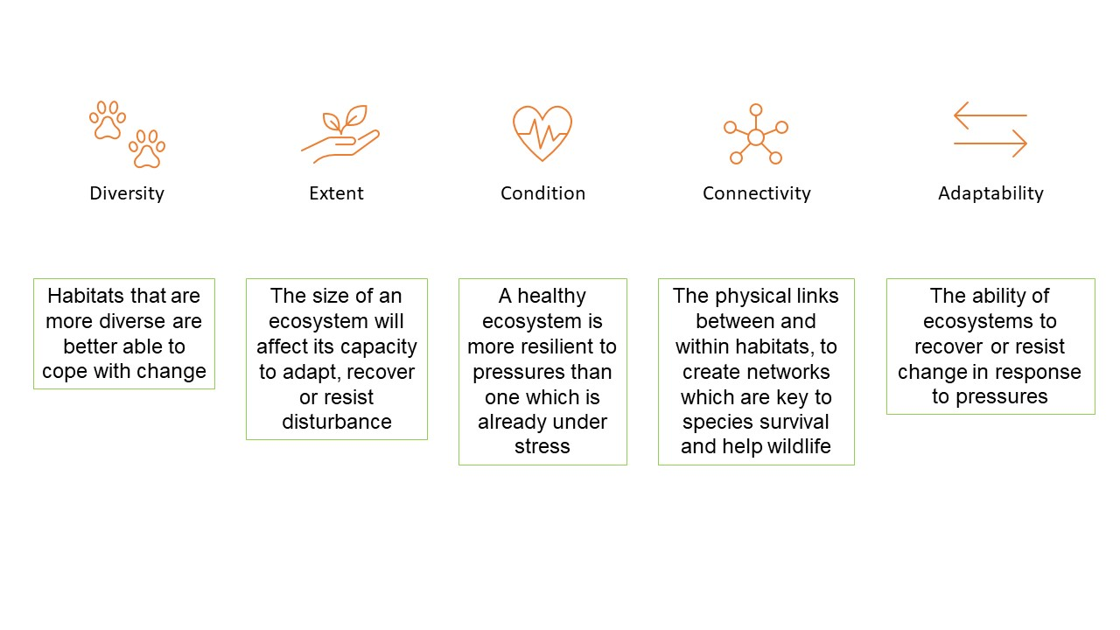
Projects should demonstrate how they will address the five attributes of ecosystem resilience above.

Grant Scheme

The Grant Scheme will be open for applications between Monday 16 October and Monday 22 November 2023. All project costs must be met before Thursday 29 February 2024.

Grant Scheme open: Monday 16 October 2023
Deadline to apply: Monday 20 November 2023

If you are applying on behalf of a school or education setting, you will need to contact us in advance of submitting an application. Please email: laldridge@valeofglamorgan.gov.uk

Tier One – up to £500
For the provision of tools, materials and resources, aimed at habitat creation and/or management, and public engagement.

Tier Two - £500 to £5000
For the provision of larger scale works, aimed at habitat creation, restoration and/or management using contractors.

Items that do not qualify for funding include:
Non-native planting; signage; landscaping including gravel, patio slabs, fencing, benches and seating; play equipment; revenue costs including staff/volunteer time and venue hire. Please get in touch if you are unsure of the eligibility of your proposed items.

Grant Criteria:

Budget
- The grant scheme funds capital costs only – no revenue costs can be included such as staff/volunteer time and venue hire.

- All materials and equipment will be purchased on behalf of the applicant.

- All items in the budget sectoin must include a url link to each item as this is essential for us to process the orders.

- This scheme provides applicants with an opportunity to bid for either up to £500 towards tools and resources, or between £501 and £5000 towards larger works.

- Applicants bidding for over £500 will be required to seek advice from the contact listed within the application form.

- Projects must show value for money and preferably draw in cash or in-kind contributions from other sources.

- Only bid for what you actually need, the budget ceilings are not targets for expenditure. By reducing consumption, we can make the world a better place for people and wildlife.

- Bids will be welcome that can demonstrate, in addition to the requested items, effective use and reuse of existing equipment and resources.

Eligibility
- The project location must be accessible to members of the public in order to receive grant funding.

- If you are applying on behalf of a school or education setting you must contact us in advance of submitting an application. Email: laldridge@valeofglamorgan.gov.uk

- Applicants can apply again to a future funding round, as long as it is not to fund a previously funded project including its maintenance.

- Applicants should indicate how their project will deliver lasting benefits, especially if ongoing management will be required after the grant funding is spent.

- Please see supporting documents, including a list of suggested suppliers to help you source items. We encourage applicants to consider sourcing locally where possible.

- Where projects involve species recording, recipients must submit all species records to South East Wales Biodiversity Records Centre.

- Planting must only include native species, be of local provenance where possible and be necessary. Don’t be afraid to let nature take its course.

- If your project involves meadow creation and/or management, please get in touch to discuss the provision of wildflower seed if required.

Insurance and Evaluation
- Recipients must have suitable public liability insurance for any work carried out under the scheme.

- Recipients must agree to maintain equipment for a minimum period of 5 years at their own cost, as a criteria of funding from the Welsh Government.

- All successful recipients must complete a case study by 31 March 2024 and a form will be supplied in advance.

Developing your project:

Gather baseline data about the types of habitats and the biodiversity which exists in your project area and surrounding areas. Record wildlife sightings and submit your data to South East Wales Biodiversity Records Centre.

Think about the current threats and pressures on local nature.

What are your goals? Examples could include:
- Improve understanding of nature and ecology within your community.
- Develop and enhance suitable habitat for a priority species important to your local area.
- Restore and maintain local habitat to promote a range of biodiversity.

Who will be responsible for delivering and maintaining the project?

How will you monitor change to see if your actions have been successful?

There is lots of useful guidance and advice online about developing biodiversity projects, please find a selection below for best practice:

ARC Amphibian and Reptile Conservation Trust
Buglife
Bumblebee Conservation Trust
Butterfly Conservation Trust
Plantlife Meadows Hub
PONT Conservation Grazing
RSPB
Wales Biodiversity Partnership
Wildlife Trust South and West Wales
Woodland Trust

Get help before you apply!
Guidance:
We advise all applicants to seek advice on developing your project before you apply, please get in touch with the following contact below:
Lauren Aldridge - Local Places for Nature Assistant
laldridge@valeofglamorgan.gov.uk

Application Form
Application Form

Contact details
Applicant name: | Applicant address:
Phone: | Email:
Are you applying on behalf of a group or organisation? If so, please supply name and registered address:

Project details
Project Title:
Project Location and Site Permission

Postal Address:

OS Grid Reference:

What 3 Words:

Insert Site Map (Google maps or GIS screenshot) and photograph of the site below:

Have you secured permission from the landowner? Yes / No (delete as appropriate)
Please provide full contact details for the landowner:

Project start date:
Project completion date:

Number of volunteers involved:

What existing wildlife and habitats have you observed in your project location?

Please provide an outline of your proposed project:

Which species or habitats will benefit from the proposed works?

Which of the five aspects of ecosystem resilience will your project protect or enhance? Please explain how:

Project engagement and evaluation
Does the project increase public engagement with or understanding of our natural environment?) Yes / No (delete as appropriate

Please explain how you will engage the public during the project:

Would people engaged in your project benefit from any of the following training? Please note that the training should have relevance to your project and we can only run training where there is sufficient demand:

Wildlife recording ☐

Scything ☐

Hedge laying ☐

Orchard management ☐

How will you evaluate and record the impact of your project?

I agree to supply a written case study on completion of the project and before 31 March 2024. Yes / No (delete as appropriate)

Project budget
The grant sum awarded will be decided by the grants panel and items will be selected on whether they meet the criteria to enhance or increase biodiversity and ecosystem resilience, are appropriate for your site location and are value for money. Items may differ from what has been requested and not all items may be purchased.
Please list proposed project items below including supplier details, item description and URL, and costs excluding VAT:
Details of costs | Cost (excluding VAT)
Item Description and URL link | £ exc. VAT
Total cost

Grant requested

Please provide details of any other sources of funding for your project including cash and in-kind contributions. State ‘None’ if the project is to be solely funded by the Vale Nature Partnership grant.

Other
Is the project location accessible to the public? Yes / No (delete as appropriate)
Please note the location must be accessible to the public in order to receive funding

Have you contacted the Vale LNP regarding your application? Yes / No (delete as appropriate)

If Yes, please state who:

Declaration
I have read and understood the ‘Notes for Applicants’. To the best of my knowledge the information supplied with this application is correct.

If successful in my application, I agree to maintain any equipment supplied for a minimum period of 5 years at my own cost.

Signed:
Date:

All information contained in this application will be handled in accordance with the Vale of Glamorgan Council’s privacy policy.
Please send your completed application and any supporting documents to laldridge@valeofglamorgan.gov.uk by Monday 20 November 2023.

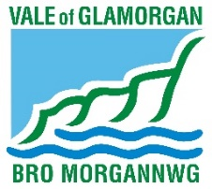
Vale Local Nature Partnership is hosted by Vale of Glamorgan Council

