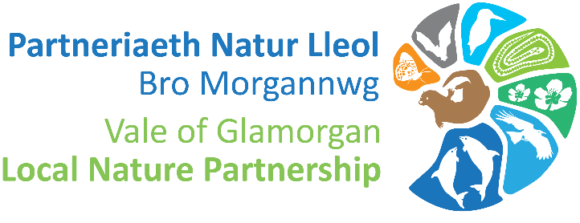

Vale of Glamorgan Nature Partnership Project Community Grant 2021/22

The Vale of Glamorgan Nature Partnership are looking for projects which will deliver upon our aim to maintain and enhance biodiversity and promote the resilience of ecosystems.
Maintain and enhance biodiversity means looking after those special places for wildlife through management and survey and creating new areas through changing how they are managed. It may be by planting trees and shrubs, putting up nest boxes, changing the mowing of grassland, digging a pond, creating a new meadow – there are lots of ways of improving things for nature.
Resilience means the capacity of ecosystems to deal with change, by resisting them, recovering from them, or adapting to them. There are five attributes of resilience which can be summarised as:
- Diversity: Habitats with more species are more able to adapt to change
- Extent: In this case, bigger is better, as habitats are less vulnerable to change
- Condition: a healthy habitat is more resilient to pressures than one which is already under stress
- Connectivity: The ability of species to move between habitats is key to their survival. The connections between natural areas are as important as the areas themselves
- Adaptability: The ability of ecosystems to adapt to change is key in ensuring that they continue to support life on Earth

Projects which address as many of these attributes as possible will be looked upon favourably.

The Vale Nature Partnership grants scheme allows local organisations and groups in the Vale of Glamorgan to apply for £500 worth of resources to support projects that deliver upon our aim of maintaining and enhancing biodiversity in the Vale of Glamorgan.

Notes for applicants
- Please note this scheme does noes not provide cash grants
- This scheme provides applicants with up to £1000 of resources which is selected at application stage.
- The Local Nature Partnership will purchase materials and equipment of up to £1000 on behalf of the applicant, please outline carefully what it is you wish to be purchased in Section 4. Please include supplier details, a product weblink, quantities and cost.
- Please see supporting documents to help you complete your application.
- Please see the list of suggested suppliers, however other suppliers can be used. We encourage applicants to support local business and source products locally where possible.
- In the interest of equal opportunities, you will not be able to submit a new application if you have received a grant from this scheme in the last 12 months.
- Projects must show value for money and preferably draw in cash or in-kind contributions from other sources. Applicants should also indicate how their project will deliver lasting benefits, especially if ongoing management would be required after the grant funding is spent.
- Recipients must have suitable public liability insurance for any work carried out under the scheme and must ensure that all work carried out complies Welsh Government guidelines and regulations to prevent the spread of Covid-19.

Top tips for creating a nature project!
- Gather baseline data about the types of habitats and the biodiversity which exists in your project area and surrounding areas.
- Think about the current threats and pressures on local nature (i.e., ground pollution, invasive species, and habitat loss/change).
- What are your goals?
Example goals:
- Improve understanding of nature and ecology within your community.
- Develop and enhance suitable habitat for a priority species important to your local area.
- Restore and maintain local habitat to promote a range of biodiversity.
- Who will be responsible for delivering and maintaining the project? (i.e., community groups, schools, students etc.)
- How will you monitor change to see if your actions have been successful?

- Use native species and source locally.
- Create a mosaic of different habitats to support greater biodiversity.
- Record wildlife and submit your data to SEWBReC, the local environmental record centre.

Examples of projects that have been undertaken in the Vale previously are hedgerow restoration, pond enhancement, supporting volunteer surveys, meadow creation, Adder monitoring and citizen science projects – but feel free to come up with something completely different!

Get help before you apply!
If you would like some advice on developing your nature project before you apply, please get in touch with either of the contacts below:
Alexis Alders (Natural Resources Wales) alexis.j.alders@cyfoethnaturiolcymru.gov.uk
Colin Cheesman (Ecologist) crcheesman@valeofglamorgan.gov.uk

Application Form

Contact details
Applicant name: | Applicant address:
Phone: | Email:

Project details
Project Title:
Project Location:
Project start date:
Project completion date:

What existing wildlife and habitats have you seen in your project location?

Please give a brief outline of your proposed project here:

Which species or habitats will benefit from the proposed works?

Which of the five aspects of ecosystem resilience will your project protect or enhance? Explain how:

How you will evaluate and record the success of your project?
How you will assess the progress your project makes for wildlife?

Project budget
Please outline how much funding you require, what it will be spent on and what other sources of cash or in-kind funding you will draw in.
Details of costs | Cost
e.g. 3 Schwegler 2F Bat Boxes from www.nhbhs.com @ £40.80 each | £122.40
Total cost

Grant requested

Details of any other sources of funding for your project. State ‘None’ if the project is to be solely funded by the Vale Nature Partnership grant.

Other
Is the project location accessible to the public? Yes / No
Does the project increase public engagement with or understanding of our natural environment? Yes / No
Please feel free to include any other relevant information here including how you will deliver your project in line with Covid-19 regulations:

Declaration
I have read and understood the ‘Notes for Applicants’. To the best of my knowledge the information supplied with this application is correct.

Signed:
Date:
Print name:

All information contained in this application will be handled in accordance with the council’s privacy policy.
Please send your completed application and any supporting documents to eshaw@valeofglamorgan.gov.uk by 7th January 2022

