Expressions of interest

Annexes 1 & 2, Old Hall, Cowbridge

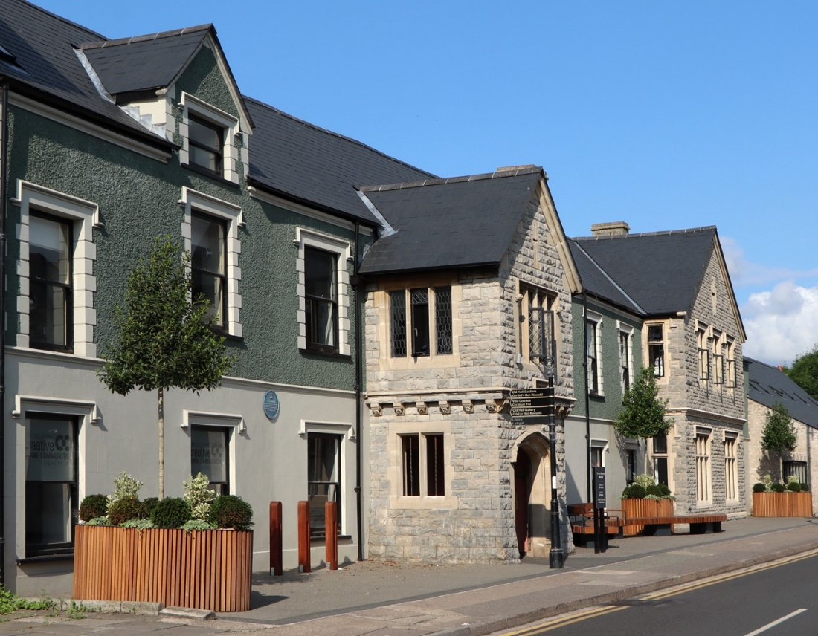

BIDS INVITED FROM INTERESTED PARTIES
This form is available in Welsh / Mae’r ffurflen hon ar gael yn Gymraeg

An exciting opportunity has arisen for businesses to apply to the Council to rent offices at Old Hall Annexes 1and 2.

Businesses are invited to submit expressions of interest for:

Use Class B1

Or

Another use may be considered subject to planning approval, but it will be the prospective tenant’s responsibility to ensure all consents are obtained.

Accommodation:
Annexe 1 – Ground floor consisting of 2 offices, kitchen and toilet.
Annexe 2- First and second floor consisting of 2 offices and 1 storage room. It has a shared access, toilet and kitchen. There is no lift.

Terms:
A new 3-year lease will be offered with the prospective tenant responsible for all rates, taxes and outgoings.

Repairs
The Council will put the accommodation into repair and then will be responsible for all external repairs with the prospective tenant responsible for internal repairs and decoration.

Expressions of Interest should be submitted no later than 12 Noon 22 May 2024 and include name and address, email address, which accommodation interested in and proposed use.

These should be emailed to: strategicpropertyonevale@valeofglamorgan.gov.uk with the reference EOI Old Hall in the subject bar.

Submitting an Expression of Interest does not commit you to making an offer for a lease. It also does not commit the Council to offering the premises for lease.

Misrepresentation Act

Whilst every effort is made to ensure that these particulars are correct, the Council cannot accept any liability whatsoever for any misrepresentation made either in these particulars or orally. Any interested party must satisfy themselves as to the accuracy of these details. The particulars are set out as a general guide only and do not form any part of an offer or contract.

