Date/Dyddiad | 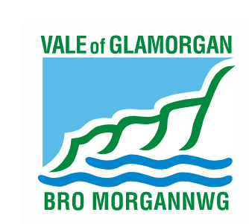  15/01/21  The Vale of Glamorgan Council  The Alps, Wenvoe CF5 6AA  Cyngor Bro Morgannwg  Yr Alpau, Gwenfô CF5 6AA  www.valeofglamorgan.gov.uk  www.bromorgannwg.gov.uk
Ask for/Gofynwch am | Stephen Irish
Telephone/Rhif ffôn | 01446 700111
Fax/Ffacs
e-mail/e-bost | visible@valeofglamorgan.gov.uk

My Ref/Cyf | Barry / NOTICE

Dear Resident

Re: Barry - Greening, Growing, Connected

Dear Sir / Madam,

The Vale of Glamorgan Council will be carrying out improvement works around Gladstone Road roundabout, junction with Court Road and along Gladstone Road, commencing on the 25/01/21.

The improvement works consist of the removal of existing hard surfacing and replacing this with wildflower gardens and trees, footway improvement works will also take place at the same time.

It is anticipated that the works will take approximately 9 weeks to complete dependent on weather conditions. Unfortunately, due to the nature of the works and the traffic management required a certain amount of disruption is unavoidable, however please be assured that every effort will be made to keep any disruption to a minimum.

Should you have any specific queries or concerns in relation to the proposed works please contact me using the above details.

Yours faithfully,
Stephen Irish

For Operational Manager - Engineering

