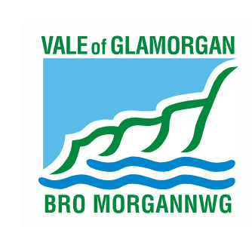

Vale of Glamorgan Council’s Age Policy for
Hackney Carriages and Private Hire Vehicles w.e.f
2 July 2019

CLASS | AGE FOR GRANT | 1  YEAR LICENCE | 6  MONTH LICENCE | 4  MONTH LICENCE
CLASS ONE | Under 6  years old | See advice below | Under 10 years old | Over 10  years old
CLASS TWO  8 seater mini bus type vehicles with an automated wheelchair lift. | Under 10 years old | See advice below | Under 10 years old | Over 10  years old

Class Two Vehicles

Must be Minibus type vehicles with an automated wheelchair lift. The wheelchair lift must remain fitted to the vehicle in order for the vehicle to remain licensed.

1 Year Licence

To qualify for a twelve month Hackney Carriage or Private Hire Vehicle licence, an application must be received by the Council within 15 working days of the first registration of the vehicle at the DVLA. The mileage at the time of application should be no greater than 500 miles. Evidence of DVLA registration must be submitted with the application.

Applicants are advised that evidence of DVLA registration for new vehicles can be provided through the Automated First Registration and Licensing (AFRL) process completed by a motor vehicle trader when the vehicle is first registered. You should ask your dealer to provide you with a copy of the AFRL certificate and submit this with your application. The applicant may be the second or a subsequent registered keeper but the applicant must demonstrate that there is no more than 15 working days between the date of first registration of the vehicle and transfer of the V5 registration to the applicant’s name.

Other suitable vehicles under six years old will be eligible for the grant of a 6 month licence.

Applications falling within these guidelines will normally be approved under delegated authority. Applications falling outside these guidelines will be referred to Committee for determination. Unless there are exceptional circumstances, an application falling outside the above criteria will normally be refused.

Applicants must satisfy themselves that the vehicle will meet the current specifications and conditions of licence before making any financial commitment. Details of the conditions for hackney carriage and private hire vehicles can be found at www.valeofglamorgan.gov.uk. Any questions on the suitability of a vehicle for licensing, should be sent to licensing@valeofglamorgan.gov.uk

