Date/Dyddiad | 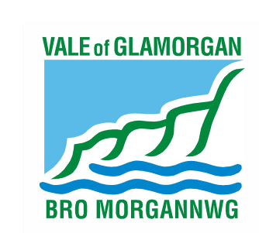  15 January 2016  The Vale of Glamorgan Council  Directorate of Learning and Skills  Provincial House, Kendrick Road, Barry CF62 8BF  Telephone: (01446) 700111 Textphone: (01446) 741219  Cyngor Bro Morgannwg  Dysgu a Sgiliau,  Tŷ’r Dalaith, Heol Kendrick, Y Barri CF2 8BF  Rhif ffôn: (01446) 700111 Ffôn testun: (01446) 741219  www.valeofglamorgan.gov.uk  www.bromorgannwg.gov.uk
Ask for/Gofynwch am | M Matthews
Telephone/Rhif ffôn | 01446 709727
Fax/Ffacs | 01446 709376
Your Ref/Eich Cyf
My Ref/Cyf | MM/CadoxtonSchools
e-mail/e-bost | MMatthews@valeofglamorgan.gov.uk

To: Parents and Guardians of children attending Cadoxton Primary School, Barry;
Parents and Guardians of children attending Cadoxton Nursery School, Barry;
Headteacher, Staff and Governors of Cadoxton Primary and Cadoxton Nursery Schools; and
Prescribed Consultees

Dear Consultee,

Consultation on the proposal to amalgamate Cadoxton Nursery and Primary schools

Further to my letter of 4 January 2016 outlining the Authority’s proposal to amalgamate Cadoxton Nursery and Primary schools, please find attached some supplementary information.

This document provides information on the alternatives that were considered and the reasons why they were not recommended.

Details of how to respond are in the original document and can be accessed at www.valeofglamorgan.gov.uk/cadoxtonschools . The closing date for comments is 15 February 2016.

If you have any queries relating to the consultation document or this supplementary information please contact Mike Matthews on 01446 709727 or MMatthews@valeofglamorgan.gov.uk

Yours sincerely,

A Brown

Anne Brown
School Organisation Manager

