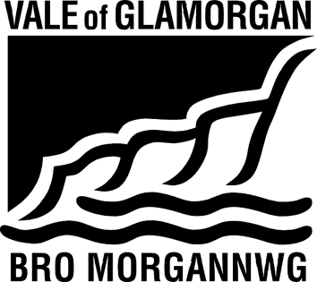

ADMISSIONS FORUM
18 November 2022, 11.00 PM.
Location: MS Teams/Go To
A G E N D A

- Apologies

- Minutes of the Previous Meeting (attached)

- Sustainable Communities for Learning (NS/KW/LL)

- Matters Arising

- Draft Annual Report of Admission Forum 2021-22 (attached) – all to comment

- Consultation on admission arrangements for 2024/2025 (policy attached) (MM/SM)

- Update on annual admission round to date (SM)

- Secondary
- Primary
- Coordinated arrangements

- Vale Welsh in Education Strategic Plan (WESP) (LL)

- Date for next meeting

Any Other Business

