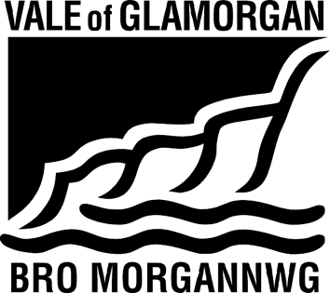

ADMISSIONS FORUM
19 November 2021, 12.00 PM.
Location: MS Teams/Go To
A G E N D A

- Apologies

- Minutes of the Previous Meeting (attached)

- Matters Arising

- Draft Annual Report of Admission Forum 2020-21 (attached) – all to comment

- Consultation on admission arrangements for 2023/2024 (attached) (MM/SM)

- Update on annual admission round to date (SM)

- Secondary
- Primary
- Coordinated arrangements

- 21st Century Schools update (NS/KW)

- Vale Welsh in Education Strategic Plan (WESP) (LL)

- Date for next meeting

Any Other Business

