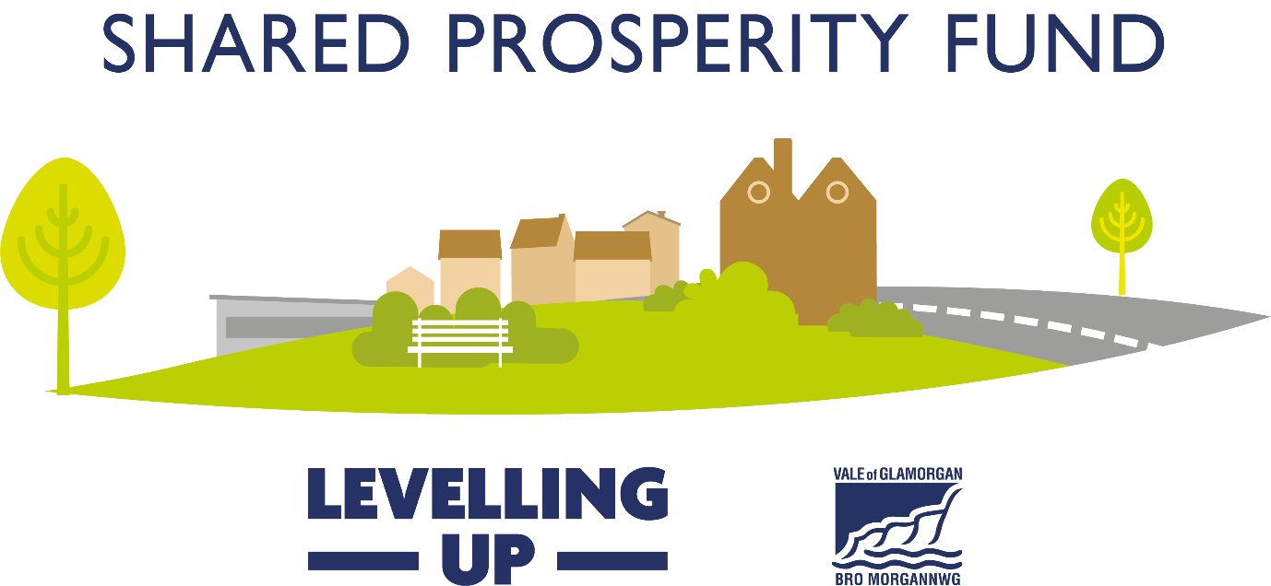
Guidance Notes
Before completing an application form, applicants are advised to read these Guidance Notes and then get in touch with the Shared Prosperity Fund team to discuss your project idea.
sharedprosperityfund@valeofglamorgan.gov.uk
What is the Shared Prosperity Fund?
The UK Government Shared Prosperity Fund (UKSPF) supports the government’s wider commitment to level up all parts of the UK and provides funding for local investment between 2022 and 2025. The primary aim of the UKSPF is to build pride in place and increase life chances across the UK. Underpinning this aim are three investment priorities. These include a range of eligible interventions which offer the opportunity to develop a flexible funding package.
The investment priorities are:
Communities and Place... to enable places to invest to restore their community spaces and relationships and create the foundations for economic development at the neighbourhood-level;
Supporting Local Business... to enable places to fund interventions that support local businesses to thrive, innovate and grow; and
People and Skills... to help reduce the barriers some people face to employment and support them to move towards employment and education. As part of the People and Skills priority there is a dedicated and ring-fenced element of the UKSPF called Multiply, which seeks to improve adult numeracy skills through free personal tutoring, digital training, and flexible courses
Each local authority has been given an allocation of the UKSPF. To access the allocation, each must outline its investment priorities further, and select a list of interventions relevant to the area. The interventions for the Vale of Glamorgan are as follows;

Vale of Glamorgan Interventions
Communities & Place

Improvements to town centres and high streets (W1)
Support for local arts, cultural, heritage and creative activities (W6)
Active travel enhancements and other small scale green transport projects (W7)
Impactful volunteering and/or social action projects (W9)
Community measures to reduce the cost of living etc (W13)
Relevant feasibility studies (W14)

Supporting Local Business

Development and promotion of the visitor economy (W17)
Research and development, supporting innovative product and service development (W19)
Enterprise infrastructure and employment / innovation site projects (W22)
Strengthening local entrepreneurial ecosystems (W23)
Training hubs, business support offers, incubators and accelerators (W24)
Supporting decarbonisation whilst growing local economy (W29)
Support relevant feasibility studies (W31)

People & Skills

Employment support for economically inactive people (W34)
Local areas to fund local skills needs (W39)
Tailored support for the employed to access courses (W38)
Support engagement and softer skills development for young people (W43)
Courses designed to increase confidence with numbers (W44)
Courses for parents wanting to increase numeracy skills (W45)
Courses for prisoners, those recently released or on temporary licence (W46)
Courses aimed at encouraging people to upskill to access jobs/careers (W47)
Additional relevant maths modules in vocational courses (W48)
Innovation programmes delivered with employers (W49)
Intensive and flexible courses for those without Level 2 maths (W50)
Courses designed to help with numeracy for managing money (W51)
Courses for 19s or over leaving or just left the care system (W52)
Provision developed in partnership with community organisations (W53)

All projects funded by the UKSPF in the Vale of Glamorgan, must align with one or more of the interventions listed above, and must contribute the outputs and outcomes associated with that intervention. (See Appendix A)

How do I apply?

Applicants must complete a Shared Prosperity Fund application form. Anyone considering making an application must contact the Shared Prosperity fund team before completing an application form, so that eligibility can be assessed at an early stage and projects can be directed to the correct application form depending on investment category (e.g: Communities & Place/ Supporting Local Business/ People & Skills). sharedprosperityfund@valeofglamorgan.gov.uk
We will provide you with an application form appropriate to the investment category and grant sum you are requesting. Additional information will normally be required in support of your application. These may include evidence of any consents, permissions or licences needed to allow you to carry out your project and financial quotations. Incomplete applications or applications submitted without the correct supporting documentation may not be considered. All applications must be submitted to the mailbox sharedprosperityfund@valeofglamorgan.gov.uk hard copies will not be permitted.
When can I apply?

You can submit an application anytime. We aim to offer feedback on your application and advise if it is fit for assessment within two weeks of submission. Once ready for assessment, we aim to advise of the outcome within eight weeks.

Who can apply?
Communities & Place | Supporting Local Business | People & Skills
Community groups and voluntary organisations, including charities, social enterprises and CICs  Town and Community Councils  Consortia of the above  Public Bodies | Established businesses from Micro to Growth  Charities, social enterprises and CICs  Business support organisations  Public Bodies | Established education providers  Established businesses  Charities, social enterprises and CICs  Business support organisations  Public Bodies
NB: All applicants will be subject to a due diligence assessment to determine their suitability as an applicant. This may include credit checks among others, applicants will be notified before any checks take place.
How much can I apply for?
Communities & Place | Supporting Local Business | People & Skills
Projects seeking funding of £25,001 and above.  For projects seeking funding for £25,000 or less, please apply to the Strong Communities Grant Fund | Applications now open for projects that support multiple businesses.  Full scheme details for grant schemes to support individual businesses are still in development. | Projects seeking funding of £25,000 and above.

How long is the funding for?

All funding must be spent by March 2025 with annual costs set out over financial years.

What can the funding be used for?

This list of eligible funding is not exhaustive, and maybe subject to change following the release of further guidance from UK Government. Additionally, some investment themes may allow different eligible activity. Please remember that all project activity must relate to one or more of the interventions listed on page two.
- Feasibility studies
- Purchase and hire of equipment, machinery or other assets
- Marketing and translation costs
- Research and development
- Capital works, including refurbishment of buildings and open spaces
- Research and other consultancy costs
- Cost of staff, only where the cost relates to delivery of the project
- Training
- Travel & subsistence related to the project, including volunteer expenses
- Irrecoverable VAT
- Venue hire

What can’t the funding be used for?

- Not for individual businesses (at this time, specific schemes available shortly)
- Day-to-day running costs (e.g. core staff, utility bills, council tax, rent and insurance)
- Projects that are more appropriate for support from other funding schemes
- Projects that cannot demonstrate need
- Projects costs incurred before we confirm our grant offer
- Items that mainly benefit individuals
- Religious or political activities, including campaign groups
- Hospitality e.g. Purchase of alcohol
- Routine repairs and maintenance – e.g. Boiler servicing, grass cutting
- Projects that do not take place in the Vale of Glamorgan
- Recoverable VAT

Determining project costs

All projects will be required to provide 20% of their total project cost in cash match funding.
All projects costs should be accurate and based on fact. Projects that are awarded funding cannot return and ask for additional funds because their project was not properly costed. Therefore, projects should be costed based on the recent acquisition of quotes, or recent experience. Projects will be required to provide evidence of the following tendering activity before grants will be paid, and we strongly advise that this is undertaken prior to application submission.

Value of contract | Minimum Procedure | Advertising Required
£0 - £24,999 | Direct award | None
£25,000 - £181,302 (services) and £4,551,413 (works) | The advert needs to incorporate or direct any interested party to the following information:  - Details of the opportunity  - What is required from all interested parties  - How successful candidate will be chosen  - Deadline and details of how to apply  Justification will also be required to demonstrate that the contract award is in line with the advert | Advertise the opportunity on the organisation’s/or other appropriate website for a minimum of 10 days.
£25,000 - £181,302 (supplies) | 3 written quotes or prices sought from relevant suppliers against a clear specification  Justification that a reasonable decision has been made on the basis of the quotes/prices | None
Over £181,302 (services and supplies) and £4,551,413 (works). | The advert needs to incorporate or direct any interested party to the following information:  - Details of the opportunity  - What is required from all interested parties  - How successful candidate will be chosen  - Deadline and details of how to apply  Impartially assess each bid against the same criteria and demonstrate this through use of a score/evaluation sheet; and  Provide evidence to demonstrate that the winning bidder has been selected on merit – as a minimum this should include a rationale behind the decision to award | Advertise the opportunity on the organisation’s/or other appropriate website for a minimum of 10 days.

Outputs & Outcomes

All projects funded by the UKSPF in the Vale of Glamorgan, must align with one or more of the interventions listed on page two, and must contribute the outputs and outcomes associated with that intervention. A full list of Outputs and Outcomes can be viewed in Appendix A. Projects will be required to provide evidence that they have achieved their proposed Outputs and Outcomes; the full list of evidence required has not yet been published by UK Government.
How will the grant be paid?

The grant will be paid in accordance with the terms and conditions set out in the funding letter. The grant will usually be paid retrospectively and subject to all evidence of expenditure being submitted to the Council as well as additional evidence of project activity such as that required to prove the project Outputs and Outcomes. In exceptional circumstances where retrospective payments could cause real difficulties for small organisations, advance payments will be considered. For organisations that would find this prohibitive to delivering their project, please speak to a member of the team before submitting your application.

How will my application be assessed?

 | Priority Criteria | Score
1 | Strategic fit with Shared Prosperity Fund Interventions | 0 – 20
2 | Value for money, including a proportionate number of Outputs and Outcomes pledged for the level of funding requested. | 0 – 20
3 | Evidence of need | 0 – 20
4 | Project is fundamentally sound, well planned and has managed risks | 0 – 20
5 | Well-being goals and 5 Ways of Working  You may find this link helpful | 0 -20
 | Total | /100

All projects must meet a pass rate of 70 to be considered for funding, this must include a minimum pass rate of 5 per criteria.

Appendix A Outputs and Outcomes

Communities & Place

Intervention | Outputs |  | Outcomes
W1 | - M2 public realm improved/created | 4520 | - Increased footfall  - Increased visitor numbers.  - Reduced vacancy rates.  - Improved accessibility.  - Improved perception of facilities/amenities. | %  5  5  5  5  5
W6 | - Number of organisations receiving grants.  - Number of local events or activities supported. | 20  2 | - Jobs safeguarded  - Increased visitors (%)  - Improved engagement numbers (%) | 10  5  5
W7 | - Amount of new or improved cycleways of paths M2 | 1,664 | - Increased use of cycleways or paths (%) | 5
W9 | - Number of volunteering opportunities supported.  - Number of projects. | 50  10 | - Improved engagement numbers (%) | 10
W13 | - Number of organisations receiving grants.  - Number of households receiving support. | 36  714 | - Greenhouse gas reduction (%) | 10
W14 | - Number of feasibility studies supported. | 4 | - Increased number of projects arising from funded studies (%) | 2

Supporting Local Business

Intervention | Outputs |  | Outcomes
W17 | - Number of businesses receiving non-financial support  - Number of local events or activities supported | 50  2 | - Increased footfall %  - Improved perception of attractions % | 5  5
W19 | - Number of businesses receiving non-financial support  - Number of businesses receiving grants  - Number of potential entrepreneurs provided assistance to be business ready | 100  50  50 | - Number of new businesses created  - Number of businesses introducing new products to the firm  - Number of new to market products  - Number of new business with improved productivity | 10  30  15  15
W22 | - Number of businesses receiving non-financial support  - Number of potential entrepreneurs provided assistance to be business ready  - Number of commercial buildings developed or improved | 80  40  1 | - Jobs created  - Number of new businesses created | 12  10
W23 | - Number of businesses receiving non-financial support  - Number of businesses receiving grants  - Number of potential entrepreneurs provided assistance to be business ready | 240  50  120 | - Jobs created  - Number of new businesses created | 97  24
W24 | - Number of businesses receiving non-financial support  - Number of businesses receiving grants  - Number of potential entrepreneurs provided assistance to be business ready | 216  26  108 | - Jobs created  - Number of new businesses created | 82  22
W29 | - Number of businesses receiving grants  - Number of potential entrepreneurs provided assistance to be business ready  - Number of decarbonisation plans developed | 122  15  1 | - Greenhouse gas reduction (%) | 5
W31 | - Number of feasibility studies supported. | 2 | - Increased number of projects arising from funded studies (%) | 1

People & Skills

Interventions | Outputs |  | Outcomes
W34 | - Number of economically inactive people engaging with keyworker support services  - Number of economically inactive people supported to engage with the benefits system  - Number of people supported to access basic skills  - Number of people accessing mental and physical health support leading to employment  - Number of people supported to engage in job-searching  - Number of people receiving support to gain employment  - Number of people supported to gain a qualification of complete a course | 138  100  200  50  200  150  150 | - Number of economical inactive individuals in receipt of benefits they are entitled to following support  - Number of people reporting increased employability through development of interpersonal skills funded by SPF  - Number of people with basic skills  - Number of people in supported employment  - Number of people engaging with mainstream healthcare services  - Number of people engage in job searching following support  - Number of people in employment (& self-employment) following support | 80  120  140  45  40  150  50
W39 | - Number of people receiving support to gain a vocational licence  - Number of people supported to gain a qualification of complete a course | 28  20 | - Number of people in employment (& self-employment) following support  - Number of people in education/training  - Number of economically active individuals engages in mainstream skills, education or training. | 45  24  20
W43 | - Number of people supported to access basic skills  - Number of people supported to engage in life skills  - Number of people supported to gain a qualification of complete a course | 190  150  90 | - Increased number of people gaining qualifications, licences and skills  - Increased number of people engaged in life skills support following interventions | 40  60
W44 – W53 | - Number of adult numeracy courses run in a local area through Multiply  - Number of people participating in Multiply funded courses  - Number of people achieving a qualification  - Number of courses developed in collaboration with employers  - Number of people referred from partners onto upskill courses  - Number of different cohorts participating in numeracy courses (e.g. learners in prison, parents etc) | 165  3156  1207  15  1180  22 | - Number of adults achieving maths qualifications up to, and including, Level 2  - Number of adults participating in maths qualifications and courses up to, and including, Level 2 | 1242  2798

