Growing Community Spirit

## 

brikam, Inc.

Email: [create@valeofglamorgan.gov.uk](mailto:create@valeofglamorgan.gov.uk)

Phone: 01446 704226.

Overview

# Overview

Within the rural Vale, there is some great community action, which brings residents together and building lasting friendships. Llancarfan’s Community Cinema, run by volunteers in the village, has proved a great way to bring the community together to watch a movie. Treoes’ Community Allotments Project has engaged with their community in food growing. Peterson Super Ely’s monthly village market and annual Pantomime brings all the residents together regularly.

Other communities may feel they have lost the community spirit they once had and residents don’t know each other. This is an opportunity to take action!

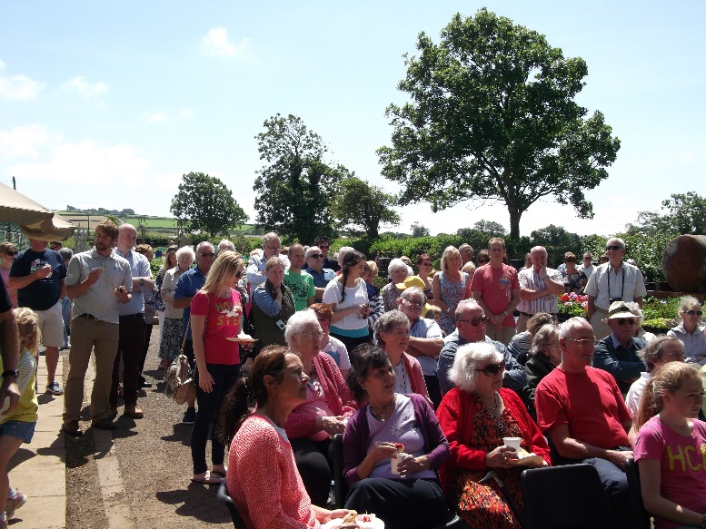

### 

### ***The Creative Rural Communities Team are launching a pilot project to help communities in the rural Vale to share their experiences and learn from each other to enable communities to strengthen and rebuild community spirit.***

Our goal is to grow community spirit in different villages in the rural Vale and show case best practice. We want local community and voluntary groups to share and celebrate their community spirit successes, so that others may be inspired to do the same.

Groups will have an opportunity to receive funding of up to £1000 to support their community to trial new innovative ideas to grow community spirit in your community.

## What do we mean by community spirit?

There are many different ways of developing community spirit. This may include:

* improving communication with all residents in the village with a new website or newsletter;
* organising a community mapping/engagement activity;
* bringing the community together for a particular activity such as tree planting;
* holding a new event to bring the community together; and
* neighbourly goodwill gestures.

## Who can get involved?

Priority will be given to groups that represent a cross section of their community eg. Community councils, village hall associations, resident’s associations. Consideration will be given to other groups if they can demonstrate that a good representation from the community is involved.

Fledgling groups will be considered for inclusion in the project through the learning stage, however they will be required to be constituted to secure funding at Part 2. Support will be given to assist with this process.

If we receive multiple applications from the groups in same community, CRC may request that there is some collaboration between groups.

CRC are seeking to achieve a wide geographical spread of projects across the rural Vale.

## What is involved?

There is a simple 2 part application process:

### Part 1: Getting Involved and Learning:

You will be required to fill out a simple part 1 expression of interest form stating why you would like to be involved in the project, what you already do as a group to develop community spirit and what you would like to learn.

All those groups expressing an interest will be able to get involved in the Part 1 Getting Involved and Learning, which will focus on the learning from each other through the visits / networking / workshops programme.

### Part 2: Innovation Fund:

All communities taking part in Part 1 Getting Involved and Learning will be invited to submit an idea, under the Part 2 Innovation Fund. You will be required to fill out a short part 2 form setting out the new innovative activity your group wish to trial in the community, how it will develop community spirit, how much it will cost and how you will share the learning.

This will be a competitive process and the most innovative ideas to boost community spirit will be supported. A maximum award of £1000 will be available.

|  |  |
| --- | --- |
| **Our commitment** | **Your commitment** |
| Support to groups to enable them to participate in the project eg. completing forms, becoming a constituted group etc.Match your group with another applicant who wants to learn about something you have done and you can learn about what they have done.Provide a range of workshops depending on participating groups’ needs.Organise learning visits for those groups interested in learning from best practice from other parts of the countryAwards available to trial anything new you have learnt on your twinning journey. | Tell us what you want to learn.Attend the welcome meetingParticipate in the learning programme including participating in visits / networking events and workshops.Complete feedback sheets and share what you have learntAttend at least 2 workshopsIdentify a new innovative activity you want to trial (in order to secure the funding)Signed timesheet from volunteersAttend the end of project celebration |

## How to get involved?

Simply GET IN TOUCH with the team and have a chat about your ideas.

Email [create@valeofglamorgan.gov.uk](mailto:create@valeofglamorgan.gov.uk)

Phone 01446 704226.

We will provide support and guidance throughout the project to enable your group to develop new ideas and become more sustainable in the future.

### **Submit your expression of interest by 11th September 2017**

***This document is available in Welsh / Mae’r ddogfen hon ar gael yn Gymraeg***