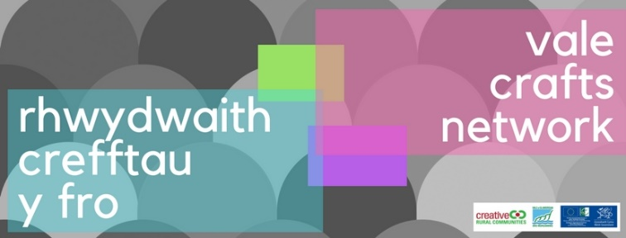
Vale Crafts Network – An Overview and Observations from Cowbridge Old Hall, Tuesday 19th June 2018

Opportunities and notes from the network meeting:

121 Sessions with Agora
Rolant Tomos from hosted 121 business support sessions with craft practitioners. As a result Rolant has I followed up the meetings with introductions to Margam Park and St Fagans where there is potential to show and sell. Also looked into possible funding to attend trade shows and how to sell to Cadw.
Agora can support those using land based products in their crafts such as wool, wood and willow. For more information, please contact Rolant or see the Agora website.
rolant.tomos@menterabusnes.co.uk
agora@menterabusnes.co.uk
02920 467 408 / 07964 354660

Brief overview of the network & Ideas for future crafts collaborative projects
The Creative Rural Communities (CRC) Local Action Group (LAG) have suggested that the network works on a collaborative project to solidify the group. Initial suggestions included an Open Studios event, and inclusion of Pop Up studios so that everyone can participate irrespective of their studio set up. Other suggestions including a rotating town market, and demonstration workshops. Further opportunities to have your say on these will follow.

Presentation from The Exchange, Cowbridge
A presentation was given by the Cowbridge Exchange group who plan to build a multi-purpose covered events space in Cowbridge. Craft practitioners are invited to share their thoughts on the development by completing this survey; https://www.surveymonkey.com/r/TheExchangeCowbridge

Introduction to formalising the network by Clive Curtis - GVS
As mentioned in previous meetings, CRC will not be able to host this group indefinitely, and the network will need to take on its own governance in time. Clive Curtis gave an overview of the types of governance that would be required to set up a basic entity, and explained how easy it is to. In short, the following elements would be needed:
- A minimum of three people to create a small committee
- A constitution agreeing the aims and objectives of the group, and the basic governance of the group
- A bank account
GVS can support the group to establish the network and can provide template constitutions as well as offering ongoing advice. Opportunities to get involved in the setting up of the group and agreeing the aims and objectives of the group will follow.

Informal Networking and Collaboration Ideas
A number of suggestions were made about collaboration opportunities, or subjects for future talks and discussions, these included;
- Open/Pop Up Studios
- Closed Facebook Group/Linked In
- Rotating Town Markets
- Social nights, bring along your crafts to do and drinks
- Demos and workshops
- Support with pop up shops
- Advice on online presence and online retail
- Support with craft fairs
- Resources knowledge and sharing, events equipment for example

Special thanks to Vale Courses for the free use of the venue for the meeting. Here’s a quick reminder of what Vale Courses can do to support crafts:
- Run a variety of courses but always on the lookout for new courses and tutors.
- There is a Pop-Up-Shop at the Old Hall with an entrance on Cowbridge High Street, this can be hired at £13 per day.
- The Old Hall affords a light and spacious gallery area in the foyer and ground floor communal spaces, this includes wall space and a number of glass display cabinets, and new exhibition proposals are always welcome.
- Vale Courses offers a number of short and one day courses aimed at small businesses, such as Excel, Social Media, Photography & Photoshop to name a few.
The date of the next network meeting is:
Tuesday 11th September 2018 at Cowbridge Old Hall

Contact Us:
Creative Rural Communities, Old Hall, High Street, Cowbridge, CF71 7AH
www.creativeruralcommunities.co.uk
01446 704707
@ruralvale
f/CreativeRuralCommunities

