Crafts Network Project Report
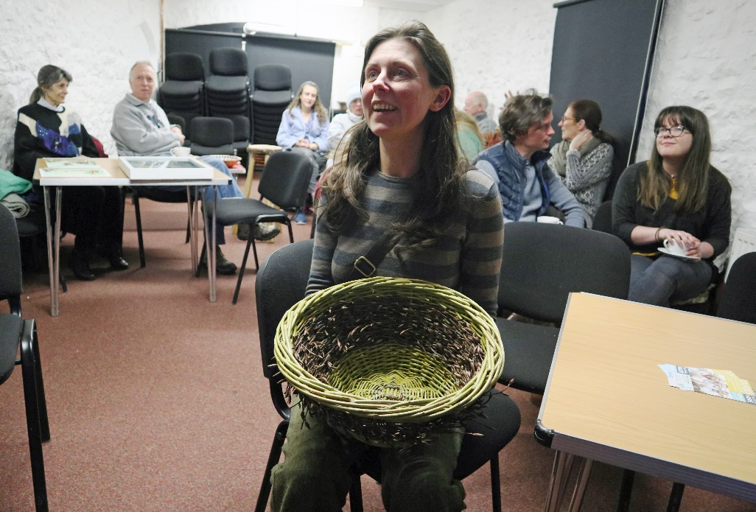
2017-19 | Exploring the potential of a Crafts Network in the Vale of Glamorgan
The Creative Rural Communities Local Action Group (LAG) tasked project officer Nicola Sumner-Smith was exploring the potential of a Crafts Network in the Vale. This report summarises the initial findings.

Crafts Network Project Report
Exploring the potential of a Crafts Network in the Vale of Glamorgan

Background
Over the past few years, Creative Rural Communities (CRC) have supported a number of craft initiatives ranging from craft business start-ups, exhibitions, pop-up events and more, and it has become apparent that craft professionals and enthusiasts across the Vale, share a desire to develop their crafts, increase their opportunities to exhibit, sell, teach and work, and may benefit from having a Craft Network to explore these opportunities and connect with like-minded people. This idea is also supported by the Vale of Glamorgan Council’s Arts Development Officer.
The CRC Local Action Group (LAG) agreed to fund a short term exploration of this. In the first instance we conducted an online survey and held two crafts network meetings gauge the appetite for the network.

The On-line Survey
An online survey was publicised between October – December 2017. The link to the survey was sent directly to known craft practitioners, the CRC database and shared widely through our social media platforms. During this time, we collected 44 responses from a wide range of crafts practitioners including wood workers, willow weavers, furniture makers, mosaicists, ceramicists, photographers and stain glass makers, to name a few.
The general response was favorable to the idea of a crafts network, and the following table indicates how they would like to progress their business (or hobby), and how they see the network supporting them:
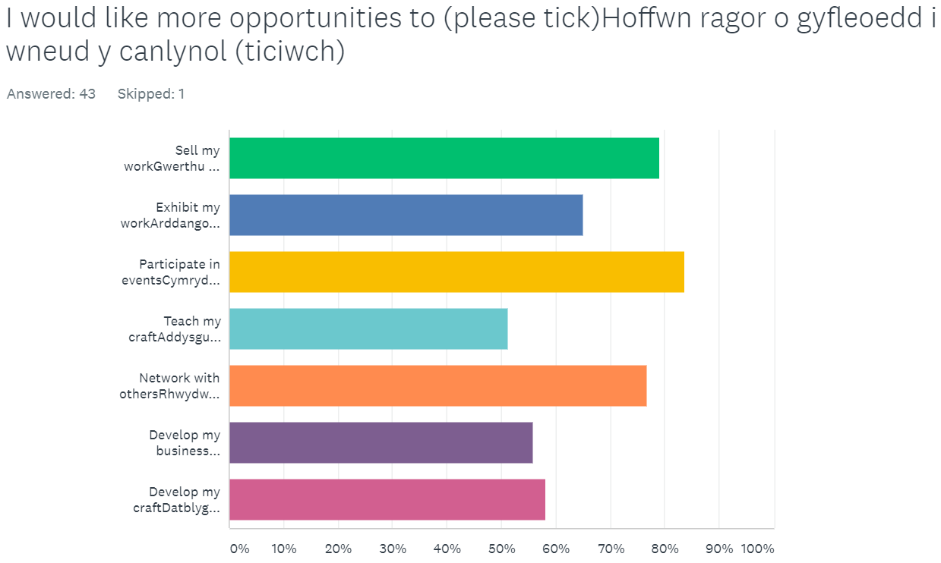

Network Meeting One

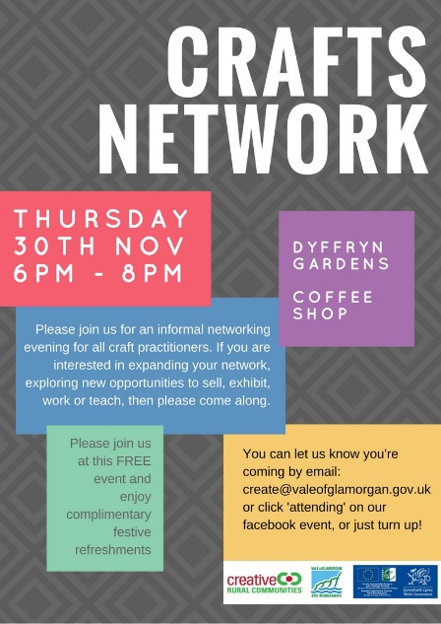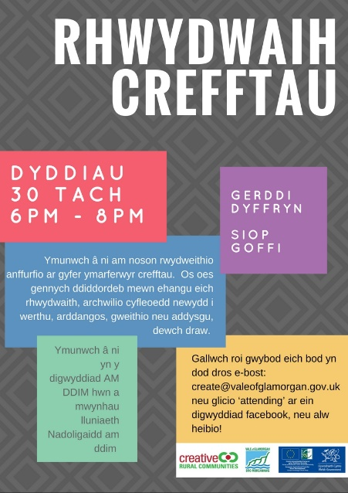

The first of the network meetings was held at Dyffryn gardens tea rooms on Thursday 30th November from 6.00 – 8.00pm, and was attended by 35 people. The evening was predominantly informal, with a short introduction from Nicola Sumner-Smith from CRC, and then an ‘open floor’ format where anyone could contribute ideas, opportunities and thoughts to the network. The general feedback was that there was a need for a crafts network, and it was generally understood that in order for the network to progress, that volunteers from within the group would need to take the lead of the group in time. A summary of the contributions and key comments from the evening can be found in Appendix One, this summary was also sent to all the attendees as well as all of the respondents to the survey following the event.

A number of people sent their apologies that they could not make the meeting, but would like to be kept informed of future events.

Following the meeting, one attendee reported that he had had several people contact him in response to his appeal for illustrators for his publishing company.
“What a great opportunity! There isn’t anything like this in the Vale where we can all get together to learn from each other or develop new ideas. We do hope that it continues.”

Network Meeting Two

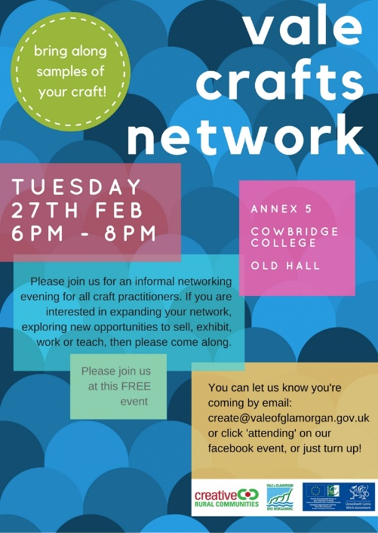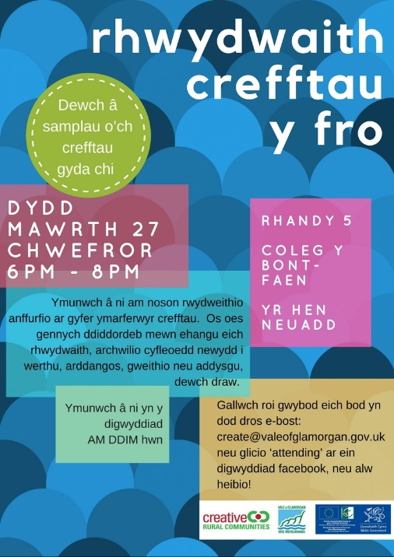

The second network event took place on a snowy evening in late February (2108), with 20 people in attendance. Again there was much enthusiasm for the network and many of the people in attendance had not been before. Aside from the informal networking and ‘open floor’ session, there were also two speakers;
Rolant Tomos – Agora
Rolant gave a brief talk about Agora which is a collaborative project supporting growers and makers across the Vale of Glamorgan and a number of counties in South Wales. Agora can support those using land based products in their crafts such as wool, wood and willow.

Chris Short and Ewart Schofield - Twt Beech Tree Project
Chris and Ewart gave a talk about the Twt Beech Tree project; a project that celebrates the life of a significant beech tree in the Cowbridge community that has had to be felled due to disease. The project will seek to engage with the local community, artists and crafts practitioners to use the wood to learn new skills, create sculptures and artworks, furniture and multiple other items. The project is calling for anyone who wishes to be involved or use some of the wood to get in touch. The project also hopes to host an open day or weekend to host workshops and demonstrations and raise the profile of the project, commission sculptures, and host an exhibition of works.
A summary of the contributions and key comments from the evening can be found in Appendix Two, this summary was also sent to all the attendees from both networking evenings as well as all of the respondents to the survey following the event.

Summary and Recommendations – Early 2018
Whilst there has been an encouraging response to the survey, the two network events, and the subsequent feedback to the events, it is too early to tell if there is any real appetite for the network, and if there will be any volunteers who wish to take on the role of administering from this point.
We recommend that the LAG agree to a continuation of the crafts network, administered in the short term by CRC. We suggest that subsequent networking events should showcase other crafts networks, and advice on setting up a committee, constitution and administration of the network, as well as championing craft opportunities and evolving the network in general.
We recommend a further three meetings to be held quarterly over the remainder of 2018, and suggest a budget of £1500 to cover venues, refreshments, speaker and advisor expenses.

Overview 2018
The LAG agreed to extend the pilot phase and CRC continued to support the network throughout 2018. The LAG also suggested that the network make a subsequent application to fund an event in the hope that this would galvanize the group further and animate members to find suitable future committee members. As they were not yet a constituted group, Sally Perini from Vale Courses agreed to lead on an application for a Crafts Festival and Open Studio trail, and a grant of £10,000 was agreed in October 2018 to fund the festival as well as an associated website. The network continued to meet throughout 2018, and hosted speakers from GVS to discuss formalizing the group, Jeanine Payne, a network member who gave a talk about selling online and her business ‘Little Me Teepee’, and largely discussions focused on the development of the funding application.

Overview 2019 – Vale Makers Festival
The festival took place in September 2019 as was well received, details of the festival activities, marketing and participants can be found in the Appendices. A number of network members volunteered to help deliver the festival and roles included attending study visits to other Open Studio trails, branding and marketing, coordinating the exhibition, coordinating the makers marker, website development and attending training.

Appendix One
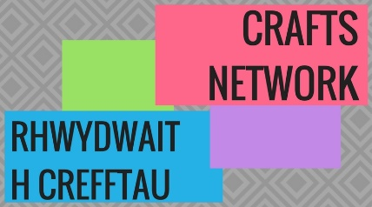
Crafts Network – An Overview and Observations from Dyffryn Gardens, Thursday 30th November 2017
An Overview:
Creative Rural Communities (CRC) is the rural regeneration team for the Vale the Glamorgan Council. We are funded by the Council and the Rural Development Plan for Wales, and can support the development of projects, ideas and networks under our five themes. Over the past few years, we have supported a number of craft initiatives ranging from craft business start-ups, exhibitions, pop-up events and more, and it has become apparent that craft professionals and enthusiasts across the Vale, share a desire to develop their crafts, increase their opportunities to exhibit, sell, teach and work, and may benefit from having a Craft Network to explore these opportunities and connect with like-minded people. This idea is also supported by the Vale of Glamorgan Council’s Arts Development Officer.
The CRC Board have agreed to fund a short term exploration of this, this means that we are happy to host some initial meetings and kick start some conversations and connections, but won’t be able to host this indefinitely. We would however be more than happy to support the group take the next steps to formalising the network, and would welcome a funding application to help cover the initial costs of hosting and marketing the network for a preliminary period, and subsequent funding applications to get some new initiatives off the ground.
However, this is of course early days and you may collectively decide that a network that meets in person is not the right way forward, or indeed the only way forward, and we would be equally happy to help the group explore a number of network ‘models’ and equally, if there is no desire to continue after the initial meetings then there is no obligation to do so.

Offers and opportunities mentioned at the meeting:
Sally Perini manages Vale Courses which operates from the adult education centre in Old Hall in Cowbridge. She informed us of the following:
- Sally already employs a number of crafts tutors to run a variety of courses but is always on the lookout for new courses and tutors.
- There is a Pop-Up-Shop at the Old Hall with an entrance on Cowbridge High Street, this can be hired at 13 pound a day.
- The Old Hall affords a light and spacious gallery area in the foyer and ground floor communal spaces, this includes wall space and a number of glass display cabinets, and new exhibition proposals are always welcome.
- Vale Courses offers a number of short and one day courses aimed at small businesses, such as Excel, Social Media, Photography & Photoshop to name a few.

Hannah Dineen from Creative Rural Communities mentioned a number of forthcoming events and initiatives that might be of interest:
- Inspiring New Workspaces is an initiative looking at news ways of developing and using workspaces, including co-working spaces. You are invited to attend an event taking place on 17th January at St Donats Arts Centre from 17.30 – 20.00. Please follow the link for more details and booking information: https://tinyurl.com/InspiringWorkspaces

- Redundant Rural Buildings is an initiative looking at underused spaces which could be utalised as work spaces, this could be a redundant rural barn, an underused space in a pub or an underutalised community venue. If you are looking for space, or have an underused space, we invite you to complete this survey: https://www.surveymonkey.co.uk/r/redundantbuildings

Paul Bartlett is a woodworker and has access to plenty of wood. Paul kindly offered to make wooden plinths for anyone wishing to display their crafts on plinths, he is not looking profit from this. Please contact CRC if you would like to be out in touch with Paul.
Ian Fell is a great ambassador for Llancarfan Church and urged all to visit it to see the medieval wall paintings, but also spoke of a deconsecrated church in Eglwys Brewis which has many crafts connections; including a history with William Morris. Ian is working with a group to explore the possibility of this becoming a crafts hub in time which may include opportunities to sell, exhibit, teach and learn crafts.
Rose Revera has recently launched House Martin Media which has developed a number of local craft professional websites. Please contact Rose if you would like to discuss your website with her.
Karen Davies from St Donats Arts Centre sent her apologies, but asked us to pass on that the gallery at the centre sometimes has availability and she would welcome conversations about possibly new exhibitions. Also, the Arts Centre would be interested in developing a programme of crafts workshops, we can explore this at subsequent meetings, but please contact Karen in the meantime if you wish.
Others commented on the need for some quality control and definition relating to ‘crafts’, feeling that craft fairs were all too often filled with items made from kits or pre-fabricated components;
That crafters at the Vale Show for example, weren’t representative of the local crafts, and this may be due to prohibitive costs or difficulty getting selected;
That craft in the Vale could have a greater presence and be on a par with West Wales for instance, celebrating a wealth of quality products through events, shows and workshops;
That artists could be considered as illustrators for a publisher that was present, if anyone interested in offering their services, please let us know and we can put you in touch;
That a closed Facebook group could be set up for crafters to share ideas and opportunities, whilst we appreciate that this won’t suit everyone, we are happy to facilitate this to see if it gains any interest, we will keep you posted regarding this;
That public liability insurance is prohibitive for part time crafters who want to do an occasional event or stall, any thoughts on this would be gratefully received!

Other noteworthy opportunities and forthcoming events
Artist Exchange is part of Arts Connect, an Art Development partnership between the Vale of Glamorgan, Rhondda Cynon Taf, Merthyr Tydfil and Bridgend local authority areas. It provides the opportunity to connect, promote, share and celebrate your art practices both locally and regionally and further afield.
The Vale of Glamorgan Council offers a variety of business support and can also sign post you to further relevant support. Please see the Business Support webpages for further information, there will also be a Business Start Up event at the end of January and we will circulate details of this when they are confirmed.

Contact Us:
Creative Rural Communities, Old Hall, High Street, Cowbridge, CF71 7AH
www.creativeruralcommunities.co.uk
01446 704707
@ruralvale
f/CreativeRuralCommunities

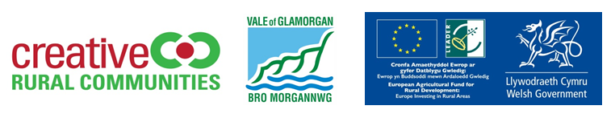

Appendix Two
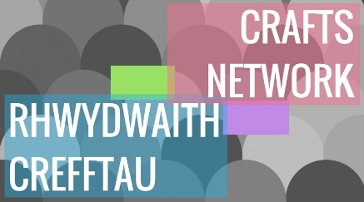
Crafts Network – An Overview and Observations from Cowbridge Old Hall, Tuesday 27th February 2018
An Overview:
Creative Rural Communities (CRC) is the rural regeneration team for the Vale the Glamorgan Council. We are funded by the Council and the Rural Development Plan for Wales, and can support the development of projects, ideas and networks under our five themes. Over the past few years, we have supported a number of craft initiatives ranging from craft business start-ups, exhibitions, pop-up events and more, and it has become apparent that craft professionals and enthusiasts across the Vale, share a desire to develop their crafts, increase their opportunities to exhibit, sell, teach and work, and may benefit from having a Craft Network to explore these opportunities and connect with like-minded people. This idea is also supported by the Vale of Glamorgan Council’s Arts Development Officer.
The CRC Board have agreed to fund a short term exploration of this, this means that we are happy to host some initial meetings and kick start some conversations and connections, but won’t be able to host this indefinitely. We would however be more than happy to support the group take the next steps to formalising the network, and would welcome a funding application to help cover the initial costs of hosting and marketing the network for a preliminary period, and subsequent funding applications to get some new initiatives off the ground.
However, this is of course early days and you may collectively decide that a network that meets in person is not the right way forward, or indeed the only way forward, and we would be equally happy to help the group explore a number of network ‘models’ and equally, if there is no desire to continue after the initial meetings then there is no obligation to do so.

Offers and opportunities mentioned at the meeting:
Special thanks to Vale Courses for the free use of the venue for the meeting. Here’s a quick reminder of what Vale Courses can do to support crafts:
- Run a variety of courses but always on the lookout for new courses and tutors.
- There is a Pop-Up-Shop at the Old Hall with an entrance on Cowbridge High Street, this can be hired at £13 per day.
- The Old Hall affords a light and spacious gallery area in the foyer and ground floor communal spaces, this includes wall space and a number of glass display cabinets, and new exhibition proposals are always welcome.
- Vale Courses offers a number of short and one day courses aimed at small businesses, such as Excel, Social Media, Photography & Photoshop to name a few.
Rolant Tomos – Agora
Rolant gave a brief talk about Agora which is a collaborative project supporting growers and makers across the Vale of Glamorgan and a number of counties in South Wales. Agora can support those using land based products in their crafts such as wool, wood and willow. The type of support includes:
- Knowledge Transfer
- Mentors
- Facilitators
- Workshops
- Study Tours
- Business Development Officer time
- Meet the Buyer events
- Developing your supply chain

For more information, please contact Rolant or see the Agora website. rolant.tomos@menterabusnes.co.uk
agora@menterabusnes.co.uk
02920 467 408 / 07964 354660

Chris Short and Ewart Schofield - Twt Beech Tree Project
Chris and Ewart gave a talk about the Twt Beech Tree project; a project that celebrates the life of a significant beech tree in the Cowbridge community that has had to be felled due to disease. The project will seek to engage with the local community, artists and crafts practitioners to use the wood to learn new skills, create sculptures and artworks, furniture and multiple other items. The project is calling for anyone who wishes to be involved or use some of the wood to get in touch. The project also hopes to host an open day or weekend to host workshops and demonstrations and raise the profile of the project, commission sculptures, and host an exhibition of works.
For more information, please see the project website: http://thetwtbeech.org.uk/

Other noteworthy comments, opportunities and forthcoming events
Glyn Evans – ffoto Image – Was on hand to take photographs of the networking evening and people’s crafts. These photographs will be available to promote the crafts network in the future and the work of CRC. Photos can be requested free of charge depicting individuals and their work to be used at their discretion.

Giles Gallery – Beth Giles came along to advise us that Giles Gallery in Pontyclun now has a dedicated workshop space to hire to run classes. Please see the gallery website for more information: http://www.gilesgallery.com/workshops/
Between the Trees Festival – This festival takes place in Candlestone Bridgend during the August bank holiday, and they are looking for crafts people to host workshops and sell their wares. Please see their website for more information: https://betweenthetreesfestival.co.uk/
Cowbridge Arts Group – Are exploring funding opportunities to update the display cabinets in Old Hall, these need painting and new lighting, and also seeking funding for promotional literature. Please get in touch if you would like to help:
Artist Exchange is part of Arts Connect, an Art Development partnership between the Vale of Glamorgan, Rhondda Cynon Taf, Merthyr Tydfil and Bridgend local authority areas. It provides the opportunity to connect, promote, share and celebrate your art practices both locally and regionally and further afield.
The Vale of Glamorgan Council offers a variety of business support and can also sign post you to further relevant support. Please see the Business Support webpages for further information, there will also be a Business Start Up event at the end of January and we will circulate details of this when they are confirmed.

Contact Us:
Creative Rural Communities, Old Hall, High Street, Cowbridge, CF71 7AH
www.creativeruralcommunities.co.uk
01446 704707
@ruralvale
f/CreativeRuralCommunities

Appendix 3

Vale Makers Festival
Makers at Crafts by the sea in Ogmore-by-Sea had open studio and willow activity. 6 people participated in willow activity.
Cowbridge Library delivered workshops for children:
• Puppet Workshop 29 children
• Letterpress 8 Children
• Collage Crafts 4 Children
• Japanese Crafts 18 Children
Colwinston CLIC Group organised a weekend of activities and makers market with over 200 visitors. Activities included:
• Making Polymer Clay Beads and Pendant
• Making Fabric Pinch Boxes
• Needle Felting
• Fabric Manipulation
• Learn to Crochet
• Wet Felting
• Block Printing
• Making Patchwork Mug Rugs
Coed Hill Green Woodworking had 2 students make a stool
Festival week at the Old Hall Cowbridge –which included the Vale Makers Exhibition, had over 300 visitors during the week and 400 visitors over the 2 day Makers Market. Visitors from Australia, Canada, Neath, Newport, Port Talbot, Swansea. Events included:
• A free demonstration and activity for Die Cutting with 8 people participating.
• Masterclass by Christine Lloyd Printing from Nature – 5 people enrolled and participated
• She Sews Sea Shells Exhibition at the Old Hall Pop Up Shop, here is a link to some feedback https://cuttingedgetextiles.wordpress.com/2019-she-sews-sea-shells-exhibition/
• Sew Lovely by Carol Bartlett was at the Old Hall for 3 days provided demonstrations to visitors and delivered a sewing workshop for 6 people.
Makers Market included:
• Emma Marshman – bee wraps and printing
• Ann Fox – Weaving
• Bernadette Gardner – needle felting
• Gill Banks – crystalline ceramics
• Frances Lloyd – fused glass
• Ingrid Walker – stained glass
• Sarah Keep – Hat making
• Maggie Cooper – textiles and leather bags
• Christine Lloyd – printing
• Karen Clements – card making
• Carol Lewis – textile bag making
• Charlotte Norton – house dioramas
• Sam Williams – natural beauty products
• Mandy Nash – jewellery and textiles

Wick Art Group
Wick Art Group held an exhibition, demonstrations and master class workshops over the festival weekend in their local village hall. Over 150 people visited.

Appendix 4

Makers Festival – Media Summary

Visit the Vale Facebook
Boosted Post - 5/9/2019 – 22k Reach – 2,971 Organic / 19,667 Paid
2,410 Thur plays of the video
£100 promotion over 9 days

In addition to this we also placed the following posts:
Visit the Vale
28/08/2019 – Introducing Post. 2104 Reach, 66 Post clicks, 50 Link Clicks
13/09/2019 – Takeover Post. 2967 Reach, 119 Post Clicks, 28 Views, 90 Other Clicks
16/09/2019 – Takeover#1. 438 Reach
16/09/2019 – Takeover#2. 689 Reach
19/09/2019 – Takeover#3. 292 Reach
17/09/2019 – Vale Makers Festival Post – 1305 Reach
18/09/2019 – Takeover#4. 498 Reach
19/09/2019 – Vale Makers Festival Post – 526 Reach
20//09/2019 – Takeover#6. 453 Reach
20/09/2019 – Getting Crafty in Cowbridge. 1661 Reach
21/09/2019 – Takeover#7. 495 Reach
23/09/2019 – Takeover#8. 395 Reach
25/09/2019 – Takeover#9. 398 Reach
26/09/2019 – Takeover#10. 323 Reach
27/09/2019 – Takeover#11. 377 Reach

Vale Makers Festival Page

Full insights available should you need them or if you haven’t got access, but in summary
Between 17/05/2019 – 24/09/2019
37381 engagements. Of them 2867 Paid. Very healthy Organic engagement.
260 Followers – and continues to grow.

Instagram – Visit the Vale
05/09/2019 – 533 reach. 735 Impressions
20/09/2019 – 515 Reach. 738 Impressions

