Community Energy Inspiration Evening
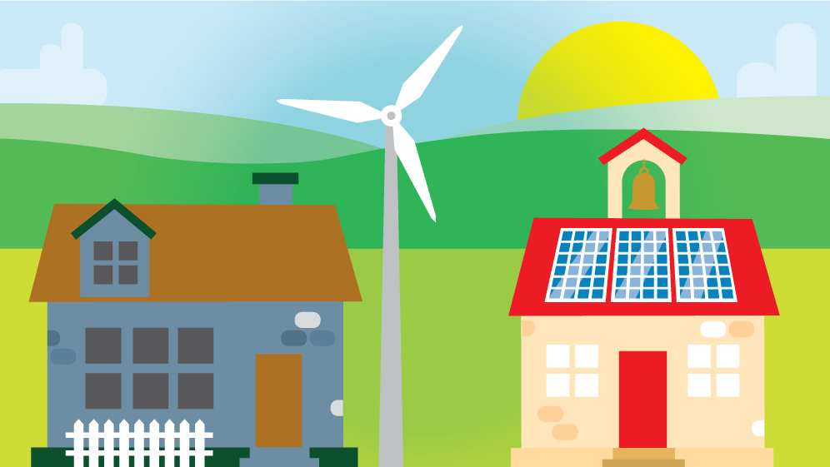
18.04.2018 | An Overview  St Donats Arts Centre
This event was for people passionate about their community, the environment and saving money who wanted to learn from others, share ideas and potentially embark on their own projects.
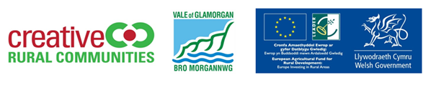
Contents
So what is Community Energy? 1
Background 1
Speaker Summaries 2
Jodie Giles - Senior Project Manager for Regen 2
Dan MacCallum - Awel Aman Tawe (AAT) 2
Phil Powell - Gwent Energy CIC 2
Ant Flanagan - Gower Power 3
Workshop – Your Community Energy Aspirations 4
What are your community energy aspirations? 4
What will your next steps be? 4
What support do you need to achieve your goal? 4
5
Next Steps 5
Contact Us: 5
Other Useful Contacts 6
8

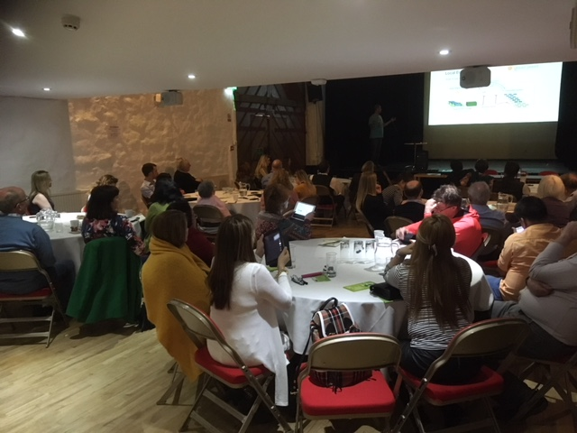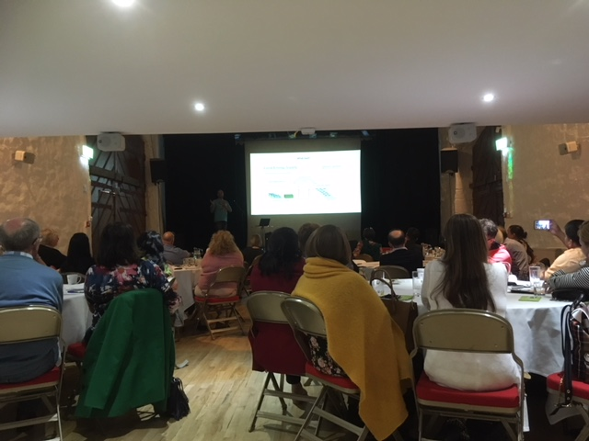

Community Energy Inspiration Evening
An Overview
St Donats Arts Centre

So what is Community Energy?
Community Energy projects are community led, and benefit the local community. They can empower people, support stronger local economies, and help people save money on their energy bills. They include projects that help reduce energy use, manage energy more efficiently, generate sustainable energy, or purchase energy more effectively.

Background
Creative Rural Communities (CRC) is the rural regeneration team for the Vale the Glamorgan Council. We support communities and enterprises across the rural Vale of Glamorgan to trial and develop new ideas for the social and economic wellbeing of the area, this is funded under our LEADER programme,
which is funded by the Vale of Glamorgan Council, the Welsh Government Rural Communities – Rural Development Programme 2014-2020 which is funded by the European Agricultural Fund for Rural Development and the Welsh Government.

Our programme funds the development of projects under five theme, ranging from support for communities to business networks, from digital technology to GREEN COMMUNITY ENERGY.
This theme is new to us, and the inspiration evenings event was designed to hopefully inspire our guests to consider developing a community energy project of their own.

We, and teams like our across Wales, can support the development of community energy projects, and have revenue funding to pilot small scale projects. If a project requires capital funding, then we will support project leaders to apply for funds from the Rural Community Development Fund, and we have a designated project officer to support project applications.

CRC are not the experts in community energy, and so we were pleased that Jodie Giles agreed to co-host the evening with us, who is the expert! Jodie joined us from Regen, and is responsible for the delivery of Regen’s community energy support programme.

Speaker Summaries
Slides from the speaker presentations can be found here

Jodie Giles - Senior Project Manager for Regen
Jodie gave us an overview of the development of community energy projects in Devon, and talked of the exponential benefits of these over the years. Jodie was also on hand to answer questions and share her vast knowledge and expertise with us.

Dan MacCallum - Awel Aman Tawe (AAT)
AAT has been developing and advising on community schemes, including wind, solar, biomass and hydro since 1998. They have implemented energy efficiency measures in thousands of homes and community centres.

A few highlights from Dan’s talk include:
- Communities can benefit from community energy projects in different ways; AAT recently donated shares in a scheme to community groups and organisations to raise awareness of the projects, their objectives and their benefits whilst increasing the sense of ownership of the project in the community
- Community energy projects can inspire communities; a performance at Pontardawe Arts Centre entitled ‘Flood’ will take place in June 2018, focussing on the effects of flooding in Swansea and the residents having to decamp to Pontardawe.
- Another example of communities inspired includes ‘Run the like the wind’ a 10k community run to the Pontardawe Wind Turbines

Phil Powell - Gwent Energy CIC
This community organisation has installed 300kW of PV on community buildings and supported over 70 community energy projects. Their latest project ‘Fully Charged’ is about the uptake of electric vehicles in communities.

A few highlights from Phil’s talk include:
- Community energy projects can come in different guises, for example, a solar panel installation on a community building maybe done under a ‘rent a roof’ scheme, whereby the building is rented to an existing energy co-operative to manage the entire project, alternatively, the facility may wish to own their own panels, but not want to oversee the installation, or finally, they may wish to own, install and manage the entire project, there are many variables each with their own pros and cons to consider to suit your organisation
- Phil has lead an electric vehicle scheme in Monmouthshire, the ‘Fully Charged’ scheme has tripled the use of electric cars in the area since it’s inception
- That the ‘Feed In Tariff’ (and now lack of) should not be the only incentive for projects when there are so many other benefits
- Phil had three great tips for us!
- You will need a hero! – Someone always needs to take the lead
- Don’t have meetings, have events – These will get you better results
- Start small, start soon – or else you never will!

Participant: “I now recognise that there is support for every aspect of a project”

Ant Flanagan - Gower Power
This organisation has installed a 1MW ground mounted solar project with a community share offer to enable local people to invest. Surplus profits will be used for regenerating the area.

A few highlights from Ants talk include:
- Ant did a great job at illustrating the impact of a community energy project through his talk, sharing his experiences of seeing skills development in the local community, the joy of shares and profits and re-investment in the community, and the wonders of social cohesion. We really love Ant’s slide which we think illustrates this perfectly.

Fig One: Slide from Ant Flanagan

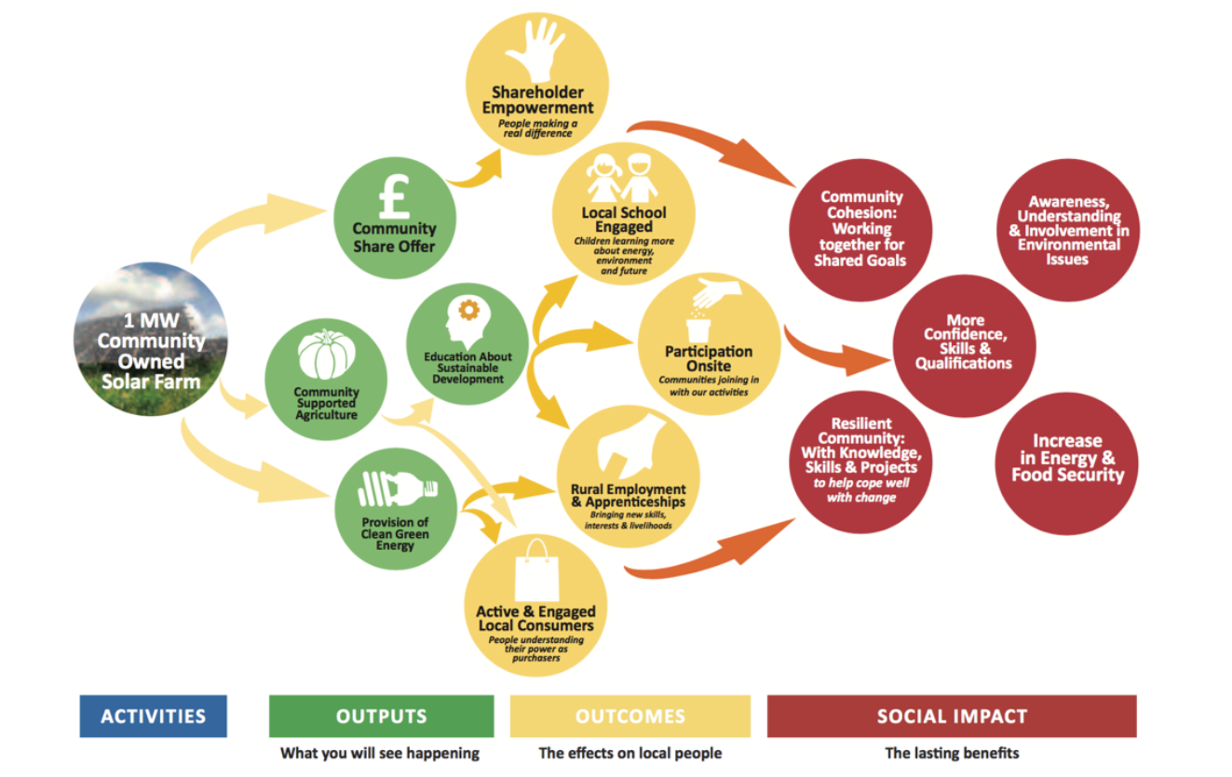

Workshop – Your Community Energy Aspirations

We hosted a workshop at the event which focused on the three questions below; we have briefly summarised some of the frequent responses:

What are your community energy aspirations?
- Increase community engagement
- Reduce emissions
- Changes to more sustainable energy sources as the norm
- Sustainable community transport
- Changes in attitude and awareness
- Positive social impacts
- Influence planning procedures
- Easy retrofit solutions
- Inspire local authority to be exemplar

What will your next steps be?
- Stay actively engaged in this network
- Visit projects of interest
- Identify partners
- Identify opportunities
- Feasibility studies
- Look into long term benefits
- Create greater understanding of benefits post ‘feed in tariff’

What support do you need to achieve your goal?
- Advice on funding opportunities/ options
- Enthusiasm
- Case studies and visits to learn from
- Peer support
- Structured group
- Understanding of support agencies
Participant: “It was inspiring to hear about the determination of communities
against all odds”

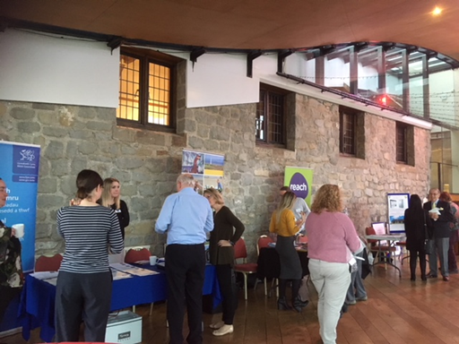

Next Steps
We hope that the evening proved inspiring and that participants are encouraged to explore community energy project possibilities in their own communities.
If you are now thinking of developing a project idea, please do get in contact with us so that we may support you to take the next steps. This may include:
- Sign posting to the relevant support agencies
- Site visits to similar projects
- Developing mentor schemes
- Facilitating peer to peer learning
- Facilitating community consultation
- Advice and sign posting regarding funding models and grant schemes
- Funding revenue based pilot projects
- Hosting topical surgeries
- And more!
Participant: “I was inspired by the concept of local communities managing
and benefitting from their local assets”

Contact Us:
Creative Rural Communities, Old Hall, High Street, Cowbridge, CF71 7AH
www.creativeruralcommunities.co.uk
01446 704707
@ruralvale
f/CreativeRuralCommunities

Other Useful Contacts
ORGANISATION/SCHEME | DESCRIPTION
Rural Community Development Fund  Local Contact:  01446 704755  www.creativeruralcommunities.co.uk | The grants will provide investment funding for a wide range of activities to help meet local needs and strengthen communities so that they can grow and thrive.  Key areas for support include:  - drawing up of community / village development plans  - investments in small scale infrastructure including renewable energy generation and energy saving actions
Wales Rural Network  ruralnetwork@gov.wales / rhwydwaithgwledig@llyw.cymru  rcdf@gov.wales  Wales Rural Network  0300 062 2302 | The Wales Rural Network manage a number of schemes under the Welsh Government Rural Communities – Rural Development Programme 2014-2020 which is funded by the European Agricultural Fund for Rural Development and the Welsh Government.  This includes the RCDF fund.
Regen  01392 494 399  https://www.regensw.co.uk/contact | Regen supports the development of Community Energy Projects across the UK. They operate a membership scheme which allows members to access forums, debates and events.
Community Energy Wales  02920 190260  http://communityenergywales.org.uk/ | Community Energy Wales is a not for profit membership organisation that has been set up to provide assistance and a voice to community groups working on energy projects in Wales. Helping to create the conditions in Wales that allow community energy projects to flourish, and communities to prosper.
Energy Saving Trust/Energy Saving Advice Line  0300 123 1234  http://www.energysavingtrust.org.uk | The Energy Saving Trust provide independent, expert advice on saving energy in your home, and information on funding for making energy efficiency improvements via the Energy Saving Advice Service, or via e-mail at the energy-advice@est.org.uk. Advice is also available on our website.
Local Energy Service  http://localenergy.gov.wales/ | The Welsh Government’s Local Energy Service which is managed by the Energy Saving Trust (EST) provides financial and technical support to help social enterprises and SMEs across Wales develop their own renewable energy schemes that deliver benefits to local people and communities. Further information about the support provided by the service, eligibility criteria, case studies and how to apply for support are available on the Service’s website.
Nest  0808 808 2244  www.nestwales.org.uk | The Welsh Government’s Warm Homes Nest Scheme provides free home energy efficiency improvements to energy inefficient homes, in which someone receiving a means tested benefit lives. A call back request form is available on the NEST website
Renew  029 2019 0260  http://www.renewwales.org.uk/ | Offers peer-to-peer support to community groups to tackle the causes and impacts of climate change through advice, training, mentoring and technical support from other experienced Community Practitioners.
Home Energy Check/Community Home Energy Check  http://hec.est.org.uk/ | The Energy Saving Trust have developed an online tool, which allows users to input details about their home in order to identify methods of achieving lower energy bills and a more comfortable home.
British Gas Energy Trust Fund  01733421020  http://www.britishgasenergytrust.org.uk/ | Aims to contribute to the relief of poverty, with a particular focus on fuel poverty, helping those who are struggling to pay for their consumption of gas and electricity get back on their feet and remain debt free going forward.
Eon Energy Fund  03303801090  https://www.eonenergyfund.com/ | The E.ON Energy Fund  can help pay current or final energy bill arrears for customers of any energy company. It can also help applicants by providing replacement household items such as cookers, fridges, fridge-freezers and washing machines – and also help to replace and repair gas boilers
SSE Priority Assistance Fund  0800 096 6192  https://sse.co.uk/help/accessibility/priority-assistance-fund | The SSE Priority Assistance fund provides support with debt relief, free benefit entitlement checks and energy efficiency and saving advice
Npower Energy Fund  01733421021  http://www.npowerenergyfund.com/ | Npower Energy Fund offers grants to domestic customers of npower to clear gas and/or electricity arrears if the client first demonstrates their commitment to achieving financial stability by making regular payments over a three month period for ongoing usage
EDF Energy Trust  01733 421020  http://www.edfenergytrust.org.uk/ | The Trust provides a significant difference to the lives of those in need by awarding grants to clear energy debts. In exceptional circumstances help is also available for energy efficient white goods and other priority debts. The Trust also funds charitable organisations to provide money and fuel debt services.
Health Through Warmth  0800 022 220  https://www.npower.com/health_through_warmth/ | Health Through Warmth offers help to people in England and Wales who have long term illnesses and are finding it hard to fully fund heating systems/repairs and insulation in their homes.
Warm Wales  01656747622  http://www.warmwales.org.uk/ | Provides advice, information and access to grant funding
WPD Power Up! Team  0808 808 2274  https://www.westernpower.co.uk/About-us/Priority-Services/Power-Up.aspx | An advice service designed to help people to save money and keep warm

